|  |  |
| --- | --- |
| Cairo University  Faculty of Engineering  Computer Engineering Department  CMPN202 (or CMP2020 for semester) | **SEM – Team 5** |
| ***Introduction to Database Systems***  **KAAK**  **FinanceVerse**  **Team Number: #5**  **Team Members:**   |  |  |  |  | | --- | --- | --- | --- | | **Name** | **BN** | **Sec** | **Emails** | | **Abdelaziz Salah** | **3** | **2** | **Abdelaziz132001@gmail.com** | | **Abdelrahman Noaman** | **2** | **2** | **bodynoaman1996@gmail.com** | | **Khaled Hesham** | **22** | **1** | **kha.hesham@gmail.com** | | **Kirollos Samy** | **12** | **2** | **kirollossamyhakim@gmail.com** |   **<1/9/2022>** | |
|  | |
|  | |

|  |  |
| --- | --- |
| Cairo University  Faculty of Engineering  Computer Engineering Department  CMPN202 (or CMP2020 for semester) | **SEM – Team 5** |
| **Data Base Schema:** | |
|  | |
|  | |

|  |  |
| --- | --- |
| Cairo University  Faculty of Engineering  Computer Engineering Department  CMPN202 (or CMP2020 for semester) | **SEM – Team 5** |
| **Database Constraints**  - Primary key constraint means that we do not allow the same value for this key attribute to be repeated as it is attribute which defines the tuple  - Referential key constraint means that the placed value in this tuple must have reference in the referencing relation which mean it must exit before to be used as reference.  - Not null constraint means that we do not allow this record to have a null value   * **Users:**   Primary key constraint (Username)   * **Transactions:**   Primary key constraint: (Trans_ID)  Not Null: All attributes  Referential constraint: (Stock_ID, Customer_ID) | |
|  | |
|  | |
|  | |
|  | |

|  |  |
| --- | --- |
| Cairo University  Faculty of Engineering  Computer Engineering Department  CMPN202 (or CMP2020 for semester) | **SEM – Team 5** |
| * **Payement:**   Primary key constraint: (Payment_ID)  Not Null: All attributes  Referential constraint: (Source_ID, Destination_ID)   * **Loan:**   Primary key constraint: (Loan_ID)  Not Null: All attributes  Referential constraint: (Acc_ID)   * **Guarantee:**   Primary key constraint: (Loan_ID, Customer_ID, Cost, Type)   * **Customer:**   Primary key constraint: (Customer_ID)  Not Null: (Name Customer_ID, username)  Referential constraint: (username) | |
|  | |
|  | |

|  |  |
| --- | --- |
| Cairo University  Faculty of Engineering  Computer Engineering Department  CMPN202 (or CMP2020 for semester) | **SEM – Team 5** |
| * **Company:**   Primary key constraint: (Company_ID)  Not Null: (Name, Company_ID)   * **Credit Card:**   Primary key constraint: (Credit_ID)  Not Null: (Acc_ID)  Referential constraint: (Acc_ID)   * **Bank:**   Primary key constraint: (Bank_ID)  Not Null: All attributes   * **Bank Account:**   Primary key constraint: (Acc_ID)  Not Null: (Bank_ID)  Referential constraint: (Username, Bank_ID) | |
|  | |
|  | |

|  |  |
| --- | --- |
| Cairo University  Faculty of Engineering  Computer Engineering Department  CMPN202 (or CMP2020 for semester) | **SEM – Team 5** |
| * **Assets:**   Primary key Constraint: (Type, Cost, Customer_ID)   * **Takes Loan:**   Primary key constraint: (Loan_ID, Customer_ID)   * **Stock:**   Primary key constraint: (Stock_ID)  Not Null: All attributes  Referential constraint: (Company_ID) | |
|  | |

**ER DIAGRAM:**

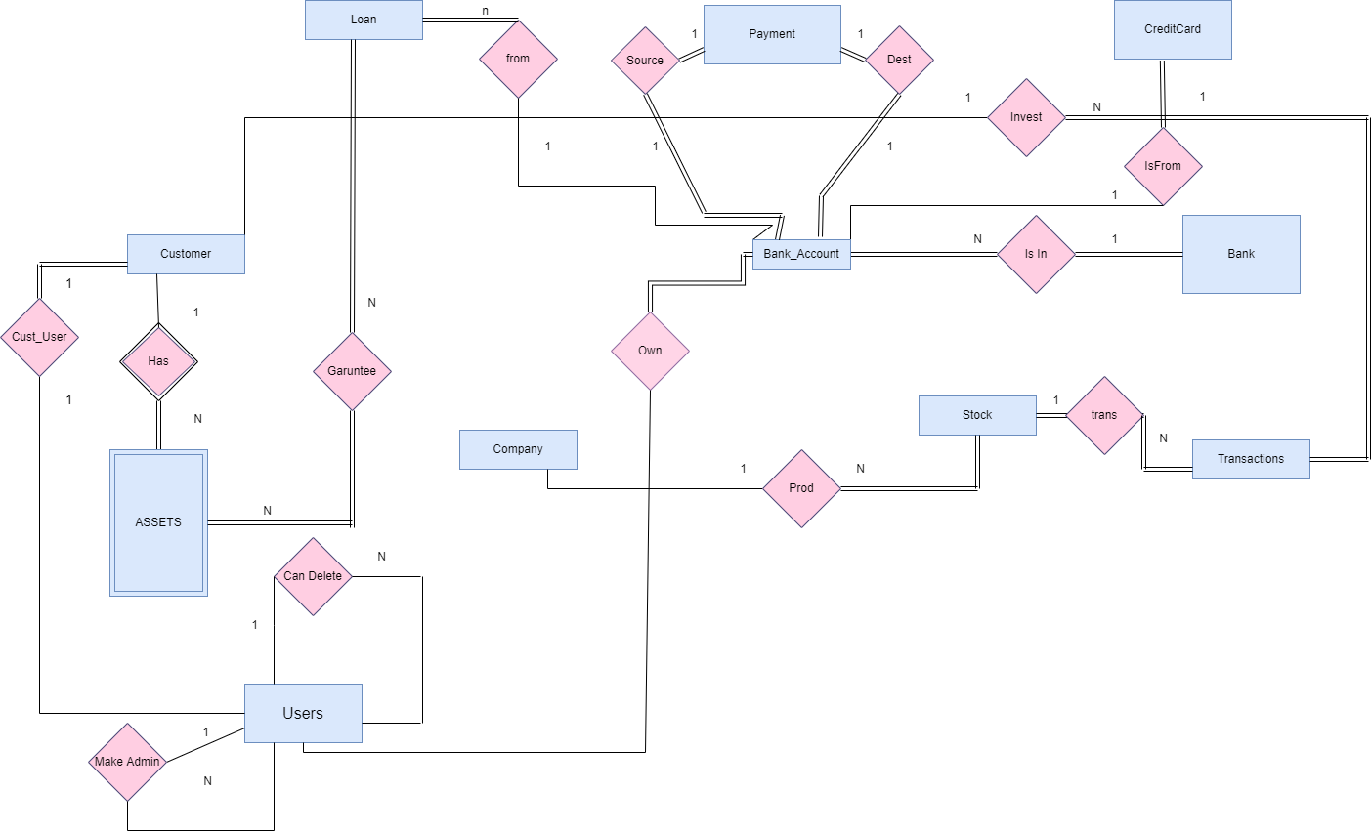

X`

