Image Features I

- Use the shown Sobel Operator to calculate the edge strength and direction for the shown image. Comment on your results.

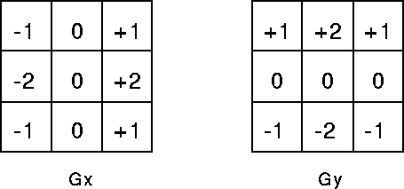
|G| = |Gx| + |Gy|
theta = arctan (Gy/Gx)

i,j | 0 | 1 | 2 | 3 | 4 | 5 | 6 | 7 | 8 | 9
0 | 0 | 0 | 0 | 0 | 0 | 0 | 0 | 0 | 0 | 0
1 | 0 | 100 | 100 | 100 | 100 | 100 | 100 | 100 | 200 | 0
2 | 0 | 10 | 50 | 0 | 0 | 0 | 0 | 0 | 200 | 0
3 | 0 | 10 | 0 | 50 | 0 | 0 | 0 | 0 | 200 | 0
4 | 0 | 10 | 10 | 0 | 50 | 0 | 0 | 0 | 200 | 0
5 | 0 | 10 | 0 | 0 | 0 | 50 | 0 | 0 | 200 | 0
6 | 0 | 10 | 0 | 0 | 0 | 0 | 50 | 0 | 200 | 0
7 | 0 | 10 | 0 | 0 | 0 | 0 | 0 | 0 | 200 | 0
8 | 0 | 10 | 10 | 10 | 10 | 10 | 10 | 10 | 200 | 0
9 | 0 | 0 | 0 | 0 | 0 | 0 | 0 | 0 | 0 | 0

- How would you suppress short edge chains in the output of Canny edge detector?

