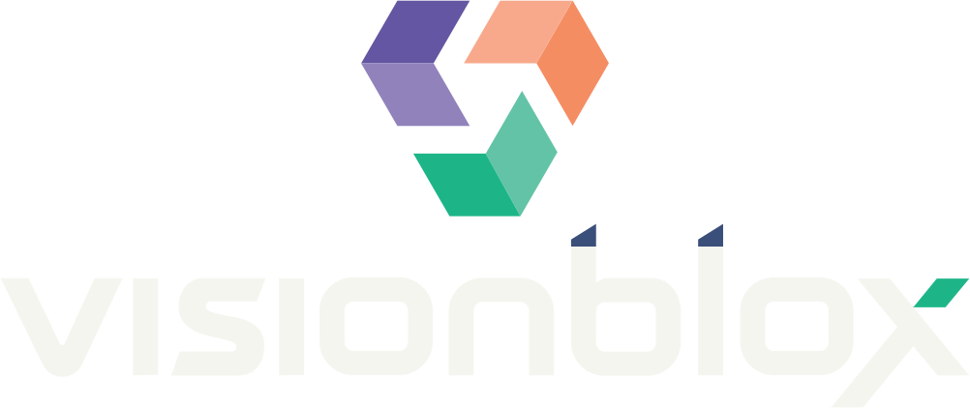  BUILD WHAT DOESN'T EXIST YET | AI-POWERED FEDERAL SOLUTIONS  Healthcare IT • Cloud • AI/ML  CAGE 9Z4X2 UEI H4X2Z7R9E3E3

Visionblox LLC is a San Jose, CA-based minority-owned small business systems integrator delivering healthcare IT, AI/ML, cloud, and enterprise modernization services to Federal and SLED clients. Our team brings 100+ years of combined experience and 50+ implementations across integrated health systems, state Medicaid agencies, and national insurers — with quantified, production-scale outcomes on every engagement.
Core Competencies
Healthcare IT & Interoperability  EHR/EMR integration (Epic), HL7 v2/FHIR APIs, 21st Century Cures Act compliance, patient portals, telehealth, Medicaid modernization (MITA-compliant). | AI/ML & Document Intelligence  Intelligent document processing, OCR/NLP pipelines at 96% accuracy, predictive analytics, AI-assisted workflow automation delivering 60% labor reduction. | Cloud & Custom Development  Cloud-native development on AWS (Batch, Lambda, EMR), microservices, serverless ETL, PHI-secure architectures, DevSecOps, legacy modernization.
Enterprise SAP S/4HANA  ERP modernization and migration, S/4HANA implementation and integration for large-scale enterprise operations, $2M+ annual savings delivered. | Cybersecurity & Compliance  HIPAA/PHI security engineering, HITRUST-aligned controls, secure SDLC, healthcare data protection across cloud and hybrid environments. | Data Engineering & Analytics  High-volume claims and clinical data pipelines processing millions of daily transactions, business intelligence, real-time dashboards.
Past Performance
PROJECT | OUTCOME | VALUE
PRIME State of Montana — Master AI Products & Services Contract (SPB26-0608GW-VSNBLX) | Competitively awarded statewide master contract — both tracks, executed Aug 2026. AI software solutions for state government operations. | Through 2028  Cooperative · nationwide
Patient Portal & EHR Integration — Leading National Integrated Healthcare System | Epic/HL7 & Cures Act integration; patient portal serving 100K+ daily users at 99.8% SLA | ~$1.2M
CA DHCS Claims & Fiscal Reporting System (CFRS) — State Medicaid | MITA-compliant modernization; AI document intelligence at 96% OCR accuracy; 60% labor reduction | ~$2.1M
Claims Processing Modernization — National Health Insurer | AWS Batch/Lambda/EMR pipeline processing millions of daily claims | Enterprise
Urgent Care Data Integration — Regional Health Network | HL7/FHIR ETL, microservices architecture, PHI-secure AWS environment | Multi-phase
Why Visionblox
CAPABILITY | PROOF POINT | GOVERNMENT BENEFIT
Healthcare-native systems integrator | Epic, HL7/FHIR, MITA delivery at state Medicaid scale | Mission-ready for federal health IT modernization
Proven AI at production scale | 96% OCR accuracy; 60% labor reduction in live state operations | Measurable efficiency gains, not pilots
Small-business agility | Minority-Owned SB; direct principal engagement on every delivery | Set-aside eligible; accountable leadership

NAICS 541511 • 541512 • 541519 • 518210  Minority-Owned Small Business • TAA Compliant • Section 889 Compliant | Khaalis Wooden, MBA — Director, Enterprise Capture & Compliance  khaalis.wooden@visionblox.com • (256) 988-1130 • visionblox.org

