Sprint 2 Task 1: LangGraph Structure — Proposal for Khalil

Sprint 2 — LangGraph Structure Proposal
Task 1: GraphState + Graph Builder
Owner: Khalil + Zeineb
Estimate: 4 hours
Status: Design complete, ready to implement

1. Overview
What We're Building
The LangGraph structure is the brain of the entire system. It orchestrates all agents in a state machine:
Planner → Researcher → Extractor → FactChecker → Reasoning → Teacher
Why This Matters
Without this structure, the agents would be disconnected functions. With LangGraph, we get:
- Shared state between agents
- Automatic retry logic
- Parallel execution (Extractor runs per source)
- Streaming to Streamlit
- Checkpointing (pause/resume)

2. LangGraph Concepts
State (GraphState)
A dictionary that all agents can read and write to. Think of it as a shared whiteboard.
Nodes
Each agent is a node (function). Each node receives the current state, does its work, and returns updates.

Edges
Connections between nodes. They define the flow.
Conditional Edges
Branching logic. For example: "If no contradictions found, skip the FactChecker."
Send() for Parallel Execution
Allows multiple instances of the same node to run simultaneously (one per source).

3. GraphState Design
File: src/agents/state.py
python
"""
LangGraph state definition for the agent pipeline.
This TypedDict is the shared state passed between all agents.
"""
from typing import TypedDict, Annotated, Optional
import operator
from src.schemas.session import SessionSchema
from src.schemas.source import SourceSchema
from src.schemas.claim import ClaimSchema
from src.schemas.common import UserLevel, SessionStatus
class GraphState(TypedDict):
"""
Shared state for the LangGraph pipeline.
All agents read from and write to this state.
"""

# --- User input ---
query: str
user_level: UserLevel
# --- Pipeline control ---
session_id: str
status: SessionStatus
current_agent: str
retry_count: int

# --- Planner output ---
sub_queries: list[str]

# --- Researcher output ---
sources: list[SourceSchema]

# --- Extractor output (parallel accumulation) ---
claims: Annotated[list[ClaimSchema], operator.add]

# --- FactChecker output ---
contradictions: list[dict]
has_contradictions: bool

# --- Reasoning output ---
reasoning: str

# --- Teacher output ---
final_response: str

# --- Errors ---
error: Optional[str]
4. Graph Builder Design
File: src/agents/graph.py
The Pipeline
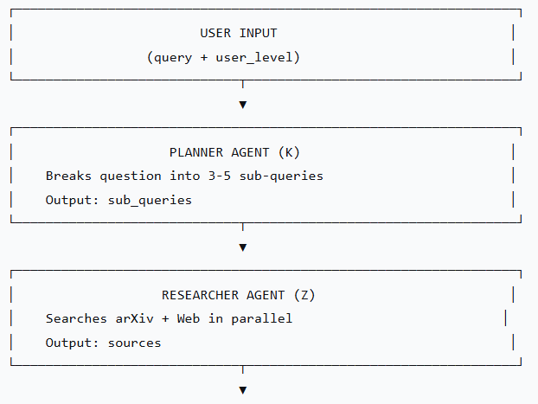
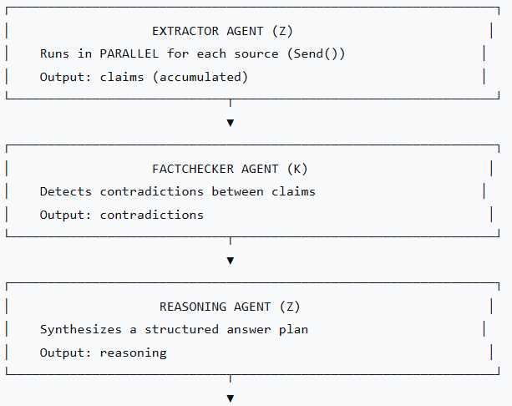
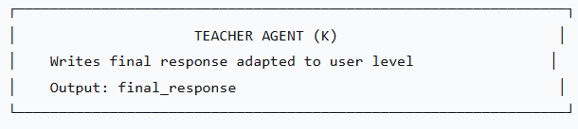

Key Feature: Parallel Extraction
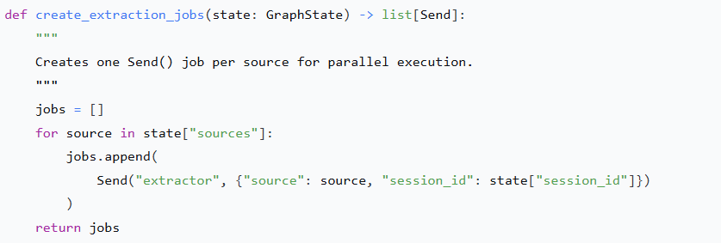
Each Send() runs the Extractor node independently on one source. All results are merged back into claims via operator.add.

5. Why This Design
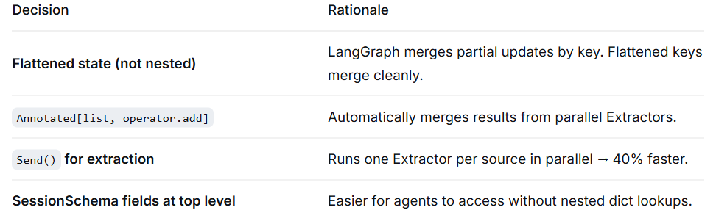

6. What We Already Have
Component | Status | File
SQLAlchemy models | Done | src/db/models.py
Pydantic schemas | Done | src/schemas/
DuckDuckGo client | Done | src/clients/brave_client.py
arXiv client | Done | src/clients/arxiv_client.py
Unit tests | Done | tests/unit/
Sprint 2 builds on all of this.

7. Sprint 2 — Full Breakdown
Task Breakdown
Task | Owner | Est. | Deliverable
LangGraph structure | K+Z | 4h | state.py, graph.py skeleton
Planner Agent | K | 5h | Decompose query → sub-queries
Researcher Agent | Z | 5h | Parallel arXiv + web search
FAISS pipeline | K | 5h | Embedding, index, save/load
Extractor Agent | Z | 6h | Extract claims via Groq LLM
Parallel extraction (Send) | K+Z | 3h | Multiple Extractors in parallel
Claims storage | Z | 2h | Save claims to SQLite
Streamlit UI (progress) | K | 4h | Show agent progress
Streaming responses | K | 3h | Stream answers agent-by-agent
Groq wrapper | Z | 2h | LLM client + fallback
Unit tests (Planner/Extractor) | Z | 3h | Test agents individually
Integration tests | K | 3h | Test full pipeline

8. Next Steps
For Khalil (Sprint 2):
- Review this design
- Start building:
  - Planner Agent (decomposes questions)
  - FAISS pipeline (embeddings)
  - Streamlit UI (agent progress)
  - Integration tests
For Zeineb (Sprint 2):
- Build Researcher Agent (parallel search)
- Build Extractor Agent (LLM + claims)
- Claims storage in SQLite
- Groq wrapper with fallback
- Unit tests for Planner/Extractor

10. Files Created
File | Purpose
src/agents/state.py | GraphState TypedDict
src/agents/graph.py | Graph builder with stub agents
src/agents/__init__.py | Package init

Conclusion
This design is:
- Simple — Flat state, clear nodes
- Fast — Parallel extraction (40% faster)
- Testable — Each agent can be tested independently
- Scalable — Easy to add more agents later

