# BAN 502 - Classification Trees Assignment

## Khayrayyah Haamid-Day

heart = heart %>% mutate(Sex = as_factor(Sex)) %>%  
 mutate(ChestPainType = as_factor(ChestPainType)) %>%  
 mutate(RestingECG = as_factor(RestingECG)) %>%  
 mutate(ExerciseAngina = as_factor(ExerciseAngina)) %>%  
 mutate(HeartDisease = as_factor(HeartDisease)) %>%  
 mutate(HeartDisease = fct_recode(HeartDisease, "No" = "0", "Yes" = "1"))

#Task 1  
set.seed(12345)  
  
heart_split = initial_split(heart, prop = 0.7, strata = HeartDisease)   
train = training(heart_split)   
test = testing(heart_split)

#Task 2  
heart_recipe = recipe(HeartDisease ~., train) %>%  
 step_dummy(all_nominal(),-all_outcomes())  
  
tree_model = decision_tree() %>%   
 set_engine("rpart", model = TRUE) %>%   
 set_mode("classification")  
  
heart_wflow =   
 workflow() %>%   
 add_model(tree_model) %>%   
 add_recipe(heart_recipe)  
  
heart_fit = fit(heart_wflow, train)  
  
tree = heart_fit %>%   
 extract_fit_parsnip() %>%   
 pluck("fit")  
  
  
fancyRpartPlot(tree)

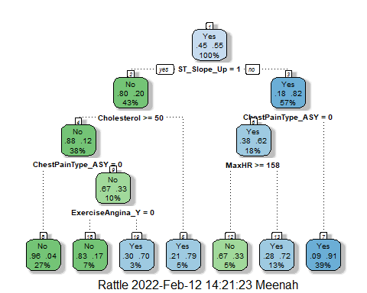

#Task 3  
heart_fit$fit$fit$fit$cptable

## CP nsplit rel error xerror xstd  
## 1 0.57491289 0 1.0000000 1.0000000 0.04389406  
## 2 0.06620209 1 0.4250871 0.4250871 0.03463635  
## 3 0.01742160 2 0.3588850 0.3588850 0.03240139  
## 4 0.01393728 4 0.3240418 0.3623693 0.03252808  
## 5 0.01000000 6 0.2961672 0.3379791 0.03161802

CP Value of .010 is the most optimal.

#Task 4 - K-fold  
set.seed(123)  
folds = vfold_cv(train, v = 5)  
  
#Tuning Grid  
heart_recipe = recipe(HeartDisease ~., train) %>%  
 step_dummy(all_nominal(),-all_outcomes())  
  
tree_model = decision_tree(cost_complexity = tune()) %>%   
 set_engine("rpart", model = TRUE) %>% #don't forget the model = TRUE flag  
 set_mode("classification")  
  
tree_grid = grid_regular(cost_complexity(),  
 levels = 25) #try 25 sensible values for cp  
  
heart_wflow =   
 workflow() %>%   
 add_model(tree_model) %>%   
 add_recipe(heart_recipe)  
  
tree_res =   
 heart_wflow %>%   
 tune_grid(  
 resamples = folds,  
 grid = tree_grid  
 )  
  
tree_res

## # Tuning results  
## # 5-fold cross-validation   
## # A tibble: 5 x 4  
## splits id .metrics .notes   
## <list> <chr> <list> <list>   
## 1 <split [513/129]> Fold1 <tibble [50 x 5]> <tibble [0 x 1]>  
## 2 <split [513/129]> Fold2 <tibble [50 x 5]> <tibble [0 x 1]>  
## 3 <split [514/128]> Fold3 <tibble [50 x 5]> <tibble [0 x 1]>  
## 4 <split [514/128]> Fold4 <tibble [50 x 5]> <tibble [0 x 1]>  
## 5 <split [514/128]> Fold5 <tibble [50 x 5]> <tibble [0 x 1]>

#Model Performance  
tree_res %>%  
 collect_metrics() %>%  
 ggplot(aes(cost_complexity, mean)) +  
 geom_line(size = 1.5, alpha = 0.6) +  
 geom_point(size = 2) +  
 facet_wrap(~ .metric, scales = "free", nrow = 2)

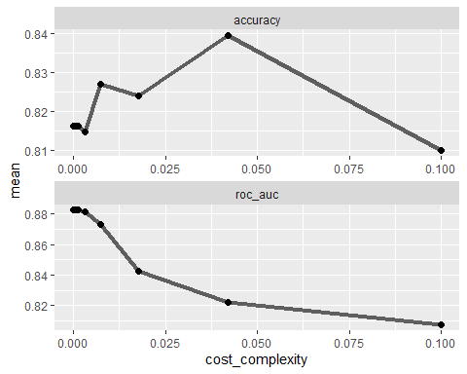

#Task 5  
best_tree = tree_res %>%  
 select_best("accuracy")  
  
best_tree

## # A tibble: 1 x 2  
## cost_complexity .config   
## <dbl> <chr>   
## 1 0.0422 Preprocessor1_Model24

CP value of .042 yields the optimal accuracy value.

#Task 6  
final_wf =   
 heart_wflow %>%   
 finalize_workflow(best_tree)  
  
final_fit = fit(final_wf, train)  
  
tree2 = final_fit %>%   
 pull_workflow_fit() %>%   
 pluck("fit")

## Warning: `pull_workflow_fit()` was deprecated in workflows 0.2.3.  
## Please use `extract_fit_parsnip()` instead.

fancyRpartPlot(tree2, tweak = 1.5)

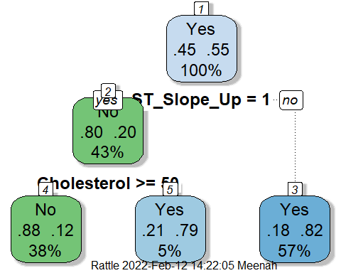

#Task 7  
tree_pred = predict(final_fit, train, type = "class")  
head(tree_pred)

## # A tibble: 6 x 1  
## .pred_class  
## <fct>   
## 1 No   
## 2 No   
## 3 No   
## 4 No   
## 5 No   
## 6 No

confusionMatrix(tree_pred$.pred_class,train$HeartDisease,positive = "Yes")

## Confusion Matrix and Statistics  
##   
## Reference  
## Prediction No Yes  
## No 213 29  
## Yes 74 326  
##   
## Accuracy : 0.8396   
## 95% CI : (0.8088, 0.8671)  
## No Information Rate : 0.553   
## P-Value [Acc > NIR] : < 2.2e-16   
##   
## Kappa : 0.6705   
##   
## Mcnemar's Test P-Value : 1.455e-05   
##   
## Sensitivity : 0.9183   
## Specificity : 0.7422   
## Pos Pred Value : 0.8150   
## Neg Pred Value : 0.8802   
## Prevalence : 0.5530   
## Detection Rate : 0.5078   
## Detection Prevalence : 0.6231   
## Balanced Accuracy : 0.8302   
##   
## 'Positive' Class : Yes   
##

The accuracy of this tree is 83% or 84%, if rounded up.

#Task 8  
blood <- read_csv("Blood.csv")

## Rows: 748 Columns: 5

## -- Column specification --------------------------------------------------------  
## Delimiter: ","  
## dbl (5): Mnths_Since_Last, TotalDonations, Total_Donated, Mnths_Since_First,...

##   
## i Use `spec()` to retrieve the full column specification for this data.  
## i Specify the column types or set `show_col_types = FALSE` to quiet this message.

blood = blood %>% mutate(DonatedMarch = as_factor(DonatedMarch)) %>%  
 mutate(DonatedMarch = fct_recode(DonatedMarch, "No" = "0", "Yes" = "1"))  
  
summary(blood)

## Mnths_Since_Last TotalDonations Total_Donated Mnths_Since_First  
## Min. : 0.000 Min. : 1.000 Min. : 250 Min. : 2.00   
## 1st Qu.: 2.750 1st Qu.: 2.000 1st Qu.: 500 1st Qu.:16.00   
## Median : 7.000 Median : 4.000 Median : 1000 Median :28.00   
## Mean : 9.507 Mean : 5.515 Mean : 1379 Mean :34.28   
## 3rd Qu.:14.000 3rd Qu.: 7.000 3rd Qu.: 1750 3rd Qu.:50.00   
## Max. :74.000 Max. :50.000 Max. :12500 Max. :98.00   
## DonatedMarch  
## No :570   
## Yes:178   
##   
##   
##   
##

#Task 9  
set.seed(1234)  
  
blood_split = initial_split(blood, prop = 0.7, strata = DonatedMarch)   
train2 = training(blood_split)   
test2 = testing(blood_split)  
  
blood_recipe = recipe(DonatedMarch ~., train2) %>%  
 step_dummy(all_nominal(),-all_outcomes())  
  
tree_model2 = decision_tree() %>%   
 set_engine("rpart", model = TRUE) %>%   
 set_mode("classification")  
  
blood_wflow =   
 workflow() %>%   
 add_model(tree_model2) %>%   
 add_recipe(blood_recipe)  
  
blood_fit = fit(blood_wflow, train2)  
  
tree3 = blood_fit %>%   
 extract_fit_parsnip() %>%   
 pluck("fit")  
  
#K-fold  
set.seed(1234)  
folds = vfold_cv(train2, v = 5)  
  
#Tuning Grid  
blood_recipe2 = recipe(DonatedMarch ~., train2) %>%  
 step_dummy(all_nominal(),-all_outcomes())  
  
tree_model3 = decision_tree(cost_complexity = tune()) %>%   
 set_engine("rpart", model = TRUE) %>%   
 set_mode("classification")  
  
tree_grid2 = grid_regular(cost_complexity(),  
 levels = 25)   
  
blood_wflow2 =   
 workflow() %>%   
 add_model(tree_model3) %>%   
 add_recipe(blood_recipe2)  
  
tree_res2 =   
 blood_wflow2 %>%   
 tune_grid(  
 resamples = folds,  
 grid = tree_grid2)  
  
tree_res2

## # Tuning results  
## # 5-fold cross-validation   
## # A tibble: 5 x 4  
## splits id .metrics .notes   
## <list> <chr> <list> <list>   
## 1 <split [418/105]> Fold1 <tibble [50 x 5]> <tibble [0 x 1]>  
## 2 <split [418/105]> Fold2 <tibble [50 x 5]> <tibble [0 x 1]>  
## 3 <split [418/105]> Fold3 <tibble [50 x 5]> <tibble [0 x 1]>  
## 4 <split [419/104]> Fold4 <tibble [50 x 5]> <tibble [0 x 1]>  
## 5 <split [419/104]> Fold5 <tibble [50 x 5]> <tibble [0 x 1]>

#Model Performance  
tree_res2 %>%  
 collect_metrics() %>%  
 ggplot(aes(cost_complexity, mean)) +  
 geom_line(size = 1.5, alpha = 0.6) +  
 geom_point(size = 2) +  
 facet_wrap(~ .metric, scales = "free", nrow = 2)

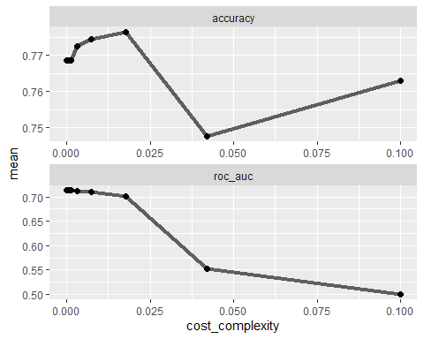

#Task 10  
best_tree2 = tree_res2 %>%  
 select_best("accuracy")  
best_tree2

## # A tibble: 1 x 2  
## cost_complexity .config   
## <dbl> <chr>   
## 1 0.0178 Preprocessor1_Model23

final_wf2 =   
 blood_wflow2 %>%   
 finalize_workflow(best_tree2)  
  
final_fit2 = fit(final_wf2, train2)  
  
tree4 = final_fit2 %>%   
 pull_workflow_fit() %>%   
 pluck("fit")

## Warning: `pull_workflow_fit()` was deprecated in workflows 0.2.3.  
## Please use `extract_fit_parsnip()` instead.

fancyRpartPlot(tree4, tweak = 1.5)

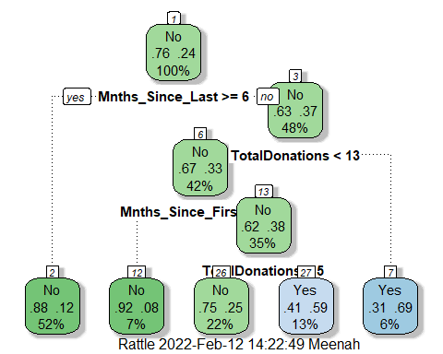

#Task 11  
tree_pred2 = predict(final_fit2, train2, type = "class")  
head(tree_pred2)

## # A tibble: 6 x 1  
## .pred_class  
## <fct>   
## 1 Yes   
## 2 Yes   
## 3 Yes   
## 4 Yes   
## 5 Yes   
## 6 Yes

confusionMatrix(tree_pred2$.pred_class,train2$DonatedMarch,positive = "Yes")

## Confusion Matrix and Statistics  
##   
## Reference  
## Prediction No Yes  
## No 361 63  
## Yes 38 61  
##   
## Accuracy : 0.8069   
## 95% CI : (0.7704, 0.8399)  
## No Information Rate : 0.7629   
## P-Value [Acc > NIR] : 0.009214   
##   
## Kappa : 0.4263   
##   
## Mcnemar's Test P-Value : 0.016936   
##   
## Sensitivity : 0.4919   
## Specificity : 0.9048   
## Pos Pred Value : 0.6162   
## Neg Pred Value : 0.8514   
## Prevalence : 0.2371   
## Detection Rate : 0.1166   
## Detection Prevalence : 0.1893   
## Balanced Accuracy : 0.6983   
##   
## 'Positive' Class : Yes   
##

tree_pred3 = predict(final_fit2, test2, type = "class")  
head(tree_pred3)

## # A tibble: 6 x 1  
## .pred_class  
## <fct>   
## 1 Yes   
## 2 No   
## 3 Yes   
## 4 Yes   
## 5 No   
## 6 Yes

confusionMatrix(tree_pred3$.pred_class,test2$DonatedMarch,positive = "Yes")

## Confusion Matrix and Statistics  
##   
## Reference  
## Prediction No Yes  
## No 150 28  
## Yes 21 26  
##   
## Accuracy : 0.7822   
## 95% CI : (0.7225, 0.8343)  
## No Information Rate : 0.76   
## P-Value [Acc > NIR] : 0.2434   
##   
## Kappa : 0.3753   
##   
## Mcnemar's Test P-Value : 0.3914   
##   
## Sensitivity : 0.4815   
## Specificity : 0.8772   
## Pos Pred Value : 0.5532   
## Neg Pred Value : 0.8427   
## Prevalence : 0.2400   
## Detection Rate : 0.1156   
## Detection Prevalence : 0.2089   
## Balanced Accuracy : 0.6793   
##   
## 'Positive' Class : Yes   
##

The training set has a accuracy of 81% and the testing set is 78%; tree’s performance on these sets is good.