서류 간 상호 확인 기반의 안전한 행정 제출서류 사전 점검 자동화
Safe Automation of Administrative Document Pre-Checks
through Cross-Document Verification
Abstract
Staff who review grant and scholarship applications check every submitted certificate by hand, and the most harmful mistake is to accept an expired document or a document of another company. We present ADVS, a web system that pre-checks administrative submission documents before staff review. Applicants upload certificates as PDFs, scans or photos. ADVS reads them from the PDF text layer or with OCR, identifies the document type, extracts the required fields and checks them against criteria that administrators edit in an admin console: required documents, the maximum age of an issue date, validity periods and fields that must match across documents. A value is accepted automatically only when a separate source supports it, such as the same number on another document; all other values are shown to staff next to the document image. ADVS consists of a Next.js applicant and staff web application, an admin console and a FastAPI back end with PaddleOCR. All nine demonstration scenarios produced the expected results, and on real certificates 56 of 78 business submissions needed no staff review while no submission was wrongly marked Ready.

1. Introduction
For grant applications and scholarship reviews, staff collect several certificates from each applicant: business registration, national and local tax payment, social insurance payment, enrollment and transcript. They open each file and check dates and values by hand. The work is repetitive, and it is easy to miss an expired certificate, a company name that differs between documents, a missing document, or a look-alike document such as a local tax certificate submitted instead of a national one. A missing document can be requested again, but a wrongly accepted one goes straight into the decision.
This capstone project, carried out with an industry partner, built ADVS to pre-check such submissions. Its goals were to remove routine checks from staff work, to never mark a submission Ready on a guess, following the idea of selective prediction [1], to let administrators change the rules without code, and to explain every result. This paper presents the requirements, the design and implementation of ADVS, and its validation.
2. Related Work
Form understanding extracts key-value pairs from scanned forms: FUNSD [2] provides annotated noisy forms, LayoutLM [3] adds the position of each word, and Donut [4] reads the image without OCR. These models improve extraction, but an extracted value still needs a reason to be trusted in a decision; ADVS adds this decision layer on top of a conventional OCR engine [6]. Electronic certificates avoid OCR and should be used where available; ADVS targets the scans and photos that applicants still submit.
3. Requirements
The requirements were set with the industry mentor from the documents used in practice (Table 1). R4 has priority over automation: a value that cannot be supported is passed to staff rather than guessed.
Table 1. Requirements and how ADVS meets them
Requirement | Realization in ADVS
R1 Accept PDFs, scans and photos | PDF text layer or OCR; type from title, issuer, labels
R2 Apply the program's rules | Checklist: required documents, issue-date age, validity, value conditions
R3 Check consistency across documents | Comparisons of numbers, names and dates (Table 2)
R4 Never mark Ready on a guess | A value is used only with a separate source; otherwise staff decide
R5 Change rules without code | Admin console with validated, versioned criteria
R6 Explain every result | Issue, document, field and fix; value shown on the original image
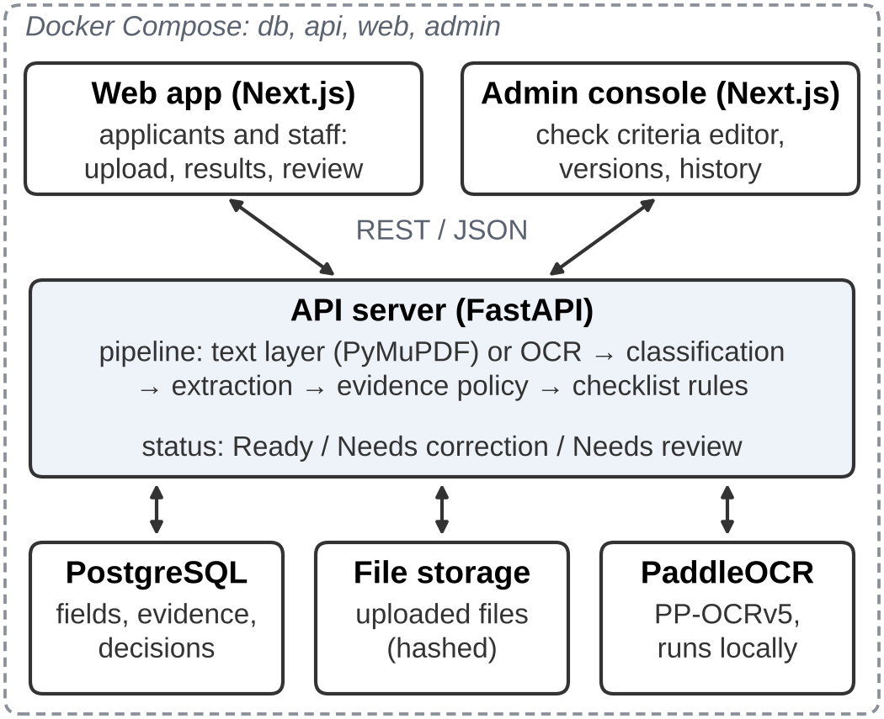
Fig. 1. System architecture of ADVS
4. System Design
4.1 Architecture
ADVS has three applications (Fig. 1). Applicants upload documents and see results in the web application, where staff also confirm open values. Administrators manage check criteria in a separate admin console. Both front ends only display results of the API server, which runs the document pipeline, stores fields, evidence and decisions in PostgreSQL, and runs OCR locally, so no document leaves the server.
4.2 Processing Pipeline
For a digital PDF the text layer is used, unless it contains invisible text or does not match the rendered page; scans and photos are read with the Korean PP-OCRv5 model of PaddleOCR [6] (Fig. 2). The document type is decided from the title, the issuer and body labels, so a local tax certificate is not taken for a national one. Each field is found next to its label and must match the expected format. The checklist of the selected workflow then decides the result: Ready, Needs correction or Needs review. Ready is a pre-check result, not an official approval.
4.3 Evidence-Based Acceptance and Cross-Document Checks
A value read by OCR is never accepted for its confidence alone. It is accepted when a separate source supports it, or when every likely misreading leads to the same decision, such as an expiry date far after the check date. The documents of one submission repeat information, which provides such sources (Table 2): the business registration number appears on three certificates and has a check digit, so the company is identified even when a blurred photo hides its name, and the enrollment certificate and transcript share name, birth date and issue date. The GPA is printed only on the transcript, so the applicant may type it, as with self-reported grades in admissions [5]. Values without support go to staff.
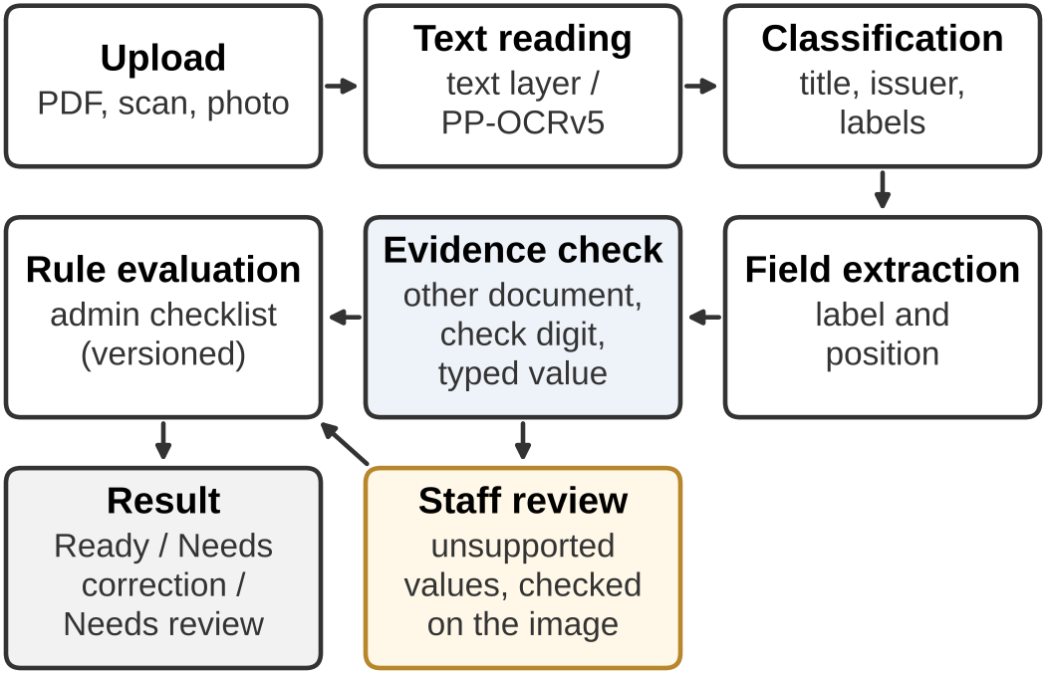
Fig. 2. Processing pipeline
Table 2. Values checked across documents
Value | Confirmed by
Student submission
Name, birth date, admission date | same values on the transcript
Issue date (90-day rule) | same issue date on the transcript
University (issuer line) | issuer line of the transcript
GPA | GPA typed by the applicant
Business submission
Business registration number | tax and insurance certificates; check digit
Company name | other certificates, if readable
National tax validity | issue date + 30 days (by law)
4.4 Configurable Check Criteria
Criteria are stored per workflow, not in code. For each document an administrator sets whether it is required, the maximum age of its issue date, whether its validity period is checked and extra conditions such as a minimum GPA; comparisons between documents are configured separately. Every change is validated by the verification engine before it is saved, is kept as a new version with editor, reason and full content, can be restored, and marks earlier results of affected submissions as outdated.
5. Implementation
The web application and the admin console are written in Next.js and TypeScript, and the API server in FastAPI with SQLAlchemy and PostgreSQL, using PyMuPDF and PaddleOCR; all services run with Docker Compose. Fig. 3 shows the result screen: the status comes first with the next step, followed by each issue with its document, field and fix, and a link to the evidence highlighted on the original. Fig. 4 shows the review screen, where staff confirm or correct a value next to its image region with one key press; the submission is then checked again without repeating OCR. Fig. 5 shows the criteria editor; the configured checks are also shown to applicants before upload, for example “issued within 90 days”. Applicants can also edit or delete a submission; the check date is set by the system, so an expired certificate cannot pass with an earlier date.
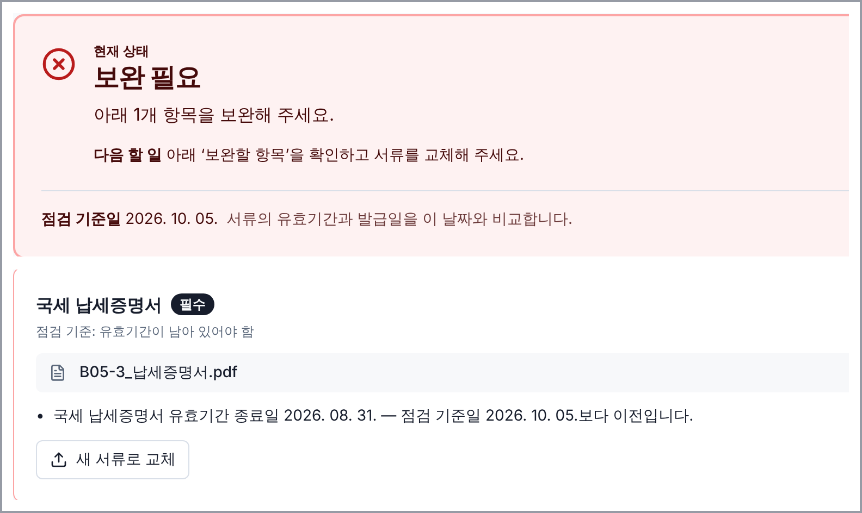
Fig. 3. Applicant result screen (Korean UI)

Fig. 4. Staff review screen (Korean UI)
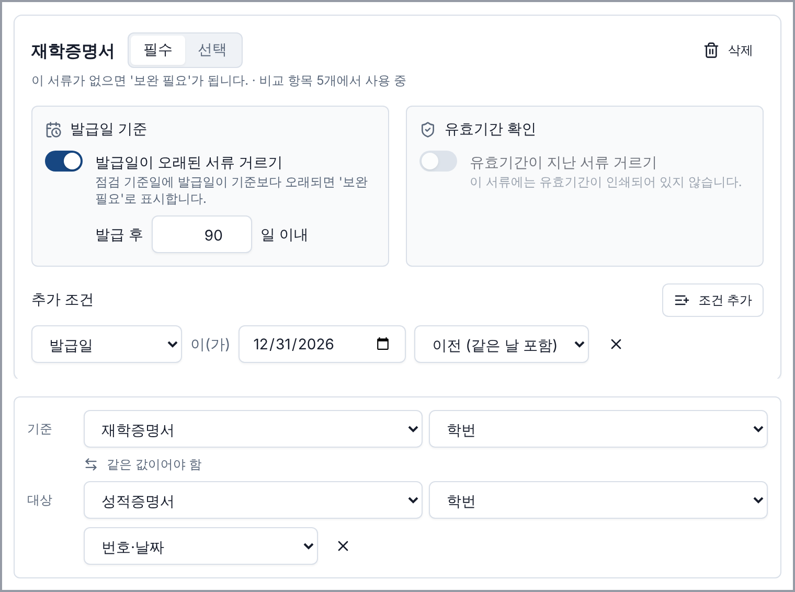
Fig. 5. Check-criteria editor in the admin console (Korean UI)
6. Validation
6.1 Testing and Demonstration
The code is covered by 889 back-end and 115 front-end automated tests, including those for the criteria editor. Nine demonstration scenarios built from synthetic documents with known answers cover the main cases; every scenario produced its expected result (Table 3).
Table 3. Demonstration scenarios (expected = actual)
Scenario | Result
D1 complete business set | Ready
D2 expired national tax certificate | Needs correction
D3 company name differs | Needs correction
D4 name notation differs ((주)/주식회사) | Ready
D5 local tax instead of national tax | Needs review
D6 scanned business set | Needs review (2 dates)
D7 complete student set | Ready
D8 required document missing | Needs correction
D9 scanned student set | Ready after 2 confirmations
6.2 Real Certificates
With consent, certificates of one university and of two companies provided by the industry partner were tested as scans, phone photos and different file formats, giving 108 student and 78 business submissions, plus submissions that must never be Ready (expired, another company or person, wrong document type). Fixes were developed on part of the data and checked on the rest. Cross-document checks made 56 business submissions Ready without staff review and reduced the items left for staff (Table 4). For students, the GPA was always the last item, because no other document prints it. None of the invalid submissions was marked Ready.
Table 4. Results on real certificates
 | Business | Student
Test submissions | 78 | 108
Ready without staff review | 56 | 0 (17*)
Items left for staff | 6.9 → 0.63 | 8.19 → 3.50
Wrongly marked Ready | 0 | 0
Items left: before → after the improvements. *With the GPA typed by the applicant (simulated). Submissions are certificates of two companies and one university under scan, photo and format conditions.
7. Discussion
Lessons. Most remaining work comes from reading fields on real forms, with stamps over text and labels split over two lines, rather than from OCR itself; synthetic documents showed few of these problems.
Limitations. The real data cover one university and two companies, staff accounts and access control are not yet implemented, and a set of documents forged consistently would pass cross-document checks.
8. Conclusion and Future Work
ADVS automates routine checks of submission documents while keeping staff in control: documents of a submission confirm each other, unsupported values go to a person, and administrators adapt the criteria without code. Next, we will add staff accounts, accept electronic certificates, test the GPA field with real applicants, and measure the staff time saved with more schools and companies.
References
[1] Y. Geifman, R. El-Yaniv, "Selective Classification for Deep Neural Networks," Advances in Neural Information Processing Systems, Vol. 30, pp. 4878–4887, 2017.
[2] G. Jaume, H. K. Ekenel, J.-P. Thiran, "FUNSD: A Dataset for Form Understanding in Noisy Scanned Documents," Proc. of the International Conference on Document Analysis and Recognition Workshops (ICDARW), Vol. 2, pp. 1–6, 2019.
[3] Y. Xu, M. Li, L. Cui, S. Huang, F. Wei, M. Zhou, "LayoutLM: Pre-training of Text and Layout for Document Image Understanding," Proc. of the 26th ACM SIGKDD Conference on Knowledge Discovery and Data Mining, pp. 1192–1200, 2020.
[4] G. Kim et al., "OCR-Free Document Understanding Transformer," Proc. of the European Conference on Computer Vision (ECCV), LNCS Vol. 13688, pp. 498–517, 2022.
[5] N. J. Walsh, "Field Notes: Using Self-Reported Academic Records in the Admissions Process," AACRAO News, American Association of Collegiate Registrars and Admissions Officers, 2016.
[6] C. Cui et al., "PaddleOCR 3.0 Technical Report," arXiv preprint arXiv:2507.05595, 2025.

