서류 간 상호 확인 기반의 안전한 행정 제출서류 사전 점검 자동화
올림조노바 무니라¹, 굴로모프 하비빌로¹^{O}, 이현지², 김동균¹*
¹경북대학교 컴퓨터학부, ²(주)플래시21
munira@knu.ac.kr, khabibillo@knu.ac.kr, lhjlhj@knu.ac.kr, dongkyun@knu.ac.kr
Safe Automation of Administrative Document Pre-Checks
through Cross-Document Verification
Munira Olimjonova¹, Khabibillo Gulomov¹^{O}, Hyunji Lee², Dongkyun Kim¹*
¹School of Computer Science and Engineering, Kyungpook National University, ²Flash21 Co., Ltd.
^{O} Presenter, * Corresponding author
Abstract
Checking administrative submission documents by hand is slow, and the most harmful mistake is to accept an expired document or a document of another company. We present ADVS, a pre-check system that combines conventional OCR with fixed rules and accepts a value automatically only when a separate source supports it: the same value printed on another document of the submission, a check digit, a validity period fixed by law, or a value typed by the applicant. On 1,972 fields from real documents, 95.8% of the correct values appeared in the OCR text, but only 79.9% of these were linked to the right field, so the gap to synthetic documents (above 99%) came mainly from field extraction rather than text recognition. With cross-document checks, 56 of 78 real business submissions (71.8%) were marked Ready without staff review when checked 20 days before the earliest expiry date, and 20 (25.6%) when checked on the expiry date itself; items needing review fell from 6.9 to 0.63 per submission. For 108 student submissions they fell from 8.19 to 3.50, and the GPA remained the last item; in an upper-bound simulation in which applicants type their correct GPA, 17 became fully automatic. No wrong value was accepted on the real documents, and no wrong Ready decision was observed there or in 6,815 synthetic error-injection cases.

1. Introduction
For grant applications and scholarship reviews, staff collect several documents from each applicant: business registration certificates, national and local tax payment certificates, social insurance payment certificates, enrollment certificates and transcripts. They open each document and check its dates and values by hand. This work is repetitive, and it is easy to miss an expired document, a company name that differs between documents, a missing document, or a similar-looking document (for example, a local tax certificate instead of a national one).
The two kinds of error are not equally costly. A missing document can be requested again, but a wrongly accepted document goes straight into the review decision. We therefore set zero wrong Ready decisions as the first requirement and treat the automation rate as second. This follows the idea of selective prediction [1]: the system decides only when it has grounds to do so and passes the rest to a person.
The individual checks we use (matching identifiers, check digits, date rules) are established practice. Our contribution is to combine them into a field-level evidence policy that holds back any value without support, and to measure it on real documents. Specifically, this paper makes three contributions. First, we design a pre-check system that accepts a value only when a separate source supports it, and we show how the documents of one submission can support each other. Second, we split the performance gap between synthetic and real documents into an OCR stage and an extraction stage. Third, we report automation results on real student and business documents, with development and validation data reported separately.
2. Related Work
Form understanding aims to extract key-value pairs from scanned forms. FUNSD [2] provides annotated noisy scanned forms for this task, layout-aware models such as LayoutLM [3] combine each word with its position on the page, and OCR-free models such as Donut [4] read the document image directly. These models improve extraction, but a correctly extracted value still needs a reason to be trusted in a decision. Our work addresses this decision layer, which could also sit on top of such extractors: a value is used only if a source outside the reading itself, such as a second document or a check digit, supports it. Where a document can be obtained digitally, for example as an electronic certificate from the government document wallet, or checked with its issuer, OCR is not needed and that route should take precedence; ADVS targets the scans and photos that applicants still submit. In university admissions, many institutions accept self-reported academic records and check them later against official transcripts, and they report few significant discrepancies [5]. Our applicant-entered GPA follows the same idea, but compares the typed value with the document at submission time.
3. System Design
3.1 Processing Pipeline
ADVS separates reading from deciding (Fig. 1). For a digital PDF it uses the text layer, unless the layer contains invisible text or does not match the rendered page; such pages are read with OCR instead. Scans and photos are read with the Korean PP-OCRv5 model of PaddleOCR [6]. If a page reads poorly, it is read again in four orientations and the best result is kept. The document type is decided from the title, the issuer and labels in the body. A local tax certificate, whose title looks like that of the national one, is recognized by issuer words such as the district office. A field value is found to the right of or below its label and must match the expected format. The rules (required documents, maximum age, validity and fields to compare) are not fixed in code but stored as versioned checklists that an administrator can edit. Each submission ends with one of three results: Ready, Needs correction or Needs review. Ready is a pre-check result, not an official approval.
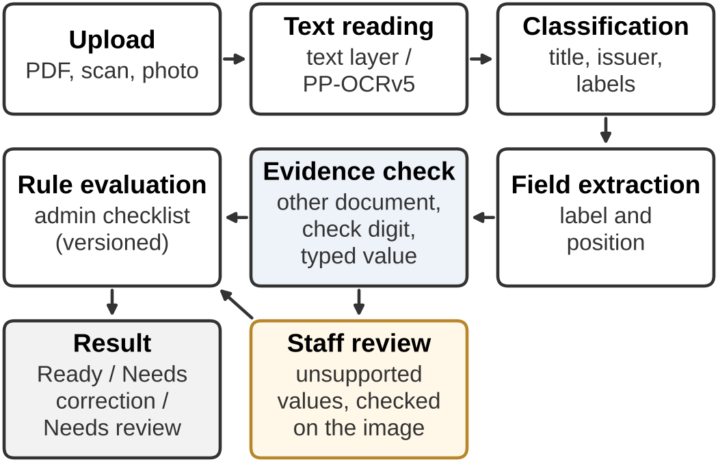
Fig. 1. Processing pipeline of ADVS
3.2 Evidence-Based Acceptance
A value read from a scan or photo is never accepted because of a high OCR confidence alone, since two readings of the same image can fail in the same way. A value is accepted automatically in only two cases. In the first case, it agrees with a source that does not depend on the same reading, such as the same value on another document or a value typed by the applicant. In the second case, every likely misreading (common OCR confusions such as a dropped, added or confused digit) leads to the same decision; for example, an expiry date far after the check date. Values of the second kind are marked "safe for the decision, value not confirmed", so that staff can tell them apart from confirmed values. If any value that a rule needs is still unconfirmed, the submission cannot be Ready. Agreement between documents shows consistency, not authenticity: documents from the same issuing system can share an error, and a consistently forged set would pass (Section 6).
3.3 Cross-Document Checks
The documents of one real submission repeat much of the same information (Table 1). In a student submission, the enrollment certificate is the main document. Its name, date of birth, admission date, issue date and issuer are compared with the transcript. Students usually request both certificates at the same time, so when the two issue dates are equal, the date is confirmed and the 90-day age rule can be checked. The GPA, however, is printed only on the transcript. The applicant can therefore enter the GPA and its scale on the upload form. The typed value confirms the OCR value only if both are exactly the same; any difference goes to review.
In a business submission, the business registration certificate is the main document. Its registration number appears again on the national tax certificate and on the social insurance certificate, where it is also part of the workplace management number. When the number passes its check digit and is the same on all documents, the company is identified even if a blurred photo makes the company name unreadable. If the company names can be read and they differ, the submission still goes to review. Date arithmetic can also serve as evidence. By law, a national tax certificate is valid for 30 days from issue unless a tax payment falls due earlier, so an issue date and an expiry date exactly 30 days apart confirm each other. Where no fixed relation exists, as for the social insurance certificate, only the printed date is used.
Table 1. Values checked across documents
Value | Confirmed by
Student submission
Name, birth date, admission date | same values on the transcript
Issue date (90-day rule) | same issue date on the transcript
University (issuer line) | issuer line of the transcript
GPA | GPA typed by the applicant
Business submission
Business registration number | tax and insurance certificates; check digit
Company name | other certificates, if readable
National tax validity | issue date + 30 days (by law)

4. Evaluation Method
Synthetic documents. We generated documents with the layout of published real forms and made-up values: one development set and three held-out sets not used during development. To test safety, we ran 6,815 error-injection cases with deliberately changed OCR results, and used manipulated PDFs with hidden, background-colored or very small text (237 files per type).
Real documents. Applicants rarely upload clean PDFs; they send scans of mixed quality, phone photos, rotated pages and other formats. To test whether one document can confirm a value unreadable on another, we used a few originals under many capture conditions (Table 2). The student documents are one student's certificates, used with consent: an enrollment certificate and a transcript scanned at 200 DPI, and three newly issued certificates (an enrollment certificate and transcripts on the 4.3 and 4.5 scales) photographed with a phone. Each source was turned into 27 conditions: scan quality (150–300 DPI, grayscale, binarization, JPEG quality 50–90, noise), geometry (skew of 1–3°, 90° and 180° rotation, shear, cropped margins), photo effects (perspective, uneven light, blur, color cast) and file format (PDF, JPG, PNG, WebP, two-page PDF). A submission is one set of required documents in one condition. The business documents are 14 originals from two companies, provided by an industry partner (business registration, national and local tax payment, and social insurance payment certificates), under 19 similar conditions with four valid document sets each. We also built submissions that must never be Ready (expired, wrong document type, another company, another person's document, edited values) and duplicate uploads. Real documents were kept private; only counts are reported.
Data roles. Data used to design fixes (the student photo set and variant set A, and company 1; 81 student and 38 business submissions) are development data. For validation data (student variant set B and company 2; 27 and 38 submissions), only total results were looked at during the final round of fixes. Because all variants come from a few originals, they are not independent.
Metrics. For each field, we measure the OCR stage (the share of correct values that appear in the OCR text) and the extraction stage (the share of those values that are linked to the right field). For each submission, we count whether it is Ready without staff review (fully automatic), whether it is Ready after at most one staff confirmation, and how many items need review or correction ("open items"). Wrongly accepted values and wrong Ready decisions measure safety. Proportions are given with Wilson 95% confidence intervals [7], and zero counts with the rule-of-three upper bound [8]; because the submissions are variants of a few originals, these intervals are descriptive only. For business submissions, the default check date is 20 days before the earliest expiry date in the submission. We also report a strict case in which the check date is that expiry date.
Table 2. Real evaluation data
 | Student | Business
Originals | 2 scans, 3 photos | 14 files, 2 companies
Conditions | 27 per source | 19
Valid submissions | 27 + 27 + 54 = 108 | 19 × 4 + 2 = 78
Dev. / validation | 81 / 27 | 38 / 38
Never Ready | 14 | 95
Student: two variant sets of the scanned pair and the photos with either transcript. Business: plus two multi-page PDFs. Duplicate uploads are not counted.
5. Results
5.1 Synthetic versus Real Documents
Field accuracy was 99.7% on the synthetic development set and 99.2% on the first held-out set. On real documents, 95.8% (95% CI 94.8–96.6%) of the correct values appeared in the OCR text, but only 79.9% (78.1–81.7%) of these were linked to the right field (Table 3). For business documents, more than 99% of the values appeared in the text, yet only 75–78% were extracted correctly. So the gap came mostly from field extraction. Real forms have stamps over text, labels split over two lines, issue dates without a label and issuer names with wide letter spacing, which our synthetic forms did not reproduce.
Table 3. Accuracy by stage before the improvements
Data | Fields | OCR stage | Extraction
Synthetic, development | 753 | 99.7% (both)
Synthetic, held-out 1 | 825 | 99.2% (both)
Real student, photo | 300 | 89.7% | 74.3%
Real student, scan | 760 | 93.7% | 85.4%
Real business, photo | 232 | 100% | 75.4%
Real business, scan | 672 | 99.4% | 78.0%
Real, total | 1,972 | 95.8% | 79.9%
Synthetic rows: both stages together. The real total includes 8 further fields.
5.2 Causes of Review
Before the improvements, 2,615 fields were not accepted automatically. They fall into five types: field mapping (38.7%; values in the text but not extracted, dates without a label), OCR (26.8%; confidence too low, re-reads disagree), cross-document comparison (23.2%; no second document, different name notation), safety policy (9.3%; no supporting source) and classification (2.0%; damaged titles, local vs. national tax). A submission that was not Ready had seven to eight open items, so fixing one type alone made almost none Ready; we ordered the fixes by the items that would complete whole submissions.
5.3 Automation
Table 3 describes field extraction before the improvements; Table 4 and Fig. 2 report submission outcomes after them. For business submissions, 56 of 78 (71.8%, 95% CI 61.0–80.6%) were Ready without staff review, and 66 (84.6%) after at most one confirmation. The development company and the validation company each reached 28 of their 38 single-file submissions; the other two are multi-page PDFs, which are never Ready, and open items are averaged over the 76. This suggests that the fixes were not fitted to one company's documents. Identifying the company by its registration number had the largest effect: before this change, most blocked submissions were photos in which the company name was too blurred to confirm on any of the three certificates. In the strict case, where the check date is the expiry date, only 20 submissions (25.6%) were fully automatic. A date close to its limit must be confirmed as a value; it cannot be treated as safe for the decision.
Table 4. Automation on real submissions (before → after)
Metric | Business (78) | Student (108)
Fully automatic | 0/78 → 56/78 | 0/108 → 0/108
with typed GPA (sim.) | - | 17/108
Ready after ≤1 confirmation | n/m → 66/78 | 0/108 → 19/108
Open items per submission | 6.9 → 0.63 | 8.19 → 3.50
Wrong Ready decisions | 0 | 0
n/m: not measured. sim.: upper-bound simulation in which the applicant types the correct GPA. Business: default check date (20 days before the earliest expiry date).
Fig. 2 shows how the results changed over the three main development steps. Step 1 combined extraction and classification fixes with the student cross-document check, step 2 identified companies by their registration numbers, and step 3 applied exact matches with the other document to low-confidence reads.
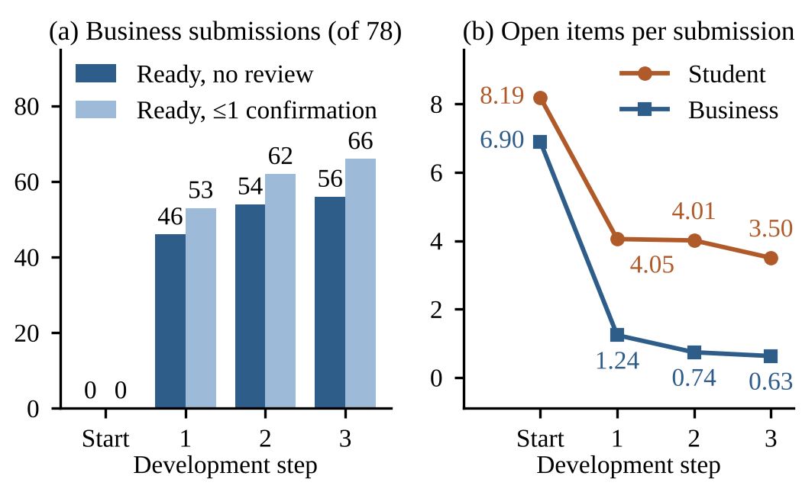
Fig. 2. Results after each development step
For student submissions, open items fell from 8.19 to 3.50 per submission. Comparing the enrollment certificate with the transcript confirmed the issue date, the name and the admission date, and 19 submissions (17.6%) were Ready after one confirmation (17 development, 2 validation). In all of them, the remaining item was the GPA. No other document prints it, and recomputing it from the semester GPAs failed: the 4.5-scale transcript converts the semester and total GPAs separately, and the photos of the 4.3-scale transcript rarely showed all semester rows clearly. In an upper-bound simulation in which the applicant types the correct GPA, 17 submissions (15.7%) were fully automatic, 15 in development and 2 in validation data. When one digit of the typed GPA was changed, the submission always went to review. We also replayed the decisions under different GPA requirements. Any threshold from 2.0 to 3.5 gave the same result, because a dropped digit can move a GPA across all of them; only removing the requirement changed it, making 19 submissions fully automatic.
5.4 Safety
On the real documents, no wrong value was accepted and no wrong Ready decision was observed (upper bound 5.4% for the 56 automatic business decisions). None of the tested invalid submissions was marked Ready: expired national tax and social insurance certificates, a local tax certificate submitted instead of a national one, documents of another company, old issues, and student submissions that contained another person's document. For a duplicate upload, the second file was ignored and the applicant was told so. In the 6,815 error-injection cases, one wrong value was accepted: the same error was injected into two documents at once, which cross-document checks cannot detect. It did not lead to a wrong Ready decision, and no other case did. In 148 cases, a misread value was used as "safe for the decision"; the decision was correct in all of them, and the value stayed marked as not confirmed. No hidden text was read from the manipulated PDFs (237 files per type, upper bound 1.3%).
6. Discussion
Synthetic data. Synthetic documents showed few of the problems of real forms and led to one wrong assumption: that a social insurance certificate is valid for 30 days after issue. On the real certificates the validity ended 7 to 28 days after issue, so an expired certificate could have been treated as valid. The system now uses only the printed expiry date.
Automation and safety. The system passes even correctly read values to staff when no separate source supports them. Business documents allow high automation because numbers repeat across documents. For students, the GPA is printed on only one document, so it needs either a staff confirmation or a second source such as the applicant's own entry. Our replay also shows that the exact GPA threshold matters less than whether a requirement exists at all.
Table 5. ADVS and alternative approaches
Approach | Trust comes from | Main limitation
Manual checking | staff judgement | slow; errors missed
IDP, extractors [3, 4] | extraction quality | no outside support
Issuer, e-certificates | the issuer | not for all documents
Self-report [5] | a later audit | errors found late
ADVS | a separate source | small real evaluation

Position among alternatives. Table 5 compares ADVS with other approaches. Digital routes give the strongest trust but do not cover every document, and learned extractors still need a reason to trust each value. ADVS adds that reason for scans and photos and can be combined with both.
Scope. The real data cover one university and two companies, so a study with more institutions will show how well the results generalize. Documents forged consistently across a whole submission are outside the scope of cross-document checks and call for issuer verification.
7. Conclusion and Future Work
We presented a pre-check system for administrative submission documents that combines conventional OCR, fixed rules and staff review, and accepts a value only when a separate source supports it. On real documents, most errors came from field extraction rather than OCR. When the documents of a submission were allowed to confirm each other, 71.8% of business submissions became fully automatic without a wrong decision. For student submissions the GPA is the last item, and an applicant-entered GPA made 15.7% of them fully automatic in an upper-bound simulation. In future work, we will test the GPA field with real applicants, accept electronic certificates, study verification with the issuers through the numbers printed on certificates, compare ADVS with commercial and learned extractors on the same data, measure the staff time it saves, and test it on documents from more schools and companies.
Acknowledgment
This research was supported by the MSIT (Ministry of Science and ICT), Korea, under the National Program for Excellence in SW (2021-0-01082) supervised by the IITP (Institute of Information & Communications Technology Planning & Evaluation).
This research was also supported by the Ministry of Science and ICT (MSIT) and the National IT Industry Promotion Agency (NIPA), Korea, through the Regional Industry SW Talent Development Infrastructure Program (지역산업 SW인재양성 기반조성 사업).
References
[1] Y. Geifman, R. El-Yaniv, "Selective Classification for Deep Neural Networks," Advances in Neural Information Processing Systems, Vol. 30, pp. 4878–4887, 2017.
[2] G. Jaume, H. K. Ekenel, J.-P. Thiran, "FUNSD: A Dataset for Form Understanding in Noisy Scanned Documents," Proc. of the International Conference on Document Analysis and Recognition Workshops (ICDARW), Vol. 2, pp. 1–6, 2019.
[3] Y. Xu, M. Li, L. Cui, S. Huang, F. Wei, M. Zhou, "LayoutLM: Pre-training of Text and Layout for Document Image Understanding," Proc. of the 26th ACM SIGKDD Conference on Knowledge Discovery and Data Mining, pp. 1192–1200, 2020.
[4] G. Kim et al., "OCR-Free Document Understanding Transformer," Proc. of the European Conference on Computer Vision (ECCV), LNCS Vol. 13688, pp. 498–517, 2022.
[5] N. J. Walsh, "Field Notes: Using Self-Reported Academic Records in the Admissions Process," AACRAO News, American Association of Collegiate Registrars and Admissions Officers, 2016.
[6] C. Cui et al., "PaddleOCR 3.0 Technical Report," arXiv preprint arXiv:2507.05595, 2025.
[7] E. B. Wilson, "Probable Inference, the Law of Succession, and Statistical Inference," Journal of the American Statistical Association, Vol. 22, No. 158, pp. 209–212, 1927.
[8] J. A. Hanley, A. Lippman-Hand, "If Nothing Goes Wrong, Is Everything All Right? Interpreting Zero Numerators," JAMA, Vol. 249, No. 13, pp. 1743–1745, 1983.

