ABSTRACT
Social media platforms have become a primary medium for communication, self-expression, and information sharing, but they also face persistent challenges around harmful content such as explicit imagery and offensive language. This project presents the design and development of a cross-platform mini social media application, available as both a mobile app and a web application, that replicates core features found in mainstream platforms such as Instagram, Snapchat, and Facebook, including user profiles, posts, comments, likes, and a social follow graph. The application is built on a shared backend architecture using Node.js and Express, with a React Native (Expo) mobile client and a React-based web client, ensuring consistent functionality and a single source of truth for application data across devices.
A key contribution of this project is the integration of an AI-based content moderation layer, implemented as an independent microservice that screens user-generated content in real time. The moderation layer employs a pretrained natural language processing model to detect offensive, toxic, or abusive language in posts and comments, and a pretrained image classification model to identify and restrict 18+ or NSFW(Not Safe For Work) visual content at the point of upload. Flagged content is either blocked automatically or queued for review based on configurable confidence thresholds, allowing the system to balance user expression with platform safety. The application further supports multi-language user interfaces, enabling accessibility for a broader and more diverse user base.
The system was developed over an eight-week period by a team of four members, divided across backend development, mobile application development, web application development, and AI model integration, with shared responsibility for system design, integration, testing, and deployment. The resulting application demonstrates a practical, end-to-end implementation of a moderated social platform, evaluated through functional testing on both platforms and quantitative evaluation of the moderation models, including precision and recall on labelled text and image samples. This project highlights how lightweight, pretrained AI models can be practically integrated into a real-world application pipeline to improve content safety without requiring large-scale infrastructure or training resources, offering a feasible blueprint for responsible content moderation in student-built and early-stage social platforms.

1.1 INTRODUCTION
Social media applications have become an essential part of modern digital communication. They provide users with a platform to connect with others, share information, express opinions, exchange multimedia content, and participate in online communities. The increasing use of social networking platforms has resulted in a continuous growth of user-generated content in the form of posts, comments, messages, images, and videos. While these platforms provide significant benefits in terms of communication and information sharing, they also face challenges related to the presence of offensive, abusive, hateful, and inappropriate content.
The Mini Social Media Application with AI-Based Content Moderation is a web-based application developed to provide the fundamental functionalities of a social media platform while incorporating an intelligent mechanism for monitoring user-generated content. The proposed system enables users to create accounts, securely log in, manage their profiles, create and interact with posts, like and comment on content, share reels, and communicate with other users. These functionalities provide an interactive environment where users can communicate and share content through a centralized platform.
A key aspect of the proposed application is its AI-Based Content Moderation System. In conventional social media platforms, identifying inappropriate content may require continuous manual monitoring, which can become difficult and time-consuming when a large amount of content is generated by users. To overcome this limitation, the proposed system integrates Artificial Intelligence and Natural Language Processing techniques to automatically analyze textual content submitted through posts and comments. The moderation component processes the submitted content and evaluates it according to predefined content categories and moderation rules.
The content moderation process begins when a user submits a post or comment. The submitted text is passed through preprocessing and Natural Language Processing techniques before being analyzed by the AI-based moderation component. Based on the analysis, the system determines whether the content is acceptable or potentially inappropriate. If the content is identified as safe, it is stored in the database and made available to users through the application. If inappropriate content is detected, the system can restrict or block the content and notify the respective user. This automated approach helps reduce the dependency on manual monitoring and provides an additional layer of protection for the platform.
The application also includes an Admin Module for monitoring and managing the activities of the platform. The administrator can oversee users, posts, comments, and moderation-related information, helping maintain proper control over the application. The system maintains relevant information in a structured database, enabling efficient storage, retrieval, and management of application data.
The proposed application is developed using a combination of web development and AI technologies. HTML, CSS, and JavaScript are used to design and implement the user interface, while Python with Flask/Django is used for server-side application development. MySQL is used as the database management system for storing user, post, comment, like, and moderation-related data. Python-based Artificial Intelligence and Natural Language Processing techniques are incorporated to perform automated content analysis.
The main objective of the project is to develop a functional and interactive social media application that combines essential social networking features with intelligent content moderation. By integrating AI-based analysis into the content submission process, the system aims to improve content management, reduce the presence of inappropriate user-generated content, support administrative monitoring, and contribute to a safer and more responsible digital communication environment.

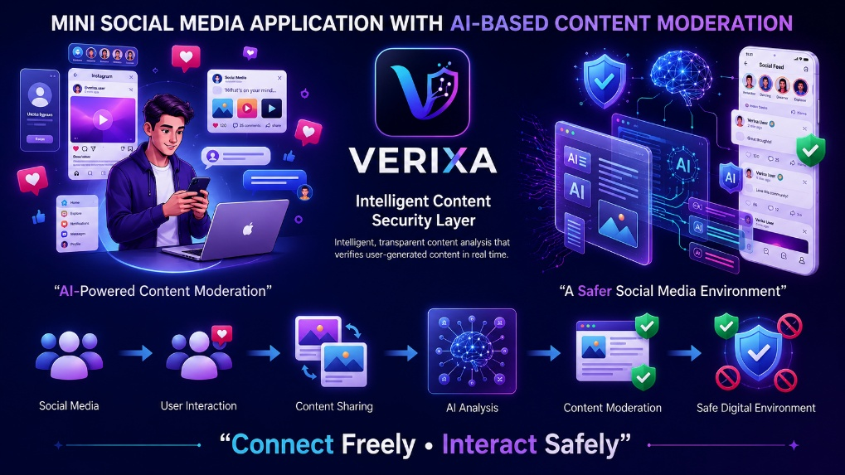

1.2 PROBLEM STATEMENT
The rapid growth of social media has transformed the way people communicate, share information, and interact with each other. Social networking platforms allow users to create posts, share multimedia content, comment, like, and communicate with other users. However, the large amount of user-generated content on these platforms also creates significant challenges related to offensive language, abusive comments, hate speech, inappropriate content, and cyberbullying. Such content can negatively affect users and reduce the safety and quality of online communication.
In many existing or basic social media applications, content monitoring depends largely on user reports and manual administrative review. Monitoring a continuously increasing volume of posts and comments manually is difficult, time-consuming, and may result in delayed identification of harmful content. Inappropriate content may remain accessible until it is reported or reviewed by an administrator. Therefore, relying only on manual moderation is not sufficient for maintaining a safe and responsible social media environment.
There is a need for an automated system that can analyze user-generated content and identify potentially harmful or inappropriate text efficiently. The system should be capable of processing the content submitted by users, detecting problematic language, and taking suitable action without affecting the normal interaction of users. At the same time, it should provide essential social media functionalities such as user registration, login, profile management, posts, likes, comments, reels, and communication.
The proposed Mini Social Media Application with AI-Based Content Moderation addresses these challenges by integrating social networking features with an Artificial Intelligence-based content moderation mechanism. The system uses Artificial Intelligence and Natural Language Processing techniques to analyze user-generated text. Safe content is permitted and stored for display, while content identified as inappropriate can be restricted or blocked, with appropriate notification provided to the user. An administrative module is also included to support monitoring and management of the platform.
The main problem addressed by this project is therefore to develop an interactive and user-friendly social media platform that enables users to connect, share, and interact freely while automatically identifying and restricting harmful content through AI-based moderation, thereby supporting a safer, more responsible, and well-managed digital communication environment.

1.3 EXISTING SYSTEM
The existing social media environment provides users with various features for communication, content sharing, and online interaction. Users can create profiles, publish posts, share multimedia content, like and comment on posts, send messages, and participate in online communities. These features have made social media an important platform for communication, entertainment, and information exchange.
However, the management of user-generated content in conventional systems presents several challenges. Content such as offensive language, abusive comments, hate speech, inappropriate posts, and cyberbullying may be generated and shared by users. In many existing approaches, the identification of such content depends on user reporting, basic filtering mechanisms, and manual review.
The general content moderation process in an existing system can be represented as:
User Creates Content → Content Published → Users Interact → Inappropriate Content Reported → Manual Review → Action Taken
This process may result in delays because harmful content is often reviewed only after it has been reported or detected. When the number of users and posts increases, manually monitoring all content becomes difficult and requires significant time and human effort.
Another limitation is that traditional keyword-based filtering may not effectively understand the context of a sentence or variations in user-generated language. As a result, some inappropriate content may not be detected accurately, while acceptable content may sometimes require unnecessary review.
The existing system therefore provides strong social networking capabilities but has limitations in real-time automated content analysis, intelligent moderation, and continuous monitoring. These limitations create a requirement for an improved approach that can integrate Artificial Intelligence and Natural Language Processing with social media functionality to support faster and more effective content moderation.
Major Limitations of the Existing System:
- Heavy dependence on manual content review.
- Delayed identification of inappropriate content.
- Difficulty in monitoring large volumes of user-generated content.
- Limited understanding of context in basic keyword-based filtering.
- Increased administrative effort for continuous monitoring.
- Harmful content may remain visible until it is detected or reported.
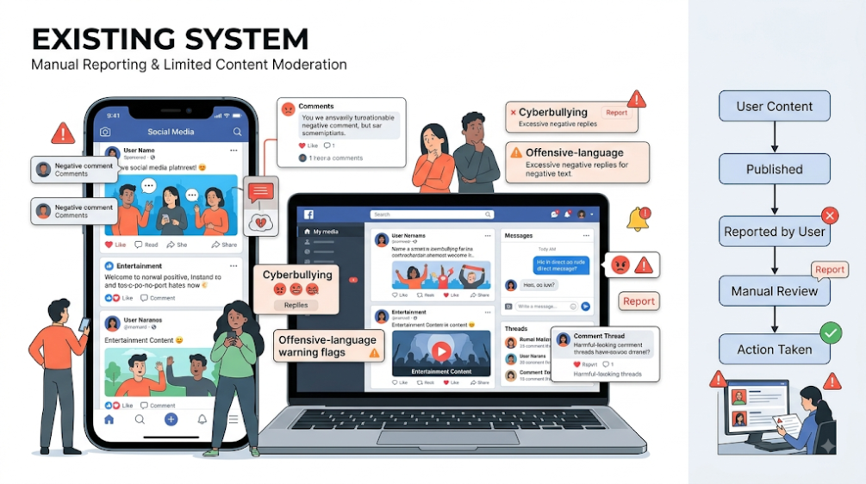
1.3.1 DISADVANTAGES OF THE EXISTING SYSTEM
- Manual Content Moderation – A large amount of content requires human monitoring and review, making the process time-consuming.
- Delayed Detection – Inappropriate or harmful content may remain visible until it is reported and reviewed.
- Difficulty in Handling Large Volumes – Continuously increasing posts, comments, and other user-generated content are difficult to monitor manually.
- Limited Context Understanding – Basic keyword-based filters may not understand the actual meaning or context of a sentence.
- Dependence on User Reports – Harmful content may only be reviewed after users report it.
- Inconsistent Moderation – Manual decisions may vary between different moderators or situations.
- Limited Real-Time Protection – Traditional moderation approaches may not identify and restrict inappropriate content immediately.
- Negative User Experience – Exposure to offensive, abusive, or cyberbullying content can negatively affect the overall social media experience.
- Difficulty in Maintaining a Safe Environment – Without intelligent automated moderation, maintaining a consistently safe and responsible social media environment becomes challenging.

1.4 PROPOSED SYSTEM
The Mini Social Media Application with AI-Based Content Moderation, developed under the application name VERIXA, is proposed as an intelligent and user-friendly social media platform that combines modern social networking features with automated content moderation. VERIXA is designed to provide users with a platform where they can connect freely, share content, interact with others, and communicate safely.
The proposed VERIXA application provides essential social media functionalities such as user registration and login, profile management, post creation, multimedia sharing, likes, comments, reels, and user communication. These features create an interactive digital environment for sharing information, entertainment, and social interaction.
The major feature of VERIXA is its AI-Based Content Moderation System. When a user submits a post or comment, the content is processed using Artificial Intelligence and Natural Language Processing (NLP) techniques. The system analyzes the submitted text and identifies potentially offensive, abusive, hateful, inappropriate, or cyberbullying-related content.
The proposed moderation process can be represented as:
User Creates Content → Text Preprocessing → AI/NLP Analysis → Content Classification → Safe / Inappropriate
If the content is identified as safe, it is stored in the MySQL database and displayed normally on VERIXA. If potentially harmful content is detected, the system can restrict or block the content and notify the user. This automated process reduces dependence on continuous manual moderation and helps improve the efficiency of content monitoring.
VERIXA also includes an Admin Module for monitoring and managing platform activities. Administrators can manage users, posts, comments, and moderation-related information, helping maintain proper control over the application and supporting a safer online environment.
The application is developed using HTML, CSS, and JavaScript for the front end, Python with Flask/Django for the back end, and MySQL for database management. Python-based Artificial Intelligence and Natural Language Processing technologies are used for automated content analysis and moderation.
The primary objective of the proposed VERIXA system is to provide an interactive, intelligent, and safer social media environment. By integrating social networking features with AI-based content moderation, VERIXA aims to reduce harmful content, support effective platform management, and provide users with a better and more responsible digital communication experience.
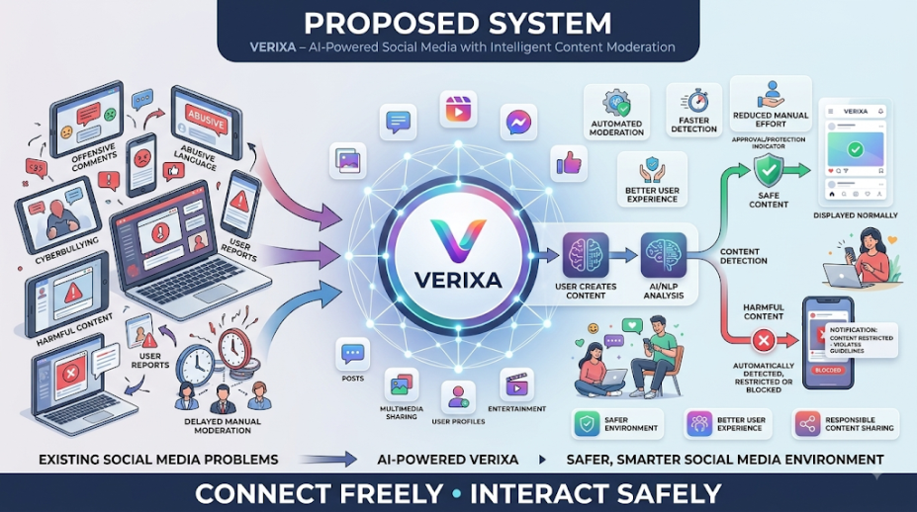

1.4.1 ADVANTAGES OF THE PROPOSED SYSTEM
- AI-Based Content Moderation – VERIXA automatically analyzes user-generated content using Artificial Intelligence and NLP techniques to identify potentially harmful or inappropriate content.
- Faster Content Detection – The system can analyze submitted content automatically, helping to identify inappropriate content more quickly than fully manual moderation.
- Reduced Manual Effort – Automated moderation reduces the amount of content that administrators need to review manually.
- Safer Social Media Environment – VERIXA helps reduce exposure to offensive, abusive, hateful, and cyberbullying-related content.
- Real-Time Content Analysis – User-generated posts and comments can be analyzed during the content submission process.
- Better User Experience – Users can interact, share posts, and communicate in a more organized and secure environment.
- Efficient Administration – The Admin Module helps administrators monitor users, posts, comments, and moderation activities efficiently.
- Integrated Social Media Features – VERIXA combines posts, likes, comments, reels, profiles, and communication within a single platform.
- Automated Content Filtering – Potentially inappropriate content can be restricted or blocked based on the moderation result.
1.5 NEED FOR THE SYSTEM
The rapid growth of social media has created a need for platforms that not only provide communication and content-sharing facilities but also ensure a safe and responsible digital environment. Users continuously generate posts, comments, messages, and other content, making it difficult to monitor every activity manually. The presence of offensive language, abusive comments, hate speech, inappropriate content, and cyberbullying highlights the importance of an efficient content moderation mechanism.
The VERIXA – Mini Social Media Application with AI-Based Content Moderation is proposed to address these challenges by integrating social networking features with Artificial Intelligence and Natural Language Processing. The system can analyze user-generated text, identify potentially inappropriate content, and take suitable action before the content is widely displayed or circulated.
The need for VERIXA arises from the following requirements:
- Automated Content Moderation: To reduce dependence on continuous manual monitoring.
- Faster Detection: To identify potentially harmful content efficiently.
- User Safety: To reduce users' exposure to offensive, abusive, and cyberbullying-related content.
- Efficient Content Management: To handle increasing volumes of user-generated content more effectively.
- Reduced Administrative Effort: To assist administrators in monitoring and managing platform activities.
- Improved User Experience: To provide a cleaner, safer, and more comfortable environment for social interaction.
- Responsible Content Sharing: To encourage users to communicate and share content within appropriate guidelines.
Therefore, VERIXA is needed to combine social media interaction with intelligent content moderation, enabling users to connect freely and interact safely while supporting efficient management of user-generated content.

1.6 OBJECTIVES OF THE PROJECT
The main objective of the Mini Social Media Application with AI-Based Content Moderation, developed under the application name VERIXA, is to create an interactive social media platform that combines essential social networking features with intelligent content moderation. The project aims to provide users with a convenient platform for communication, content sharing, and entertainment while promoting a safer digital environment.
SPECIFIC OBJECTIVES
- To develop VERIXA as a user-friendly social media application for connecting and interacting with other users.
- To provide essential social media features such as registration, login, profiles, posts, likes, comments, reels, and user communication.
- To integrate Artificial Intelligence and Natural Language Processing for analyzing user-generated textual content.
- To automatically identify potentially harmful content, including offensive, abusive, hateful, inappropriate, and cyberbullying-related content.
- To restrict or block inappropriate content based on the result of the AI-based moderation process.
- To reduce dependency on manual content moderation and minimize the administrative effort required for monitoring user-generated content.
- To improve user safety and experience by reducing exposure to harmful or inappropriate content.
- To provide an Admin Module for monitoring users, posts, comments, and moderation activities.
- To maintain organized data management using a structured MySQL database.
- To create a responsible digital environment where users can “Connect Freely • Interact Safely.”

1.7 SCOPE OF THE PROJECT
The scope of the Mini Social Media Application with AI-Based Content Moderation, developed under the application name VERIXA, covers the design and development of an interactive social media platform with an integrated mechanism for intelligent content moderation. The system focuses on providing essential social networking functionalities while improving the safety and quality of user interactions through AI-based content analysis.
The major areas covered by the project include:
- User Management: Provides user registration, login, profile management, and basic account-related functionalities.
- Social Interaction: Allows users to create posts, share content, like posts, add comments, view reels, and interact with other users.
- Content Management: Enables the creation, storage, retrieval, and display of user-generated content in an organized manner.
- AI-Based Content Moderation: Uses Artificial Intelligence and Natural Language Processing techniques to analyze textual content submitted through posts and comments.
- Harmful Content Detection: Identifies potentially offensive, abusive, hateful, inappropriate, or cyberbullying-related content based on the implemented moderation mechanism.
- Automated Content Filtering: Allows safe content to be displayed normally while potentially inappropriate content can be restricted or blocked.
- User Notification: Provides appropriate notifications when submitted content is restricted due to moderation results.
- Admin Management: Provides an Admin Module for monitoring users, posts, comments, and moderation-related activities.
- Database Management: Uses MySQL to store and manage user information, posts, comments, likes, and moderation-related data.
Overall, the scope of VERIXA is to develop a functional, interactive, and AI-assisted social media platform that supports content sharing and communication while promoting a safer and more responsible online environment.

2.1 FEASIBILITY STUDY
The feasibility study is conducted to determine whether the proposed Mini Social Media Application with AI-Based Content Moderation (VERIXA) can be successfully developed and implemented using the available resources, technologies, and time.
1. Technical Feasibility
The proposed system is technically feasible because it can be developed using commonly available technologies such as HTML, CSS, JavaScript, Python, Flask/Django, and MySQL. Python-based AI and NLP techniques can be used for content moderation. The required hardware and software resources are easily accessible.
2. Economic Feasibility
VERIXA is economically feasible because the major development technologies and libraries are open-source and freely available. The system can be developed using existing computer resources, reducing the need for additional infrastructure and licensing expenses.
3. Operational Feasibility
The system is operationally feasible as VERIXA is designed with a simple and user-friendly interface. Users can easily perform social media activities such as creating posts, liking, commenting, sharing content, and communicating with others. AI-based moderation and the Admin Module support efficient platform management.
4. Schedule Feasibility
The project is feasible within the planned development period. The system can be developed in separate modules such as user management, social media features, database, AI-based moderation, and administration, followed by integration and testing.
Conclusion
Based on the technical, economic, operational, and schedule analysis, VERIXA is a feasible project that can be developed using the available resources and technologies to provide an interactive and safer social media environment.
2.2 REQUIREMENT ANALYSIS:
Requirement Analysis is a fundamental phase in the development of the Mini Social Media Application with AI-Based Content Moderation, developed under the application name VERIXA. It defines the capabilities, behavior, constraints, and quality standards required for the successful implementation of the proposed system. A clear analysis of requirements ensures that the application meets the expectations of users and administrators while achieving the primary objective of providing a safer and more responsible social media environment.
VERIXA is intended to provide a complete social media experience through features such as user authentication, profile management, post creation, likes, comments, reels, content sharing, and user interaction. The system additionally incorporates Artificial Intelligence and Natural Language Processing (NLP) to analyze user-generated textual content and identify potentially harmful or inappropriate content. The requirements of the system are categorized into Functional Requirements and Non-Functional Requirements.
2.2.1 FUNCTIONAL REQUIREMENTS
Functional requirements define the specific functions and services that the VERIXA application is expected to provide to its users and administrators. They describe how the system should respond to user actions, manage application data, process user-generated content, and perform AI-based content moderation. These requirements form the core operational features of VERIXA and ensure that users can interact with the platform effectively while the system maintains appropriate content management and administrative control. The major functional requirements of the proposed system are as follows:.
1. User Registration and Authentication
VERIXA shall provide a registration mechanism through which new users can create accounts. Registered users shall be authenticated through a secure login process before accessing protected application features.
2. User Profile Management
The system shall provide individual user profiles containing relevant account information and user activities. Users shall be able to view and manage their profile information according to the permissions provided by the system.
3. Post and Content Management
Users shall be able to create, publish, view, and manage posts. The system shall store the required post information and make approved content available through the social media feed.
4. Social Interaction
The application shall allow users to interact with shared content through features such as likes and comments. The system shall record these interactions and associate them with the corresponding users and posts.
5. Reels and Multimedia Sharing
VERIXA shall provide entertainment-oriented features such as reels and multimedia content sharing, allowing users to view and interact with supported content through the platform.
6. User Communication
The system shall provide communication facilities that enable users to interact with other users through the available communication features while maintaining appropriate access controls.
7. AI-Based Content Analysis
The system shall analyze user-generated textual content using Artificial Intelligence and Natural Language Processing techniques. Submitted posts and comments shall undergo the defined content analysis process before being displayed.
8. Harmful Content Detection
The AI-based moderation component shall identify potentially offensive, abusive, hateful, inappropriate, and cyberbullying-related content according to the moderation criteria implemented in the system.
9. Content Moderation and Restriction
Based on the moderation result, safe content shall continue through the normal publishing process. Content identified as potentially inappropriate shall be restricted or blocked according to the defined system rules.
10. User Notification
When content is restricted or blocked, the system shall provide an appropriate notification to the concerned user. This helps users understand that their submitted content did not meet the defined content guidelines.
11. Administrative Management
VERIXA shall provide an Admin Module for monitoring and managing platform activities. The administrator shall be able to oversee relevant users, posts, comments, and content moderation information.
12. Database Operations
The system shall use MySQL for structured storage and retrieval of application information, including user details, posts, comments, likes, and moderation-related records.
2.2.2 NON-FUNCTIONAL REQUIREMENTS
Non-functional requirements define the quality attributes, operational characteristics, and constraints that determine the effectiveness and overall quality of the VERIXA application.
1. Usability
The application shall provide a clear, consistent, and user-friendly interface. Navigation between major features should be simple and understandable so that users can interact with the platform without unnecessary difficulty.
2. Performance
The system should process user requests efficiently and provide timely responses during normal operation. Operations such as loading content, submitting posts, adding comments, and performing moderation analysis should be completed within an acceptable response time.
3. Security
The system shall protect user accounts and application data from unauthorized access. Authentication and appropriate access controls should be implemented to ensure that users and administrators can access only the functionalities permitted to them.
4. Reliability
VERIXA should provide consistent and dependable operation under expected conditions. Application data should be processed accurately, and important user and system information should be maintained reliably.
5. Availability
The application should remain accessible to authorized users whenever the system is operational. The system should minimize unnecessary interruptions and ensure that core services remain available during normal usage.
6. Scalability
The system should be capable of accommodating future growth in the number of users, posts, comments, and other activities. Its architecture should allow additional functionality to be incorporated without major changes to the existing system.
7. Maintainability
The application should follow a structured and modular development approach. This should allow developers to identify errors, modify existing components, implement improvements, and maintain the system efficiently.
8. Accuracy
The AI-based moderation mechanism should provide consistent and meaningful analysis of submitted content based on the defined moderation criteria. The system should aim to minimize incorrect classification and improve the quality of automated content screening.
9. Data Integrity
All information stored in the database should remain accurate, consistent, and properly organized. Database operations should maintain relationships between users, posts, comments, likes, and moderation records.

10. Privacy
User information and application data should be handled appropriately and protected from unauthorized access. Access to sensitive information should be controlled according to the user's role and system permissions.
11. Compatibility
As a web-based application, VERIXA should operate correctly in commonly used web browsers and standard computing environments. The technologies selected for development should support reliable integration between the user interface, server, database, and AI components.
12. Extensibility
The system should be designed to support future enhancements such as additional social media features, improved content classification techniques, advanced administrative capabilities, and other AI-based safety mechanisms.
Summary
The requirement analysis establishes a clear foundation for the development of VERIXA. The functional requirements define the essential services and operations of the application, while the non-functional requirements establish the standards for performance, security, reliability, usability, scalability, maintainability, privacy, and accuracy. Together, these requirements ensure that VERIXA can provide a complete social media experience while supporting an intelligent and safer approach to user-generated content moderation.

2.3 HARDWARE REQUIREMENTS
The VERIXA – Mini Social Media Application with AI-Based Content Moderation requires a reliable computing environment to support application development, database management, web server execution, and AI-based content analysis. The following hardware configuration is recommended for efficient development, testing, and demonstration of the system.

Hardware Component | Recommended Requirement
Processor | Intel Core i5 / AMD Ryzen 5 or equivalent
RAM | 8 GB or higher
Storage | 256 GB SSD or higher
Display | 1366 × 768 resolution or higher
Network | Stable Internet connection
Keyboard | Standard keyboard
Pointing Device | Standard mouse or touchpad
System Architecture | 64-bit processor and operating system

The proposed hardware configuration provides sufficient processing capability for running the VERIXA web application, MySQL database, development environment, and AI/NLP-based content moderation components. An SSD and adequate RAM help improve application loading, database operations, and overall system responsiveness. The configuration can also support future development and testing of additional features within the application.

2.4 SOFTWARE REQUIREMENTS
The VERIXA – Mini Social Media Application with AI-Based Content Moderation requires a suitable software environment for developing the user interface, implementing server-side operations, managing the database, and performing AI-based content analysis. The software requirements selected for the project provide the necessary environment for development, integration, testing, and deployment.

Software / Technology | Requirement / Purpose
Operating System | Windows 10/11 or compatible 64-bit OS
Frontend Technologies | HTML5, CSS3, JavaScript
Backend Technology | Python with Flask/Django
Database | MySQL
Database Connectivity | MySQL Connector / compatible database driver
AI / ML Environment | Python-based AI and Machine Learning libraries
NLP Technologies | NLTK and related Natural Language Processing libraries
Machine Learning | Scikit-learn / suitable ML libraries
Development Environment | Visual Studio Code / PyCharm or equivalent IDE
Web Browser | Google Chrome, Microsoft Edge, or equivalent
Web Server / Local Server | Flask/Django development server; XAMPP where required
Package Management | Python pip
API Testing | Postman, where required
Version Control | Git / GitHub, where required

The combination of these technologies provides a complete software environment for developing and testing VERIXA. The frontend technologies are used to create an interactive user interface, Python with Flask/Django manages the application logic, MySQL handles structured data storage, and Python-based AI/NLP technologies support automated content analysis and moderation.

3.1 PROGRAMMING ENVIRONMENT
The Programming Environment defines the set of programming languages, frameworks, technologies, libraries, and development tools used for designing and implementing the Mini Social Media Application with AI-Based Content Moderation, developed under the application name VERIXA. The selected programming environment supports the complete development lifecycle of the application, including user interface development, server-side processing, database management, AI-based content analysis, testing, and maintenance.
The programming environment is designed to provide a structured and flexible platform for integrating social media functionality with intelligent content moderation. The major components of the programming environment are described below.

3.1.1 PROGRAMMING LANGUAGES
PYTHON
Python is the primary programming language used for the back-end and AI-based components of VERIXA. It provides a simple and flexible programming environment and supports web development, database connectivity, Artificial Intelligence, Machine Learning, and Natural Language Processing.
Python is mainly used for implementing application logic, processing user requests, connecting the application with the database, and developing the AI-based content moderation mechanism.
JAVASCRIPT
JavaScript is used to provide dynamic and interactive functionality on the client side of the application. It helps manage user interactions, dynamic page elements, form validation, and communication between the front end and back end where required.
HTML
HTML5 is used to create the basic structure of the VERIXA web application. It defines elements such as navigation sections, forms, buttons, posts, comments, user profiles, and other components of the user interface.
CSS
CSS3 is used to design and style the application interface. It controls the layout, typography, spacing, responsiveness, and visual appearance of VERIXA, helping create a clean and user-friendly social media interface.

3.1.2 FRONT-END TECHNOLOGIES
The front-end of VERIXA is responsible for providing the user interface through which users interact with the application. The major front-end technologies include HTML5, CSS3, and JavaScript.
HTML5
HTML5 provides the structural foundation of the application. It is used to organize different sections of the application, including login pages, registration forms, user profiles, feeds, posts, comments, and other social media components.
CSS3
CSS3 is used to provide a consistent visual design across the application. It helps implement layouts, responsive designs, buttons, navigation elements, cards, forms, and other user interface components.
JAVASCRIPT
JavaScript provides client-side interactivity. It can be used for handling user actions, validating input, updating interface elements, and supporting dynamic interactions within the application.
The combination of these technologies allows VERIXA to provide an interactive and visually organized user experience.

3.1.3 BACK-END TECHNOLOGIES
The back-end is responsible for processing requests, implementing application logic, managing authentication, communicating with the database, and connecting the social media features with the AI-based moderation component.
PYTHON
Python acts as the primary back-end programming language. It handles server-side operations and provides integration between the front end, database, and AI components.
FLASK / DJANGO
Flask or Django can be used as the Python web framework for implementing the server-side application.
Flask provides a lightweight and flexible framework suitable for developing modular web applications and APIs. It allows developers to manage routes, requests, responses, authentication, and database connectivity.
Django provides a more comprehensive web development framework with built-in features for URL routing, database operations, authentication, administration, and application management.
The selected framework provides the communication layer between the VERIXA user interface, database, and AI moderation system.

3.1.4 DATABASE ENVIRONMENT
MYSQL
MySQL is used as the primary database management system for VERIXA. It provides structured storage and retrieval of application data.
The database can maintain information related to:
- User accounts and profiles
- Posts and multimedia content
- Comments
- Likes and interactions
- User communication records
- AI moderation results
- Administrative information
MySQL provides a reliable relational structure for maintaining relationships between different entities of the application. It also supports efficient querying, updating, and retrieval of information required by the application.
DATABASE CONNECTIVITY
The Python back end communicates with MySQL through an appropriate database connector. This allows the application to perform operations such as inserting new records, retrieving user information, updating content, and maintaining moderation-related data.

3.1.5 AI AND MACHINE LEARNING ENVIRONMENT
Artificial Intelligence is an important component of VERIXA because it enables the system to automatically analyze user-generated content. The AI environment is primarily based on Python and suitable Machine Learning libraries.
ARTIFICIAL INTELLIGENCE
AI techniques are used to support automated content moderation. The system analyzes submitted textual content and determines whether it is potentially safe or inappropriate according to the defined moderation criteria.
MACHINE LEARNING
Machine Learning techniques can be used to train or implement classification models capable of identifying patterns in textual data. The moderation model can classify content into appropriate categories based on the dataset and classification approach used during development.
SCIKIT-LEARN
Scikit-learn can be used for implementing Machine Learning algorithms, preprocessing data, feature extraction, model training, and content classification. It provides a practical environment for developing and testing text classification models.
The AI and Machine Learning environment helps VERIXA reduce dependence on manual content monitoring and supports automated analysis of user-generated content.

3.1.6 NATURAL LANGUAGE PROCESSING ENVIRONMENT
Natural Language Processing (NLP) is used to enable the system to process and analyze human language. Since posts and comments may contain different forms of textual expressions, NLP techniques help convert raw text into a suitable form for AI-based analysis.
NLTK
Natural Language Toolkit (NLTK) is a Python library that can be used for text preprocessing and Natural Language Processing tasks. It provides facilities for operations such as tokenization, stop-word handling, text normalization, and other language-processing operations.
TEXT PREPROCESSING
Before content is analyzed by the moderation model, the submitted text may undergo preprocessing operations such as:
Raw Text → Cleaning → Normalization → Tokenization → Feature Extraction → Classification
Text preprocessing helps remove unnecessary elements and prepares the content for further analysis.

3.1.7 TESTING ENVIRONMENT
Testing is an essential part of the development environment of VERIXA and is performed to ensure that all components of the application function correctly and work together as expected. The testing environment covers the verification of the front end, back end, database, AI-based content moderation, and overall system functionality.
Postman can be used to test and validate back-end APIs, requests, responses, authentication, and communication between different components. MySQL tools are used to verify database operations, including data insertion, retrieval, updating, and relationships between records. Web browsers such as Google Chrome and Microsoft Edge are used to test the user interface, navigation, forms, posts, comments, and other interactive features.
The AI-based content moderation component is tested using different categories of textual inputs to verify whether the system can appropriately distinguish between safe and potentially inappropriate content. Integration testing is also performed to ensure proper communication between the front end, back end, database, and AI moderation module.
This testing environment helps identify functional errors, database issues, interface problems, and integration failures during development, thereby improving the reliability, accuracy, usability, and overall quality of VERIXA.

3.2 DEVELOPMENT TOOLS AND LIBRARIES
The development of VERIXA requires several tools and libraries to support coding, database management, testing, and AI development.
VISUAL STUDIO CODE / PYCHARM
Visual Studio Code or PyCharm can be used as the primary development environment. These tools provide facilities for writing, editing, organizing, and debugging application code.
MYSQL TOOLS
MySQL development tools can be used to create databases, tables, relationships, queries, and manage application data during development and testing.
XAMPP
XAMPP can be used as a local development environment where required for database and server-related development. It provides an easy environment for managing local services during application development.
PYTHON LIBRARIES
Python libraries are used to extend the functionality of the application. Libraries related to web development, database connectivity, Artificial Intelligence, Machine Learning, and Natural Language Processing can be installed and managed according to the requirements of VERIXA.
PIP
pip is Python's package management tool. It is used to install, update, and manage the Python packages required for the back-end and AI/NLP components of the application.
POSTMAN
Postman can be used for testing and validating APIs developed for the VERIXA back end. It helps verify requests, responses, authentication, and communication between different application components.

3.3 VERSION CONTROL
Git is a distributed version control system that can be used to track changes made during the development of VERIXA. It allows developers to maintain different versions of the source code and provides a mechanism for recovering previous versions when required.
GitHub can be used as a remote repository for storing and managing the VERIXA project source code. It also supports collaboration, project backup, version tracking, and organized management of development files.
Version control is useful throughout the development process because it helps maintain a history of changes, reduces the risk of losing source code, and makes future maintenance and development easier.

Overall Programming Environment
The programming environment of VERIXA combines Python, HTML, CSS, JavaScript, Flask/Django, MySQL, Artificial Intelligence, Machine Learning, and Natural Language Processing technologies into a unified development platform. Front-end technologies provide the user interface, while Python and the selected web framework manage the application logic. MySQL provides structured data storage, and AI/NLP technologies enable automated content analysis.
This combination of technologies provides the necessary foundation for developing VERIXA as an interactive, intelligent, and user-friendly social media application with AI-based content moderation.

4.1 USE CASE DIAGRAM
The Use Case Diagram of VERIXA – Mini Social Media Application with AI-Based Content Moderation represents the functional interaction between the users, administrator, and the major services provided by the system. It gives a high-level view of the system by identifying the main actors and the activities they can perform. The diagram helps to understand the functional requirements and overall behavior of the application in a simple and structured manner.
4.1.1 ACTORS IN THE SYSTEM
The VERIXA application mainly consists of two actors: User and Admin. Each actor has different responsibilities and access to the system functionalities.
1. User
The User is the primary actor who interacts with the social media features of VERIXA. The user can create an account, log in securely, manage their profile, create and view posts, like posts, add comments, view reels, communicate with other users, and receive notifications. The user's comments are processed through the AI-based content moderation mechanism before they are displayed.
2. Admin
The Admin is responsible for managing and monitoring the overall VERIXA application. The administrator can manage user accounts, monitor posts and comments, review moderation activities, and handle reported or inappropriate content. Admin access helps maintain the security, reliability, and proper functioning of the platform.
4.1.2 MAJOR USE CASES
The major use cases of the VERIXA application are:
- User Registration – Allows new users to create an account in the system.
- User Login – Allows registered users and administrators to securely access their respective accounts.
- Profile Management – Allows users to view and update their profile information.
- Create Post – Enables users to create and publish posts on the platform.
- View Posts – Allows users to view available posts and content in the application.
- Like Post – Enables users to interact with posts by adding likes.
- Comment on Post – Allows users to add comments to posts.
- AI-Based Content Moderation – Analyzes submitted comments or content to identify potentially inappropriate or harmful content.
- View Reels – Allows users to view short-form entertainment content.
- Messaging – Enables users to communicate with other users through messages.
- Notifications – Provides users with updates related to interactions and activities.
- Manage Users – Allows the administrator to monitor and manage registered users.
- Manage Posts – Allows the administrator to monitor and manage posts available on the platform.
- Monitor Comments – Enables the administrator to review comments and moderation-related activities.
- Monitor AI Moderation – Allows the administrator to monitor the results and activities of the AI-based moderation system.
- Manage Reports – Enables the administrator to review and manage reported content or user activities.
4.1.3 USER INTERACTION WITH THE SYSTEM
The User interacts with VERIXA through various social media functionalities. After registration and login, the user can manage their profile and access the home feed. Users can create posts, view posts, like posts, and add comments. When a comment is submitted, the AI-based content moderation module processes the content and determines whether it is suitable for publication. Safe content can be allowed, while potentially inappropriate content can be restricted according to the moderation result.
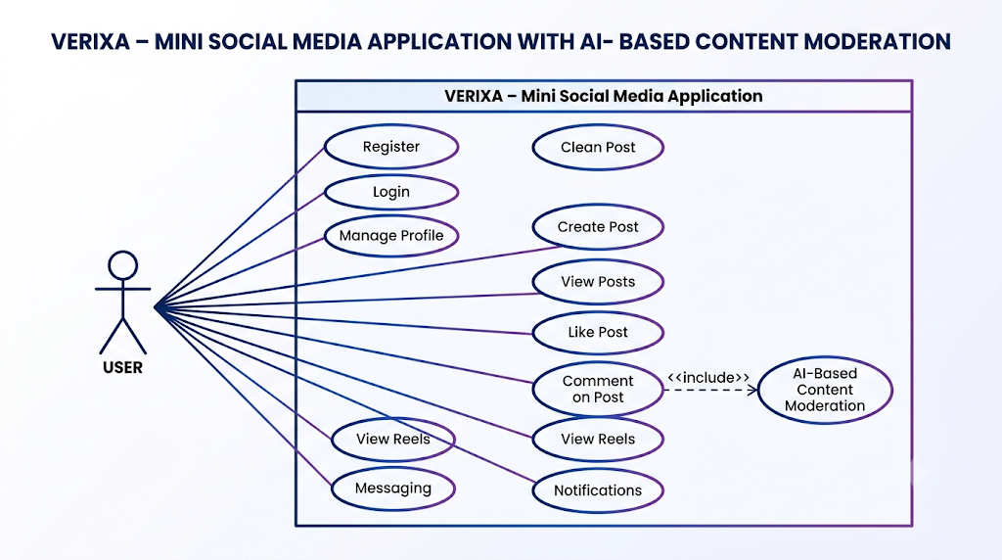
Users can also access reels, communicate through messaging, and receive notifications regarding relevant activities and interactions. These functionalities provide users with a complete and interactive social media experience.
4.1.4 ADMIN INTERACTION WITH THE SYSTEM
The Admin interacts with the system through administrative functions. After secure admin login, the administrator can manage users, monitor posts and comments, review AI moderation activities, and manage reports. These functions help the administrator identify inappropriate activities and maintain the proper operation of the VERIXA platform.
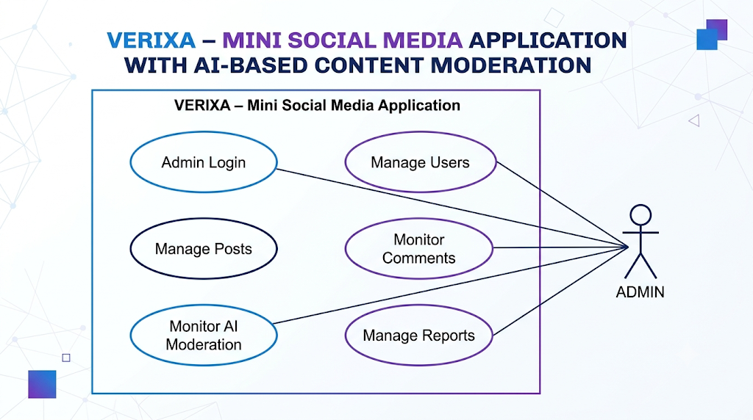
4.1.5 AI-BASED CONTENT MODERATION INTERACTION
AI-Based Content Moderation is an important use case of VERIXA. When a user submits a comment, the system processes the text using text preprocessing and Natural Language Processing techniques. The processed content is then analyzed by the AI/ML model to determine whether it is safe or potentially inappropriate.
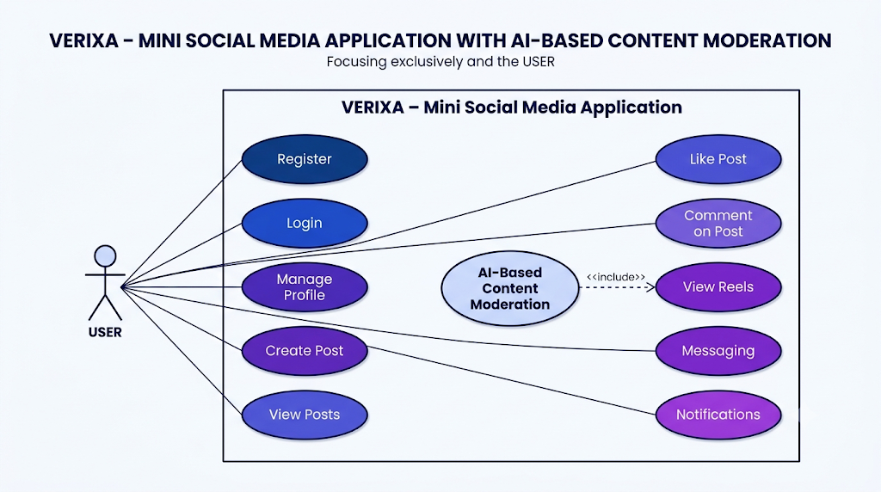
Based on the moderation result, the system can allow suitable content to be published or restrict content identified as inappropriate. The moderation result can also be monitored by the administrator for maintaining a safer and more controlled platform.
4.1.6 OVERALL USE CASE DESCRIPTION
The Use Case Diagram provides a clear representation of how different actors interact with the VERIXA application. The User primarily performs social media activities, while the Admin performs management and monitoring activities. The AI-Based Content Moderation functionality acts as an important supporting component that helps control inappropriate comments and content.
Thus, the Use Case Diagram defines the functional boundaries of VERIXA and provides a clear understanding of the major interactions between the actors and the system. It serves as a foundation for the subsequent system architecture, AI workflow, user interface design, and database design.
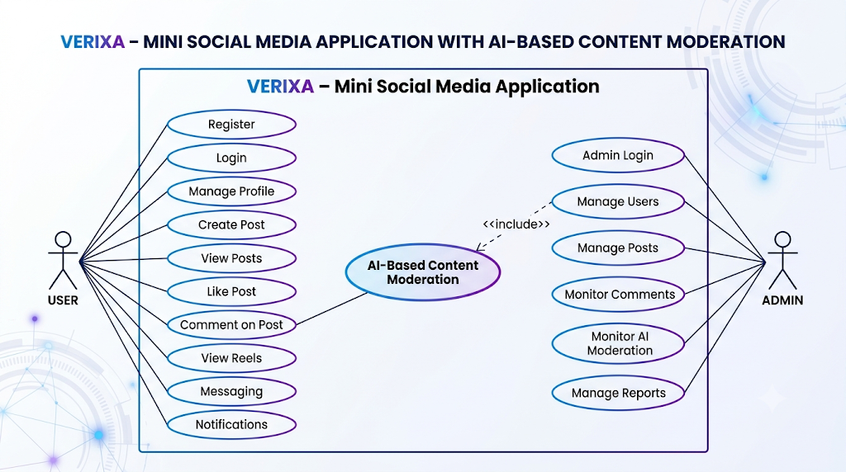

4.2 SYSTEM ARCHITECTURE
The System Architecture of VERIXA – Mini Social Media Application with AI-Based Content Moderation defines the overall structure of the application and describes how its major components communicate with each other. The architecture is designed to integrate social media functionalities, database management, and AI-based content moderation into a unified web-based platform.
VERIXA follows a layered architecture, in which the application is divided into separate logical layers. This approach improves modularity, maintainability, scalability, and communication between different components of the system.
1. Presentation Layer
The Presentation Layer provides the user interface through which users and administrators interact with VERIXA. It is developed using HTML, CSS, and JavaScript. This layer provides interfaces for registration, login, user profiles, posts, comments, likes, reels, communication, notifications, and administrative functions.
2. Application / Business Logic Layer
The Application Layer is responsible for processing user requests and implementing the core logic of VERIXA. Python with Flask/Django is used to handle authentication, user activities, post management, interactions, notifications, and communication between the front end and other system components.
This layer also controls the content moderation workflow and forwards submitted textual content to the AI-based moderation component for analysis.
3. AI-Based Content Moderation Layer
The AI Moderation Layer is the major intelligent component of VERIXA. When a user submits a post or comment, the content is passed through text preprocessing and NLP techniques before being analyzed using suitable Machine Learning or AI models.
The moderation process can be represented as:
User Content → Text Preprocessing → NLP Analysis → AI/ML Classification → Moderation Decision
Based on the analysis, the content is identified as safe or potentially inappropriate. Safe content proceeds for storage and display, while potentially harmful content can be restricted or blocked.
4. Database Layer
The Database Layer uses MySQL to store and manage application information. It maintains structured data related to users, profiles, posts, comments, likes, communication, and AI moderation results.
The application layer communicates with the database through appropriate database connectivity mechanisms to perform operations such as data insertion, retrieval, modification, and deletion.
5. Administration Layer
The Administration Layer provides authorized administrators with facilities for monitoring and managing the platform. It supports the monitoring of users, posts, comments, and moderation-related information, helping maintain proper control over the VERIXA application.
Overall System Flow
The overall architecture of VERIXA can be represented as:
User / Admin
↓
Presentation Layer
HTML • CSS • JavaScript
↓
Application Layer
Python • Flask/Django
↓
AI-Based Content Moderation
Preprocessing • NLP • AI/ML Analysis
↓
Database Layer
MySQL
↓
Response / Moderated Content Display

4.3 AI WORKFLOW
The AI Workflow of VERIXA – Mini Social Media Application with AI-Based Content Moderation describes the process through which Artificial Intelligence and Natural Language Processing are used to analyze and moderate user-generated textual content. The workflow is designed to identify potentially harmful content before it is displayed or circulated on the platform, thereby supporting a safer and more responsible social media environment.
The AI-based moderation process consists of the following stages:
1. User Content Submission
The process begins when a user creates and submits a post or comment on VERIXA. The submitted textual content is passed to the moderation component for analysis.
2. Text Preprocessing
The raw text is prepared for analysis using NLP preprocessing techniques. Unnecessary characters, unwanted elements, and other irrelevant information may be cleaned or normalized to produce suitable input for the AI model.
3. Natural Language Processing
The preprocessed text is analyzed using Natural Language Processing (NLP) techniques. The system converts the textual information into a form that can be processed by the selected AI/ML model.
4. Feature Extraction
Relevant characteristics or features are extracted from the processed text. These features help the Machine Learning model identify patterns associated with different categories of user-generated content.
5. AI/ML Classification
The extracted features are provided to the trained or selected AI/Machine Learning model. The model analyzes the content and determines whether it falls within the defined safe or potentially harmful categories.
6. Moderation Decision
The system generates a moderation result based on the classification:
Safe Content → Allow
Potentially Harmful Content → Restrict / Block
Safe content proceeds through the normal publishing process, while potentially inappropriate content is restricted according to the moderation rules implemented in VERIXA.
7. Database Storage
Approved content and relevant moderation information are stored in the MySQL database. This allows the system to maintain records and retrieve them when required.
8. User Notification
If content is restricted or blocked, the system can notify the user about the moderation action. This provides transparency and informs the user about the applicable content guidelines.
9. Admin Monitoring
The moderation results and related activities can be made available to the Admin Module, allowing authorized administrators to monitor content and platform activities.
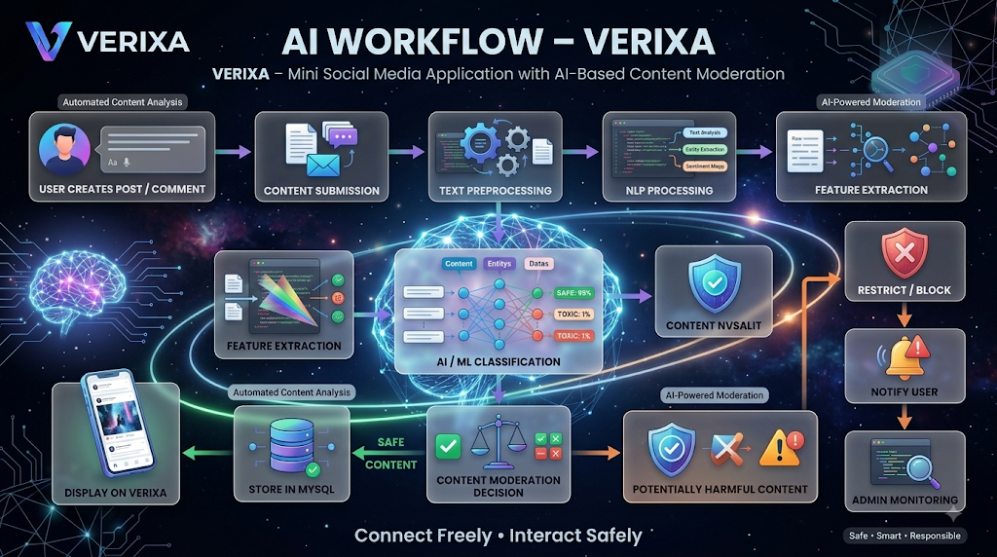

AI Workflow Summary
User Creates Post/Comment
↓
Content Submission
↓
Text Preprocessing
↓
NLP Processing
↓
Feature Extraction
↓
AI/ML Classification
↓
◇Is Content Safe?◇
↙ ↘
YES NO
↓ ↓
Store in MySQL Restrict / Block
↓ ↓
Display on VERIXA Notify User
↓
Admin Monitoring
This workflow enables VERIXA to integrate AI-based analysis into the social media content lifecycle, reducing dependence on manual moderation and helping create a safer environment for user interaction.

4.4 USER INTERFACE (UI) DESIGN
The User Interface (UI) Design of VERIXA – Mini Social Media Application with AI-Based Content Moderation focuses on providing a clean, attractive, intuitive, and user-friendly environment for social interaction and content sharing. The interface is designed to make the major features of the application easily accessible while maintaining a consistent visual identity across all screens.
The VERIXA interface follows a modern social media design approach with a consistent color scheme, typography, icons, navigation elements, and responsive layouts. The selected VERIXA brand colors are applied throughout the application to create a recognizable and consistent user experience.
1. Login and Registration Interface
The Login and Registration screens provide secure access to the VERIXA application. New users can create an account, while existing users can log in using their registered credentials. The interface includes clearly labelled input fields, buttons, and navigation options to ensure a simple authentication experience.
2. Home / Feed Interface
The Home screen acts as the primary interface of VERIXA. It displays posts and shared content from users in an organized feed. Users can view content and interact with posts through available options such as like, comment, and share.
3. Post Creation Interface
The Post Creation screen allows users to create and publish their own content. Users can enter textual content and provide supported multimedia content. Before inappropriate textual content is displayed, it can be processed through the AI-Based Content Moderation mechanism.
4. Profile Interface
The Profile screen displays user-related information and activities. It provides access to the user's profile details, posts, and other relevant account information in an organized layout.

5. Comments and Interaction Interface
The Comments interface allows users to view and add comments to posts. Users can interact with other users' content through likes and comments, creating an engaging social environment.
6. Reels and Entertainment Interface
The Reels interface provides a dedicated area for short-form entertainment and multimedia content. The design focuses on easy navigation and smooth interaction while maintaining the overall VERIXA visual style.
7. Messaging Interface
The Messaging interface provides users with a convenient environment for communicating with other users. It includes conversation lists, message areas, and appropriate interaction controls.
8. AI Content Moderation Interface
The AI moderation functionality is integrated into the content submission process rather than being presented as a complex interface to the user. When a user submits a post or comment, the system analyzes the content using AI and NLP techniques. Safe content is allowed to proceed, while potentially harmful content can be restricted or blocked and the user can be notified.
9. Notification Interface
The Notification screen provides users with updates related to interactions and important system activities, including notifications regarding content moderation actions when applicable.
10. Admin Dashboard
The Admin Dashboard provides authorized administrators with a centralized interface for monitoring users, posts, comments, and moderation-related activities. The dashboard is designed to present important information in a structured and easily manageable format.
UI Design Principles
The VERIXA interface is developed according to the following design principles:
- Consistency: Common colors, typography, icons, and layouts are maintained across screens.
- Simplicity: Interfaces are designed to avoid unnecessary complexity.
- Accessibility: Important controls and information are presented clearly.
- Responsiveness: The interface is designed to adapt to different screen sizes where applicable.
- User-Centered Design: Features are arranged according to common user interaction patterns.
- Visual Hierarchy: Important information and actions are given appropriate visual emphasis.
Overall, the UI design of VERIXA aims to provide a modern, attractive, intuitive, and consistent social media experience while integrating AI-based content moderation seamlessly into the user interaction process.

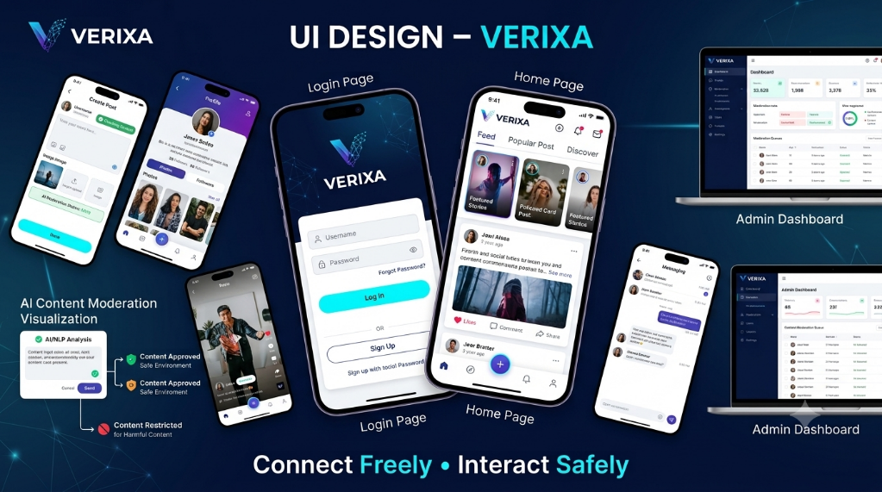

4.5 DATABASE DESIGN
The Database Design of VERIXA – Mini Social Media Application with AI-Based Content Moderation defines how application data is stored, organized, related, and managed. Since VERIXA handles user accounts, posts, comments, likes, and AI moderation information, a structured database is required to maintain data consistency, integrity, security, and efficient data retrieval.
MySQL is used as the primary Database Management System. The database follows a relational approach in which information is organized into related tables using primary keys and foreign keys. This structure helps reduce data redundancy and maintains relationships between different components of the application.
Main Database Entities
1. USER
The USER entity stores information related to user registration, authentication, profiles, and account status.
Key Attributes: User ID, Username, Email, Password, Profile Details, Account Status.
2. POST
The POST entity stores content created and published by users on VERIXA, including textual and multimedia information.
Key Attributes: Post ID, User ID, Content, Media, Date/Time, Status.
3. COMMENT
The COMMENT entity maintains comments submitted by users on posts.
Key Attributes: Comment ID, Post ID, User ID, Comment Content, Date/Time, Status.
4. LIKE
The LIKE entity records user interactions with posts and helps maintain the like information associated with each post.
Key Attributes: Like ID, Post ID, User ID, Date/Time.
5. AI MODERATION
The AI MODERATION entity stores information generated during the AI-based analysis of posts and comments.
Key Attributes: Moderation ID, Content ID, Content Type, Analysis Result, Category, Status, Date/Time.
6. ADMIN
The ADMIN entity stores information about authorized administrators who are responsible for monitoring and managing the VERIXA platform.
Key Attributes: Admin ID, Admin Name, Login Credentials, Role, Account Status.
Entity Relationships
The major relationships between the database entities are:
- USER → POST: A user can create multiple posts.
- USER → COMMENT: A user can write multiple comments.
- USER → LIKE → POST: Users can like posts and each post can receive likes from multiple users.
- POST / COMMENT → AI MODERATION: User-generated content can be analyzed by the AI moderation system.
- ADMIN → Platform Management: Administrators can monitor users, posts, comments, and moderation activities.
These relationships allow VERIXA to maintain proper connections between users and their activities. Primary keys uniquely identify records, while foreign keys establish relationships between related tables.
Database Design Approach
The database uses a relational design approach, where each type of information is maintained in an appropriate table. This avoids unnecessary duplication of data and improves consistency. Proper relationships between tables also support efficient data retrieval and maintain referential integrity.
The design allows different modules of VERIXA to access the required information without storing the same data repeatedly. This makes the database easier to maintain and provides a structured foundation for future enhancements.

Database Operations
VERIXA performs standard CRUD operations for managing application data:
- Create: Adds new users, posts, comments, likes, and moderation records.
- Read: Retrieves user profiles, posts, comments, and other required information.
- Update: Modifies permitted user, post, and account information.
- Delete: Removes permitted content or records according to system rules.
These operations ensure that application data remains updated and available whenever required.
Role of Database in VERIXA
The database acts as a central storage component connecting the major modules of VERIXA. User activities performed through the application are processed by the back end and stored in the appropriate tables. Similarly, AI moderation results can be stored for maintaining moderation records and supporting administrative monitoring.
A properly structured database enables VERIXA to manage users, social interactions, content, and moderation information efficiently. Thus, the database design provides a reliable foundation for the application and supports its objective of delivering an interactive, organized, and safer social media environment.

5.1 DATABASE INTEGRATION
Database Integration in VERIXA – Mini Social Media Application with AI-Based Content Moderation refers to the connection between the application, back-end services, and the MySQL database. It enables the system to securely store, retrieve, update, and manage the information generated through different application activities.
The integration is implemented through the back-end layer, which acts as an intermediate layer between the user interface and the database. When a user performs an operation such as creating a post, adding a comment, or updating profile information, the request is processed by the back end and the required database operation is performed.
Database Integration Process
The overall integration process can be represented as:
User Interface → Back-End Application → Database Connector → MySQL Database → Response → User Interface
1. Database Connection
The back-end application establishes a connection with the MySQL database using an appropriate database connector. The connection provides access to the required tables and database operations.
2. Data Insertion
When users register, create posts, add comments, or perform other supported activities, the application sends the required information to the back end. The back end validates the information and stores it in the appropriate MySQL table.
3. Data Retrieval
When users access their profiles, view posts, comments, or other information, the back end retrieves the required records from MySQL and sends the results to the user interface.
4. Data Modification
Authorized operations such as updating profile information or modifying permitted content are processed by the back end and reflected in the corresponding database records.
5. Data Deletion
When permitted content or records need to be removed, the back end performs the appropriate
database operation while following the application's access and management rules.
6. AI Moderation Integration
Database integration also supports the AI-based content moderation workflow. When a user submits a post or comment, the content can be processed by the AI/NLP component. The moderation result can then be stored in the database along with the relevant content and moderation status.
7. Security and Data Integrity
Database access is controlled through the back-end application rather than allowing direct access from the user interface. Appropriate authentication, authorization, validation, and database constraints help protect application data and maintain its integrity.
Conclusion
Database integration provides effective communication between the VERIXA user interface, back-end application, AI moderation component, and MySQL database. It ensures that application data is stored and retrieved efficiently while maintaining consistency and supporting the major functionalities of the system.

5.2 SECURITY IMPLEMENTATION
The Security Implementation of VERIXA – Mini Social Media Application with AI-Based Content Moderation focuses on protecting user accounts, application data, user-generated content, and administrative functions from unauthorized access and misuse. Since the application manages user information and social interactions, security measures are incorporated across the user interface, back-end, database, and content moderation components to maintain confidentiality, integrity, and controlled access.
1. User Authentication
VERIXA implements user authentication to verify the identity of users before allowing access to protected features. Users must provide valid credentials during login, ensuring that only registered users can access their accounts.
2. Password Security
User passwords are protected using secure password hashing techniques instead of storing them as plain text. This provides an additional layer of protection for account credentials and reduces the risk of direct password exposure.
3. Authorization and Role-Based Access
The system controls access according to user roles. Normal users can access social media features, while administrative functions are limited to authorized administrators. This prevents users from accessing restricted management operations.
4. Input Validation
All user-provided inputs are validated before processing and storage. Validation helps ensure that the application accepts appropriate data and reduces the possibility of malicious or invalid input affecting system operations.
5. Database Security
The MySQL database is accessed through the back-end application rather than directly through the user interface. Database credentials and other sensitive configuration information should be securely
managed and should not be exposed to users.
6. Content Security
User-generated posts and comments are processed through the application's content management and AI moderation mechanisms. Potentially harmful or inappropriate textual content can be identified and restricted according to the defined moderation rules.
7. Admin Security
Administrative operations are protected using authentication and authorization mechanisms. Only authorized administrators can access information related to users, posts, comments, and moderation activities.
8. Session Management
The application manages authenticated user sessions to maintain secure access to protected features. Proper session handling helps prevent unauthorized access through invalid or expired sessions.
9. Data Integrity
Primary keys, foreign keys, database constraints, and controlled database operations are used to maintain the accuracy and consistency of stored information. This ensures that relationships between users, posts, comments, likes, and moderation records remain valid.
10. Secure Error Handling
The system should provide appropriate error messages without exposing sensitive information such as database details, credentials, or internal application logic. This helps prevent unnecessary disclosure of technical information.
11. Privacy Protection
User information should be accessed only when required by the application and according to the user's role and permissions. The system should avoid unnecessary exposure of personal account information to other users.

12. Secure Data Communication
Communication between the client and server should use secure mechanisms where applicable. This helps protect information transmitted between the user's browser and the VERIXA application from unauthorized interception.
Conclusion
The security implementation of VERIXA combines authentication, password protection, authorization, input validation, database security, session management, privacy protection, secure communication, and AI-assisted content moderation. These measures provide multiple levels of protection for the application and its users, helping VERIXA maintain a secure, reliable, and responsible social media environment.

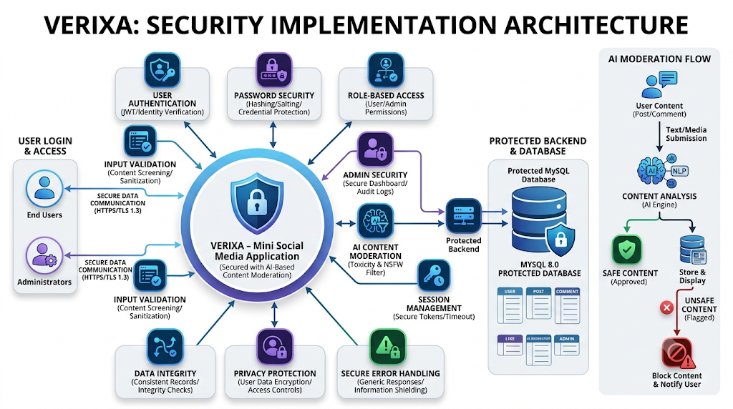

5.3 PERFORMANCE OPTIMIZATION
The Performance Optimization of VERIXA – Mini Social Media Application with AI-Based Content Moderation focuses on improving the speed, responsiveness, scalability, and overall efficiency of the application. Since the system handles users, posts, comments, likes, messages, and AI-based content moderation, optimization techniques are used across the front-end, back-end, database, and AI processing components to provide a smooth and reliable user experience.
1. Database Optimization
The MySQL database is optimized by using proper table structures, primary keys, foreign keys, and suitable indexes. Efficient database queries are used to reduce unnecessary processing and improve the speed of retrieving user, post, comment, and moderation data.
2. Query Optimization
Database queries are designed to retrieve only the required information instead of loading unnecessary records. Proper filtering, indexing, and optimized queries help reduce database processing time and improve application response time.
3. Efficient Data Retrieval
VERIXA uses efficient data retrieval techniques when displaying posts, comments, likes, and user information. Large amounts of data are loaded in smaller portions to reduce processing and improve the responsiveness of the application.
4. Pagination
Pagination can be implemented for feeds, posts, comments, and other large datasets. Instead of loading all records at once, the system retrieves a limited number of records at a time. This reduces memory usage and improves page loading speed.
5. Backend Optimization
The Flask/Django backend is optimized by reducing unnecessary processing and executing operations efficiently. Lightweight API requests and proper handling of server-side operations help improve the overall response time of the application.
6. AI Processing Optimization
The AI-based content moderation module is optimized to analyze user-generated content efficiently. Text preprocessing techniques such as cleaning and normalization reduce unnecessary data before sending it for analysis, helping the moderation process operate faster.
7. Front-End Optimization
The user interface is designed to load required resources efficiently. Optimized HTML, CSS, JavaScript, images, and other resources help reduce loading time and provide a smoother experience when users browse posts, comments, and other application features.
8. Caching
Frequently accessed information can be temporarily stored using caching techniques. Caching reduces repeated database operations and allows commonly requested data to be retrieved faster, improving overall system performance.
9. Memory Management
The application avoids unnecessary storage of temporary data and releases resources when they are no longer required. Efficient memory management helps maintain stable application performance during continuous usage.
10. Server Performance
The server is configured to handle multiple user requests efficiently. Proper resource management and optimized backend operations help maintain good response times when several users access the application simultaneously.
11. Image and Media Optimization
Images and other media uploaded by users can be optimized before storage or display. Appropriate file sizes and formats help reduce storage requirements, network usage, and loading time while maintaining acceptable quality.

12. Performance Monitoring
The performance of the application can be monitored by checking response time, database execution time, memory usage, and server resource utilization. Monitoring helps identify performance bottlenecks and provides opportunities for further optimization.
Conclusion
The Performance Optimization of VERIXA combines database optimization, query optimization, pagination, efficient data retrieval, backend optimization, AI processing optimization, caching, memory management, front-end optimization, and performance monitoring. These techniques help reduce response time, minimize resource usage, and improve the scalability and reliability of the application, providing users with a fast, efficient, and smooth social media experience.
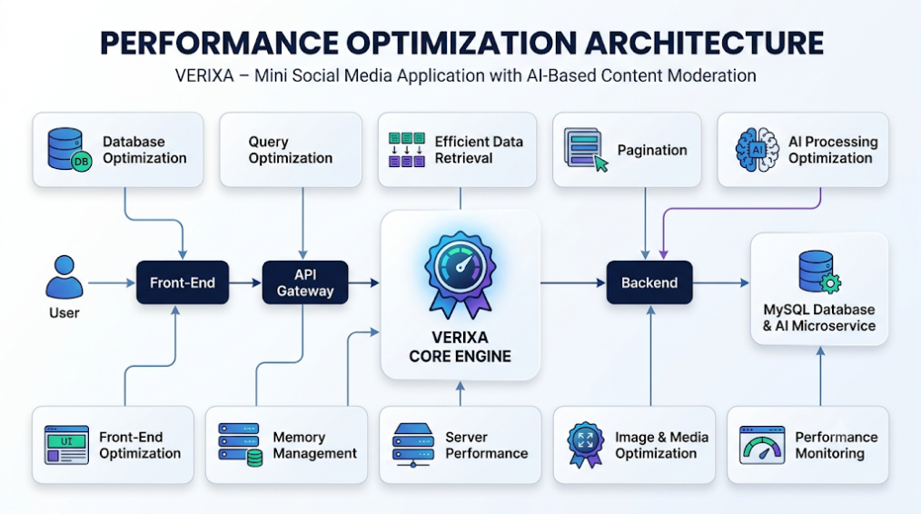

6.1 FRONT-END IMPLEMENTATION

7.1 LOGIN & HOME TESTING
- TESTING OBJECTIVE
Login and Home Testing is performed to verify whether the authentication process and home page of the VERIXA application function correctly. The testing ensures that valid users can securely log in, invalid credentials are properly handled, and the authenticated user is successfully redirected to the home page. It also verifies that the home page displays the required content and interaction features correctly.

- TEST PROCEDURE
The Login and Home modules are tested by providing different inputs and observing the system response. Valid and invalid login credentials are used to verify authentication and validation. After successful authentication, the home page is checked for proper loading, user information, posts, navigation options, and interaction features.
The following procedure is followed:
- Open the VERIXA Login page.
- Enter valid username/email and password.
- Submit the login form.
- Verify successful authentication and redirection to the Home page.
- Enter invalid login credentials and verify the displayed error or validation message.
- Leave required login fields empty and verify input validation.
- Check whether the Home page loads correctly after successful login.
- Verify that posts and user-related information are displayed properly.
- Test available navigation and interaction options on the Home page.
- Verify that the system provides the expected response for each test condition.

TEST CASES
Test Case ID | Test Scenario | Test Input / Action | Expected Result | Status
TC-01 | Valid Login | Enter valid login credentials | User should be authenticated successfully | Pass
TC-02 | Invalid Login | Enter incorrect credentials | Appropriate error message should be displayed | Pass
TC-03 | Empty Fields | Submit login without required details | Required field validation should be displayed | Pass
TC-04 | Home Page Loading | Login with valid credentials | User should be redirected to Home page | Pass
TC-05 | Post Display | Open Home page | Available posts should be displayed correctly | Pass
TC-06 | Navigation | Select available navigation options | Selected section should open correctly | Pass
TC-07 | User Information | Access Home page after login | User-related information should be displayed correctly | Pass

- ACTUAL OUTPUT
The actual output of the Login and Home Testing is verified through screenshots captured from the running VERIXA application. These outputs provide practical evidence that the tested functionalities are working as expected.
- Output 1 – Login Page:
The VERIXA login interface is displayed with the required authentication fields and login option.


- Output 2 – Invalid Login:
When incorrect credentials are entered, the system displays an appropriate validation or error message instead of allowing unauthorized access.

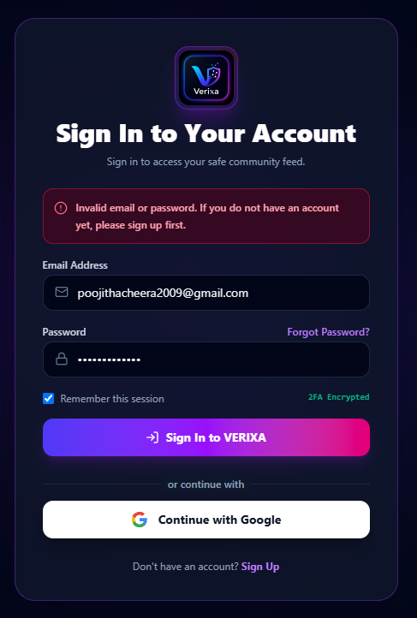

- Output 3 – Home Page:
After successful authentication, the Home page loads correctly and displays the available posts, user information, and relevant navigation or interaction options.

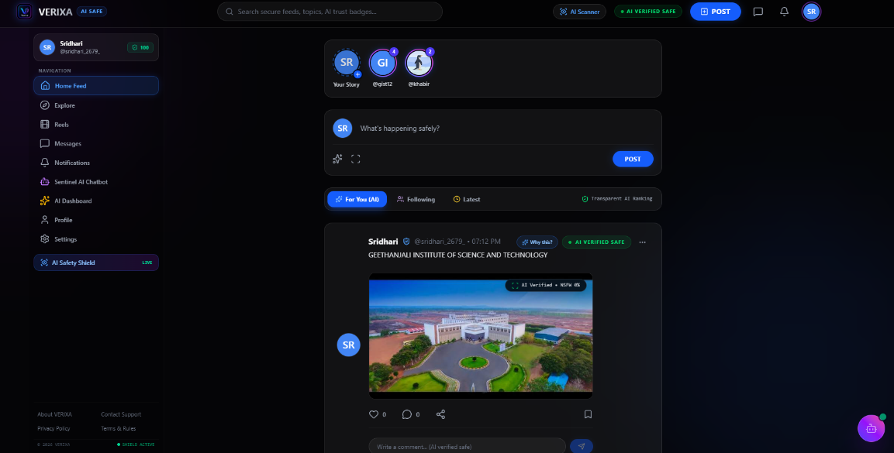

- EXPECTED VS ACTUAL RESULT
The expected results are compared with the actual behavior of the application during testing. Valid credentials result in successful authentication and access to the Home page, while invalid or incomplete credentials are handled through appropriate validation. The Home page loads correctly and provides access to the required social media functionalities.

- TEST OUTCOME
The Login and Home Testing confirms that the authentication and home page functionalities of VERIXA operate according to the specified requirements. The module successfully handles valid and invalid login conditions, performs required input validation, and provides authenticated users with access to the Home page and its available features.

7.2 POST & COMMENT TESTING
- TESTING OBJECTIVE
Post and Comment Testing is performed to verify whether the post creation, post display, and comment functionalities of the VERIXA application work correctly. The testing ensures that users can create valid posts, view published posts, and submit appropriate comments. It also verifies that invalid or empty inputs are handled correctly by the system.

TEST CASES
Test Case ID | Test Scenario | Test Input / Action | Expected Result | Status
TC-01 | Valid Post Creation | Enter valid post content and submit | Post should be created successfully | Pass
TC-02 | Empty Post | Submit post without required content | Appropriate validation message should be displayed | Pass
TC-03 | Post Display | Open the Home page after creating a post | Created post should be displayed correctly | Pass
TC-04 | Valid Comment | Enter a valid comment and submit | Comment should be submitted successfully | Pass
TC-05 | Empty Comment | Submit comment without entering content | Appropriate validation message should be displayed | Pass
TC-06 | Comment Display | Submit a valid comment on a post | Comment should appear under the respective post | Pass
TC-07 | Multiple Comments | Add multiple valid comments to a post | Comments should be displayed correctly without affecting existing comments | Pass

- ACTUAL OUTPUT
The actual outputs are verified using screenshots captured from the running VERIXA application.
- Output 1 – Create Post:
The user enters valid content and successfully creates a post.
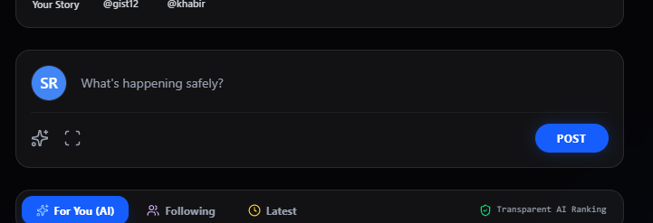
- Output 2 – Published Post:
The created post is displayed correctly on the Home page.

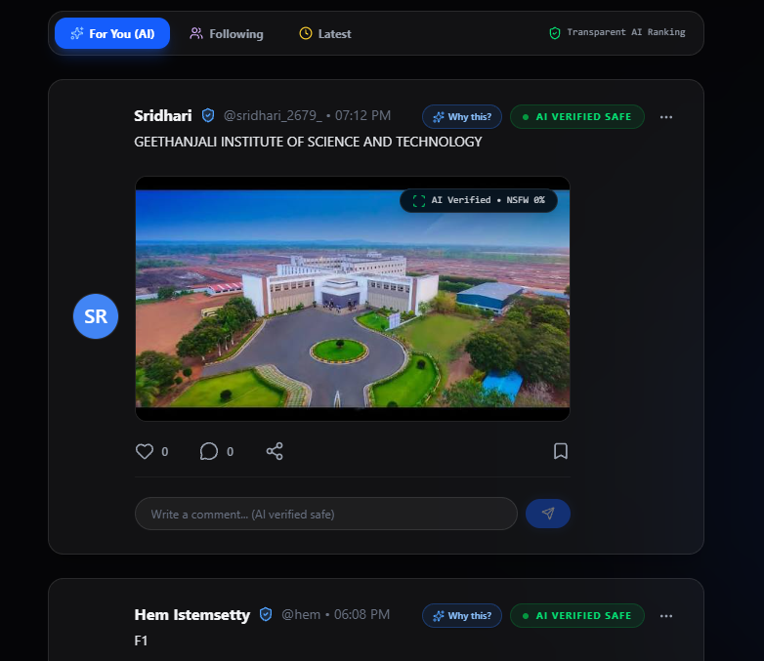

- Output 3 – Comment Submission:
The user enters a valid comment and submits it successfully.

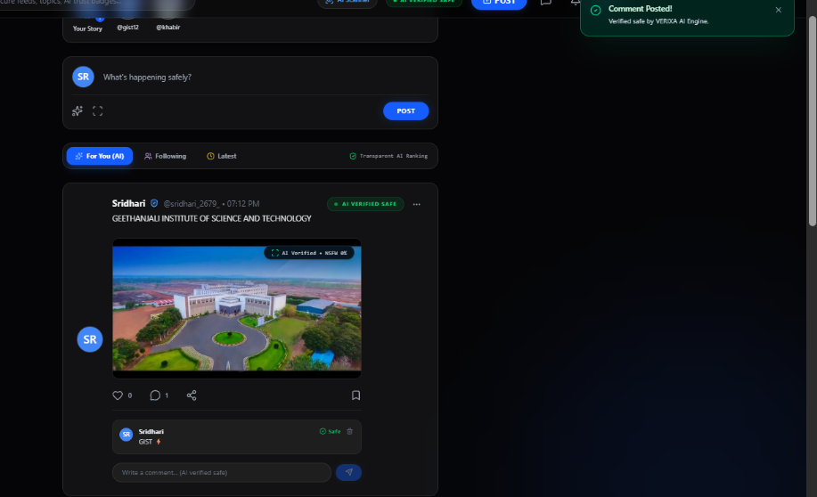

- Output 4 – Comment Display:
The submitted comment is displayed under the corresponding post.
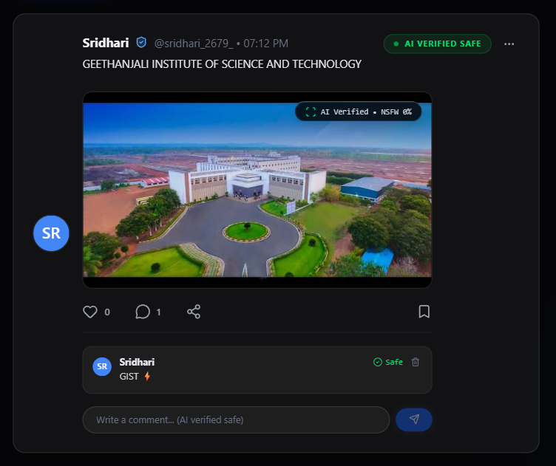
- Output 5 – Input Validation:
When an empty post or comment is submitted, the system displays an appropriate validation message.

- EXPECTED VS ACTUAL RESULT
The expected results are compared with the actual behavior of the application. Valid posts and comments are successfully processed and displayed, while empty or invalid inputs are handled through appropriate validation. The tested functionalities produced the expected results.

- TEST OUTCOME
The Post and Comment Testing confirms that VERIXA successfully supports post creation, post display, and comment interaction. The system also performs the required input validation and maintains the proper display of posts and comments.

7.3 AI COMMENT MODERATION TESTING
- TESTING OBJECTIVE
AI Comment Moderation Testing verifies whether the AI-based moderation system correctly analyzes user comments and identifies potentially inappropriate or harmful content. The testing ensures that safe comments are allowed and harmful or inappropriate comments are restricted according to the defined moderation rules.

TEST CASES
Test Case ID | Test Scenario | Test Input / Action | Expected Result | Status
TC-01 | Safe Comment | Enter a normal and appropriate comment | Comment should be allowed successfully | Pass
TC-02 | Harmful Comment | Enter a harmful or inappropriate comment | Comment should be detected and restricted | Pass
TC-03 | Offensive Comment | Enter an offensive comment | AI moderation should identify and restrict the comment | Pass
TC-04 | Empty Comment | Submit comment without entering content | Appropriate validation message should be displayed | Pass
TC-05 | Comment Classification | Submit different types of comments | AI should classify comments according to moderation rules | Pass
TC-06 | Moderation Result | Submit a comment for analysis | Correct moderation decision should be displayed/applied | Pass
TC-07 | Allowed Comment Display | Submit a safe comment | Safe comment should be stored and displayed under the post | Pass

- ACTUAL OUTPUT
The actual outputs of AI Comment Moderation Testing were verified using screenshots captured from the running VERIXA application.
- Output 1 – Safe Comment:
A normal and appropriate comment is entered and successfully accepted by the system.


- Output 2 – Offensive Comment:
An offensive comment is analyzed and the system applies the appropriate moderation action.

- Output 3 – Moderation Result:
The AI moderation component provides the appropriate result based on the analyzed comment.
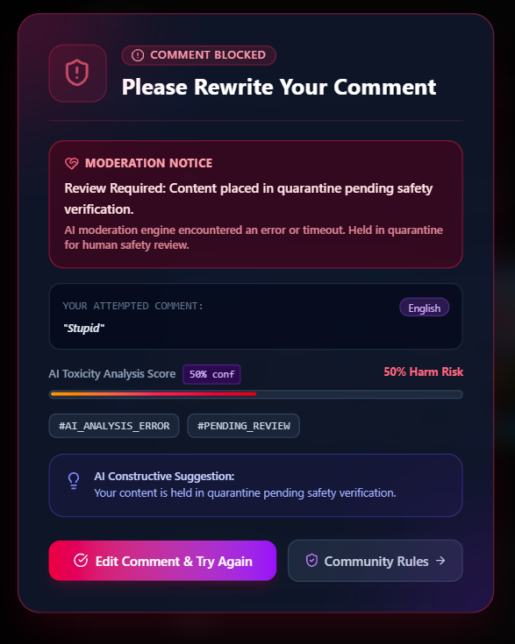
- EXPECTED VS ACTUAL RESULT
The expected results were compared with the actual outputs obtained from the VERIXA application. Safe comments were successfully processed and displayed, while harmful and inappropriate comments were identified and restricted. Empty inputs were also handled through proper validation. The tested AI moderation functionalities produced the expected results.

- TEST OUTCOME
The testing confirms that the AI-based comment moderation system in VERIXA effectively analyzes user comments and applies appropriate moderation actions. The system successfully supports safe comment handling, harmful content restriction, classification, and input validation.
7.4 IMAGE MODERATION TESTING
- TESTING OBJECTIVE
Image Moderation Testing verifies whether the system can analyze uploaded images and identify potentially inappropriate or restricted visual content. The testing ensures that acceptable images are processed successfully, while inappropriate images are detected and restricted according to the defined moderation rules.

TEST CASES
Test Case ID | Test Scenario | Test Input / Action | Expected Result | Status
TC-01 | Valid Image Upload | Upload a valid and appropriate image | Image should be uploaded successfully | Pass
TC-02 | Inappropriate Image | Upload an inappropriate image | Image should be detected and restricted | Pass
TC-03 | Image Analysis | Submit an image for moderation | Image should be analyzed by the moderation system | Pass
TC-04 | Invalid Image | Upload an unsupported or invalid image | Appropriate validation message should be displayed | Pass
TC-05 | Image Display | Upload a valid image and create a post | Image should be displayed correctly with the post | Pass
TC-06 | Moderation Result | Submit an image for analysis | Appropriate moderation result should be applied | Pass
TC-07 | Restricted Image | Upload a restricted image | Image should not be displayed publicly | Pass

- ACTUAL OUTPUT
The actual outputs of Image Moderation Testing were verified using screenshots captured from the running VERIXA application.

- Output 1 – Valid Image Upload:
A valid and appropriate image is uploaded successfully through the application.
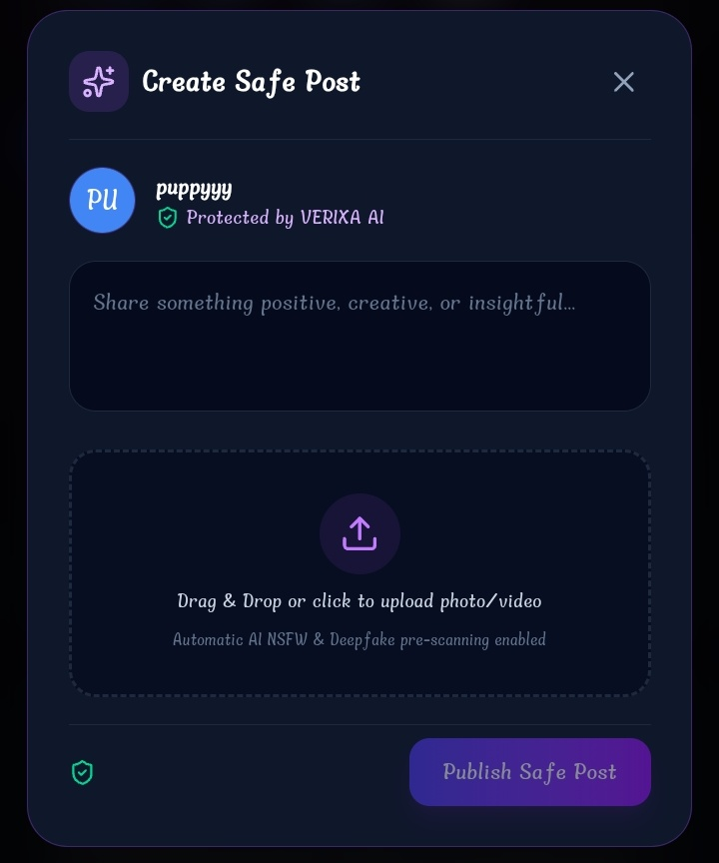
- Output 2 – Image Analysis:
The uploaded image is processed by the image moderation component for content analysis.
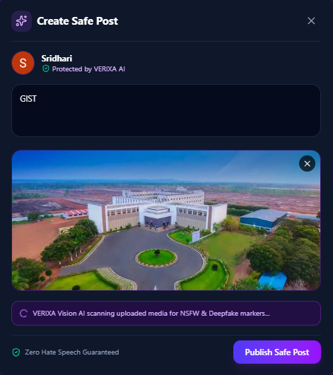
- Output 3 – Inappropriate Image:
An inappropriate image is detected and restricted from being displayed.
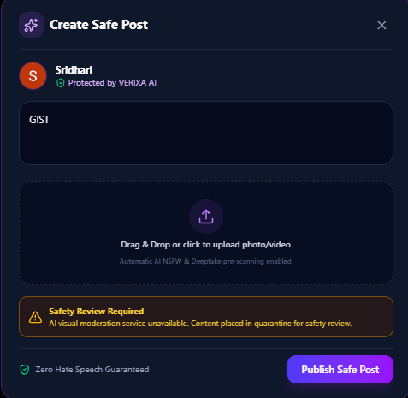
- Output 4 – Image Display:
A valid image is successfully displayed along with the corresponding post.

- EXPECTED VS ACTUAL RESULT
The expected results were compared with the actual outputs obtained from the VERIXA application. Valid images were successfully uploaded, analyzed, and displayed, while inappropriate or restricted images were detected and prevented from being displayed publicly. Invalid image inputs were also handled through appropriate validation. The tested image moderation functionalities produced the expected results.
- TEST OUTCOME
The testing confirms that the image moderation functionality in VERIXA successfully handles image uploads and applies appropriate moderation actions. The system supports image analysis, validation, safe image display, and restriction of inappropriate visual content.

CONCLUSION
The Mini Social Media Application with AI-Based Content Moderation (VERIXA) was successfully designed and developed as a practical social media platform that combines user interaction with intelligent content safety. The system provides essential features such as user registration and login, profile management, post creation, likes, comments, reels, messaging, notifications, and administrative management. Along with these social media functionalities, the integration of Artificial Intelligence, Machine Learning, and Natural Language Processing
enables the system to analyze user-generated content and identify potentially harmful, offensive, or inappropriate comments. Image moderation further enhances the safety of shared visual content by supporting the identification and restriction of inappropriate images.
The project demonstrates the effective integration of HTML, CSS, JavaScript, Python, Flask/Django, MySQL, TensorFlow, Scikit-learn, and NLTK to develop a complete web-based application. The database manages user and application data efficiently, while security mechanisms such as authentication, password protection, authorization, input validation, and secure data handling help maintain the reliability of the system. Different testing activities, including login and home testing, post and comment testing, AI comment moderation testing, and image moderation testing, were performed to verify the major functionalities of the application. Overall, VERIXA provides a user-friendly, functional, and intelligent social media environment that promotes safer digital communication and demonstrates the practical application of AI-based content moderation in modern web applications.

FUTURE ENHANCEMENT
The VERIXA project provides a strong foundation for developing a more advanced and intelligent social media platform in the future. With the continuous development of Artificial Intelligence, Machine Learning, and modern web technologies, several additional features can be incorporated to improve the system’s functionality, security, scalability, and user experience.

The AI-based content moderation system can be enhanced by implementing advanced Deep Learning and Natural Language Processing models to improve the accuracy of detecting offensive, abusive, harmful, and cyberbullying-related content. A multilingual content moderation feature can be introduced to analyze user-generated content in multiple languages. The existing image moderation functionality can also be extended with advanced visual analysis and video content moderation to identify inappropriate content in images, reels, and uploaded videos.

The social networking features of VERIXA can be expanded by adding AI-based personalized content recommendations, improved search and discovery, story sharing, real-time messaging, and enhanced notification systems. The application can also include spam detection, fake-account detection, advanced reporting and blocking mechanisms, and improved privacy controls to provide a safer user experience.

In addition, VERIXA can be developed as a dedicated Android and iOS mobile application to provide convenient access across different devices. Cloud deployment can be implemented to improve scalability, availability, and performance when the number of users increases. Advanced analytics and an improved administrator dashboard can also help administrators monitor platform activity and moderation results more effectively.

Overall, these enhancements can help transform VERIXA into a more intelligent, secure, scalable, and feature-rich social media platform, capable of adapting to the evolving needs of users and the growing challenges of online content management.

REFERENCES
- Python Software Foundation – Python Documentation.
- Pallets Projects – Flask Web Framework Documentation.
- Oracle – MySQL Reference Manual.
- TensorFlow – TensorFlow Documentation.
- Scikit-learn – Scikit-learn User Guide and Documentation.
- NLTK Project – Natural Language Toolkit Documentation.
- MDN Web Docs – HTML, CSS, and JavaScript Documentation.
- Postman – Postman API Documentation.
- GitHub – GitHub Documentation and Git Version Control Resources.
- W3C – Web Standards and HTML/CSS Specifications.

BIBLIOGRAPHY
- Goodfellow, I., Bengio, Y., & Courville, A. (2016). Deep Learning. MIT Press.
- Bird, S., Klein, E., & Loper, E. (2009). Natural Language Processing with Python. O'Reilly Media.
- Russell, S., & Norvig, P. Artificial Intelligence: A Modern Approach. Pearson.
- Manning, C. D., Raghavan, P., & Schütze, H. (2008). Introduction to Information Retrieval. Cambridge University Press.
- Géron, A. Hands-On Machine Learning with Scikit-Learn, Keras, and TensorFlow. O'Reilly Media.
- Szeliski, R. (2022). Computer Vision: Algorithms and Applications. Springer.
- Silberschatz, A., Korth, H. F., & Sudarshan, S. Database System Concepts. McGraw-Hill.
- Pressman, R. S., & Maxim, B. R. Software Engineering: A Practitioner's Approach. McGraw-Hill Education.
- Jurafsky, D., & Martin, J. H. Speech and Language Processing. Pearson.
- Han, J., Kamber, M., & Pei, J. Data Mining: Concepts and Techniques. Morgan Kaufmann.

