VERIXA
AI-Safe Social Media Platform
Unified Modeling Language (UML) Documentation Set
Prepared for Project Report · First Review · Final Review · Viva Presentation
Project Overview
VERIXA is an AI-powered, safety-first social media platform that gives users direct, visible signals about content moderation rather than hiding it behind the scenes. The system combines a full social feature set — profiles, posts, stories, reels, comments, likes, follows, messaging, notifications, and explore/search — with an AI moderation gateway that evaluates text, image, and video content for toxicity, hate speech, and unsafe media before it reaches the public feed.
The platform is built on Supabase (PostgreSQL, Authentication, and Storage) with Google OAuth as an alternative sign-in path, and every moderation decision — ALLOW, WARNING, QUARANTINE, or BLOCK — is written to an auditable moderation log.
Contents
1. Use Case Diagram
2. Class Diagram
3. Login Sequence Diagram
4. Post Moderation Sequence Diagram
5. Comment Moderation Sequence Diagram
6. Create Post — Activity Diagram
7. User Authentication — Activity Diagram
8. Component Diagram
9. Deployment Diagram
10. Entity-Relationship (ER) Diagram

1. Use Case Diagram
Actors: User · AI Moderation Engine · Supabase Authentication · Supabase Storage · Database
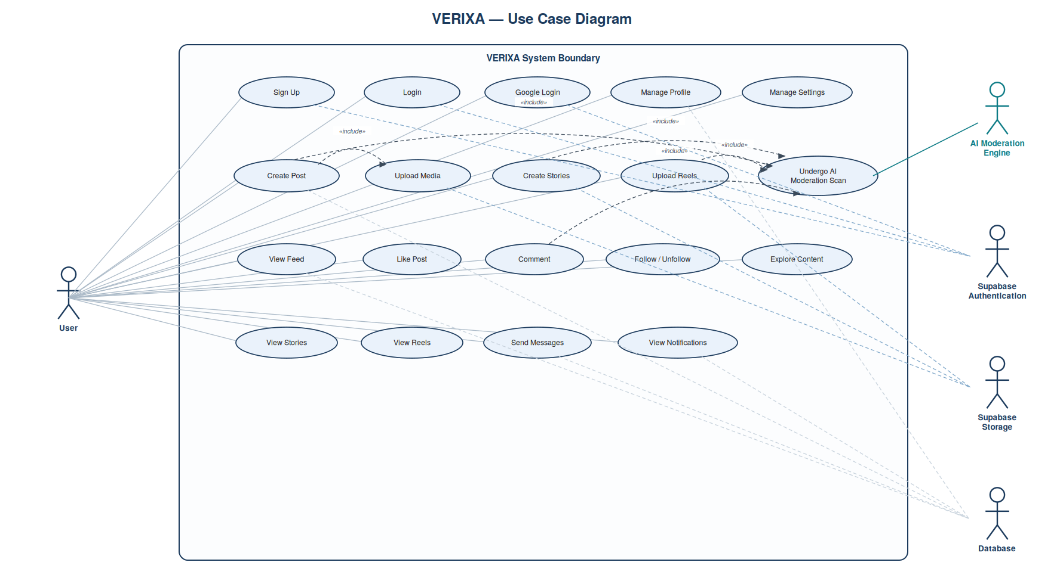

2. Class Diagram
Core domain entities, attributes, primary/foreign keys, methods, and multiplicities.
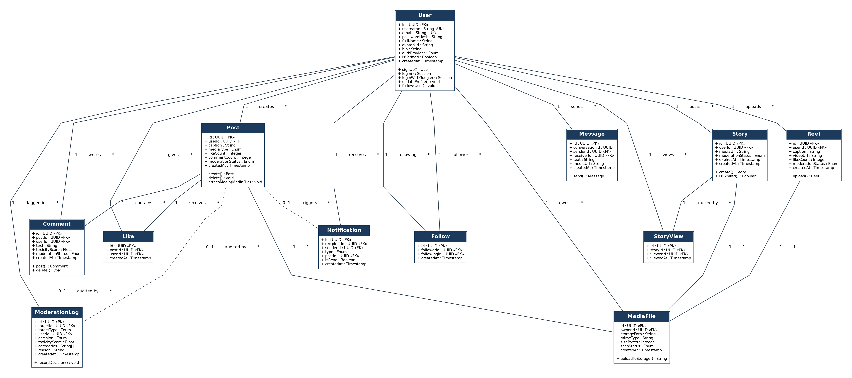

3. Login Sequence Diagram
Email/password login flow with Google OAuth shown as an alternative (alt) flow.
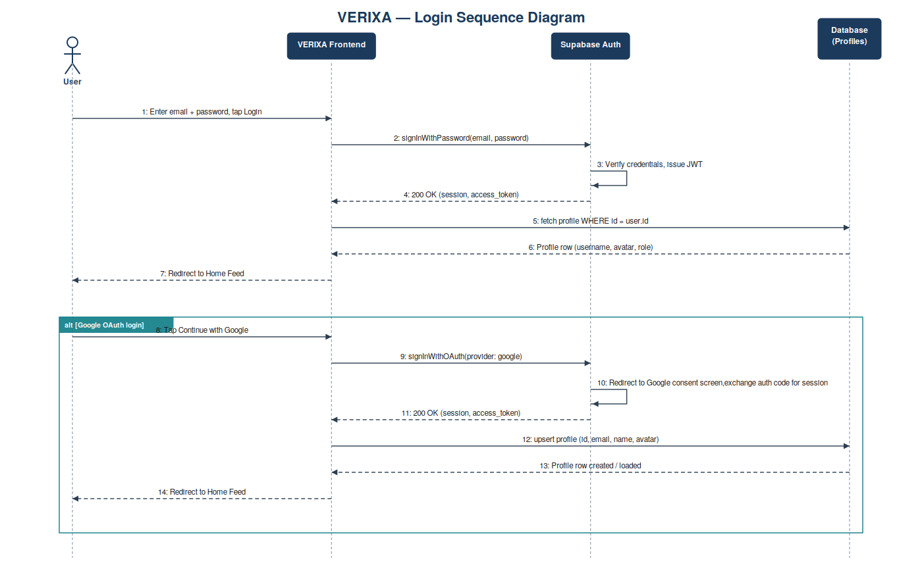

4. Post Moderation Sequence Diagram
Create Post pipeline: media upload, AI moderation gateway, and ALLOW / WARNING / QUARANTINE / BLOCK outcomes.
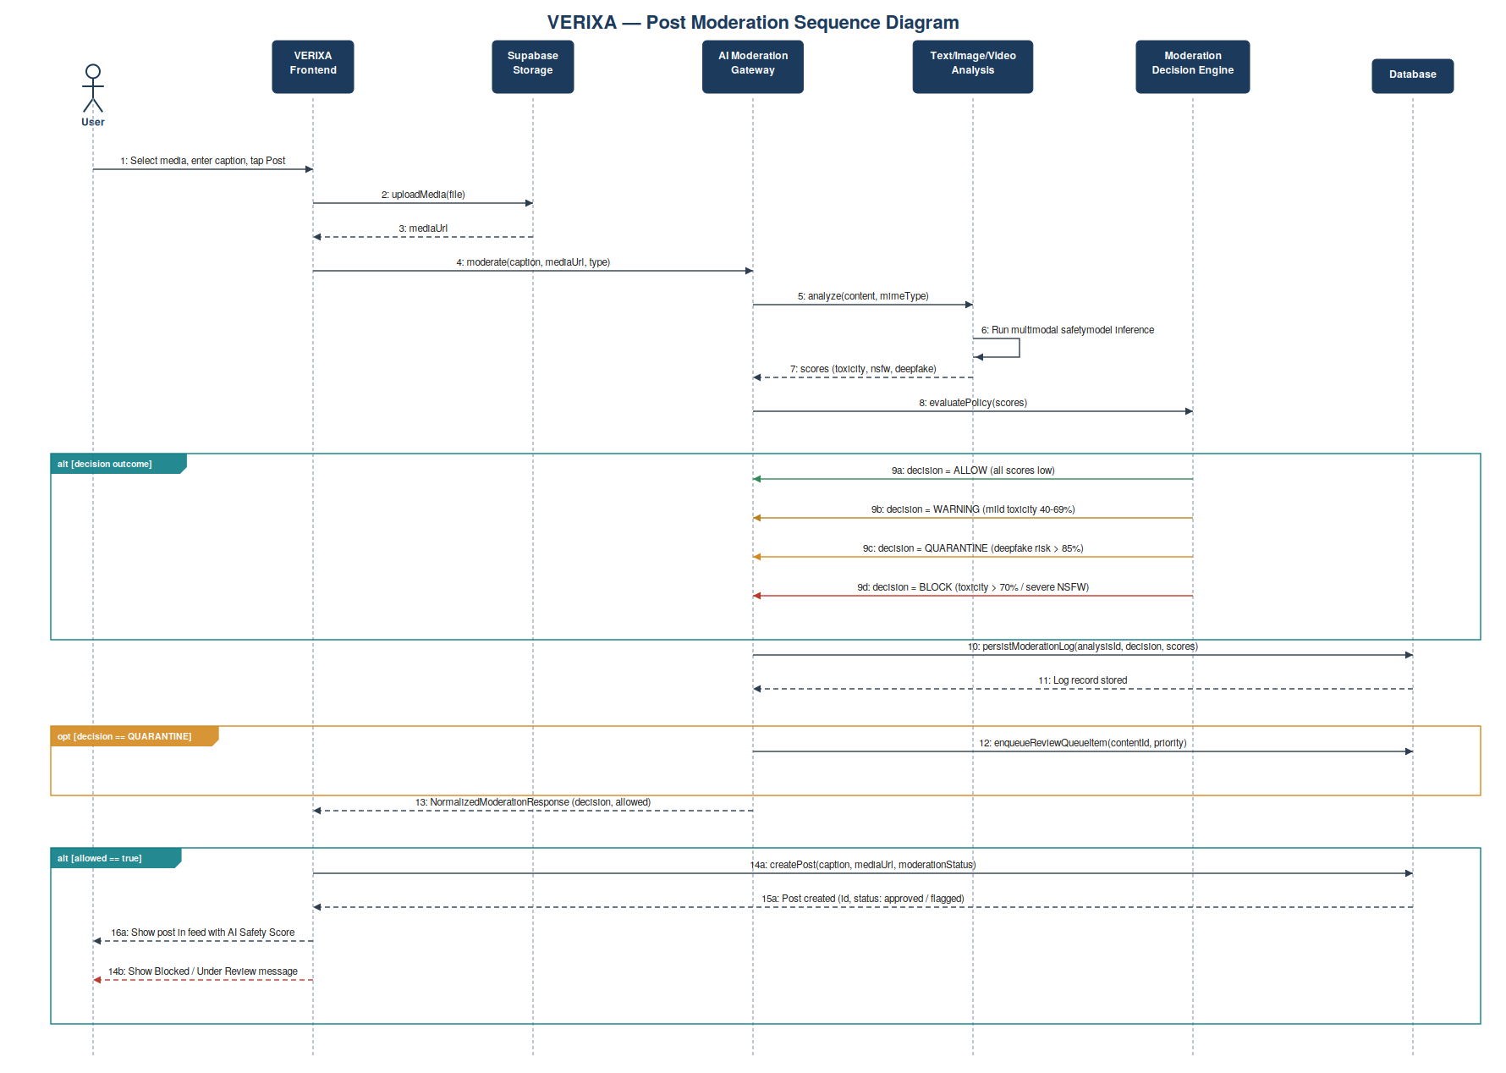

5. Comment Moderation Sequence Diagram
Comment submission through the AI Moderation Engine, with safe vs. toxic/offensive outcomes.
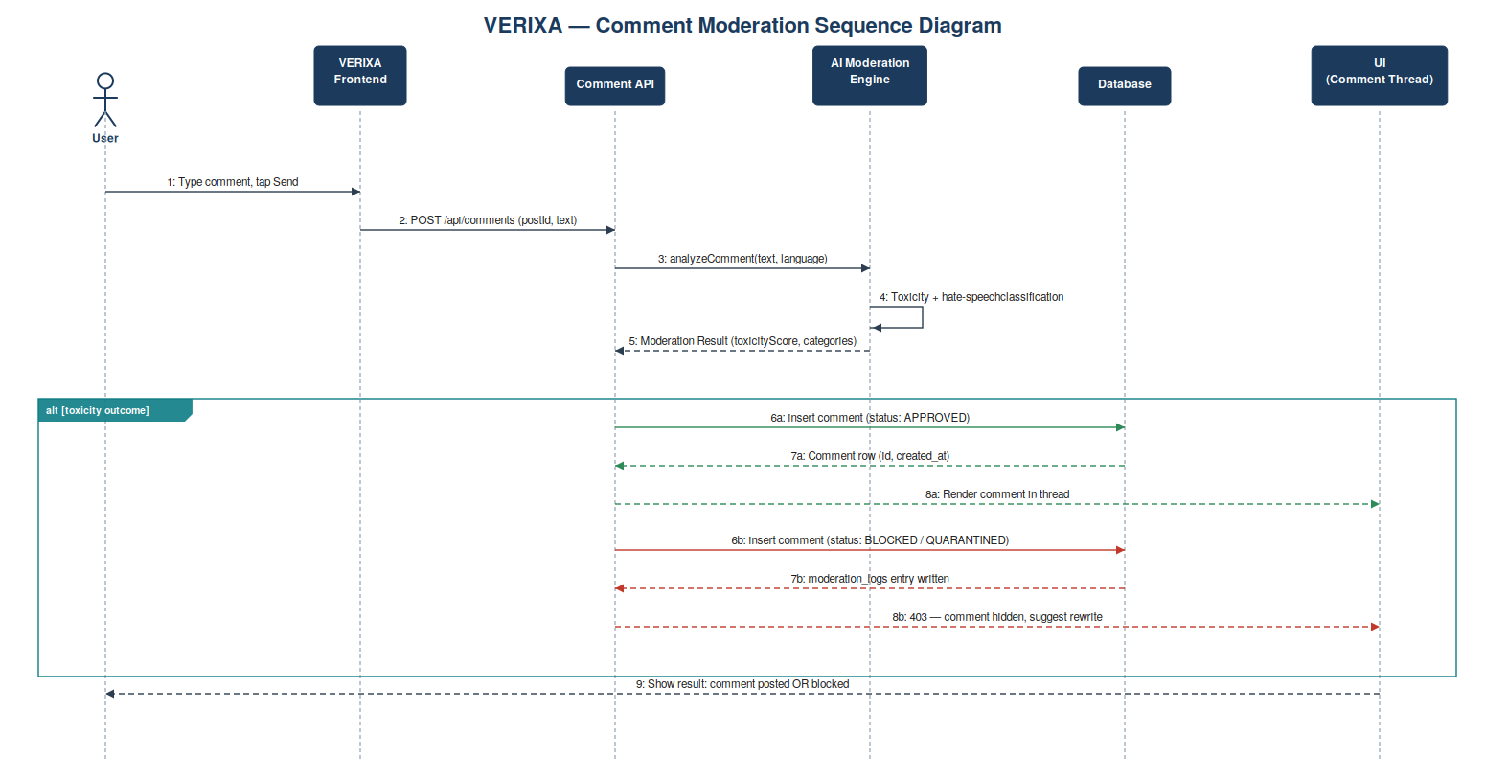

6. Create Post — Activity Diagram
End-to-end workflow from media selection through AI moderation decision to publish or reject.
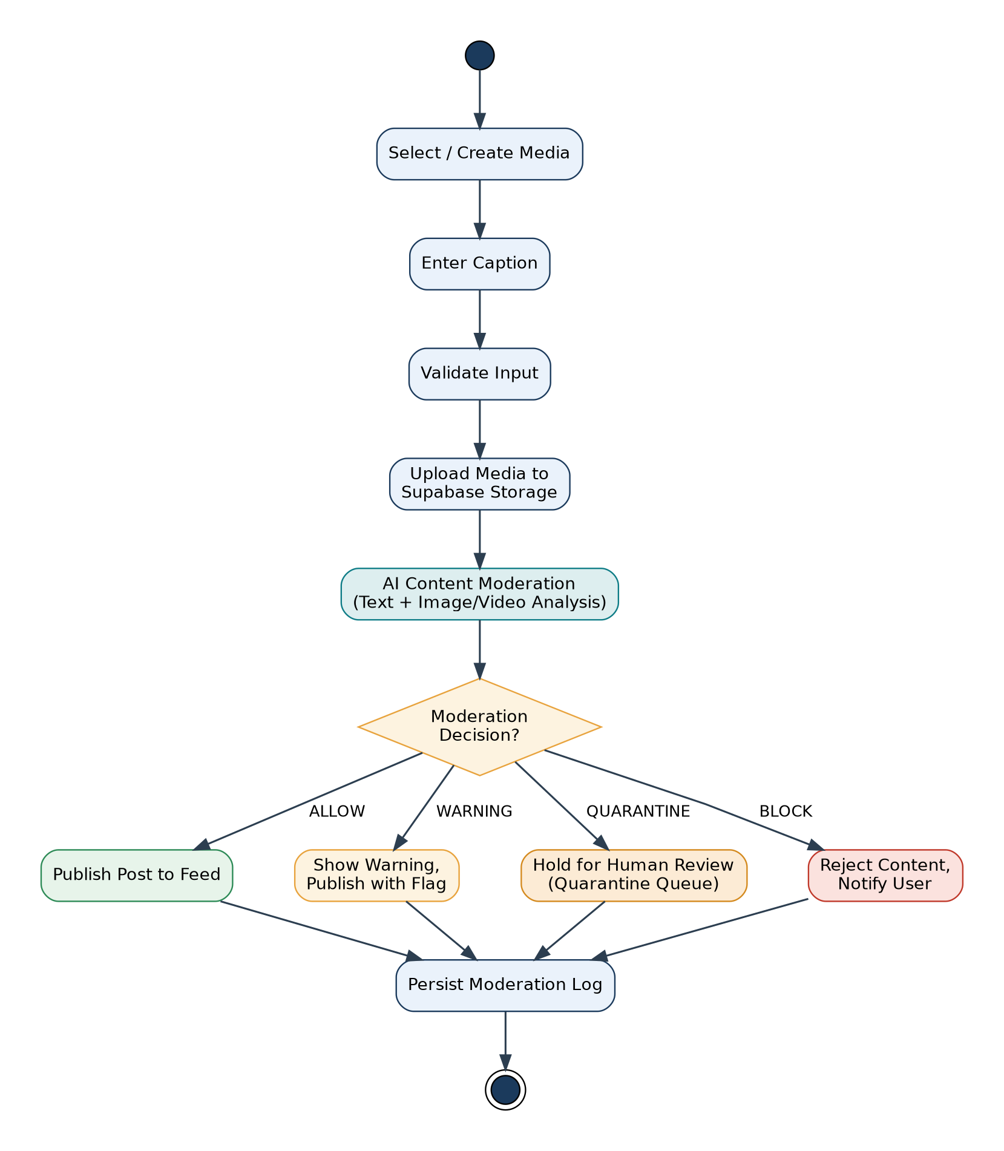

7. User Authentication — Activity Diagram
Login / sign-up flow including credential validation and the Google OAuth alternative path.
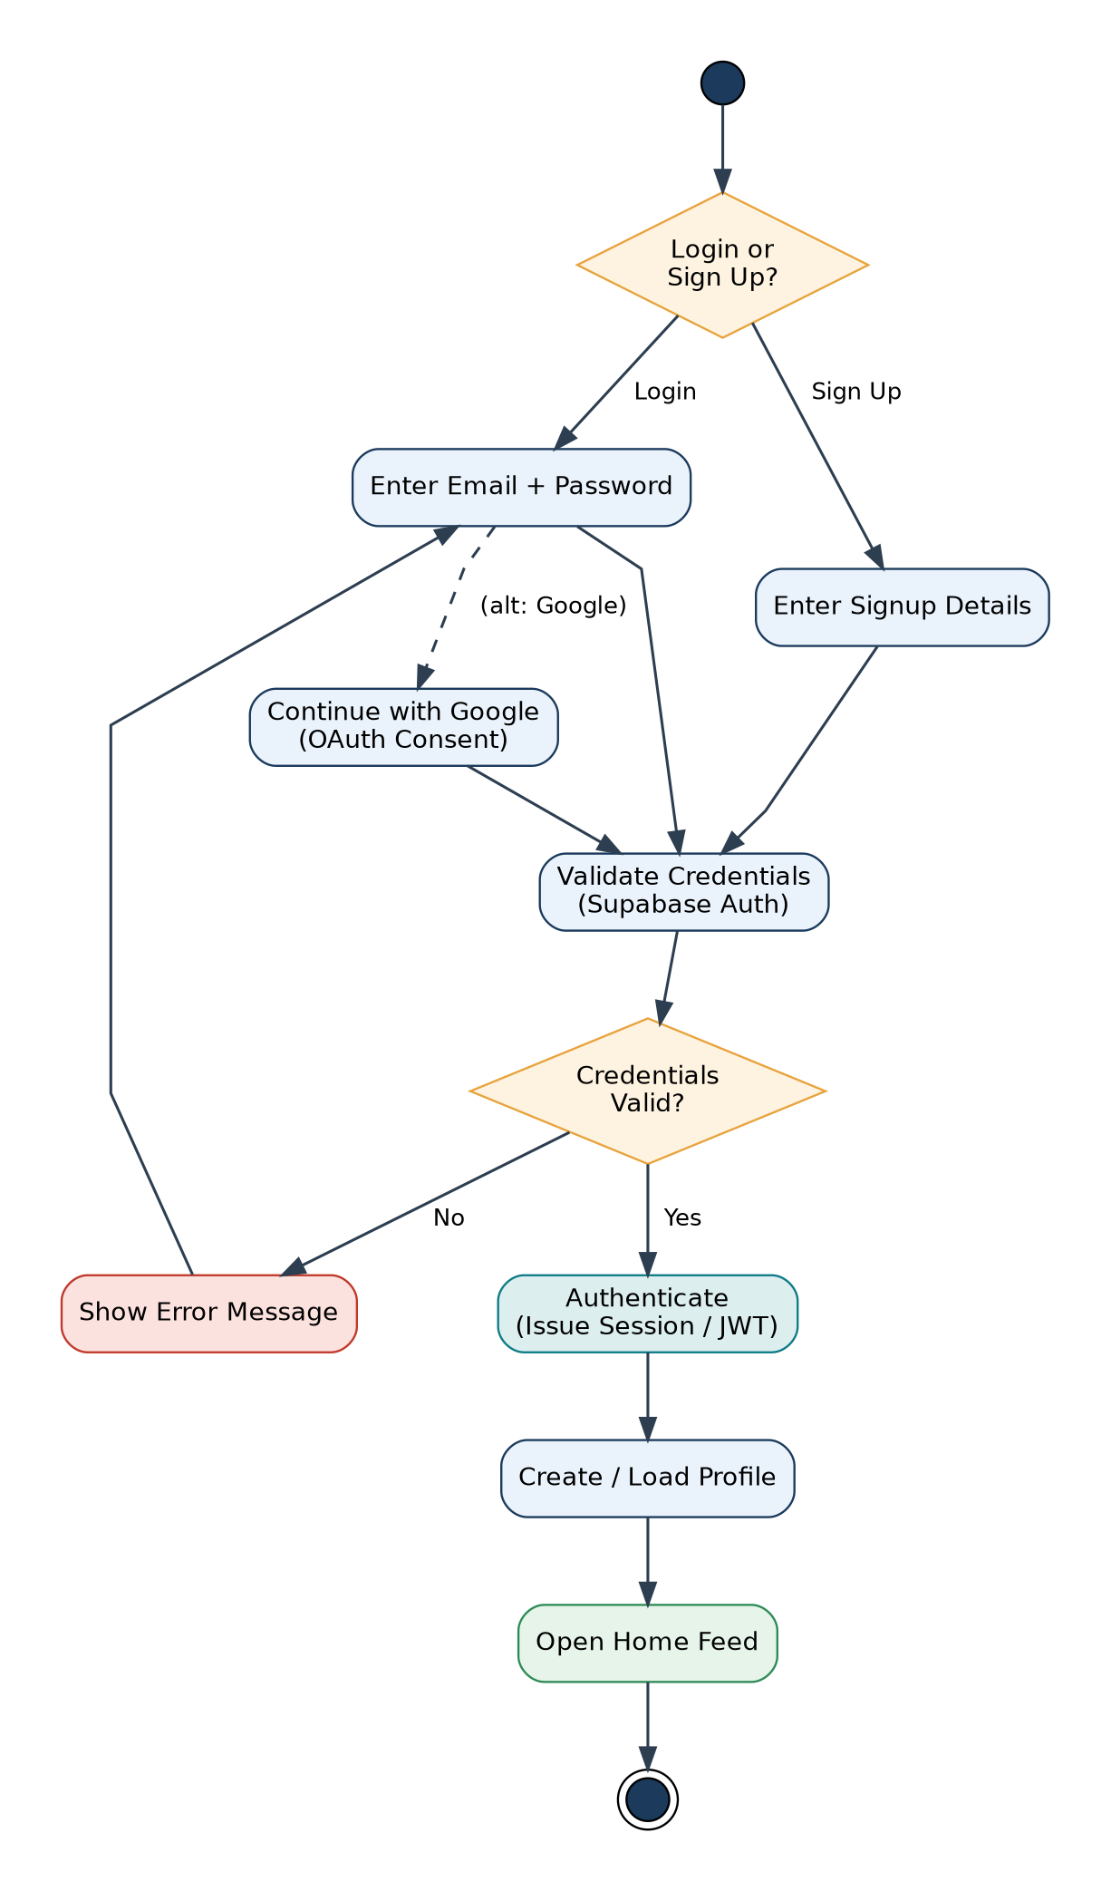

8. Component Diagram
VERIXA Web Frontend, AI Moderation Gateway, and Supabase platform components with their dependencies.
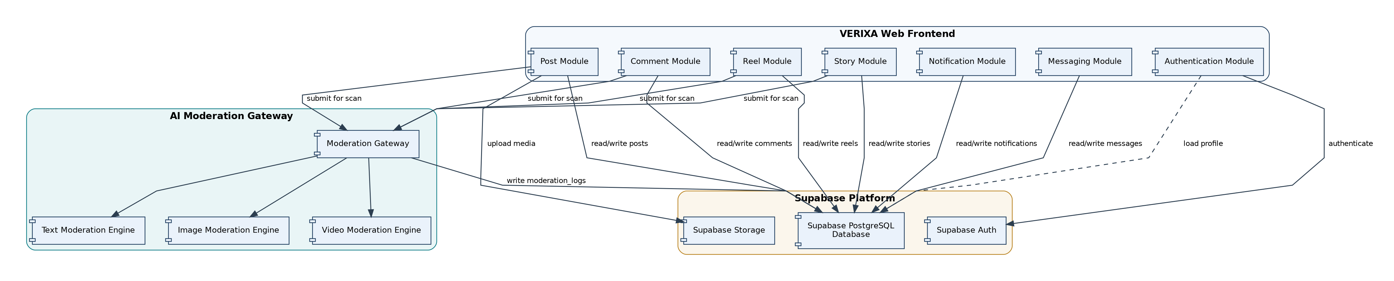

9. Deployment Diagram
Physical deployment topology: browser client, application server, AI moderation service, and Supabase cloud.
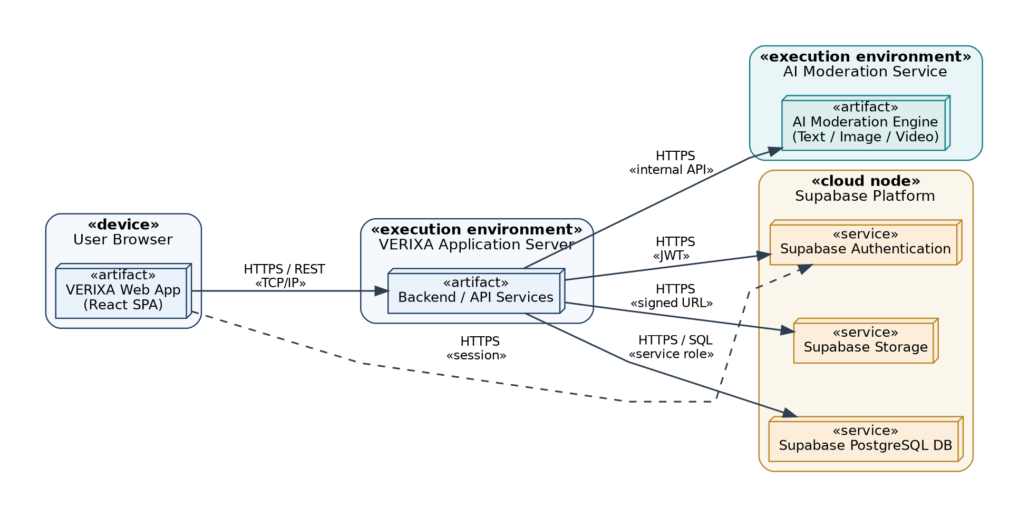

10. Entity-Relationship (ER) Diagram
Database schema for VERIXA's core tables with primary keys, foreign keys, and relationships.
