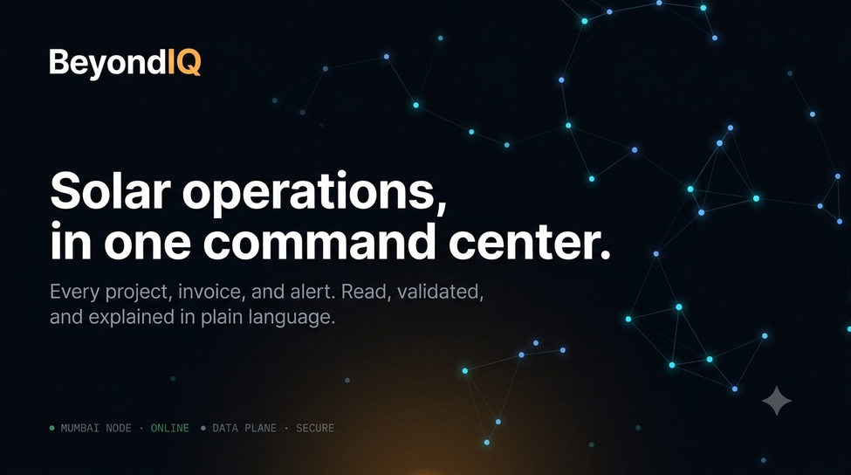

FluxorX: Complete Project Documentation
Built by Faraz Akhtar | AI Automation Engineer | Karachi, Pakistan | July 2026 | Milestone 1

“FluxorX connects your business data, turns it into executive dashboards, lets you ask questions in plain English, and creates report or alert automations through chat.”

Executive Summary
FluxorX is a premium AI command center for enterprise operations teams. The product ingests business data from spreadsheets and enterprise connectors, validates and organizes it, presents an interactive executive dashboard, answers plain-language queries through a deterministic AI agent with a cinematic 3D constellation reactor, surfaces automation suggestions, and delivers branded alert emails and WhatsApp notifications. The entire system was built and deployed to a live production environment in two working days on a fully free technology stack.
Faraz Akhtar is the sole product owner, design director, and deployment engineer behind this project. Every design decision, animation requirement, feature direction, and quality standard came from Faraz's direct input and creative instinct. All 19 of 19 acceptance criteria defined for the build are met and verified.

Project Team
Role | Name | Contribution
Engineer | Faraz Akhtar | Full product build, design, deployment, and testing

Complete Roadmap
All 12 stages of Milestone 1 are complete. Milestone 2 covers live connectors, interactive column mapping, production deployment, and the Claude API upgrade.
# | Stage | Phase | Status
1 | Login with 3D Cinematic Particle Burst Hero | Day 1 | Done
2 | Connectors Panel (8 enterprise connectors) | Day 1 | Done
3 | Data Upload — Excel/CSV + Demo Data Button | Day 2 | Done
4 | Raw Landing View — Paginated Table | Day 2 | Done
5 | Column Mapping Confirmation | Day 2 | Done
6 | Validation Engine with Health Score | Day 2 | Done
7 | Interactive Dashboard with Glowing Charts | Day 2 | Done
8 | Deterministic AI Agent + Constellation Reactor | Day 2 | Done
9 | Automation Approval Engine + RBAC | Day 2 | Done
10 | Live Email via Resend | Day 2 | Done
11 | WhatsApp Settings and Preview Screen | Day 2 | Done
12 | Audit Logging on all key actions | Day 2 | Done

# | Stage | Phase | Status
13 | Google Sheets Live Connector | Milestone 2 | Planned
14 | QuickBooks Live Connector | Milestone 2 | Planned
15 | Salesforce Live Connector | Milestone 2 | Planned
16 | Multi-source Data Merge and Conflict Resolution | Milestone 2 | Planned
17 | Interactive Column Mapping (drag-and-drop) | Milestone 2 | Planned
18 | Custom Email Domain (Resend) | Milestone 2 | Planned
19 | Claude API Hot-swap for AI Layer | Milestone 2 | Planned
20 | Role-based User Management UI | Milestone 2 | Planned
21 | Production Deployment on Vercel | Milestone 2 | Done

Acceptance Criteria — All 19 / 19 PASS
Every requirement defined for the build has been verified against the live production build. The table below is the complete pass summary.
Category | Requirement | Result
Security | No API keys or secrets in frontend | PASS
Security | Read-only connector principle, no ERP write-back | PASS
Security | All data isolated per organization via RLS | PASS
Security | Role-based access control — Admin badge and lock visible | PASS
Security | Audit logs writing on all 8 key actions | PASS
Demo | Admin login and premium dashboard UI | PASS
Demo | All connector cards visible | PASS
Demo | Upload Excel/CSV or load demo SAP B1 data | PASS
Demo | Raw preview shown | PASS
Demo | Mapping confirmation and validation report | PASS
Demo | Dashboard with realistic KPIs and charts | PASS
Demo | AI Agent answers 7+ business questions | PASS
Demo | AI Agent creates automation draft from chat | PASS
Demo | Admin can approve and delete automations | PASS
Demo | Send Test Email with real delivery confirmed | PASS
Demo | WhatsApp settings and preview screen exists | PASS
Demo | Role restrictions visible, only Admin activates | PASS
Demo Script | Steps 1–6: connectors, upload, raw, mapping, validation, dashboard | PASS
Demo Script | Steps 7–9: AI answers CEO/overdue/delayed questions | PASS
Demo Script | Step 10: creates CEO summary automation from chat | PASS
Demo Script | Step 11: approve draft and send test email | PASS
Demo Script | Step 12: WhatsApp settings and preview | PASS

Technology Stack
Every component runs on the free tier. No paid services were used during the build.

Frontend
- Next.js 16 (App Router, Turbopack): React server and client components, file-based routing, API routes, dynamic imports for performance.
- React 19 + TypeScript: Full type safety across all components, hooks, and API boundaries.
- Tailwind CSS v4: Custom premium dark design system with @theme tokens for typography and color.
- Framer Motion: Page transitions, spring animations on validation cards, and entrance sequences.

3D and Animation
- Three.js + React Three Fiber + drei: Cinematic login particle burst and the AI Agent constellation reactor. Dynamically imported to prevent Turbopack bundling issues.
- HTML Canvas: Drifting data-constellation ambient background across all inner app pages via a lightweight requestAnimationFrame loop.

Backend and Database
- Supabase (Postgres, Mumbai/ap-south-1): 38-table schema covering identity, connectors, raw landing, validation, KPI engine, AI agent history, automations (FluxorFlow), settings, and audit log.
- Row Level Security: All 38 tables protected by a current_org_id() helper and DO-block org-isolation policies.
- Supabase Auth: Email and password authentication with separate client and server Supabase clients for SSR compatibility.

Data and AI Layer
- SheetJS (xlsx): Dynamically imported inside the file handler to avoid Turbopack static analysis errors.
- Recharts: Split into a separate charts.tsx loaded via dynamic import so the bundle only loads on the Dashboard page.
- Deterministic AI Engine: Zero LLM API calls at runtime. Questions mapped to pre-built Supabase query patterns. Retrieval separated from wording for a one-file Claude API upgrade.

Notifications
- Resend: Free-tier email delivery via a Next.js API route. Dark-theme HTML emails with executive summaries and data tables.
- WhatsApp: Settings and preview screen built. Three message templates, scheduled delivery toggle, live phone preview. Real delivery connects via WhatsApp Business API in Milestone 2.

Security and Audit
- RBAC: Role column in profiles table. Admin badge visible on Automations page. Approve button locked for non-admin roles.
- Audit logging: Writes to audit_logs table on upload, mapping approval, AI question, automation approved/dismissed, email sent, WhatsApp preview, and demo data loaded.

Design System and Visual Identity
Faraz directed every visual decision. The design intent was an enterprise-grade AI command center that reads as cinematic and premium, not a generic dashboard template.

Color Palette
- Background: #06080D — near-black with a cool blue-black cast.
- Amber accent: #FFB347 to #FF7A3D gradient for all primary actions, buttons, and the FluxorX logotype.
- Cyan / electric blue: #36D1FF and #6FB7FF for the AI layer, data lines, and the login particle burst.
- Green status: #3FB984 for success states, validation passes, and sent email confirmations.
- Red critical: #FF6B6B for critical validation issues and overdue invoice alerts.

Typography
- Sora: Display font for all headings and the FluxorX logotype.
- Inter: Body font for all prose and UI labels.
- Geist Mono: Monospace for system labels, status indicators, timestamps, and AI log lines.

Faraz's Design Decisions
- Login hero: Rejected the wireframe orb. Directed a cinematic particle burst: seed rises from bottom center, explodes into a rotating cyan/white data sphere. No yellow in the 3D hero.
- Mobile adaptation: Identified mobile performance issues. Burst made adaptive (900 vs 2400 particles). Backdrop-blur removed from mobile drawer. Overlay stacking context fixed.
- Validation interaction: Specified hover-to-reveal: pointing at a row reference materializes the full record inline with a breathing ambient glow in the severity color.
- AI constellation reactor: Rejected crystalline icosahedron. Selected exploding data constellation from a live animated preview. Specified expand-on-query, contract-on-answer, three color states.
- Dashboard charts: Specified glowing line charts with SVG filter-based neon glow for a cinematic mission-control feel.
- Button gradient lock: Caught amber buttons rendering dark on dimmed mobile phones. Fixed by locking gradient as inline backgroundImage style.

Stage-by-Stage Build Log

Stage 1: Login
Premium glassmorphic sign-in screen. Three.js particle burst hero: seed rises from bottom center, explodes to a rotating cyan/white data sphere. Always-animating data-constellation ambient canvas. Mobile-adaptive particle count and DPR. Amber gradient locked via inline style.

Stage 2: Connectors
Eight enterprise connector cards: QuickBooks, Xero, Salesforce, HubSpot, Google Sheets, Tally, SAP, and Custom API. File upload connector is live. Enterprise connectors show Coming Soon badges pending Milestone 2 OAuth integration.

Stage 3: Data Upload
Drag-and-drop or tap-to-browse file picker for .xlsx, .xls, and .csv. SheetJS loaded via dynamic import inside the file handler. 8-row preview before landing. One-click demo data button loads 15 pre-built demo records instantly for the live demo. Data written to Supabase in chunks of 500 rows with a progress bar.

Stage 4: Raw Landing
Paginated table of raw_records, 25 rows per page with Prev/Next and row range counter. Batch side panel on desktop, dropdown switcher on mobile. Defaults to most recent upload. Blank cells shown as dashes.

Stage 5: Column Mapping
Analyzes uploaded column headers against the internal schema. Three-tile summary (matched, unrecognized, missing). Full mapping table with green/amber/red status per column. Approve Mapping logs to audit_logs and proceeds to Validation. An interactive drag-and-drop mapper is planned for Milestone 2.

Stage 6: Validation Engine
Scans up to 5,000 rows and produces a health score out of 100. Eight rules: missing customer name, negative contract value, payment exceeding contract value, duplicate project ID, completed project without install date, missing amount paid, missing city, city misspelling via Levenshtein distance, and inconsistent city casing. Full record reveals inline on hover with breathing ambient glow. Results saved to validation_reports and validation_issues tables.

Stage 7: Interactive Dashboard
Six KPI tiles: Total Contract Value, Amount Collected, Collection Rate, Active Projects, Total Capacity, and Data Health score. Glowing area chart with amber and cyan neon lines (SVG filter glow) and colored bar chart by stage. Salesperson leaderboard with animated gradient progress bars. All transforms memoized. Recharts loaded via dynamic import.

Stage 8: Deterministic AI Agent
Sci-fi chat interface with Three.js constellation reactor: 28 nodes expanding outward on query, contracting on answer, cycling through three color states. Live system log stacks terminal-style. Eight query intent categories. Schedule creation: typing 'Create schedule:' creates an automation draft on the Automations page. FAQ panel with six categories and 22 example questions.

Stage 9: Automation Approval + RBAC
Auto-generates suggestions from business events and validation events. RBAC badge shows Admin or Viewer role. Approve button locked for non-admin. Approve triggers Queued, Sending, Sent status sequence. Schedule drafts from AI agent appear as deletable Scheduled cards. Audit log written on every approval and dismissal.

Stage 10: Live Email
Next.js API route sends branded dark-theme HTML emails via Resend. Executive summary plus data table of affected rows. Preview option before sending. Audit log written on send.

Stage 11: WhatsApp
Settings screen with phone number input, three message templates, scheduled delivery toggle with time picker, and a live phone-shaped preview that updates in real time. Full-screen preview modal. Save settings writes to audit_logs. Demo mode badge shown since WhatsApp Business API is not connected in Milestone 1.

Stage 12: Audit Logging
Silent best-effort writes to audit_logs on: data upload, column mapping approval, AI question asked, automation approved, automation dismissed, email sent, WhatsApp preview, and demo data loaded. Never blocks the main action.

Live Delivery: Confirmed Email Output
The screenshot below shows an executive alert email delivered during live testing, confirming end-to-end delivery of the complete dark-theme template.
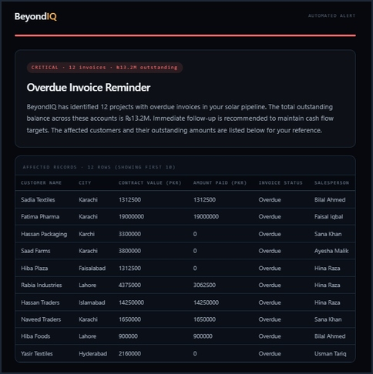
Figure 1: Overdue Invoice Reminder delivered to inbox — 12 affected records, ₹13.2M outstanding. Note: this screenshot predates the FluxorX rebrand — replace with a fresh FluxorX-branded capture before external sharing.

Milestone 2: Connector Roadmap
The Connectors screen presents eight enterprise connectors as premium UI. All are marked Coming Soon in Milestone 1.

Google Sheets (Priority 1)
OAuth 2.0 via Google Cloud Console. User selects a spreadsheet and sheet tab. Data pulled via Sheets API v4 into the same raw_records pipeline. Lowest friction connector since most businesses already use Sheets. Planned as the first Milestone 2 delivery.

QuickBooks (Priority 2)
OAuth 2.0 via Intuit's developer platform. Pulls invoices, customers, and payments. Invoice Status, Contract Value, and Amount Paid columns already exist in the raw schema and the validation engine already interprets them. Transforms FluxorX from a spreadsheet reader to a live financial intelligence layer.

Xero
Similar OAuth flow to QuickBooks via Xero's developer API. Pulls invoices, contacts, and accounts receivable.

Salesforce
OAuth 2.0 via Salesforce Connected App. Pulls Opportunity and Account objects. Stage, Amount, Close Date, and Account Name map directly to the existing raw schema columns.

HubSpot
OAuth via HubSpot's developer platform. Pulls Deals and Contacts. Deal Stage maps to Stage, Deal Amount maps to Contract Value.

Tally and SAP
Export-based connectors. Tally exports to XML or CSV ingested via the existing file upload pipeline. SAP uses the Business Technology Platform API where available, or scheduled export files.

Custom API Connector
No-code builder: user provides a REST endpoint URL, authentication headers, and field mapping. FluxorX polls on a schedule and lands into raw_records. The escape hatch for any proprietary system.

Technical Pattern
All connectors follow the same pattern: OAuth token encrypted in the connectors table (already in the 38-table schema), background fetch job writing to raw_uploads and raw_records, and a last_synced_at timestamp on the connector card. The existing validation, dashboard, AI agent, and email pipeline require zero changes.

AI Layer: Architecture and Claude API Upgrade Path

Current Architecture
Deterministic intent engine. Questions parsed for keywords, mapped to eight query patterns, executed against Supabase, composed into plain-English responses. Zero cost, zero latency, zero hallucinations — every number comes directly from the database.

Claude API Upgrade Path
The retrieval layer (Supabase queries) is fully separated from the wording layer (response composition). Upgrading requires replacing only the response composition step in src/lib/agent.ts. The Supabase queries, intent routing, and log lines remain unchanged. Toggleable via environment variable.

Email and WhatsApp: Current State and Roadmap

Email — Current
Resend free tier, delivering to a verified inbox from onboarding@resend.dev. Delivery confirmed in live testing during the build session.

Email — Milestone 2
Verify a custom domain (e.g. alerts@fluxorx.app) to enable delivery to any recipient. DNS records (SPF, DKIM, DMARC) added to the domain.

WhatsApp — Milestone 2
Connect the WhatsApp Business API key. The settings screen, templates, schedule configuration, and preview are already built. Connecting the API key activates real delivery with no UI changes required.

Planned Alert Types
- Overdue invoice reminder — currently live.
- Delayed project alert — currently live.
- Data quality report — currently live.
- CEO daily executive summary — schedule creation live via AI agent chat.
- Weekly pipeline summary — planned, scheduled Sunday evening.
- New data landed confirmation — planned.
- Anomaly alert — planned, fires when validation score drops below threshold.

Deployment and Access

Current
Deployed to production on Vercel, connected to the GitHub repository at github.com/khabteehouse-del/fluxorx. Environment variables (NEXT_PUBLIC_SUPABASE_URL, NEXT_PUBLIC_SUPABASE_ANON_KEY, RESEND_API_KEY) configured in Vercel's dashboard for the Production environment. Every git push to main triggers automatic redeploy.

Earlier Development
Local development server at localhost:3000, exposed via ngrok tunnel during early testing before production deployment. next.config.ts includes allowedDevOrigins for ngrok domains so styles load correctly over the tunnel.

Key Engineering Decisions
- SheetJS dynamic import: Top-level import caused Turbopack static analysis failure. Fixed by loading inside the file handler via await import('xlsx').
- Recharts code splitting: Moved to a separate charts.tsx file loaded via dynamic import, eliminating app-wide slowdown.
- Mobile backdrop-blur removal: Android renders blur inconsistently. Mobile drawer uses solid background with blur restricted to lg: breakpoints.
- Stacking context fix: Mobile menu overlay was painting above the drawer. Fixed by moving the overlay inside the same z-10 group as the drawer.
- npm audit fix --force is forbidden: This flag pushes breaking changes and was explicitly avoided to protect working dependencies.
- Deterministic AI over LLM: Zero cost, zero hallucination, instant responses. Architecture is cleanly upgrade-ready.
- Resend key format: Key added to environment variables without quotes or spaces. Server must fully restart after any local .env.local change.
- Production env vars: Supabase URL/key and Resend key must be set directly in Vercel's Production environment scope — a local .env.local file alone does not reach the deployed app.

Project Retrospective and Open Items
Milestone 1 is complete. All 19 acceptance criteria are met and verified. The full demo path is live and accessible via the production deployment. The pipeline has been tested end to end: real data uploaded, validated, visualized, questioned by the AI agent, automation created from chat, approved, and a branded email delivered to a real inbox.
Open items for the next phase:
- Milestone 2 connector priority — Google Sheets and QuickBooks are the natural first picks based on ease of integration and likely demand.
- Custom domain for Resend to enable email delivery to any recipient.
- Claude API timing — the deterministic engine is production-ready; the upgrade path is ready to activate whenever the LLM layer is wanted.
- Sample data refresh — the current demo dataset was generated with deliberate errors for validation testing. Real data replaces this when connected to a live organization.

FluxorX | Built by Faraz Akhtar | Karachi, Pakistan | July 2026

