ITOPS | IT OPERATIONS
_____________________________________________________________________________________

DEBSMSF
System Architecture
Logical, physical and integration architecture of the
SMSF / RHL / SOURCE loan origination platform.

Document ID | ITOPS-ARCH-2026-001
Version | 1.0
Classification | Internal — IT Operations
Status | Draft for Approval
Date issued | 2026-04-20
Prepared for | Josh (Executive Sponsor)

Document ID: ITOPS-ARCH-2026-001 Version: 1.0 Classification: Internal — IT Operations Prepared by: ITOPS Engineering Prepared for: Josh (Executive Sponsor) Status: Draft for Approval Date issued: 2026-04-20 <!-- ITOPS-HEADER-END -->
──────────────────────────────────────────────────────────────────────

DEBSMSF — System Architecture

Document Control

Version History
Version | Date | Author | Description of change
1.0 | 2026-04-20 | ITOPS Engineering | Initial architecture baseline issued.

Review & Approval
Role | Name | Signature | Date
Author | ITOPS Engineering |  | 2026-04-20
Technical Reviewer | _____________ |  | __________
Executive Sponsor | Josh |  | __________
IT Operations Lead | _____________ |  | __________

Distribution List
- Executive Sponsor (Josh)
- IT Operations
- Engineering Leads (Backend, Integrations)
- Security & Compliance
- Product Management

Related Documents
- docs/project-overview-pdr.md — Product Development Requirements
- docs/codebase-summary.md — Codebase structure
- docs/deployment-guide.md — Deployment runbook
- docs/code-standards.md — Engineering standards
──────────────────────────────────────────────────────────────────────

1. Executive Summary
DEBSMSF is an enterprise-grade loan origination and SMSF (Self-Managed Super Fund) lending platform serving the Australian market. It automates the end-to-end application journey from broker submission through credit assessment, AI-assisted document extraction, e-signing, to settlement. Core products supported: RHL (Reduce Home Loan), SMSF lending, and SOURCE (non-conforming).
The platform is implemented as a modular ASP.NET Core API layered on Entity Framework Core, backed by SQL Server and PostgreSQL. Business rules are data-driven through 100+ configuration entities, cached in-memory for low-latency decisioning. External integrations include Equifax (credit bureau), DocuSign (e-sign), Google/Azure Document AI (OCR), Zoho CRM, Twilio (SMS), and SendGrid (email).
This document describes the logical and physical architecture, component responsibilities, data flow, external integrations, deployment topology, and non-functional characteristics (security, compliance, performance).
──────────────────────────────────────────────────────────────────────

2. Business Context
Aspect | Description
Product | Loan origination platform for Australian SMSF and residential lending
Primary users | Brokers, Credit Officers, Settlement Officers, Administrators, Applicants
Lenders served | Multiple funders via configurable rules (Source, Mezy/Capitaliser, Well Nigh, MA Money, +)
Loan products | RHL (Reduce Home Loan), SMSF, SOURCE (non-conforming)
Regulatory context | Australian responsible lending (NCCP Act), AML/CTF, Privacy Act, SMSF/SIS Act
Multi-tenancy | White-labelled companies via ConfigWhiteLabelledCompany

──────────────────────────────────────────────────────────────────────

3. Architecture Principles
- Data-driven business rules — all lender rules, LVR matrices, checklist requirements, approval conditions are stored as Config* entities, not hard-coded.
- Clear layer separation — Controllers → Services → Repositories → EF Core → Database.
- Stateless API instances — horizontal scale behind a load balancer; shared state lives in DB and (future) distributed cache.
- Integration via adapters — each external service (Equifax, DocuSign, DoxAI, Zoho, Twilio, SendGrid) has a dedicated service class isolating SDK/API details.
- Async-first — long-running work (report generation, calculator jobs, bulk emails) is offloaded to background engines or the Windows Support App.
- Audit by default — application state transitions logged (Log_* entities); change tracking at entity level.
──────────────────────────────────────────────────────────────────────

4. High-Level Component Architecture
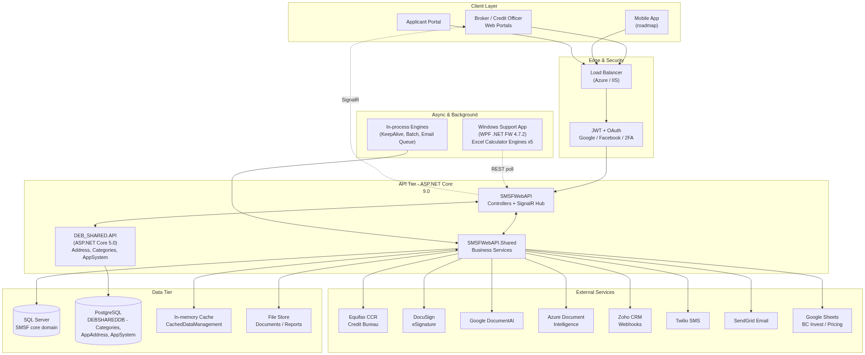
Figure 1.
──────────────────────────────────────────────────────────────────────

5. Solution & Project Structure
The repository contains three independent .NET solutions deployed as separate artifacts.
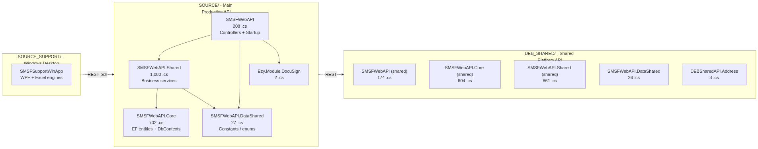
Figure 2.
Project file counts (C# source files):
Solution | Project | Files | Framework
SOURCE | SMSFWebAPI | 208 | ASP.NET Core 9.0
SOURCE | SMSFWebAPI.Core | 702 | .NET 9.0
SOURCE | SMSFWebAPI.Shared | 1,080 | .NET 9.0
SOURCE | SMSFWebAPI.DataShared | 27 | .NET 9.0
SOURCE | Ezy.Module.DocuSign | 2 | .NET 9.0
DEB_SHARED | SMSFWebAPI | 174 | ASP.NET Core 5.0
DEB_SHARED | SMSFWebAPI.Core | 604 | .NET 5.0
DEB_SHARED | SMSFWebAPI.Shared | 861 | .NET 5.0
DEB_SHARED | SMSFWebAPI.DataShared | 26 | .NET 5.0
DEB_SHARED | DEBSharedAPI.Address | 3 | ASP.NET Core 5.0
SOURCE_SUPPORT | SMSFSupportWinApp | ~50 | .NET Framework 4.7.2
Total |  | ~3,737

──────────────────────────────────────────────────────────────────────

6. Logical Layer Architecture
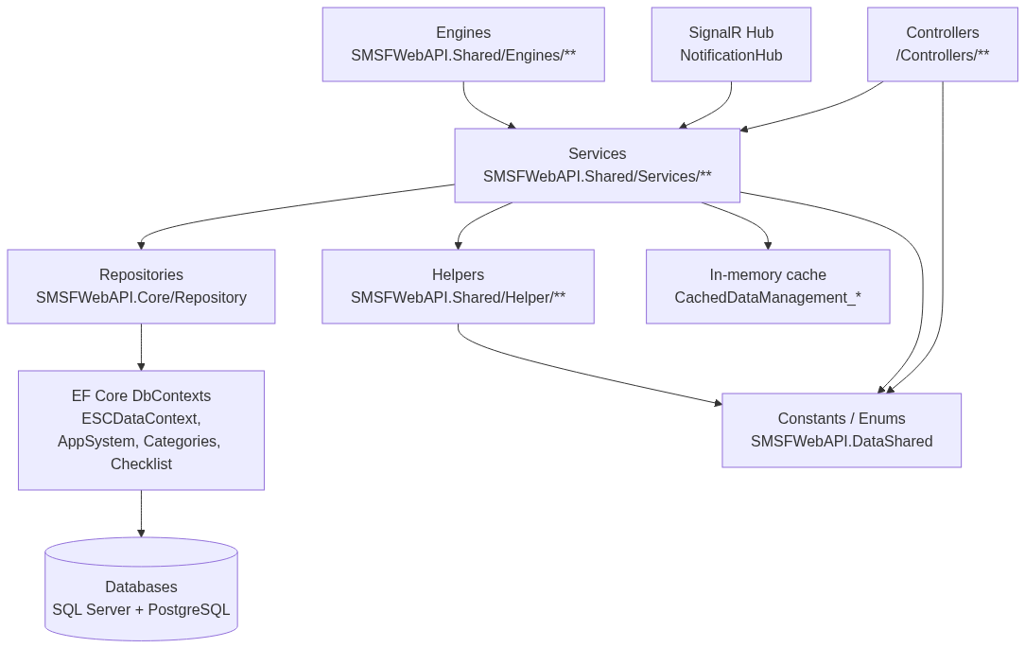
Figure 3.
Layer responsibilities
Layer | Responsibility | Location
Controllers | HTTP request routing, model binding, [Authorize] enforcement, DTO mapping | SMSFWebAPI/Controllers/**
SignalR Hub | Push real-time notifications to connected clients | NotificationHub
Services | Business workflow orchestration, integration calls, transaction scoping | SMSFWebAPI.Shared/Services/**
Helpers | Reusable pure-ish utilities (validation, email composition, encryption, calculators) | SMSFWebAPI.Shared/Helper/**
Engines | Background / scheduled workloads (batch, keepalive, email queue flush) | SMSFWebAPI.Shared/Engines/**
Repositories | Data access abstraction (limited usage; most services call EF directly) | SMSFWebAPI.Core/Repository
EF Core | O/R mapping, migrations, LINQ queries | SMSFWebAPI.Core/Data/**
Cache | In-memory lookup of Config* entities; refreshed on startup + on-demand invalidation | DataInfo/Cached/**
Constants | Enums, code lookups, base DTOs shared across assemblies | SMSFWebAPI.DataShared/**

──────────────────────────────────────────────────────────────────────

7. Loan Application Data Flow (End-to-End)
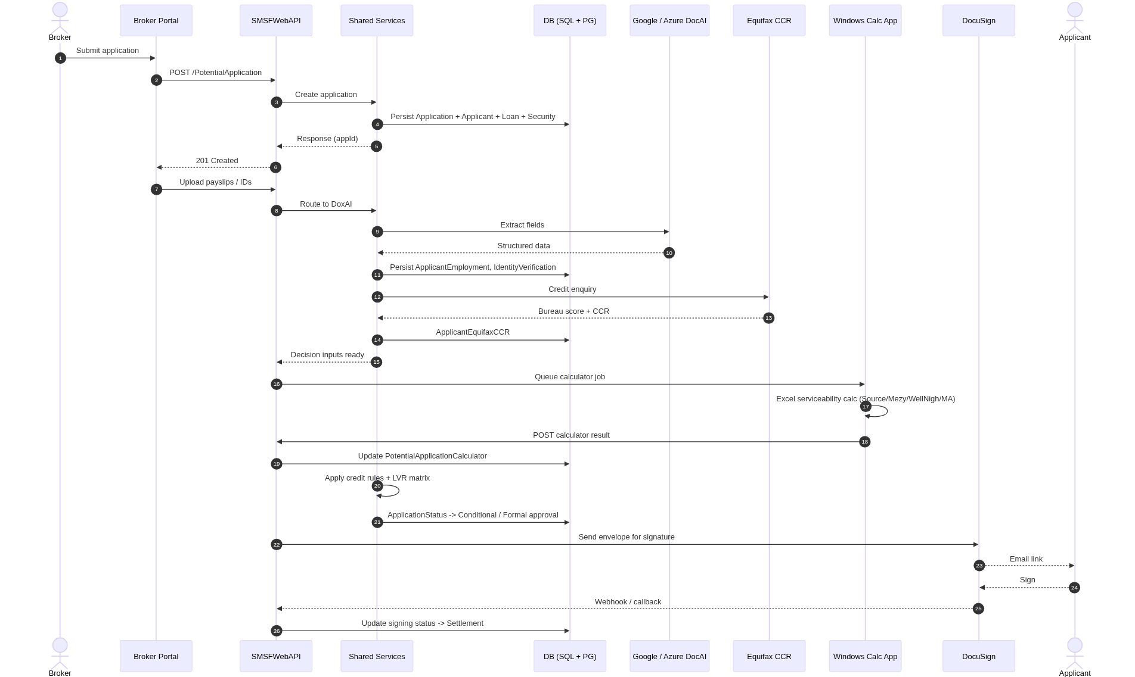
Figure 4.
──────────────────────────────────────────────────────────────────────

8. Database Architecture

8.1 DbContexts
Context | Database | Scope
ESCDataContext | SQL Server | Primary loan domain: applications, applicants, loans, securities, households
AppSystemEntities | SQL Server / PostgreSQL | Staff, user login, email templates, system config, audit
CategoryEntities | PostgreSQL | Lookup & configuration data (funders, postcodes, loan purposes, property types)
AppAddressEntities | PostgreSQL | Australian address reference, geocoding history
AppDataEntities | SQL Server | Dynamic data entity definitions & validation metadata
ChecklistEntities | SQL Server | Document / credit / AI checklists
DocAIEntities | SQL Server | DoxAI templates, extraction logs

8.2 Core Domain Entity Map
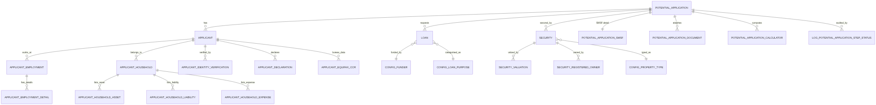
Figure 5.

8.3 Configuration-as-Data
Over 100 Config* tables encode business rules (approval conditions, LVR matrix, document requirements, funder-specific overrides). Each Config* entity has a matching CachedDataManagement_* class that lazy-loads and caches the full table, with explicit cache invalidation on mutation.
──────────────────────────────────────────────────────────────────────

9. External Integration Topology
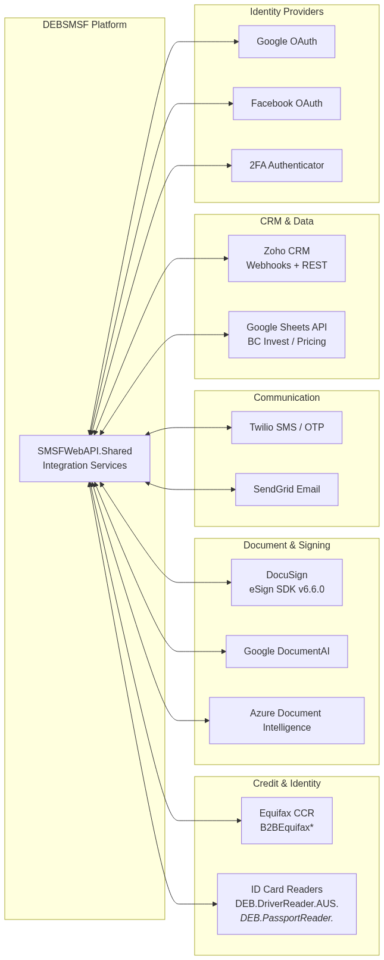
Figure 6.

Integration inventory
Integration | Purpose | Protocol | Library / Endpoint
Equifax | Credit bureau / CCR enquiry | REST (XML) | B2BEquifaxSearchTypes, B2BEquifaxCreditEnquiryType
DocuSign | Loan document e-signing | REST | DocuSign.eSign SDK v6.6.0
Google DocumentAI | OCR / field extraction | REST | Google Cloud SDK
Azure Document Intelligence | OCR alternative | REST | Azure.AI.DocumentIntelligence 1.0.0
Zoho CRM | Lead / opportunity webhooks | Webhook + REST | RHLZohoWebhookLogDataService
Twilio | SMS OTP / notifications | REST | Twilio SDK
SendGrid | Transactional email | REST | Logged via Log_SendGrid
Google Sheets | BC Invest postcode + broker pricing | REST | Google.Apis.Sheets.v4
Google OAuth | Social login | OpenID Connect | ASP.NET social auth
Facebook OAuth | Social login | OpenID Connect | ASP.NET social auth
ID Card Readers | AU state driver licenses + 11 passports | DLL (on-prem) | DEB.DriverReader.AUS.*, DEB.PassportReader.*

──────────────────────────────────────────────────────────────────────

10. Authentication, Authorization & Security
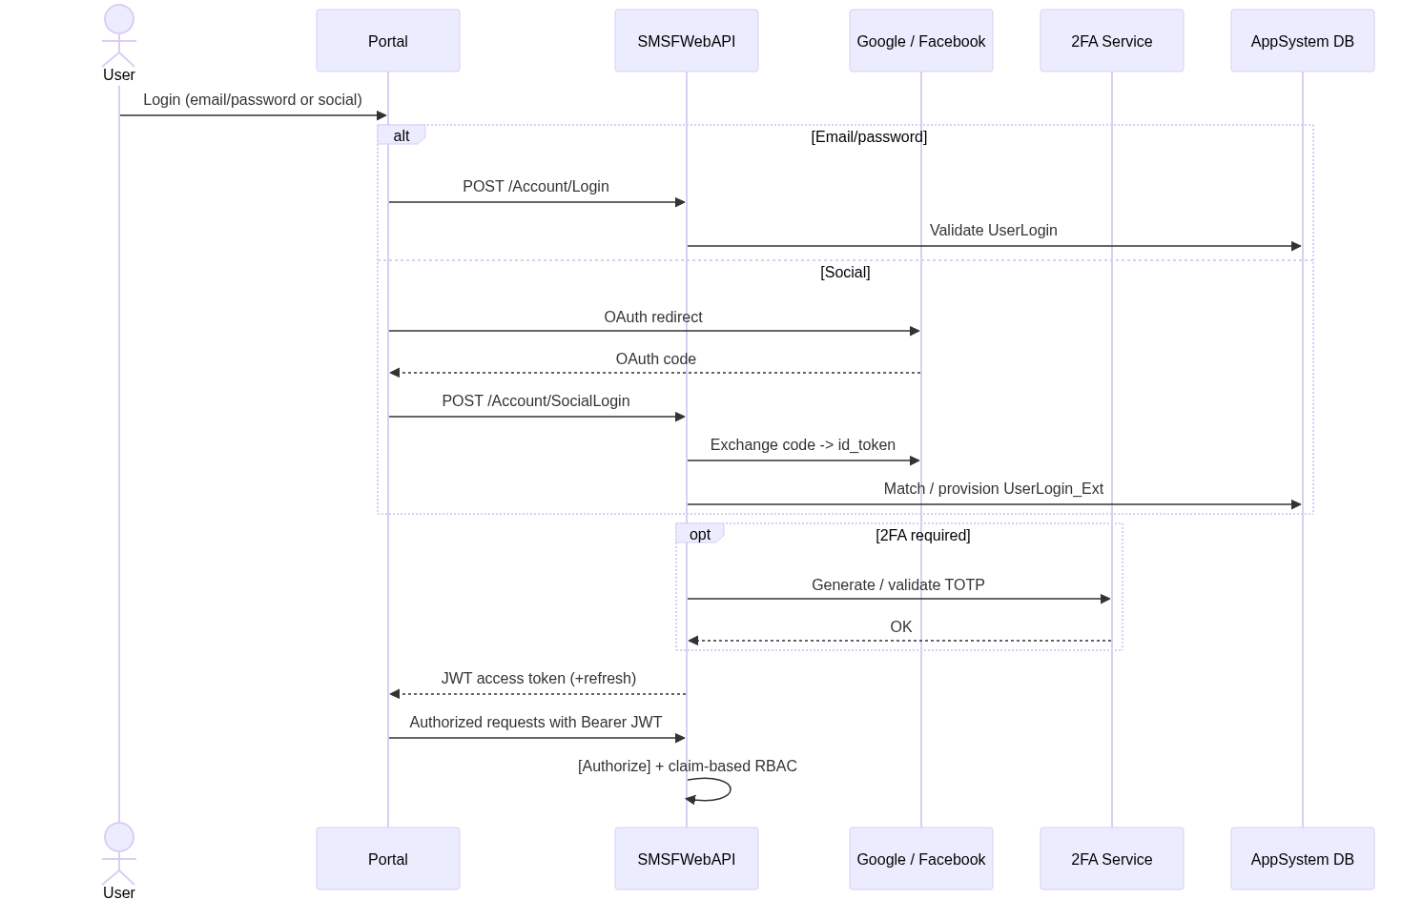
Figure 7.

Security controls
Control | Implementation
Transport security | HTTPS/TLS enforced at LB / IIS; X-Forwarded-Proto honoured
Authentication | JWT Bearer + Google OAuth + Facebook OAuth + optional 2FA (TOTP)
Authorization | [Authorize] attribute baseline; function-level via FunctionPermissionKeys
Secret management | Gitignored config files: Configs/Auth/*.json, EquifaxSetting.json, App_Data/Setting.txt
Data encryption at rest | DB provider-level (SQL Server TDE, PostgreSQL disk)
Data encryption in transit | TLS for all external integrations
PII handling | Bureau data stored per Privacy Act retention rules; audit via SystemBusinessChangeTracking
Input validation | DebDataValidation engine + EF model constraints
CORS | Configurable allow-origin (currently permissive, to be tightened)
DoS / abuse mitigation | Recommended: add rate-limiting middleware + WAF (gap — see §13)

──────────────────────────────────────────────────────────────────────

11. Caching Architecture
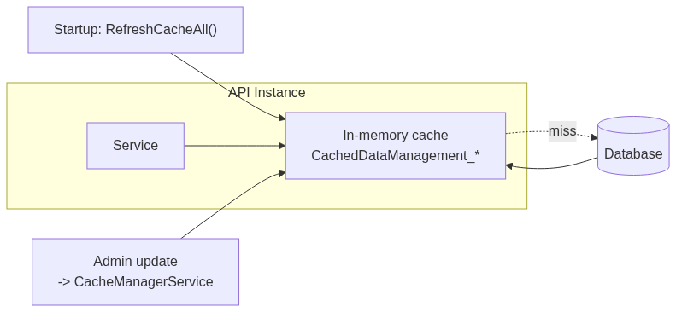
Figure 8.
- Populated at startup via CachedDataManagement.RefreshCacheAll().
- Lazy per-table refresh on miss.
- Invalidation on mutation through ICacheManagerService.
- Limitation: cache is per-instance (in-process) — horizontal scale-out currently risks stale reads until all instances reload. Distributed cache (Redis) is identified as a tech-debt item.
──────────────────────────────────────────────────────────────────────

12. Deployment Topology
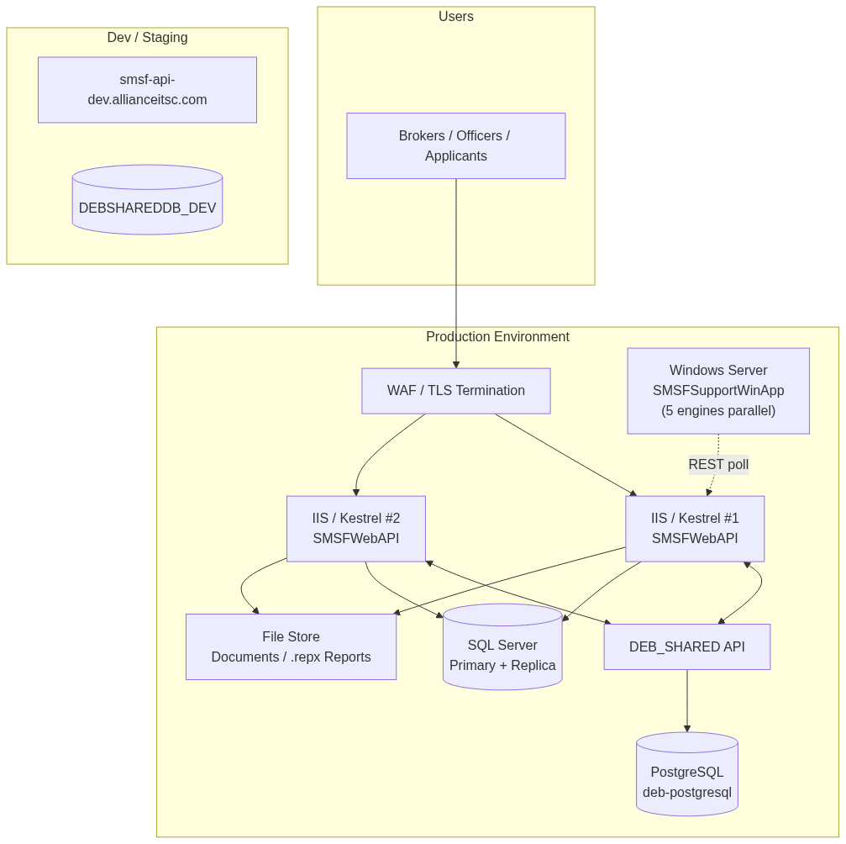
Figure 9.

Environments
Environment | URL / Host | Database
Development | smsf-api-dev.allianceitsc.com | DEBSHAREDDB_DEV (PostgreSQL)
Staging | TBA by ITOPS | TBA
Production | TBA by ITOPS | SQL Server cluster + PostgreSQL

Deployment artifacts
Artifact | Packaging | Target
SMSFWebAPI | dotnet publish → IIS (web.config present) or Kestrel + systemd | Windows / Linux
DEBSharedAPI | dotnet publish | Windows / Linux
SMSFSupportWinApp | WPF installer + Windows Run registry auto-start | Windows Server

Startup sequence (first run)
- EzyAPIStartupService.StartupService() — initialises framework services
- CachedDataManagement.RefreshCacheAll() — loads config caches
- ReduceEngineHelper.StartAllEngines() — starts background engines
- EzyFA2AuthenticatorManager.Register() — registers 2FA provider
- ESCFrameWorkManagement.InitServiceWithSystemConfig() — applies runtime system config
──────────────────────────────────────────────────────────────────────

13. Non-Functional Requirements & Observations
Dimension | Current State | Observation / Gap
Availability | IIS / Kestrel stateless instances, multi-instance capable | In-process cache limits safe scale-out — Redis cache recommended
Scalability | Horizontal behind LB for API; WinApp vertically scaled (5 engines) | Calculator throughput ceiling; consider serverless or queue-based workers
Performance | Gzip + Brotli compression; in-memory cache of config; async EF queries | Target p95 < 500 ms for API; long-running calc jobs offloaded to WinApp
Security | JWT + OAuth + 2FA; gitignored secret files | CORS to be tightened; add rate-limiting + WAF; central secret vault (Azure KeyVault) recommended
Compliance | Audit trails via SystemBusinessChangeTracking and Log_* tables | Formal retention policy for PII/CCR data to be documented
Observability | Log files under App_Data; basic ILogger usage | No centralised logging / APM yet — recommend Application Insights or equivalent
Testability | Few automated tests present | Unit + integration test coverage is a tracked tech-debt item
API discoverability | Swagger currently commented out in Startup | Re-enable Swagger / OpenAPI for internal API catalogue
Framework currency | SOURCE on .NET 9; DEB_SHARED on .NET 5 (EoL) | Upgrade DEB_SHARED to .NET 8 LTS or 9
Disaster recovery | DB-level backup only (assumed) | Document RPO/RTO; formalise restore runbook

──────────────────────────────────────────────────────────────────────

14. Windows Support App Integration Pattern
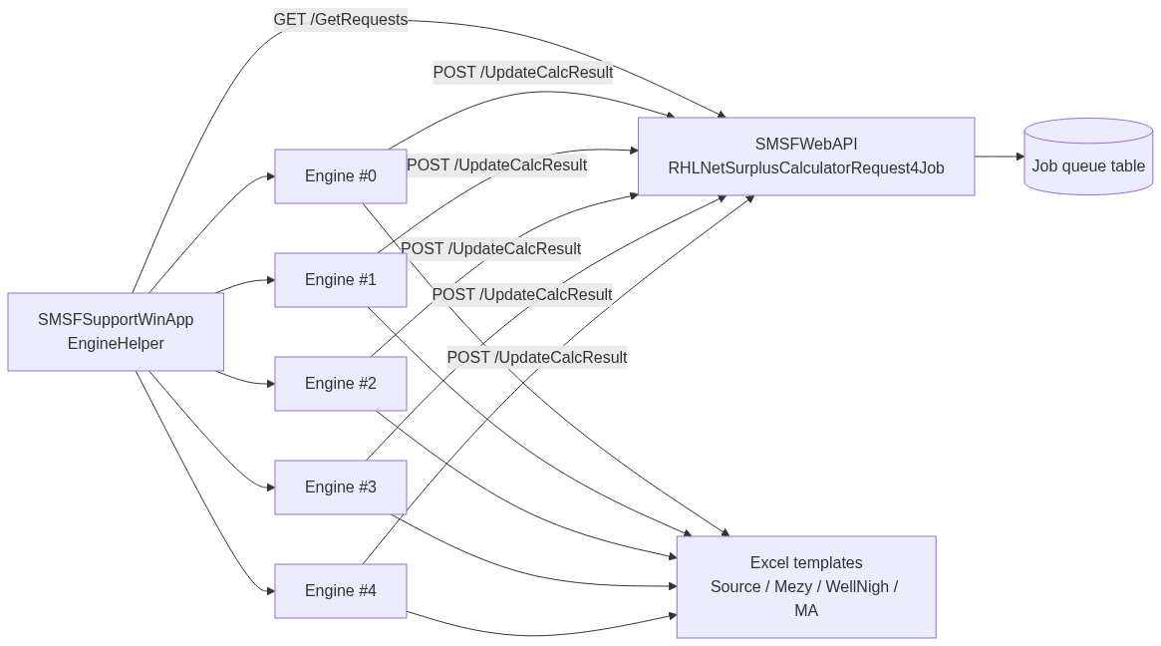
Figure 10.
Operational notes
- Polling interval configurable via Config.json (EngineTimeOutSecond).
- Templates per funder stored outside the binary in ExcelTemplateFileSetting.
- Auto-starts via Windows Run registry; minimises to system tray.
- Failures captured through ExceptionHelper and surfaced in the Monitoring tab.
──────────────────────────────────────────────────────────────────────

15. Risks & Recommendations
# | Risk / Issue | Severity | Recommendation
1 | DEB_SHARED on .NET 5 (out-of-support) | High | Upgrade to .NET 8 LTS or unify on .NET 9
2 | In-process cache only; stale reads on scale-out | Med | Introduce Redis / distributed cache with cache-aside pattern
3 | Swagger disabled | Med | Re-enable for internal API catalogue + contract tests
4 | Permissive CORS in Startup | Med | Restrict to known origins per environment
5 | No centralised observability | Med | Adopt Application Insights (traces, metrics, logs)
6 | Limited automated test coverage | Med | Establish unit + integration test baseline; CI gating
7 | Calculator throughput bound by WinApp | Med | Evaluate queue-based Linux workers or Azure Functions
8 | Secrets in local config files | Med | Move to Azure Key Vault / AWS Secrets Manager
9 | No documented DR runbook | High | Define RPO/RTO; document restore procedure; drill annually
10 | Two independent "SMSFWebAPI" solutions cause naming ambiguity | Low | Rename DEB_SHARED projects for clarity

──────────────────────────────────────────────────────────────────────

16. Glossary
Term | Meaning
SMSF | Self-Managed Super Fund — Australian retirement savings vehicle self-administered by members
RHL | Reduce Home Loan — residential mortgage product
SOURCE | Non-conforming lending product line
LVR | Loan-to-Value Ratio
CCR | Comprehensive Credit Reporting (Equifax)
DoxAI | Internal document AI extraction pipeline
NCCP | National Consumer Credit Protection Act (AU)
B2B | Broker-to-Lender submission path
EoL | End of Life (framework support status)
RPO/RTO | Recovery Point Objective / Recovery Time Objective

──────────────────────────────────────────────────────────────────────

17. Appendix A — Key Source Locations
Concern | Path
API Startup | SOURCE/SMSFWebAPI/Startup.cs, Program.cs
Controllers | SOURCE/SMSFWebAPI/Controllers/**
Business services | SOURCE/SMSFWebAPI.Shared/Services/**
Helpers | SOURCE/SMSFWebAPI.Shared/Helper/**
EF DbContexts & entities | SOURCE/SMSFWebAPI.Core/Data/**
Background engines | SOURCE/SMSFWebAPI.Shared/Engines/**
Constants / enums | SOURCE/SMSFWebAPI.DataShared/**
Report templates | SOURCE/SMSFWebAPI/ReportTemplate/** (.repx)
DEB shared platform | DEB_SHARED/**
Windows calculator app | SOURCE_SUPPORT/SMSFSupportWinApp/**
Ignored config (secrets) | Configs/Auth/*.json, App_Data/Setting.txt

──────────────────────────────────────────────────────────────────────
End of document — ITOPS-ARCH-2026-001 v1.0

