**REPORT**

**LAB 2 : Mi Card**

**Student name: Võ Khắc Đoài**

**Student ID: 21IT335**

**Student email: doaivk.21it@vku.udn.vn**

# **Introduction**

* Purpose of the Lab Report:

The goal of this lab is to develop a foundational understanding of the core components that make up Flutter's UI. Additionally, it aims to introduce participants to the integration of extra elements, such as font libraries and images. Through hands-on activities, participants will learn how to combine these elements to create user interfaces that are both visually appealing and functional.Provide background information on your mobile app.

* Background Information on the Mobile App:

App Name: Mi Card

Purpose: MiCard is designed to streamline the creation of personalized business cards through a sleek and user-friendly interface. Utilizing Flutter Widgets, the app ensures flexibility and optimal performance across multiple platforms. The app’s primary aim is to enable users to design their own business cards effortlessly while ensuring a visually appealing experience.

# **Objectives**

* State the objectives of the lab.

The lab aims to equip participants with essential skills and knowledge required to set up a Flutter development environment, create projects, utilize basic elements like Scaffold, manage dependencies using the Pubspec file, and incorporate icons into Flutter applications. Through hands-on exercises and demonstrations, participants will gain practical experience in Flutter app development fundamentals.

# **Methodology**

* Describe the methodology used in the lab.

The methodology used in the lab about programming with Flutter involves a combination of theoretical explanations, practical demonstrations, and hands-on exercises to ensure participants grasp the concepts effectively.

* Explain how your app was developed.

# **Results**

* Present the results of the lab.
* Include screenshots of the app.

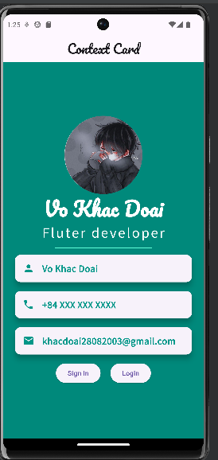

# **Discussion**

* Discuss the results obtained.

Understanding of Flutter Environment Setup:

Project Creation and Structure:

Understanding of Scaffold Widget:

Working with Pubspec File:

Integration of Icons:

Quality of Lab Report Documentation:

Feedback and Improvement Opportunities:

# **Conclusion**

* Summarize the main findings of the lab.

Strong understanding and utilization of the Scaffold widget for app layout.

Effective management of dependencies and assets using the Pubspec file.

High-quality documentation providing clear instructions and explanations.

* Provide recommendations for future work.

Explore advanced Flutter topics like state management and animation.

Assign real-world projects for practical application of skills.

Encourage collaborative group projects for teamwork experience.

Provide continuous learning resources and encourage self-study.