**REPORT**

**LAB 6 : Flash Chat**

**Student name: Võ Khắc Đoài**

**Student ID: 21IT335**

**Student email: doaivk.21it@vku.udn.vn**

# **Introduction**

* This report presents a code snippet written in Flutter, a programming language for mobile app development. This code includes constant declarations for text styles, decorations, and layouts for user interface components in a messaging application. These constants are designed to enhance consistency and maintainability in the user interface.

.

# **Objectives**

The main objectives of this code snippet are to:

* Define text styles for the send message button.
* Provide decorations for the message input field, improving user interaction experience.
* Establish a decoration style for the message containers, creating a visually appealing and user-friendly interface.
* Create a consistent decoration style for input fields.

.

# **Methodology**

The code uses Flutter widgets such as TextStyle, InputDecoration, and BoxDecoration to create constants for styling and layout. Specifically:

* kSendButtonTextStyle is defined with properties such as color, font weight, and font size to ensure the send message button stands out.
* kMessageTextFieldDecoration and kTextFieldDecoration utilize InputDecoration to define the appearance of input fields, including attributes like contentPadding, hintText, and different border styles.
* kMessageContainerDecoration uses BoxDecoration to create a top border for the message container, adding a highlight to the interface.

# **Results**

* Include screenshots of the app.

|  |  |
| --- | --- |
|  |  |

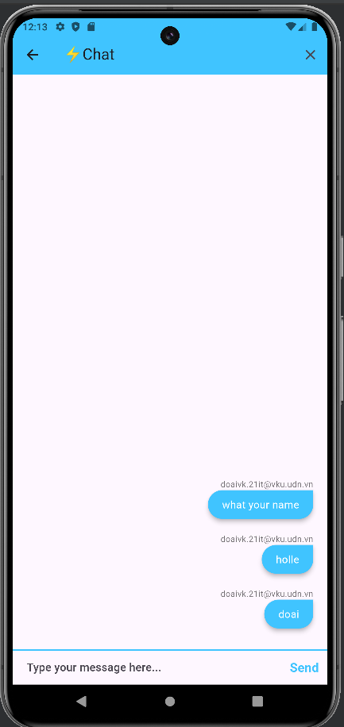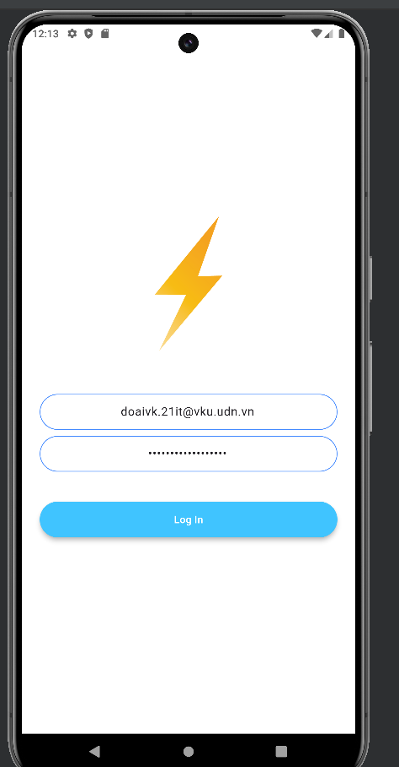

# **Discussion**

* Using constants for styling and decoration helps make the code clearer and more maintainable. If the design needs to change, developers only need to modify these constants without adjusting each widget individually. This reduces the likelihood of errors and increases consistency in the user interface. However, it is essential to note that using hard-coded values may limit customization possibilities in the future, so a balance between consistency and extensibility should be considered.

# **Conclusion**

This Flutter code snippet demonstrates an effective method for defining constants for the user interface in a messaging application. By using constants, developers can create a beautiful, user-friendly, and maintainable interface. This not only enhances the user experience but also helps the development team save time and effort in maintaining the codebase.