**I. Turorial Open Project-khachuynguyen0**

**-Step 1: Choose a folder to save REPO**

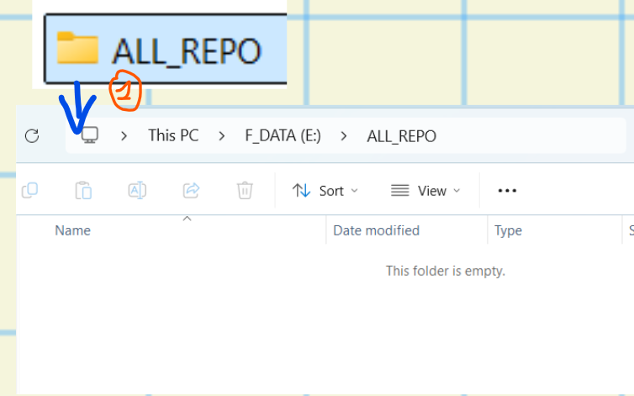

**-Step 2: Open cmd/PowerShell, then copy->past, Open project**

https://github.com/khachuynguyen0/project-02-frontend-shopee-website-clone.git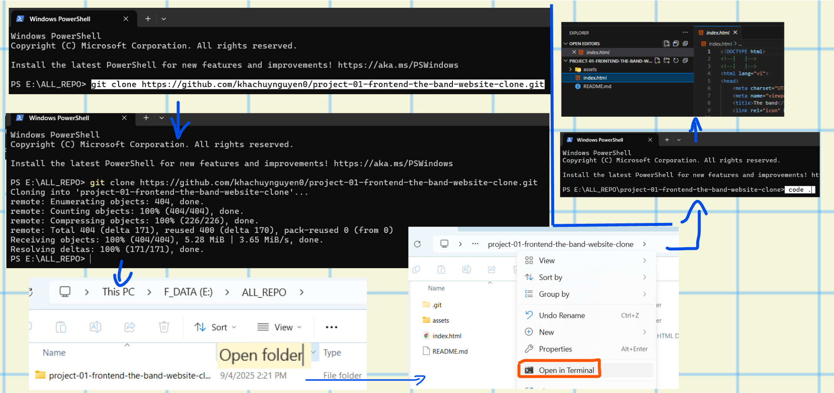

**II. UI Preview**

**2.1 PC**

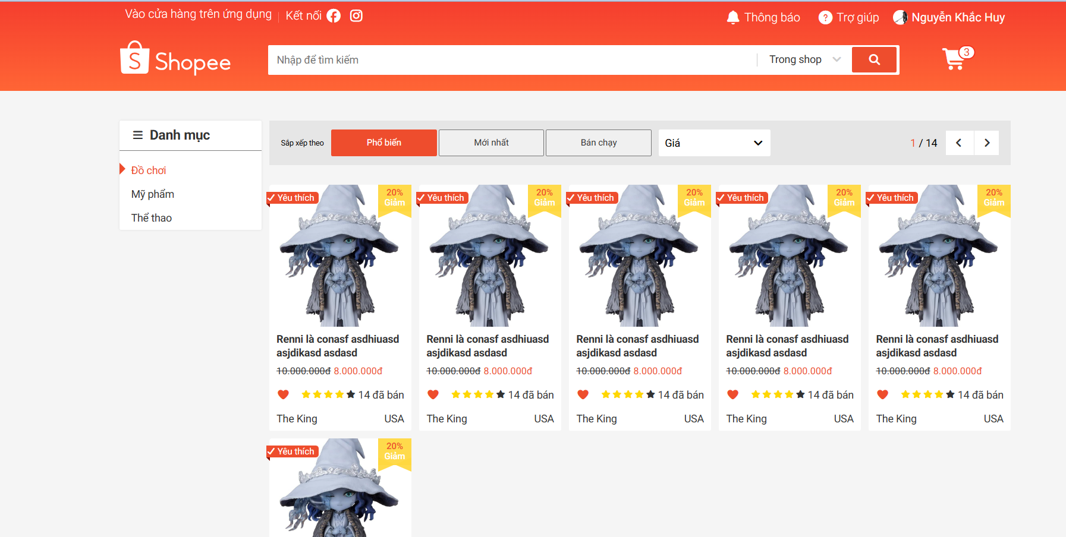

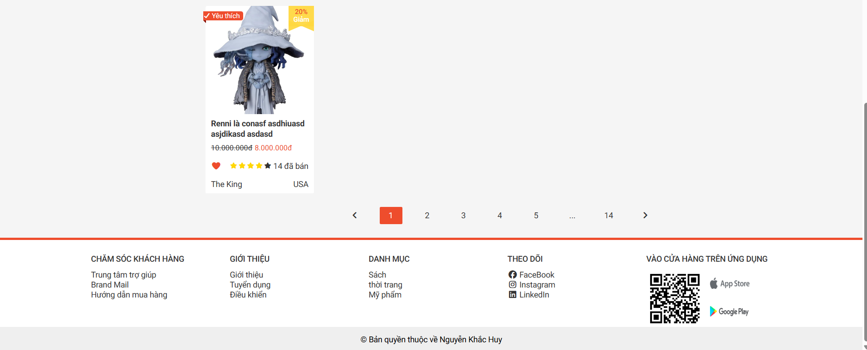

**2.2 Tablet**

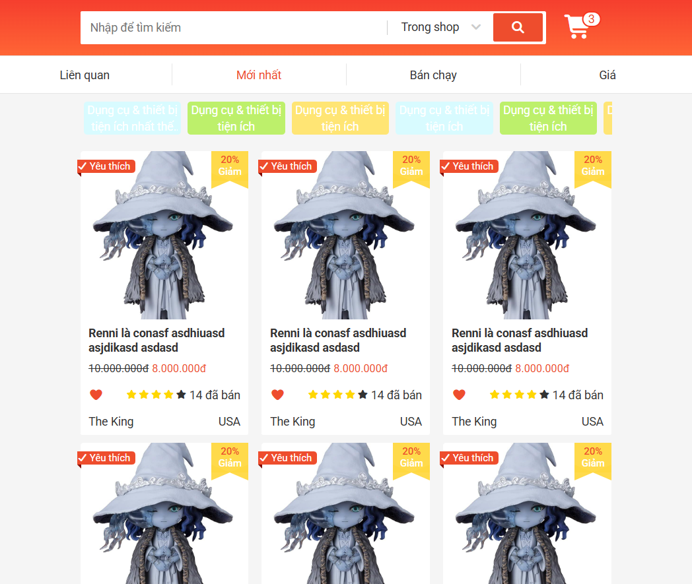

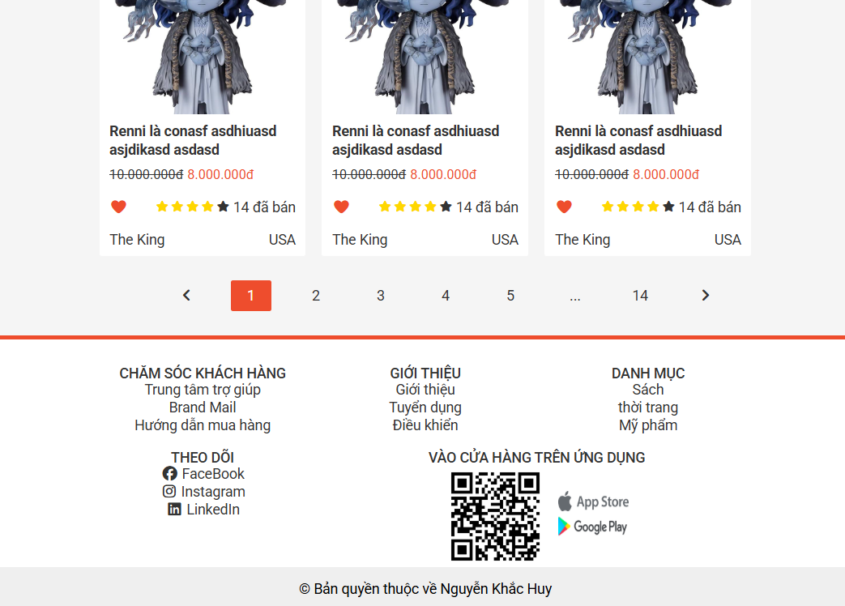

**2.3 Mobile**

