**I. Turorial Open Project-khachuynguyen0**

**-Step 1: Run File .exe(vd: ReadAllFileOfFolder.exe)**

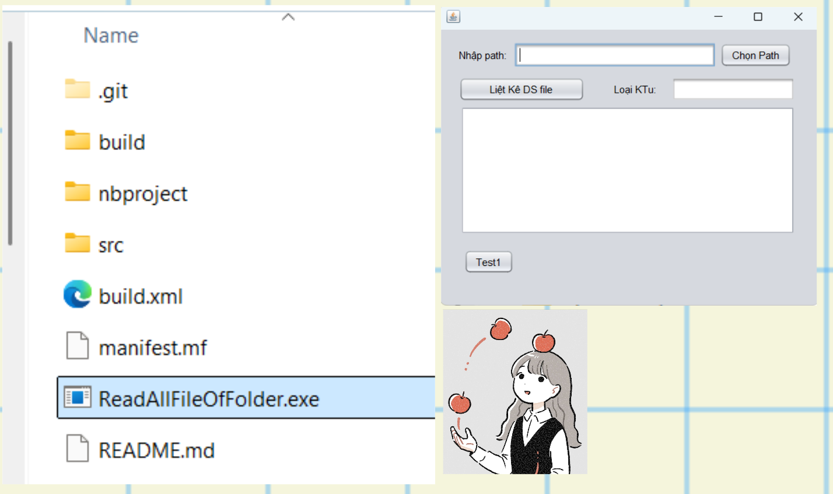

**II. UI Preview**

**2.1 PC**

