I. Turorial Open Project-khachuynguyen0
-Step 1: Run File .exe(vd: ReadAllFileOfFolder.exe)
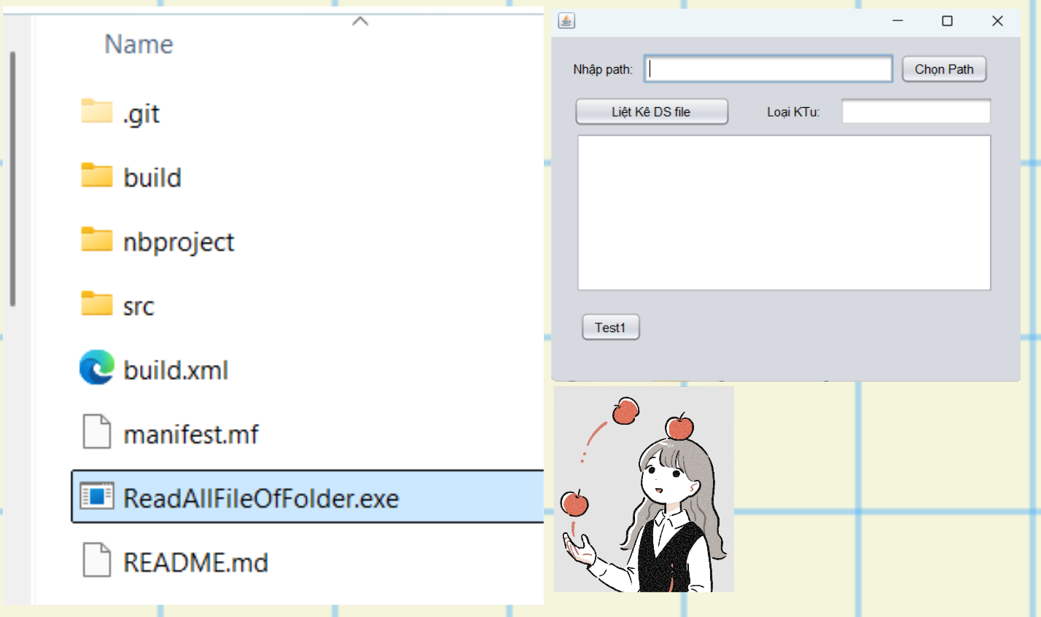

II. UI Preview
2.1 PC
