Email Archiver EML_2_PDF
Writen by: luongkhactung@gmail.com

1. Overview
- Purpose: Convert email (*.EML) to PDF
- Features:
  - Support multiple templates
  - Modify templates using JS effects
  - Display EML as HTML
  - Download PDF
  - Print out

2. Components
- NodeJS Mail-Parser: parse .eml to an Object
https://npmjs.org/package/mailparser
- PhantomJS and corresponding Node module: generate PDF
http://phantomjs.org/build.html
https://npmjs.org/package/phantom

3. Dataflow
EML Parser
- Save eml object into session
HTTP POST: EML file
Homepage

EML Object
Main
- Create html from EML object
- Generator PDF from html file using phantom
- Find and write file attachments from EML object

Change Template
Change CSS

4. Usage
http://192.168.10.236:3300/
- Upload eml file:
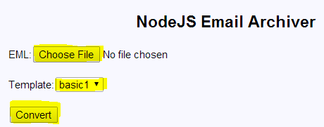

Screenshot 01: Homepage

- Change template, Effect, Download PDF, Print:
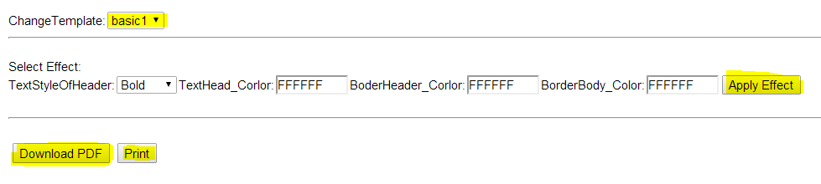

Screenshot 02: Change template, CSS, Download, Print

- Download Attachments:

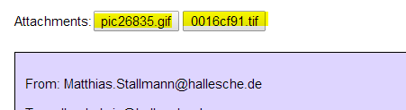

Screenshot 03: Download Attachments

