Expanation:
-----------
The framework for this program contains no widgets. but does show ho to setup a simple File menu located in the top-left corner of the GUI. Take a loo at the beginning of the program and notice the classes begin imported from QWidgets. We still import QApplication, but there are also two new classes. QMainWindow and QAction. You may also notice that this time there is no QWidget class.

The QMainWindow class provides the necessary tools for building an application's graphic user interface. Notice tha the BasicMenu class in the preceding code is is written as :
class BasicMenu(QMainWindow)

The class to build our window inherit from QMainWindow instead of QWidgets.

QMainWindow vs. QWidget:
The QMainWindow class focuses on creating and managing the layout for the main window of an application. It allows tyou to setup a window with status bar ,toolbar, dock widgets, or other menu options in predefined places all designed around functions that the main should have.

The QWidget class is the base for all user interface objects in Qt. The widget is the basic building block of GUIs. It is interactive, allowing the user to communicate with computer to perform some task. Many of the widgets you have already looked functionality to your programs.

A window in an application is really just a widget that is not embedded in a parent widget. What is important to understand is that QMainWindow actually inherits from the QWiget class. It is special purpose class focusing mainly on creating menus and housing widgets in your program. In figure below you can see the different widgets that QMainWindow can use have areas specifically assigned for them. Take a look at the inside of the main window.

The central widget in the center of the window must be set if you are going to use MainWindow as your base class. For example you could use single QTextEdit widget or create a QWidget object to act as a parent to number of other widgets then use setCentralWidget(), and set your central widget for the main window.

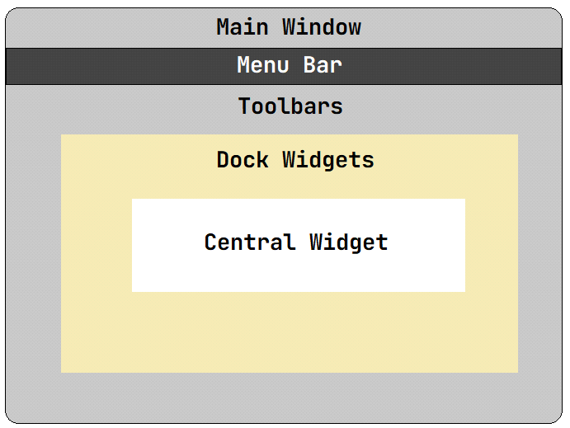

Creating the Menubar and Adding Actions.
----------------------------------------
At the top of the window in figure above, you will se the menubar which contains one menu, File. In order to create a menubar, you must create an instance of the QMenuBar class, Which we create by:
menu_bar = self.menuBar()
You could create a menubar by actualy calling the QMenuBar class butn it is just easy to create menubar using menuBar() function provided by QMainWindow.

Note:
Due to guidelines set by the MacOS system, you must set the property to user the platfrom’s native setting to False. Otherwise the menu will not appear in the window. You can do with menu_bar.setNativeMenuBar(False). For those using windos or Linux, you can comment this line out or delete it completely from your code.

Adding menus to the menubar is also really simple in PyQt:
file_menu = menu_bar.addMenu(‘File’)

Here we are using the addMenu() method to add a menu named “File” to the menu_bar. Using addMenu() add a QMenu to object to our menu_bar. Once again it is just simple to use the functions provided by the QMainWindow class.
A menu contains a list of action items such as Open, Close, and Find. In PyQt, there actions are created from the QAction class, defining actions for menus and toolbars.
Many actions in an application are also given shortcut key making it easy to perform that task, for example: Crtl+V for the past action (cmd+v on MacOS=) or Crtl+X for cut action (cmd+X on MacOS). Take a look at how the Exit action is created and then add to file_menu.

exit_action = QAction(“Exit”,self)
exit_action.setShortcut(“Crtl+V”)
exit_action.triggered.connet(self.close)

The Exit action, exit_action, is an instance of the QAction class, In the next line the shortcut for exit_action is set explicitly using the setShorcut() method with key combination Crtl+Q. Another way to set the shortcut is to use the ampersand key,&, in front of the letter you want to use as the shortcut. For example:
opent_action = QAction(“&Open”, self)

Note:
By default, on MacOs shortcut are disabled. The best way to use them is with setShortcut()

Similar to QPushButtons, actions in the menu emit a signal and need to be connect to a slot in order to perform an action. This is done using triggered
Connect(). Using the QAction class is very useful since many common commands can be invoket through the menu, toolbars , or shortcuts and need to be able to perform correctly no matter which widget invokes the action.

