**MPMC**  
  
HISTORY:   
EVENT:  
ORGANIZATIONAL CHART(BOD):  
ABOUT:   
VISION & MISSION:

Our Vision

Pinapangarap ng Mabuting Pastol Multi-Purpose Cooperative (MPMC) ang isang Samahang matatag at may dangal at pinagbuklod ng Pananampalatayang Kristiyano na nagpupunyagi para sa isang malawak, malalim at makahulugang pantao sa pamamagitan ng sama-samang paglalaan ng sarili upang itaguyod ang pangkalahatang kaunlaran tungo sa buhay ng ganap at kasiya-siya

Our Mission

Bigyang kapangyarihan ang mga kasapi sa pamamagitan ng patuloy na pag aaral at paghuhubog ayon sa diwa at pamantayan ng kilusang kooperatiba

Itaguyod ang gawaing kooperatiba bilang daan tungo sa kaunlarang pangkabuhayan, pampulitika at katarungang panlipunan bilang kaagapay sa mabungang pakikisalamuha sa pandaigdigang pamayanan ng kilusang kooperatiba.

Patuloy na pananaliksik at paglinang sa kaugaliang Pilipino na makakatulong sa pag-ulan ng Mabuting Pastol Multi-purpose Cooperative at iba pang mga Kooperatiba

SERVICES:

Tulong Abot-Kamay : Available to all Members (Associate & Regular Members) With 1,000 One Time Membership.

G-Cash Services : Cash In / Cash Out / Loan Payments

Bills Payment: Meralco , Maynilad and Many More!

Ticketing

Loans:

* Appliances Loan
* Pangkabuhayan Loan
* Multi - Purpose Loan
* Emergency Loan
* Bigasan Loan
* Pension Loan
* Educational Loan
* Time Deposit
* Investment
* Special Loan
* Housing Loan

Savings:

Be A Regular Member.

Live the Coop Way.

1.For 2,000 Initial Share Capital

2. Attend Pre - Membership Seminar

3. Fill Out Registration Form

4. Pay Registration and Seminar fee

Be an Associate Member for Only 350 Pesos!

CONTACT US:

Contact Number : 0906-3451-153

Email: [mpmcmain1998@gmail.com](mailto:mpmcmain1998@gmail.com)

Facebook: Mabuting Pastol Multi-purpose Cooperative

Location : MPMC Bldg. Gate1 MRB Compound , NGCHP Pilot Area,Brgy Commonwealth Quezon City

**CMS  
  
ADMISSION:**   
**ACADEMIC OFFERINGS**  
Nursery to Kinder  
Grade School (Grades 1 to 6)  
Junior High School (Grades 7 to 10)  
  
**SCHOOL FACILITIES**  
  
Fully-air conditioned Classrooms, Library, HE laboratory, Computer Laboratory, Science Laboratory, Canteen, Multipurpose Hall, Playground  
  
**CONTACT US**09542619639 / 09153172485 Landline: (02) 88175776  
Facebook: Cordis Mariae School  
Email: cms2010.eedu@gmail.com

HISTORY  
VISION/MISSION  
ORGANIZATIONAL CHART  
FACULTY  
EVENTS  
TOURS

**7/11**  
**STAFF: PICTURE**

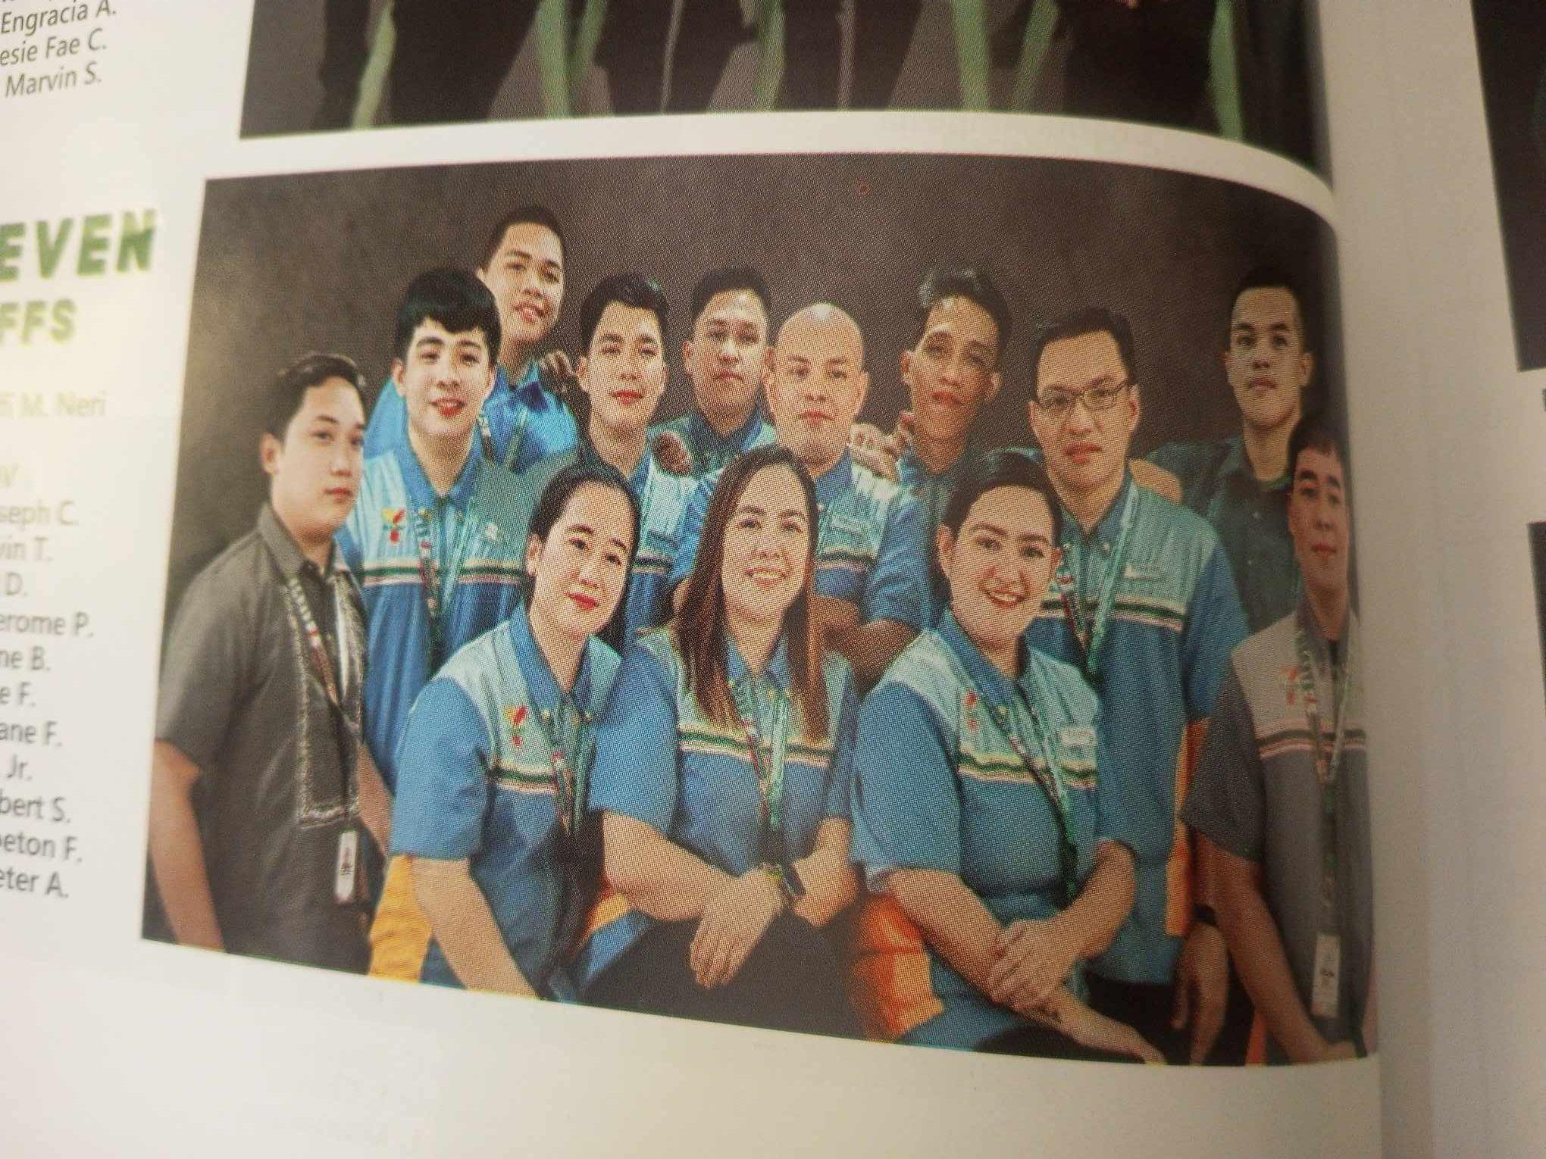

**ABOUT :**   
  
**VISION & MISSION:**  
**MISSION**   
To make daily life easier by providing modern convenience.  
**VISION**  
Our vision is to be the best retailer of convenience for emerging markets.  
  
**CORE VALUES:  
TEAM WORK**We foster an environment of synergy to attain the goals of the organization through active participation and mutual respect. **INTEGRITY**We are honest and trustworthy to our fellow employees, customers and business partners. **RELIABILITY**We deliver what we promise.  
**CUSTOMER FOCUS**We put our customer first.   
**DATA-DRIVEN**We make decisions based on data.  
**SERVICES:**

**CLIQQ**Pay bills, buy load, add e-money and more! You can do these using CLiQQ Kiosks that are available at almost all 7-Eleven branches nationwide, or you can use the CLiQQ App. **7/11 ATM**Offers convenient banking services like cash withdrawals, balance inquiries, and funds transfers, with free transactions for BDO, LBP, and RCBC debit cardholders.