DAY9 SESSION ASSIGNMENTS(Theory)

1.Draw a Use Case Diagram for an online Library Management System.

Login

Add record

Search book

Search member record

Administrator Teacher
Issue book

Download e book

Update book record

Update member record

Reserve book

Maintain database

Delete record

Logout

Librarian Student
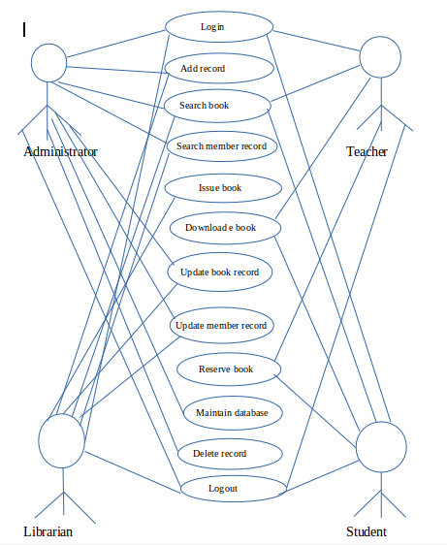

2.List down the best practices from Agile/Scrum methodology.

Here is a list of some best practices for Agile/scrum:
- Burn downchartcan be used to monitor sprint status. Graphical representations are better than tabular list views in planning.
- Planning poker is another useful way to determine sprint item finish durations. And using Fibonacci numbers is a good practice for planning poker numbers.
- ROI(Return on investment) values are useful to determine item priorities in a sprint. Planning poker can be used to determine ROI values.
- Using a board and simple planning/reporting tools (e.g. excel) are important and enough as process quality equipments.
- Scrum methodology does not offer documenting everything, but this does not mean "no documentation". Really needed documentation can be done as required.
- Daily meetings must not be longer than 15 minutes. Scrum is an agile methodology and no one needs to listen to other members' problem details. These details may be discussed after the daily meeting with the scrum master with only required subset of team members.

- Stand up meeting style is better for daily meetings, to keep meeting short. Also meeting location and time are recommended to be the same for each day.

- Product backlog may contain items which will not be developed. According to ROI values, some items may not be developed and this is normal. Product backlog should contain all possible items anyway.Give backlog items ID numbers, to manage simply.

- Sprint length (in weeks) changes are not recommended. But according to the sprint retrospective meeting results, sprint week lengths may be changed if there are really important reasons.

- 6 hours per a day is a realistic planning input. Total sprint hour capacity can be calculated as: (number of team members) * (number of sprint days) * 6 hours
3.Collaboration
a.How does collaboration help agile development?
- Collaboration is very necessery in an agile project.Collaboration plays a very key role in making the project a success.
- Collaboration in simple words means to wrok together rather than doing a task all alone.Team work is given more importance than doing the same work alone.
- By collaboration it become a way to communicate with people from varios feilds.It helps in making businees and IT inter relate.
- It encourages strong communication between business owners, from whom we get requirements for products, and the technical team that produces the product. Collaboration is also very important between members of the technical team. Rather than working in differently Agile methodologies promote frequent and face-to-face communication between all team members.
- The cooperative behaviour of a team empowered to solve a clear and
meaningful problem, such that the capabilities of the team are
leveraged in addition to the collection of individual talents.
- Two of the four values in the Agile manifesto highlight the emphasis Agile methodologies place on strong collaboration.
- Interactions and individuals over processes and tools reminds us of the importance of strong and respectful communication.
- Customer collaboration over contract negotiation reminds us that it's more important for a development team to allow for some flexibility to please a customer, seeking a collaborative solution to issues that might arise during product development, rather than to stick to a rigid contract.
- Be collaborate if in a agile project otherwise it becomes difficult.

Collaboration has the following advantages:
- Satisfy the customer through early and continuous delivery
- Welcome changing requirements
- Business people and developers work together daily
- The best way to convey information is face-to-face
- The team regularly tunes and adjust its behavior

b.What if the team is distributed and can you achieve the same productivity?

It wouldnt be possible at the first look.But if the people are highly trained and experts and with the help of techology are able to cope up in making the tteam work possible then yes to some extend productivity can be achieved.
Achieving the best results with agile requires a well-connected team. If the team is distributed the productivity tends to decrease.Agile is known for its team work and collaboration.
The issues in distributed development are:
- Strategic: Difficulty in using available resources, best practices are often deemed proprietary, are time consuming and difficult to maintain.
- Project and process management:Difficulty synchronizing work between distributed sites and people.
- Communication:Lack of effective communication mechanisms that cause delays.
- Cultural: Conflicting behaviors, processes and technologies.
- Technical: Incompatible data formats,schemas, and standards.
- Security: Ensuring electronic transmission confidentiality and privacy.

c.What would you do to achieve the productivity for a distributed team?

Communication and collaboration are probably the most important attributes to delivering projects on time. With distributed teams, being good at this is even more pronounced. Fortunately, the tools and technologies available today to distributed teams can nearly match the ultimate communication and collaboration tool of meeting face to face.But as we know, distributed workforces are the future so you’ll probably being seeing less and less of your colleague in person

Following are the methods to achieve productivity in a distributed agile team:
- Optimize Team Size and Team Mix:Finding the right mix of talent at every location is critical when the team is distributed.Effective distributed Agile development is about minimizing the impact of distribution.
- Distribute Work Evenly:Make sure all team members understand their role and have fairly equal workloads. In a distributed team, if the workload is uneven, you may risk the overall project delivery schedule if you ignore the imbalance. Uneven workloads can also cause bottlenecks
- Set Up Pair Programming:Pair programming, where two team members sit side by side and work on the same code, is a challenge for distributed teams
- Enforce and Re-enforce Agile Practices:Agile approaches rely on a set of mutually supporting practices. When one practice doesn’t make sense for one team, the practice should be either abandoned or replaced. With distributed teams, enforcing and reinforcing a practice takes time and effort
- Use Online Tools for Agile Artifacts:take advantage of Agile process artifacts (white boards, sticky notes, and so on) by moving them from their physical environment to an online tool.
- Understand Time Differences
- Understand Cultural Differences
- Adapt Communication for Remote Teams
- Arrange Face-to-Face Interactions
- Plan Frequent Demos and Retrospectives

4.What is Sprint Zero in Agile?Describe the activities that are done in Sprint Zero.
- Sprint Zero is also called as Iteration Zero.It is the first initial; step before the first sprint which is very critical in the development and completion of the project.
- Sprint Zero is usually kept for the readiness for the sprint 1 and for all the up coming sprints. Management has to make things like requirements, infrastructure, people etc. ready for the up coming sprints. Duration of the sprint zero is something that needs to be decided by the project team and has a dependency on the procurement of all the required items

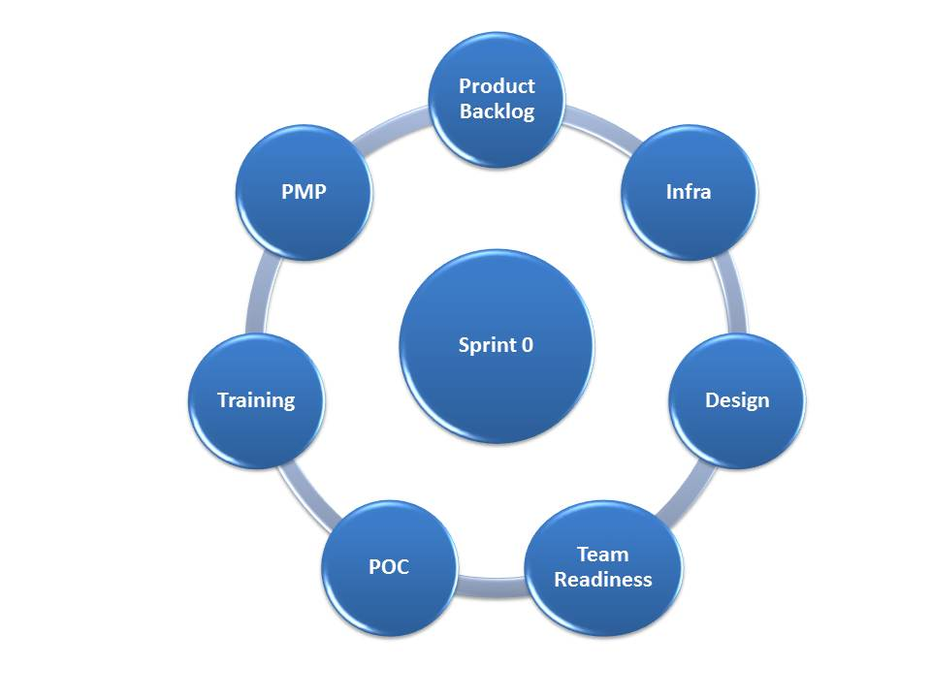

- Product backlog/Requirements:These are the product requirements that team will be building in the coming sprints. Product owner and Technical Architect need to work closely here to prepare the backlog for the team. Product owner should be ready for the release plan so that team can visualize the PO's vision from the product perspective.
  - Product Onwer's Vision on the product
  - Product Owner should be ready with the Release Plan
  - Preparation for sprint Planning
  - Requirements freeze at least for sprint 1 and 2

- Infrastructure readiness:Without the infrastructure, team will not be able to progress on anything. So a high dependency on the systems, software, licenses, environments etc. Delivery Manager need to work with the infra stakeholder to get these things done.

- Design/architechture:High level architecture management plan that talks about the technical architecture of the future product from the technical architect. Next step will be to convert the architect plan into the architecture solution i.e. the coding platform for the developers.

- Team Readiness:Creation of the team as per the resourcing plan. You do not need the entire team on day 1 of sprint 0. But you have to make the team ready with the training, tools, systems configured for them for coming sprint.

- POC:Developers and tester should make their self ready for the sprint 1 with some kind of POC where they will actually code and test. This exercise is very important so that they can make the sprint productive. From sprint 1 onwards team is start delivering the working software.

- Training:Training will make team ready for the development/testing. These trainings are critical to project success. I would also recommend that these trainings should be recorded for the future use. Recorded sessions will be utilized during the ramp up period for the new associates.

- Project Management Plan:Comprehensive project management plan will be the bible for the project team members as far as project processes are concerned. Agile PMP document is different than the traditional PMP. Here critical items are the test and defect management plan. You should clearly write down the process of testing in the project. What kind of testing?; which environment will used for which testing?; how many types of defects?; how will team fix the defects?; all these questions should be answered by the test strategy.

