Self-Diagnosing Health Care Chatbot using Machine Learning

This project is trained on below files using SKLEARN and Chatter Box package and each file contains a series of question and answer which ask and given by chat bot.

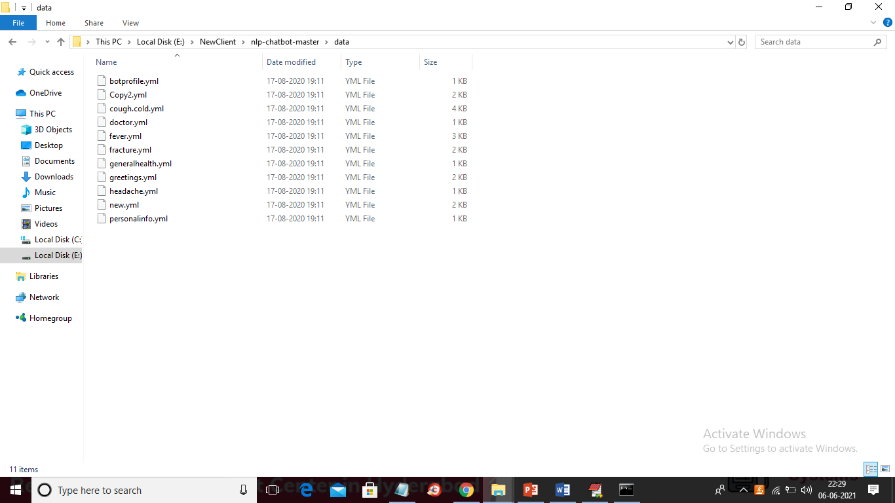

To run project install all packages given in ‘requirement.txt’ file and then double click on ‘run.bat’ file to get below screen which start FLASK server

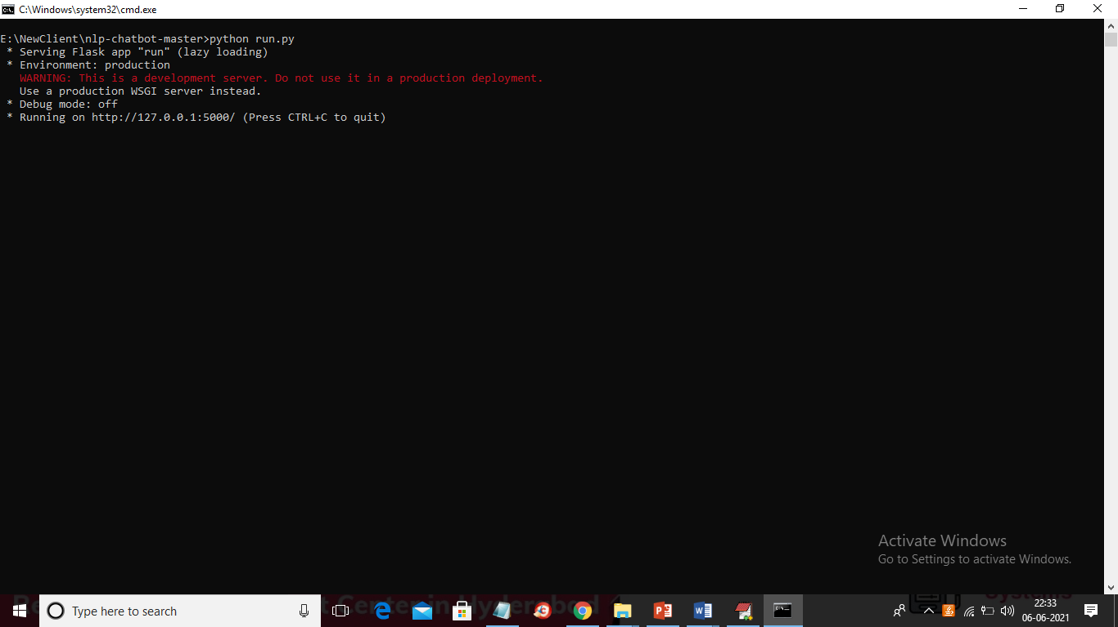

In above screen flask server started and now open browser and then enter URL as <http://127.0.0.1:5000> and press enter key to get below home page

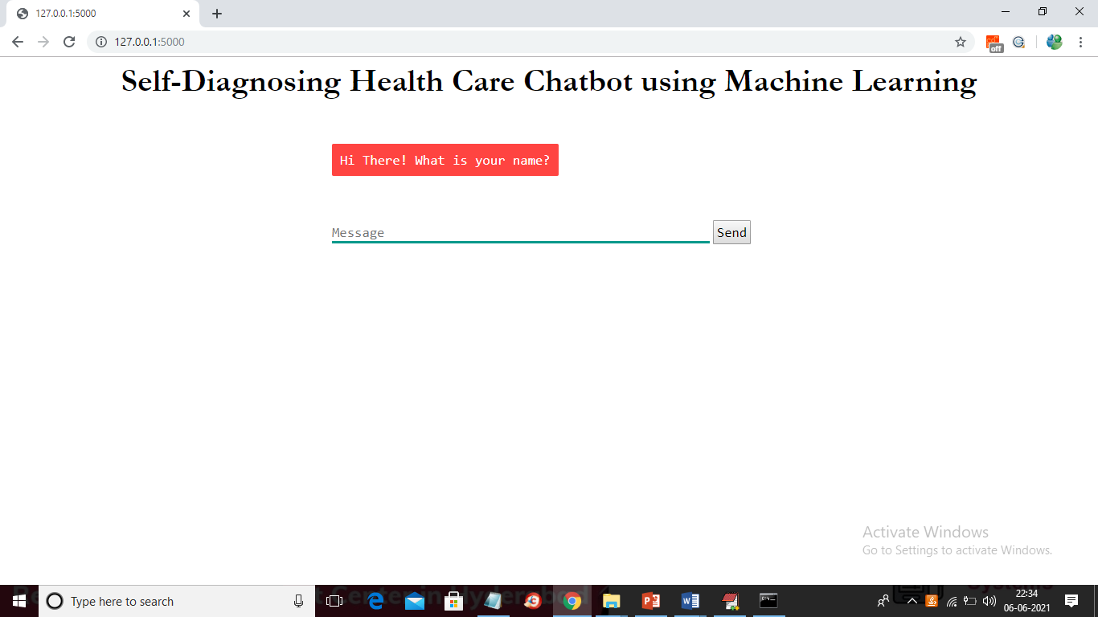

In above screen you can ask question then chat bot will answer

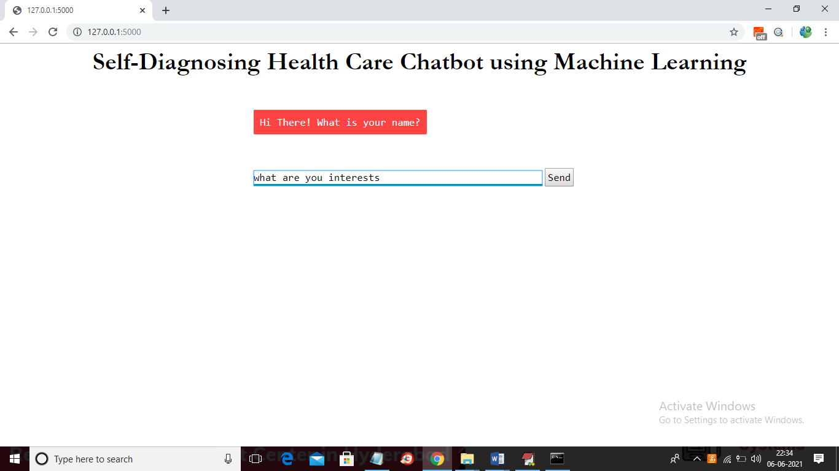

In above screen I entered some question and press ‘Send’ button to get below response

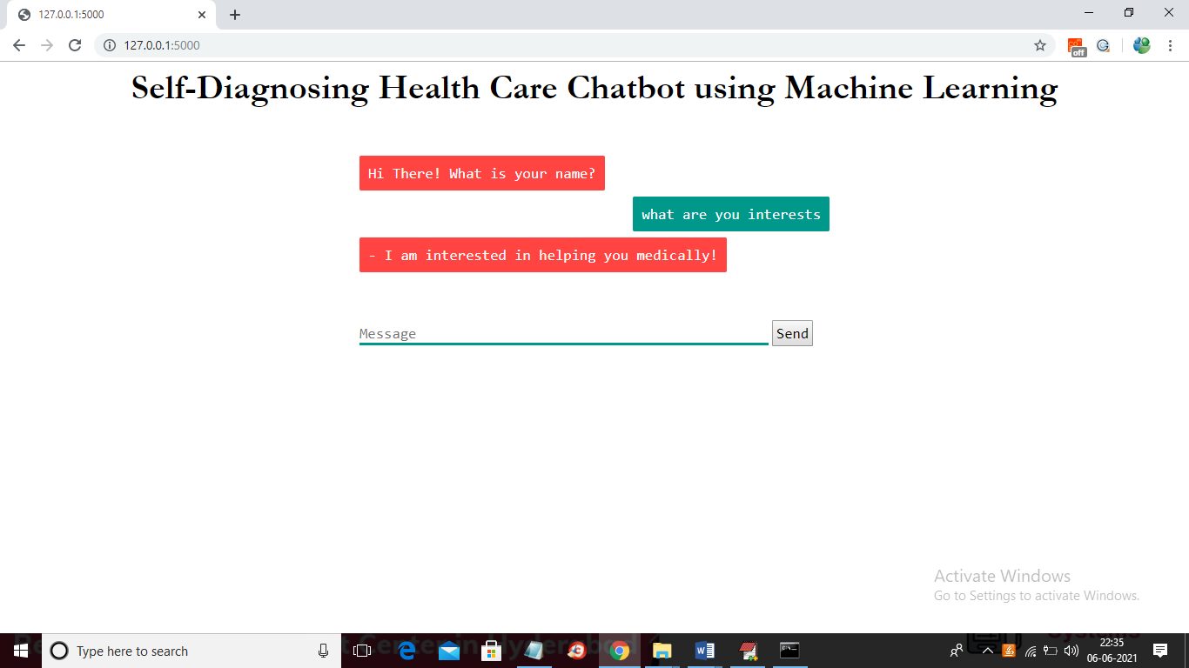

In orange colour text you can see response from chat bot and now ask series of question

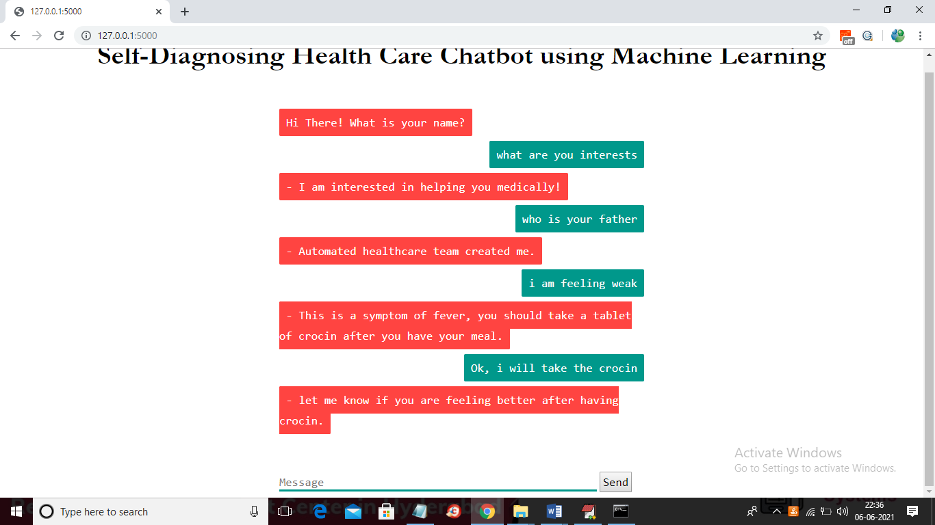

In above screen I ask some series of questions and then got response from chat bot. Similarly you can ask any question and if question available in train data then chat bot will respond