# YARN(Yet Another resource negotiator)

## YARN Architecture

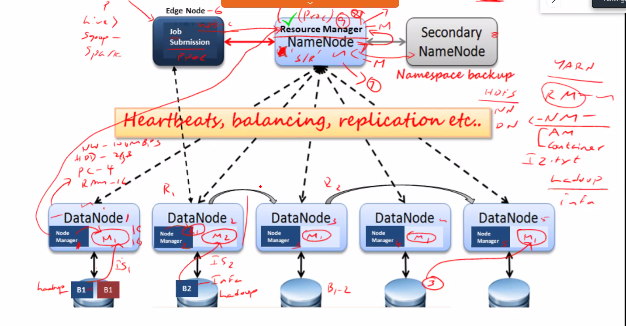

HDFS (only to get and put data in HDFS)

Edge Node 🡪 NameNode 🡪 DataNode

Master 🡪 NameNode

Slave 🡪 DataNode

YARN (Only for processing jobs)

Edge 🡪 ResourceManager 🡪 NodeManager

Master 🡪 ResourceManager

Slave 🡪 NodeManager