Mee goreng is a spicy noodle dish originally from Indonesia. It is stir- fried over a high heat with a special paste and prawn fritters. Commonly sold in Malaysia and Singapore.

Fresh produce markets

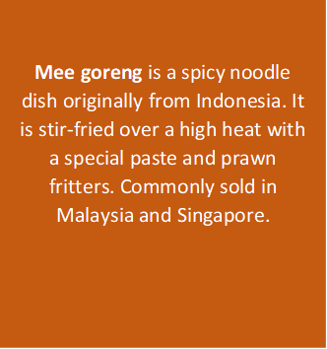

**Mee goreng** is a spicy noodle dish originally from Indonesia. It is stir-fried over a high heat with a special paste and prawn fritters. Commonly sold in Malaysia and Singapore.

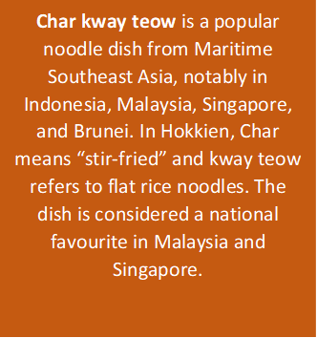

**Char kway teow** is a popular noodle dish from Maritime Southeast Asia, notably in Indonesia, Malaysia, Singapore, and Brunei. In Hokkien, Char means “stir-fried” and kway teow refers to flat rice noodles. The dish is considered a national favourite in Malaysia and Singapore.

**Nasi lemak** is a Malay fragrant rice dish cooked in coconut milk and pandan leaf. It is commonly found in Malaysia, where it is considered the national dish; it is also the native dish in neighbouring areas with significant Malay populations such as Singapore; Brunei, and Southern Thailand

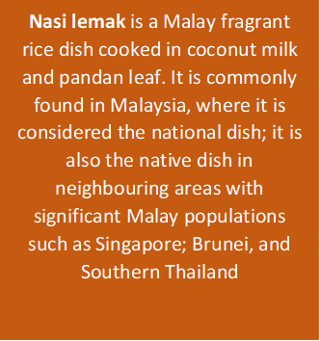

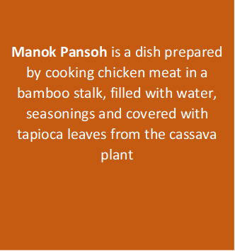

**Manok Pansoh** is a dish prepared by cooking chicken meat in a bamboo stalk, filled with water, seasonings and covered with tapioca leaves from the cassava plant

**Famed night markets** offering varied Southeast Asian street food cooked & sold from stalls. So many things to see from seafood, street food, souvenirs, salted fish, fruits and many more. Markets that will teach valuable things particularly the culture and a must visit place if you come to Borneo.

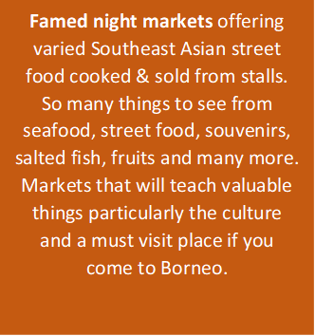

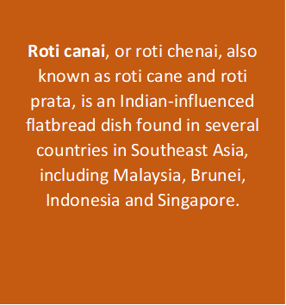

**Roti canai**, or roti chenai, also known as roti cane and roti prata, is an Indian-influenced flatbread dish found in several countries in Southeast Asia, including Malaysia, Brunei, Indonesia and Singapore.

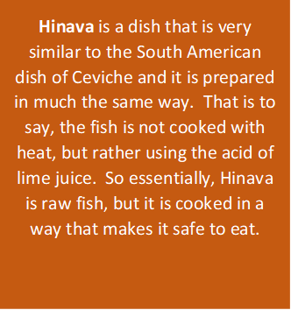

**Hinava** is a dish that is very similar to the South American dish of Ceviche and it is prepared in much the same way.  That is to say, the fish is not cooked with heat, but rather using the acid of lime juice.  So essentially, Hinava is raw fish, but it is cooked in a way that makes it safe to eat.

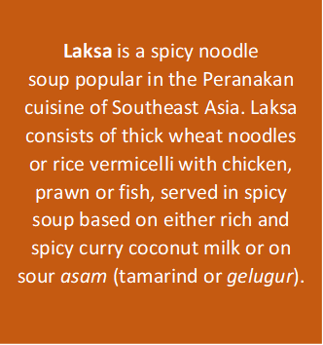

**Laksa** is a spicy noodle soup popular in the Peranakan cuisine of Southeast Asia. Laksa consists of thick wheat noodles or rice vermicelli with chicken, prawn or fish, served in spicy soup based on either rich and spicy curry coconut milk or on sour *asam* (tamarind or *gelugur*).

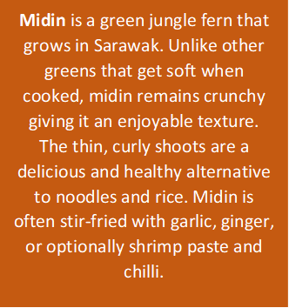



**Midin**is a green jungle fern that grows in Sarawak. Unlike other greens that get soft when cooked, midin remains crunchy giving it an enjoyable texture. The thin, curly shoots are a delicious and healthy alternative to noodles and rice. Midin is often stir-fried with garlic, ginger, or optionally shrimp paste and chilli.