ROOTME
QUESTION1: how many ports are open
we use nmap port scan nmap ip adress -sV
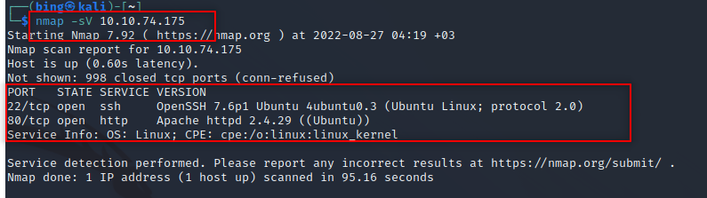
and we find that we have 2 open ports

ANSWER: 2

QUESTION2: what version of Apache is running
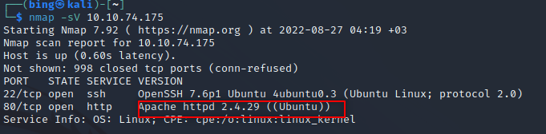
ANSWER: 2.4.29

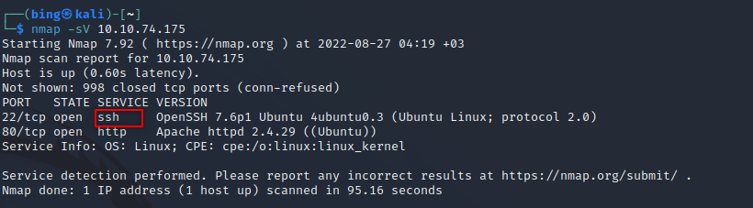
QUESTION3: what service is running on port 22
ANSWER: ssh

QUESTION4,5:what is the hidden directory

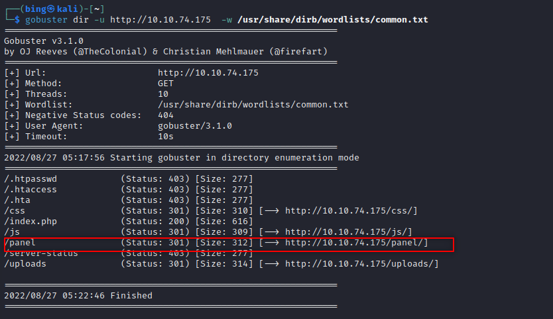
ANSWER: / panel /

QUESTION6: find the flag

First we should find the php reverse shell file then we should open the new text editor and name that “rootme.php5”. We should copy the php reverse shell file and paste to rootme.php5 then change IP address to our IP address.

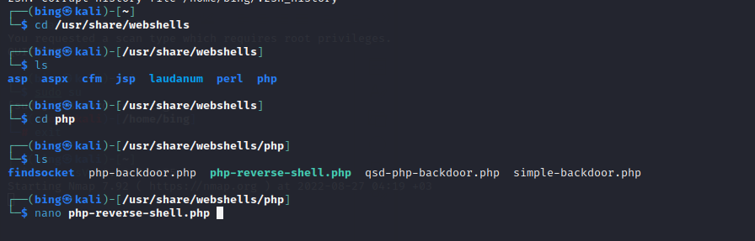
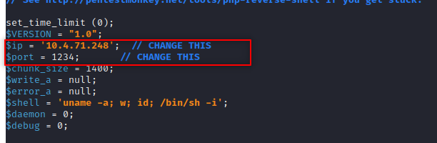

After this we will upload it to the site after this we should listen to port 1234 nc -nvlp 1234 now we are listening to port

we should find the user.txt file and open it

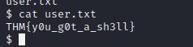

ANSWER: THM{y0u_g0t_a_sh3ll}

