ADVENT OF CYBER 2

DAY1:

Firstly, we should write our IP adress and enter the website.Then we should register and login there.

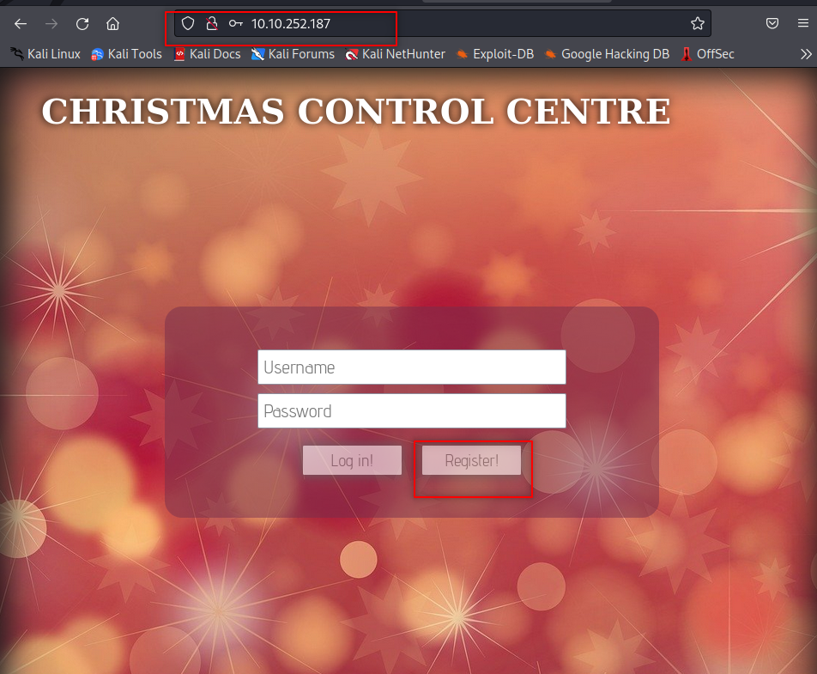

QUESTION 1,2,3

After logging in we use F12 to view Browser’s Developer Tools we go to Storage and click on cookies now we see name and value of cookie.

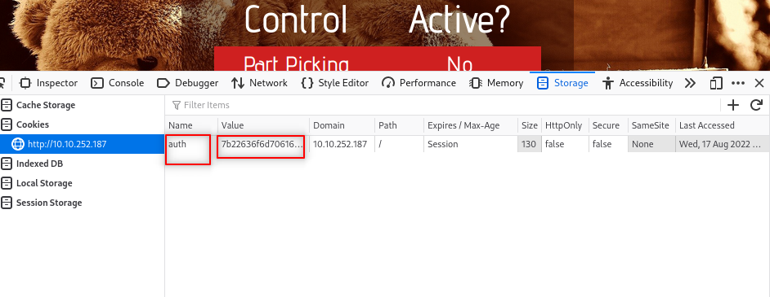

Answer: auth and hexadecimal

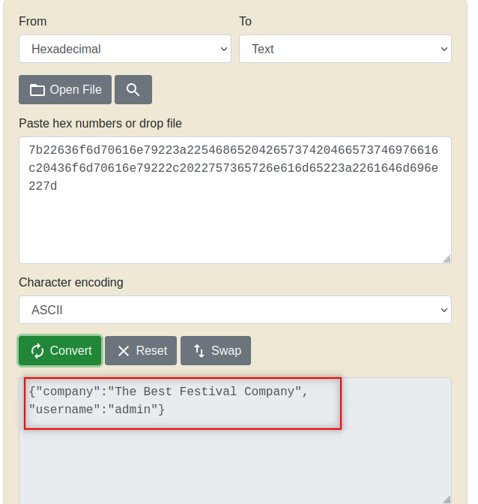
QUESTION 4
We copy the value and convert it from hexadecimal to text format

ANSWER: JSON

QUESTION 5

We changed username admin to “santa” and decoded it again

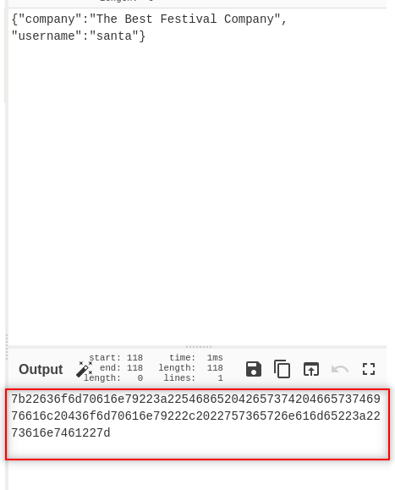

ANSWER: 7b22636f6d70616e79223a22546865204265737420466573746976616c20436f6d70616e79222c2022757365726e616d65223a2273616e7461227d

QUESTION 6

After finding Santa’s cookie value we come back to developer tools and change it with this value
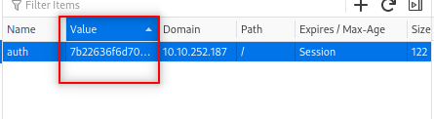

Then when we refresh the site we will have our flag
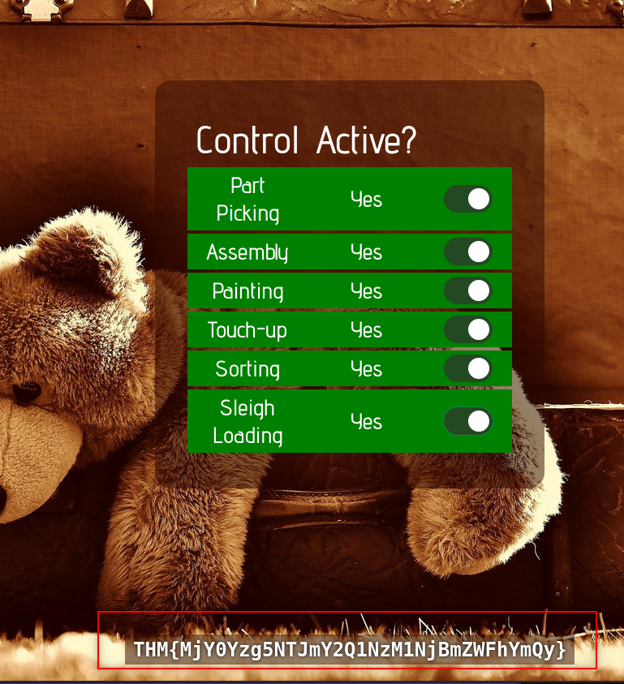

ANSWER : THM{MjY0Yzg5NTJmY2Q1NzM1NjBmZWFhYmQy}

