Screenshot 1 (a): Successful Register
POST http://localhost:5050/api/auth/register - 201 Created
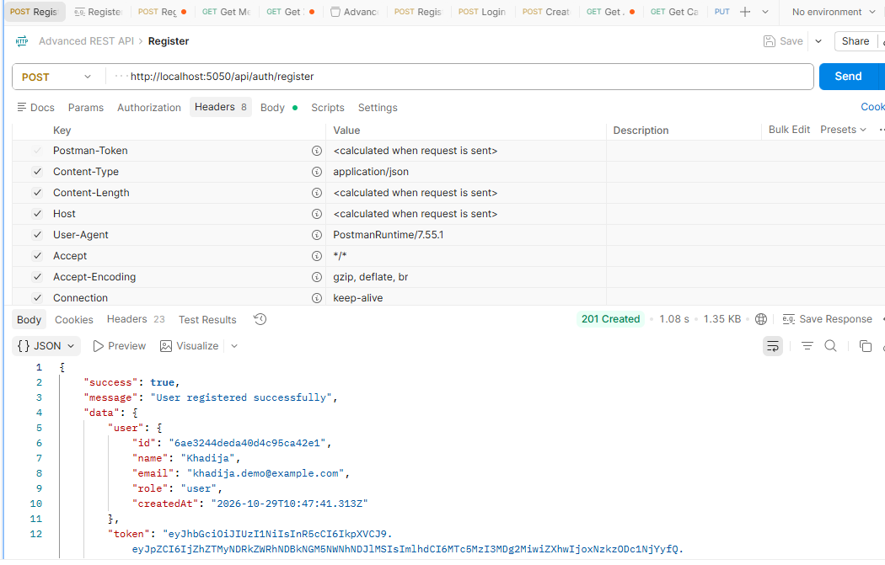
Screenshot 1 (b): Successful Login
POST http://localhost:5050/api/auth/login - 200 OK
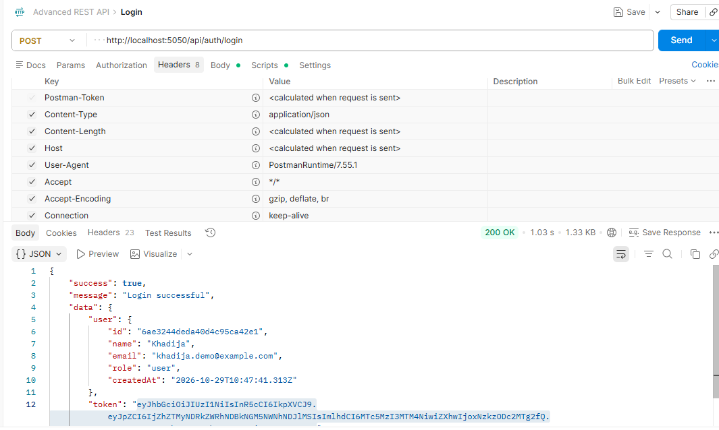
Screenshot 2: Create Category
POST http://localhost:5050/api/categories - 201 Created
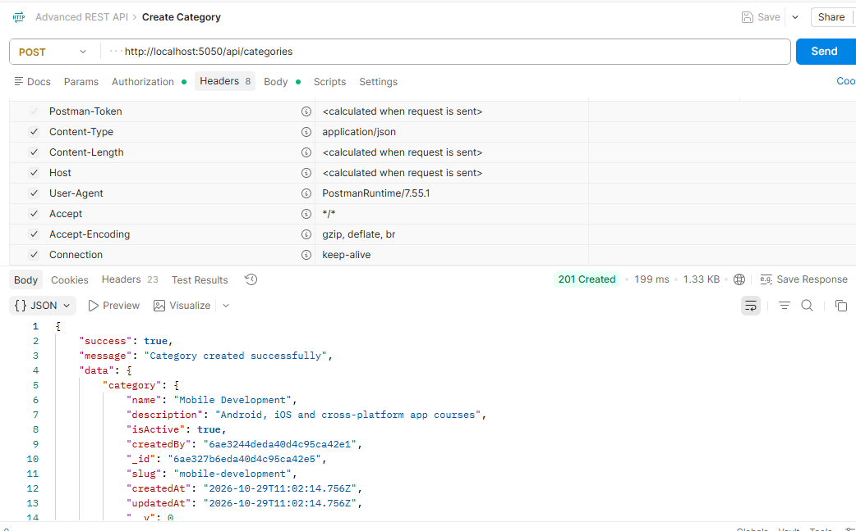
Screenshot 3: Get All Categories
GET http://localhost:5050/api/categories - 200 OK
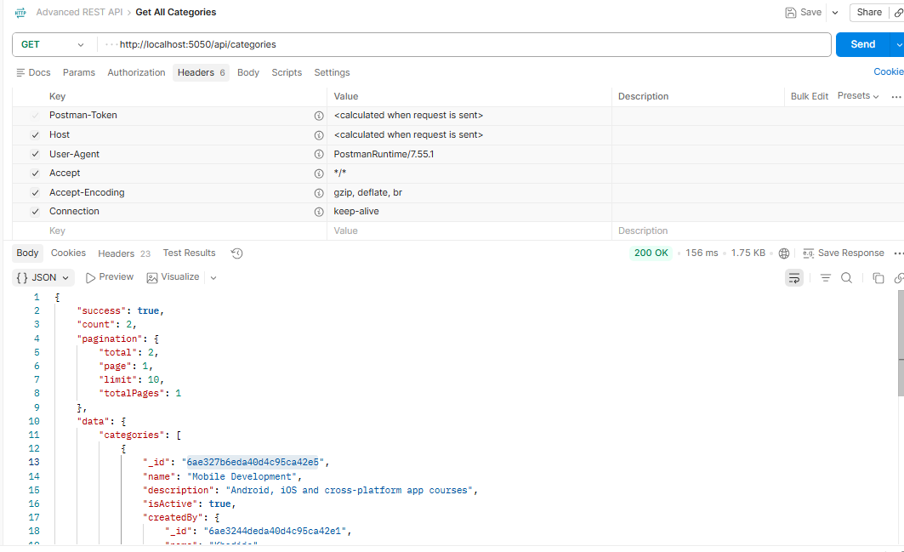
Screenshot 4: Validation Error (required field missing)
POST http://localhost:5050/api/auth/register - 400 Bad Request
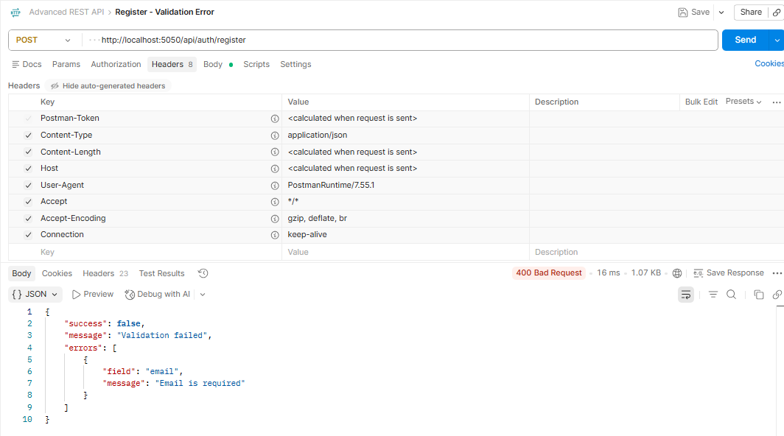
Screenshot 5 (a): Route Not Found (unknown URL)
GET http://localhost:5050/api/unknown - 404 Not Found
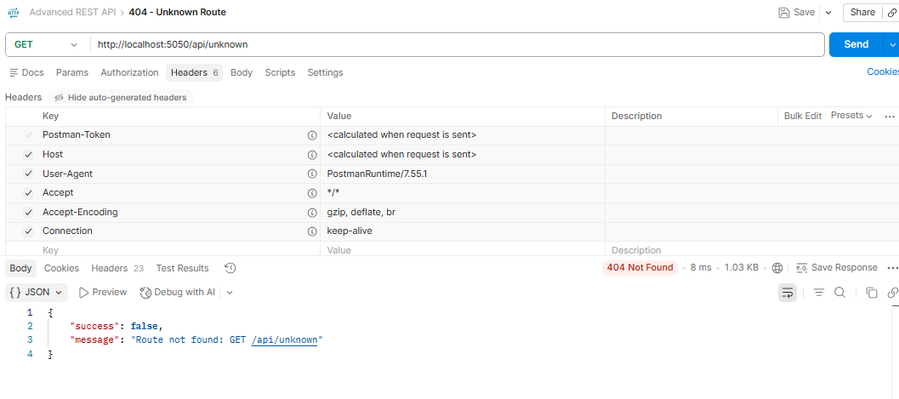
Screenshot 5 (b): Not Found (ID does not exist)
GET http://localhost:5050/api/categories/000000000000000000000000 - 404 Not Found
