

From:
Netflix Support <netflixsupportverify@gmail.com>
To:
customer@gmail.com
Date:
June 28, 2026
Subject:
Your Netflix Subscription Has Expired

--------------------------------------------------------
Dear Customer,
We noticed that your recent payment could not be processed.
To avoid interruption of your Netflix service, please verify your account information immediately.
Click the link below to restore access:

http://netflix-account-verify.xyz

Failure to verify within 24 hours will result in permanent suspension of your account.
Thank you.
Netflix Billing Department

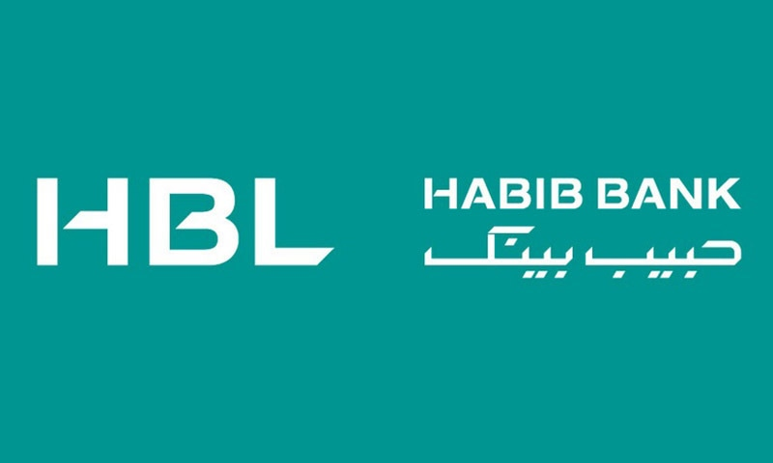
From:
HBL Security Team <hblsecurityverify@gmail.com>
To:
customer@gmail.com
Date:
June 28, 2026
Subject:
Your HBL Online Banking Account Has Been Locked

Dear Customer,
We detected multiple suspicious logins attempts on your HBL account.
To protect your account, online banking services have been suspended.
Please verify your identity immediately by clicking the secure link below:

https://secure-hbl-login.xyz

Failure to complete verification within 12 hours may result in permanent account suspension.
Thank you,
HBL Online Security Team

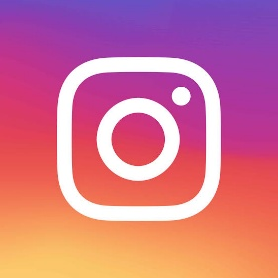
From:
Instagram Security <instagramverify@gmail.com>
To:
customer@gmail.com
Date:
June 28, 2026

Subject:
Suspicious Login Attempt Detected

Dear User,
Someone attempted to sign in to your Instagram account from an unknown device.
If this wasn't you, verify your account immediately using the secure link below.

http://instagram-security-check.xyz

Failure to verify may result in temporary account suspension.
Thank you,
Instagram Security Team



From:
Amazon Customer Support <amazonsupportverify@gmail.com>
To:
customer@gmail.com
Date:
June 28, 2026

Subject:
Your Amazon Account Has Been Suspended

Dear Customer,
We detected unusual activity on your Amazon account. To continue shopping and protect your account, please verify your identity immediately.
Click the link below:

http://amazon-account-verify.xyz

Failure to verify within 24 hours may result in permanent account suspension.

Thank you,
Amazon Customer Support

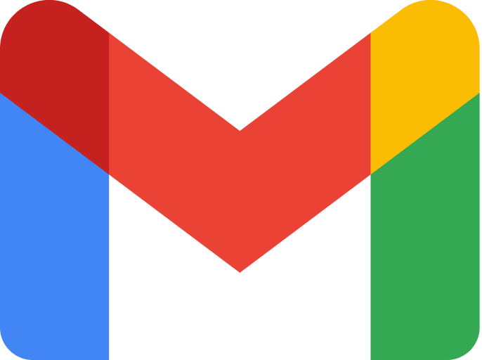
From:
Google Account Team <googleaccountverify@gmail.com>
To:
customer@gmail.com
Date:
June 28, 2026

Subject:
⚠ Your Google Account Will Be Disabled

Dear User,

We noticed unusual sign-in activity on your Google account. Please verify your account immediately to prevent permanent suspension.
Click below to secure your account:

http://google-account-security.xyz

Failure to verify within 24 hours will disable your Gmail services.
Thank you,
Google Account Protection Team

