

DECODELABS
Industrial Training Program 2026
CYBER SECURITY
Project 3
Phishing Awareness Analysis

Submitted By
Khadija Farooq

Batch
JUNE -2026

Powered By
DecodeLabs

Submission Date
June 2026

Acknowledgement
I would like to express my sincere gratitude to DecodeLabs for providing me with the opportunity to work on this Cyber Security project. This project helped me understand how phishing attacks are designed and how cybersecurity professionals analyze suspicious emails to protect users from online threats.
Through this project, I gained practical knowledge about phishing techniques, social engineering attacks, suspicious URLs, fake sender identities, and methods used by attackers to steal sensitive information. It also enhanced my analytical thinking and improved my ability to identify common phishing indicators.
I am thankful for the guidance, learning resources, and practical exposure provided during this training program. The knowledge and experience gained from this project will contribute significantly to my future career in Cyber Security.

Table of Contents
- Introduction
- Objectives
- Methodology
- Phishing Email Analysis – Netflix
- Phishing Email Analysis – HBL Bank
- Phishing Email Analysis – Instagram
- Phishing Email Analysis – Amazon
- Phishing Email Analysis – Google
- Conclusion
- Recommendations
- References

Introduction
Phishing is one of the most common forms of cybercrime and is considered a major threat to both individuals and organizations. It is a type of social engineering attack in which cybercriminals impersonate trusted organizations such as banks, online shopping platforms, social media companies, or email service providers to trick users into revealing sensitive information. This information may include usernames, passwords, banking credentials, credit card details, or other confidential data.
Phishing attacks are commonly delivered through emails, text messages, or fake websites that appear legitimate. These messages often create a sense of urgency, fear, or excitement to manipulate users into clicking malicious links or downloading harmful attachments. Once the victim interacts with the phishing content, attackers may gain unauthorized access to personal accounts, financial information, or organizational systems.
The purpose of this project is to analyze simulated phishing emails and identify the indicators that reveal malicious intent. Five different phishing email scenarios representing well-known organizations were created and examined. Each email was analyzed to identify suspicious sender addresses, deceptive URLs, social engineering techniques, urgent language, and requests for sensitive information.
By performing this analysis, users can better understand how phishing attacks operate and learn practical techniques to recognize and avoid such cyber threats. Developing phishing awareness is an essential step toward improving cybersecurity knowledge and reducing the risk of successful cyberattacks.

Objectives
The primary objective of this project is to develop practical knowledge of phishing awareness by analyzing simulated phishing emails and identifying common indicators of cyberattacks.
The specific objectives of this project are:
- To understand the concept of phishing and its impact on cybersecurity.
- To identify common phishing characteristics such as fake sender addresses, suspicious links, urgent language, and impersonation techniques.
- To analyze different phishing scenarios targeting various online services and organizations.
- To evaluate the potential risks associated with phishing attacks.
- To improve the ability to recognize malicious emails before interacting with them.
- To recommend appropriate security practices that can help users avoid phishing attacks.
- To enhance cybersecurity awareness through practical threat analysis.
- To develop analytical and critical thinking skills required for identifying online security threats.

Methodology
The methodology followed in this project was based on practical phishing email analysis. Instead of analysing real phishing emails, simulated phishing emails were created to represent realistic cyberattack scenarios involving well-known organizations such as Netflix, HBL Bank, Instagram, Amazon, and Google.
The project was completed using the following steps:
- Selection of Organizations: Five popular online services were selected because they are commonly targeted in phishing campaigns.
- Creation of Simulated Phishing Emails: Realistic phishing emails were designed by including fake sender addresses, suspicious hyperlinks, urgent messages, and requests for account verification.
- Email Documentation: Each simulated phishing email was organized and documented with screenshots to represent how phishing messages typically appear to users.
- Threat Analysis: Every email was carefully examined to identify phishing indicators, including fake domains, suspicious URLs, social engineering techniques, impersonation, and requests for sensitive information.
- Risk Assessment: The potential impact and likelihood of each phishing attack were evaluated to determine the overall risk level.
- Security Recommendations: Appropriate preventive measures and cybersecurity best practices were suggested to help users recognize phishing attempts and protect their online accounts.
This methodology provided a structured approach for understanding phishing techniques and demonstrated how cybersecurity analysts evaluate suspicious communications to identify potential threats.

EMAIL 1: NETFLIX

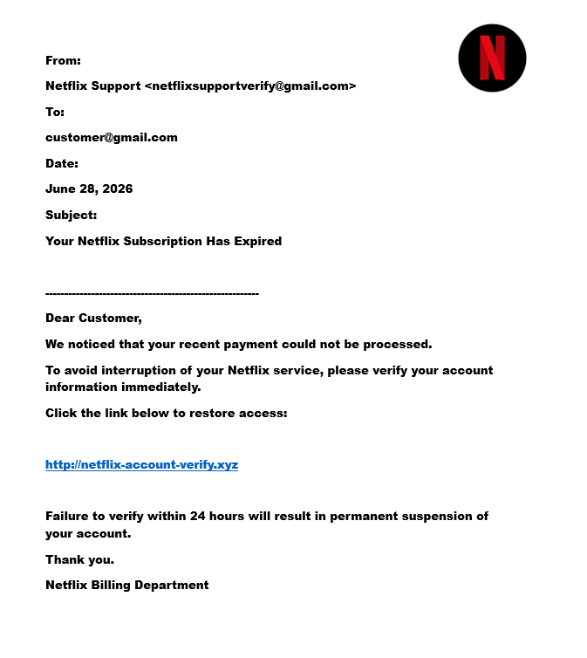

Email Analysis:
FIELD | DETAIL
COMPANY NAME | NETFLIX
SENDER EMAIL | netflixsupportverify@gmail.com
SUBJECT | Your Netflix Subscription Has Expired
ATTACK TYPE AND TARGET | Credential Phishing
RISK LEVEL | Credential Phishing

PHISHING INDICATORS:
RED FLAGS | INDICATOR
FAKE SENDER ADDRESS | The sender uses a Gmail account instead of an official @netflix.com domain. Legitimate Netflix emails are sent from company-owned domains.
Suspicious URL | The link http://netflix-account-verify.xyz does not belong to Netflix. The .xyz domain is commonly abused in phishing attacks.
URGENT LANGUAGE | The message pressures the user to act immediately by threatening account suspension within 24 hours.
REQUEST SENSITIVE INFORMATION | Users are instructed to verify their account information, which is a common phishing technique to steal login credentials.
IMPERSONATION | The attacker pretends to be Netflix to gain the victim's trust.

Threat Analysis:
The attacker attempts to create panic by claiming that the user's Netflix subscription has expired. The email encourages the recipient to click a malicious link and enter sensitive account credentials. If the victim follows the instructions, their username and password may be stolen.

Possible Consequences
- Netflix account compromise
- Password theft
- Financial loss (if payment information is entered)
- Identity theft
- Unauthorized access to personal information

Risk Assessment
Category | Level
Risk Level | = High
Likelihood | = High
Impact = | High

Recommended Actions
- Never click suspicious links.
- Verify the account only through the official Netflix website.
- Report the email as phishing.
- Delete the email immediately.
- Enable Multi-Factor Authentication (MFA).

Final Verdict
This email is a phishing attempt because it uses social engineering techniques, a fake sender address, a suspicious website, and urgency to trick users into revealing sensitive information. Users should avoid interacting with the email and report it immediately.
EMAIL 2: HBL
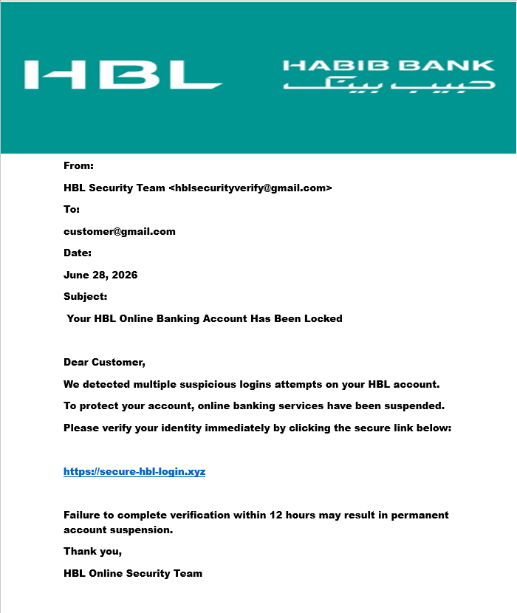

EMAIL OVERVIEW:
FIELD | DETAIL
COMPANY NAME | HBL Bank
SENDER EMAIL | hblsecurityverify@gmail.com
SUBJECT | Your HBL Online Banking Account Has Been Locked
ATTACK TYPE AND TARGET | Banking Credential Phishing  Online Banking Customers
RISK LEVEL | Critical

REG FLAGS:
- Gmail address instead of an official @hbl.com domain.
- Fake banking verification link.
- Threat of account suspension.
- Creates urgency.
- Requests identity verification
Threat Analysis
This phishing email impersonates HBL Bank and attempts to steal online banking credentials. Victims who enter their banking username, password, or OTP could lose access to their bank accounts and suffer financial loss.
Possible Consequences
- Banking credential theft
- Financial fraud
- Unauthorized transactions
- Identity theft
- Loss of confidential financial information
Risk Assessment
Critical Risk
Recommended Actions
- Never click the link.
- Contact HBL through official channels.
- Report the phishing email.
- Delete the message.
- Enable two-factor authentication.
Final Verdict
This is a banking phishing attack designed to steal customer credentials and should be treated as a critical security threat..

EMAIL 3: INSTAGRAM
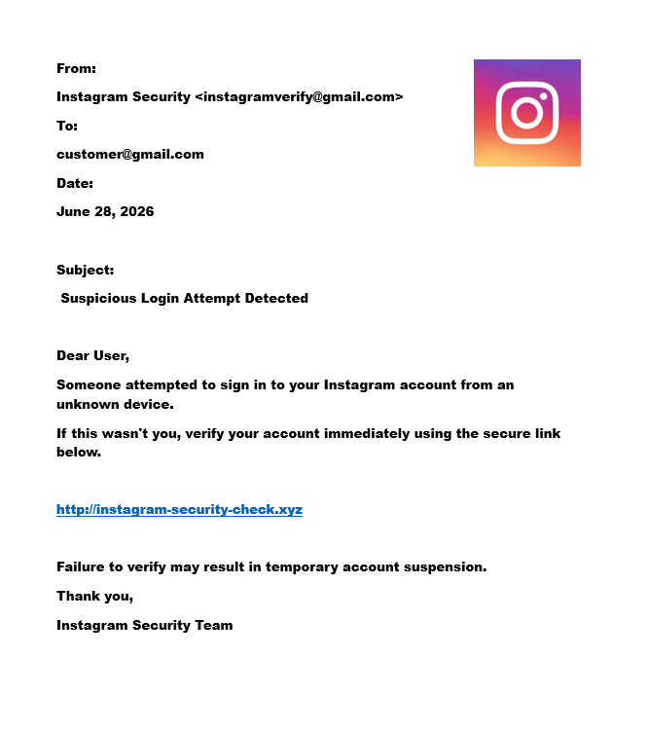

EMAIL OVERVIEW:
FIELD | DETAILS
COMPANY NAME | Instagram
SENDER EMAIL | instagramverify@gmail.com
SUBJECT | Suspicious Login Attempt Detected
ATTACK TYPE AND TARGET | Social Media Credential Phishing  Instagram Users
RISK LEVEL | High
PHISING INDICATOR:
RED FLAG | EXPLANATION
Fake Sender Address | The email is sent from a Gmail account instead of an official @instagram.com domain. Legitimate Instagram security emails are always sent from official company domains.
Suspicious URL | The provided link does not belong to Instagram. Attackers often use fake domains to steal usernames and passwords.
Urgent Language | The email creates fear by claiming that someone attempted to access the user's account and asks for immediate verification.
Requests Sensitive Information | The email asks the recipient to verify their account, which usually leads victims to enter their login credentials on a fake website.
Impersonation | The attacker pretends to be Instagram Security to gain the user's trust.

Threat Analysis
This phishing email attempts to convince users that their Instagram account is under attack. By creating panic and urgency, the attacker tricks victims into clicking a malicious link. If users enter their credentials, attackers can gain full control of their Instagram account.

Possible Consequences
- Instagram account hijacking
- Loss of personal photos and messages
- Fake posts or scams sent from the victim's account
- Password theft
- Privacy breach

Risk Assessment
Category | Level
Risk Level | High
Likelihood | High
Impact | Medium to High

Recommended Actions
- Never click suspicious verification links.
- Log in only through the official Instagram website or mobile application.
- Change your password immediately if you suspect phishing.
- Enable Multi-Factor Authentication (MFA).
- Report the email as phishing.
Final Verdict
This email is a phishing attempt because it impersonates Instagram and uses fear, urgency, and a fake verification link to steal user login credentials. Users should avoid clicking the link and report the message immediately.

Security Tip
Always verify login alerts directly from the official Instagram app instead of clicking links received through emails.

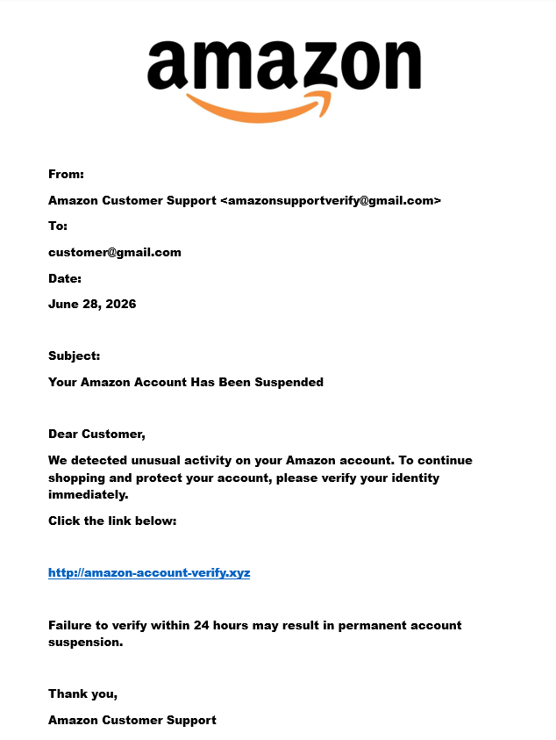
EMAIL 4: AMAZON
EMAIL OVERVIEW:
FIELDS | DETAILS
COMPANY NAME | AMAZON
SENDER EMAIL | amazonsupportverify@gmail.com
SUBJECT | Your Amazon Account Has Been Suspended
ATTACK TYPE NAD TARGET | E-commerce Credential Phishing  Amazon Customers
RISK LEVEL | High

PHISHING INDICATOR:
RED FLAGS | EXPLANATION
Fake sender address | Amazon never sends important account notifications from Gmail addresses. Official emails come from Amazon-owned domains.
Suspicious URL | The verification link uses a fake domain instead of the official Amazon website.
Urgent language | The email pressures users to verify their account immediately to avoid suspension.
Request personal information | Victims are asked to verify account details, which may lead to credential theft.
Impersonation | The attacker impersonates Amazon Customer Support to appear trustworthy.

Threat Analysis
The attacker attempts to scare users into believing that their Amazon account has been suspended. Victims who click the malicious link may unknowingly provide their Amazon login credentials, allowing attackers to access personal information, saved payment methods, and order history.

Possible Consequences
- Amazon account compromise
- Unauthorized purchases
- Exposure of saved payment methods
- Theft of personal information
- Financial loss
Risk Assessment
Category | Level
Risk Level | High
Likelihood | High
Impact | High

Recommended Actions
- Do not click suspicious links.
- Access Amazon only through the official website.
- Change your password if you accidentally entered your credentials.
- Enable Multi-Factor Authentication (MFA).
- Report the phishing email.
Final Verdict
This email is a phishing attack designed to steal Amazon account credentials by creating urgency and directing users to a fake website. Users should ignore the email and verify account information only through Amazon's official website.

Security Tip
Never verify shopping accounts through links in unexpected emails. Always type the official Amazon website address directly into your browser.

EMAIL 5 GOOGLE:
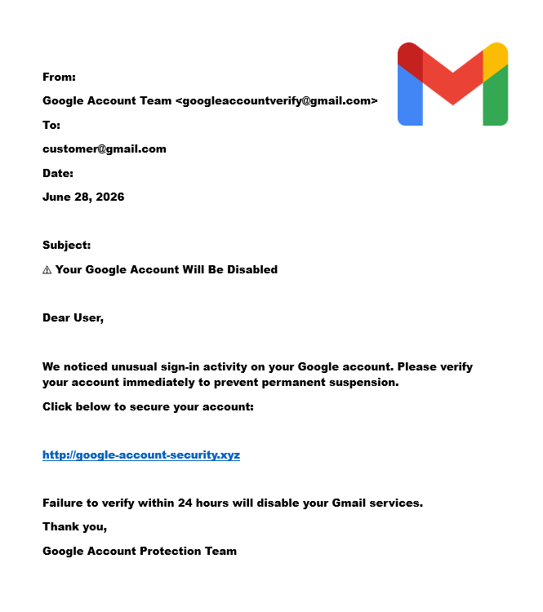

EMAIL OVERVIEW:
FIELD | DETAILS
COMPANY NAME | Google
SENDER EMAIL | googleaccountverify@gmail.com
SUBJECT | Your Google Account Will Be Disabled
ATTACK TYPE AND TARGET | Google Account Credential Phishing  Google Account Users
RISK LEVEL | Critical

PHISHING INDICATOR:
RED FLAGS | EXPLANATION
Fake sender address | The sender uses a Gmail address instead of an official Google security domain. Official Google notifications are sent from verified Google domains.
Suspicious URL | The email contains a fake verification link instead of directing users to the official Google Accounts website.
Urgent language | The message threatens account suspension within 24 hours, encouraging users to react without verifying the information.
Request sensitive information | Users are instructed to verify their account credentials, which is a common phishing tactic.
Impersonation | The attacker pretends to represent Google's Account Protection Team to gain trust
Threat Analysis
This phishing email attempts to steal Google account credentials by convincing users that their account will be disabled. Since Google accounts provide access to Gmail, Google Drive, Google Photos, and other services, compromising one account can expose a significant amount of sensitive information.

Possible Consequences
- Gmail account compromise
- Loss of access to Google Drive files
- Exposure of personal photos and documents
- Unauthorized access to other linked Google services
- Identity theft

Risk Assessment
Category | Level
Risk Level | Critical
Likelihood | High
Impact | Very High

Recommended Actions
- Never click suspicious verification links.
- Sign in only through the official Google Accounts website.
- Enable Multi-Factor Authentication (MFA).
- Change your password immediately if you suspect compromise.
- Report the email as phishing and delete it.

Final Verdict
This email is a highly dangerous phishing attempt that impersonates Google to steal user credentials. Because a Google account provides access to multiple services, compromising it can result in serious privacy, financial, and security risks.
Security Tip
Always check the sender's email address carefully and access your Google account by typing accounts.google.com directly into your browser instead of using links from emails.

Conclusion
Phishing remains one of the most common and dangerous cyber threats because it exploits human trust rather than technical vulnerabilities. Throughout this project, five simulated phishing emails representing different organizations were analyzed to identify common phishing techniques and security risks.
The analysis showed that phishing emails often contain fake sender addresses, suspicious URLs, urgent language, requests for sensitive information, and social engineering tactics designed to manipulate users into revealing confidential data. These indicators make phishing attacks highly effective against unsuspecting users.
This project enhanced practical knowledge of phishing detection and demonstrated the importance of carefully examining emails before responding or clicking any links. Developing awareness of phishing indicators is one of the most effective ways to reduce cyber risks and improve personal and organizational security.

Recommendations
To reduce the risk of phishing attacks, the following security practices are recommended:
- Always verify the sender's email address before responding to any email.
- Never click suspicious or shortened links received through unsolicited emails.
- Access websites by typing the official URL directly into the browser.
- Avoid sharing passwords, OTPs, or personal information through email.
- Enable Multi-Factor Authentication (MFA) on all important accounts.
- Keep operating systems, browsers, and antivirus software updated.
- Report suspected phishing emails to the appropriate service provider or IT department.
- Conduct regular cybersecurity awareness training to help users recognize phishing attempts.

References
- Google Safety Center – Online Security Best Practices
- Netflix Help Center – Account Security
- Amazon Customer Service – Account Protection
- HBL Digital Banking Security Guidelines
- Instagram Help Center – Account Security
- Cybersecurity and Infrastructure Security Agency (CISA) – Phishing Guidance
- OWASP Foundation – Phishing and Social Engineering Awareness

