Part 1: Concept Explanation
The Needleman-Wunsch Algorithm:
Example Sequences:
Let’s align "GATTACA" and "GCATGCU".Scoring: Match = +1, Mismatch = -1, Gap = -2
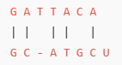
So, the alignment score is -8 for this alignment using the Needleman-Wunsch algorithm with the given scoring system.

Part 2: Hands-on Coding Exercise
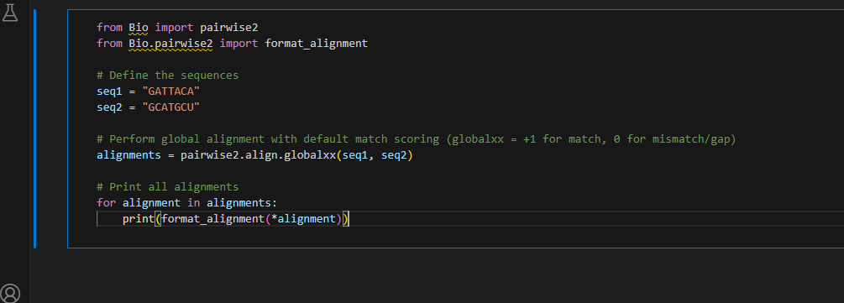
globalxx: This performs global alignment with match = +1 and all mismatches and gaps = 0 (good for quick matches only).
Output:
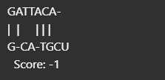

Part 3: Group Challenge & Exercises
We will align the sequences using:
- Match = +1
- Mismatch = -1
- Gap = -2
Group 1: "ATGC" vs. "AGC" Group 2: "GACT" vs. "GAT"
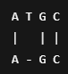
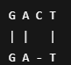 = 1
Group 3: "TGCAG" vs. "TGAC" Group 4 : "ACGTAC" vs. "ACTGAC"
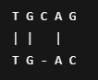
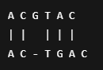

Scores:
Group 1: 1, Group 2:1, Group 3: 0, Group 4:1
Effect of Changing Gap Penalty:
Gap Penalty | Alignment Score (Group 1) | Comments
-1 | 2 | More tolerant of gaps
-2 | 1 | Balanced gaps and mismatches
-3 | 0 | Gaps become expensive
-5 | -2 | Alignment avoids gaps more

Why does increasing the gap penalty lead to shorter alignments?
Because the algorithm avoids inserting gaps to minimize the penalty, resulting in more direct matches/mismatches.
What happens when sequences do not align well?
The alignment score becomes low or negative, indicating poor similarity. More gaps and mismatches occur.
How does this algorithm differ from Smith-Waterman?
Needleman-Wunsch is for global alignment (entire sequence), while Smith-Waterman is for local alignment (best matching subsequence).

Individual Exercises
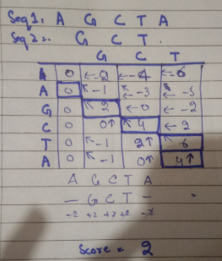
Exercise 1: Identify Optimal Alignment For "AGCTA" and "GCT", compute the optimal alignment score manually using match = 2, mismatch = -1, gap = -2.

Exercise 2: Custom Alignment Function Write a Python function that:
● Takes two sequences as input.
● Uses pairwise2.align.globalms() with custom scoring.
● Returns the best alignment only.

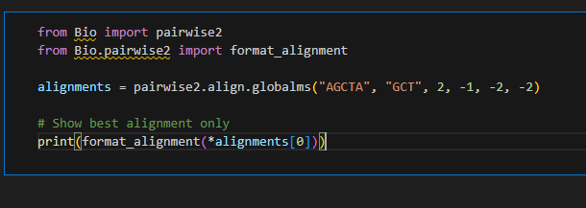

Output:
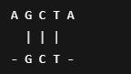
Score Calculation:
G-G: +2
C-C: +2
T-T: +2
A-Gap: -2
A-Gap: -2
Total Score = 2 + 2 + 2 - 2 - 2 = 2

Exercise 3: Effect of Gap Penalty
Gap Penalty | Alignment Score | Observation
-1 | 4 | More gaps accepted
-2 | 2 | Balanced
-3 | 0 | Fewer gaps, more mismatches
-5 | -2 | Gaps strongly discouraged

Higher gap penalty = fewer gaps but may lower score.
Lower gap penalty = longer alignment, possibly more biologically meaningful.

