Part no 1: Concept Explanation
Example Sequences: Let’s align "TGTTACGG" and "GGTTGACTA" using Smith-Waterman.
Scoring System:
● Match: +2
● Mismatch: -1
● Gap penalty: -2
Optimal Local Alignment:
 | - | G | G | T | T | G | A | C | T | A
- | 0 | 0 | 0 | 0 | 0 | 0 | 0 | 0 | 0 | 0
T | 0 | 0 | 0 | 2 | 2 | 0 | 0 | 0 | 2 | 0
G | 0 | 2 | 2 | 0 | 1 | 4 | 2 | 0 | 0 | 1
T | 0 | 0 | 1 | 4 | 2 | 2 | 2 | 0 | 2 | 0
T | 0 | 0 | 0 | 2 | 6 | 4 | 2 | 0 | 2 | 1
A | 0 | 0 | 0 | 0 | 4 | 3 | 6 | 4 | 2 | 4
C | 0 | 0 | 0 | 0 | 2 | 2 | 4 | 8 | 6 | 4
G | 0 | 2 | 2 | 0 | 0 | 4 | 2 | 6 | 6 | 5
G | 0 | 2 | 4 | 2 | 0 | 2 | 1 | 4 | 5 | 5

🔍 Maximum Score = 8
- Found at cell (6,7) → corresponds to the subsequence "ACGG" and "ACTA"

TGTTACGG
||||
GACTA Alignment Score: 4(-2) +2(-1)+2(2)=-8-2+4=-6

Part 2: Hands-on Coding Exercise
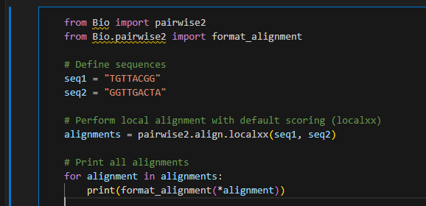
Output:
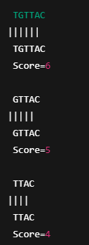
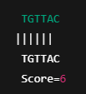
Many alignments exist, but the best one is below. Score = 6

Part 3: Group Challenge & Exercises
Each group aligns two short sequences manually using the scoring:
Match = +2, Mismatch = -1, Gap = -2
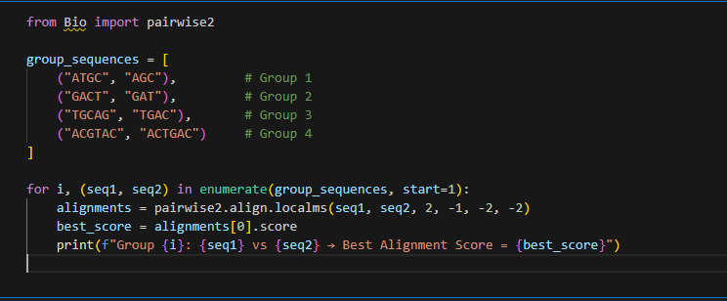
Output:
Group | Sequence 1 | Sequence 2 | Best Alignment Score
1 | ATGC | AGC | 4.0
2 | GACT | GAT | 4.0
3 | TGCAG | TGAC | 6.0
4 | ACGTAC | ACTGAC | 8.0

Discussion: How do gap penalties affect the alignment?
The alignment scores reflected how many matches were found after accounting for gap penalties.
If gap penalties were lower, the alignments might allow a few gaps to increase the match score.
If penalties were higher, the algorithm would avoid gaps—even if it meant missing a good match.

Individual Exercises
Exercise 1: Identify Best Local Alignment For "AGCTA" and "GCT", compute the best local alignment score manually using match = 2, mismatch = -1, gap = -2.
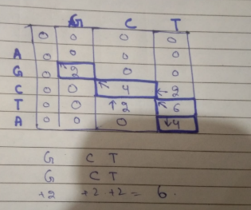
Exercise 2: Custom Alignment Function Write a Python function that: ● Takes two sequences as input. ● Uses pairwise2.align.localms() with custom scoring. ● Returns the best local alignment only.
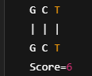
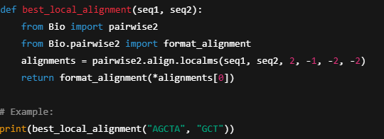

Exercise 3: Effect of Scoring System Run alignments with different gap penalties (-1, -2, -3, -5) and analyze how the results change.

- Higher penalties make gaps expensive, so the algorithm avoids them even if it means fewer matches.
- Lower penalties make gaps cheaper, so the algorithm may insert them to align more characters.
- The optimal penalty depends on the nature of sequences and biological context.

