

Name: Khadeeja Anjum
Roll no: 023
Section: A

1.Create a Solidity smart contract that uses a string array to store messages, emits an event whenever a new message is added, and provides functions to add and retrieve all messages.

CODE:

// SPDX-License-Identifier: MIT
pragma solidity ^0.8.0;

contract MessageLogger {
// Array to store messages
string[] private messages;

// Event emitted when a new message is added
event MessageAdded(address indexed sender, string message);

// Function to add a new message
function addMessage(string memory _message) public {
messages.push(_message);
emit MessageAdded(msg.sender, _message);
}

// Function to retrieve all messages
function getAllMessages() public view returns (string[] memory) {
return messages;
}
}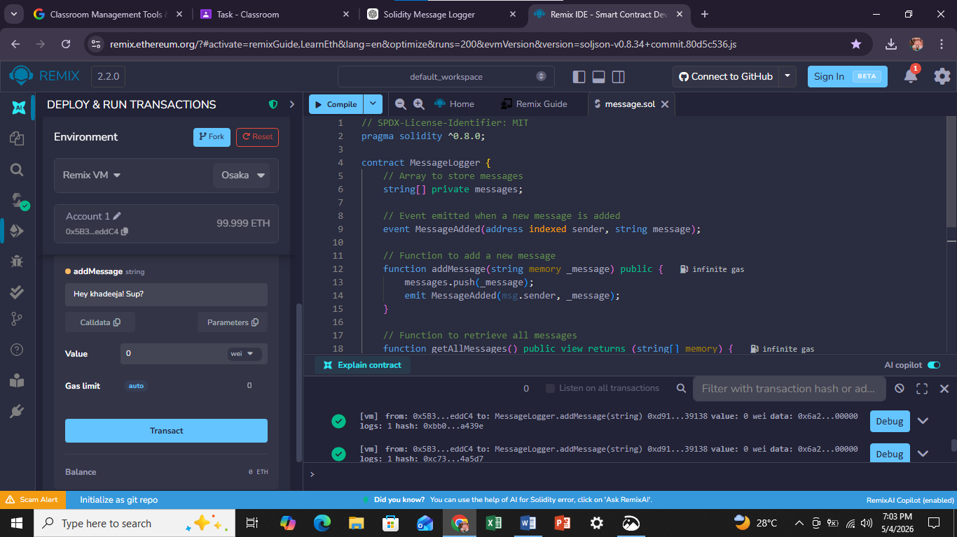
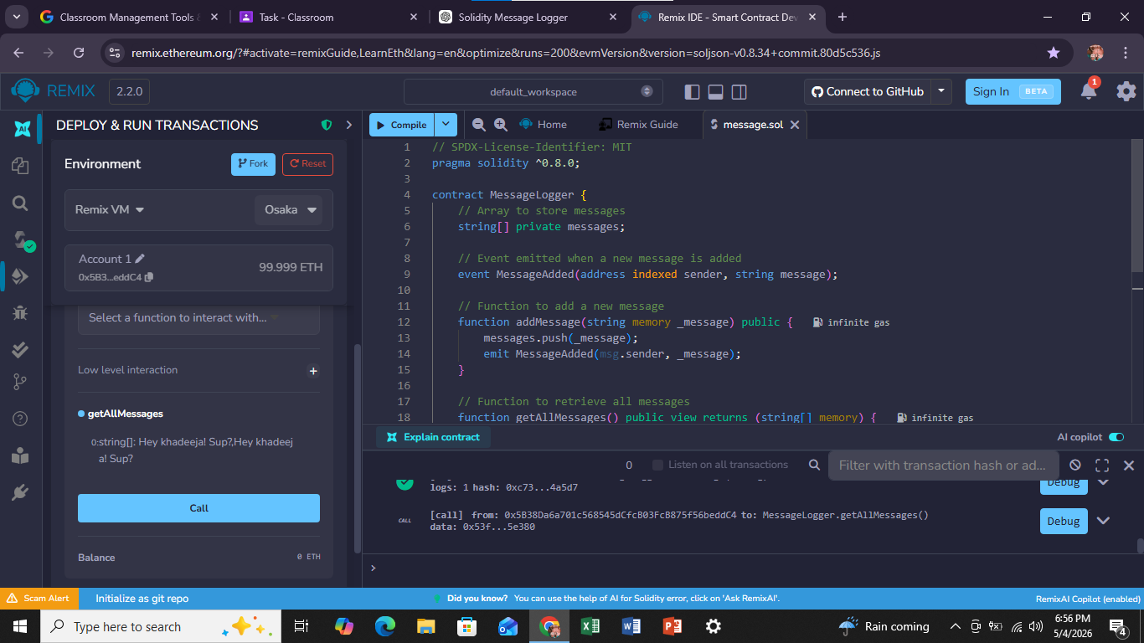

2.Modify the EventLogger contract to store each user’s messages in a mapping(address => string[]), emit an event on every message, and provide a function to retrieve messages for a specific user.

CODE:

// SPDX-License-Identifier: MIT
pragma solidity ^0.8.0;

contract EventLogger {
// Mapping from user address to their messages
mapping(address => string[]) private userMessages;

// Event emitted when a new message is added
event MessageAdded(address indexed user, string message);

// Function to add a message for the sender
function addMessage(string memory _message) public {
userMessages[msg.sender].push(_message);
emit MessageAdded(msg.sender, _message);
}

// Function to retrieve messages for a specific user
function getMessages(address _user) public view returns (string[] memory) {
return userMessages[_user];
}
}
