|  |  |
| --- | --- |
| Name | Khadija Azam |
| Ag # | 2018-ag-1762 |
| Section | B |
| Github ID | Khadijaazamuaf |

**Assignment week 1**

Question #1

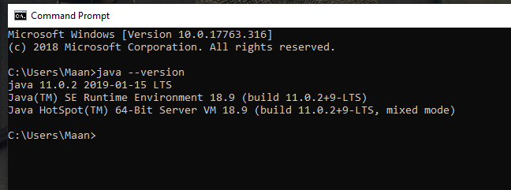

Question #2

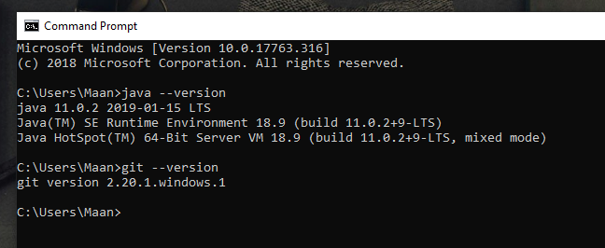

Question #3

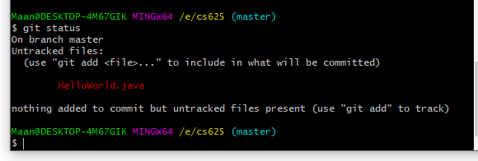

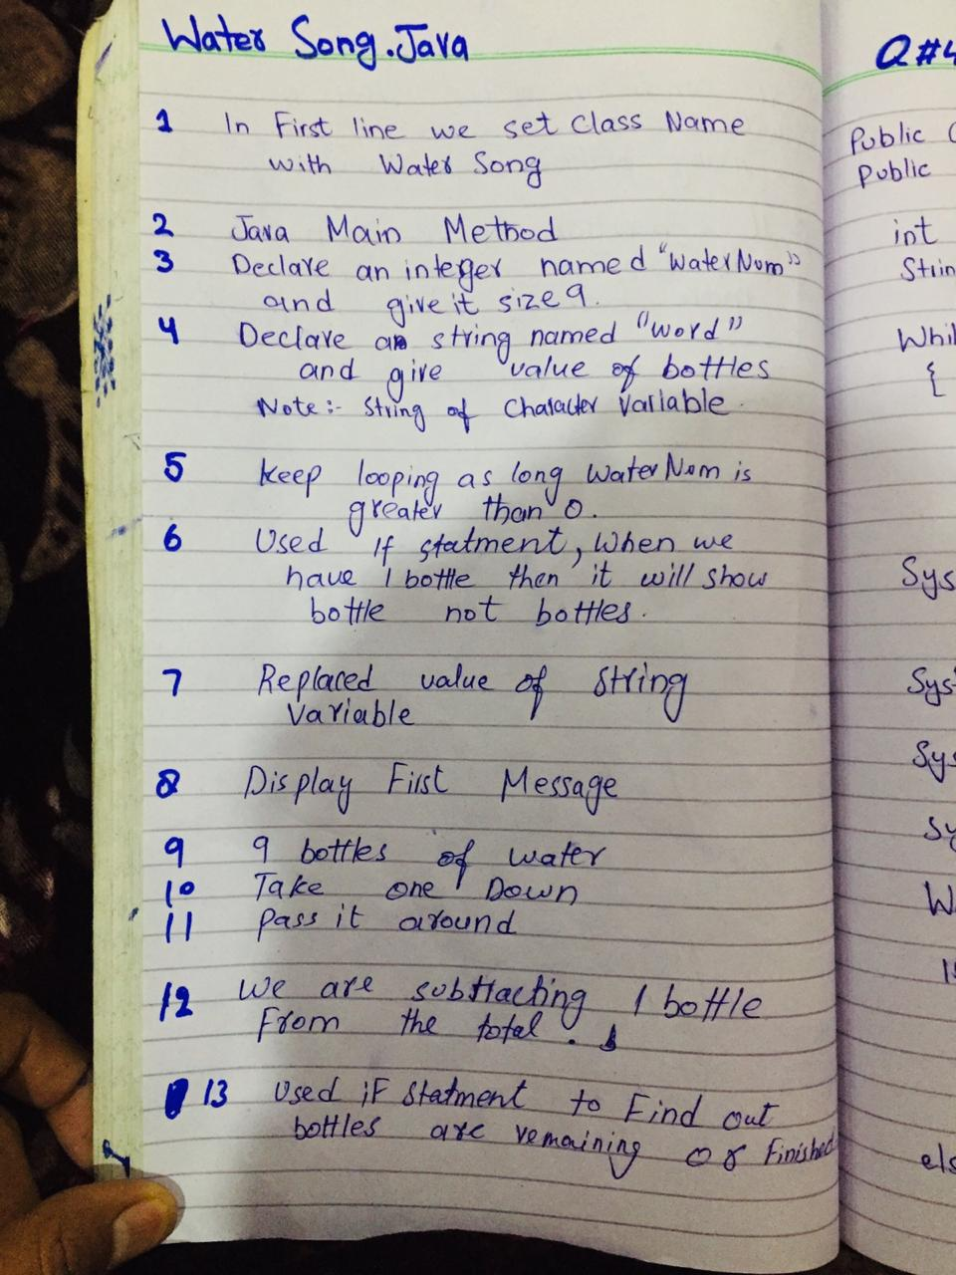

Question #4

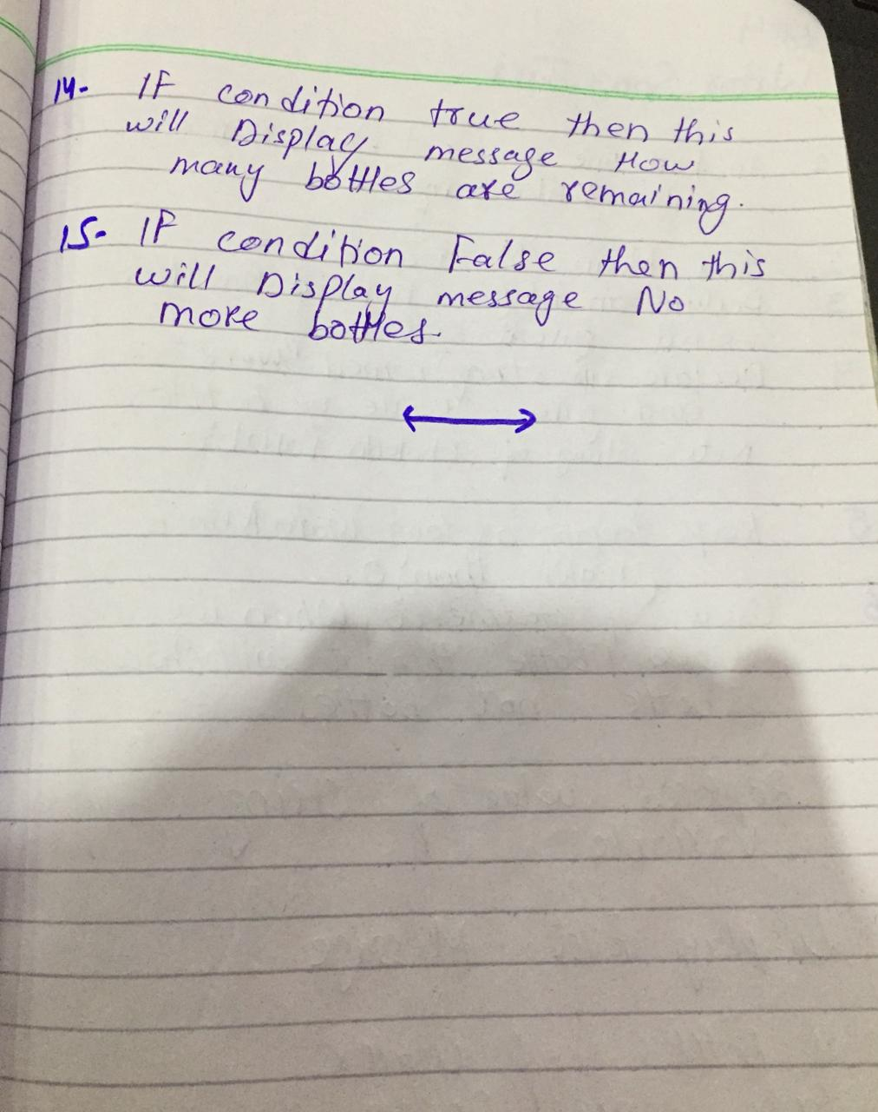

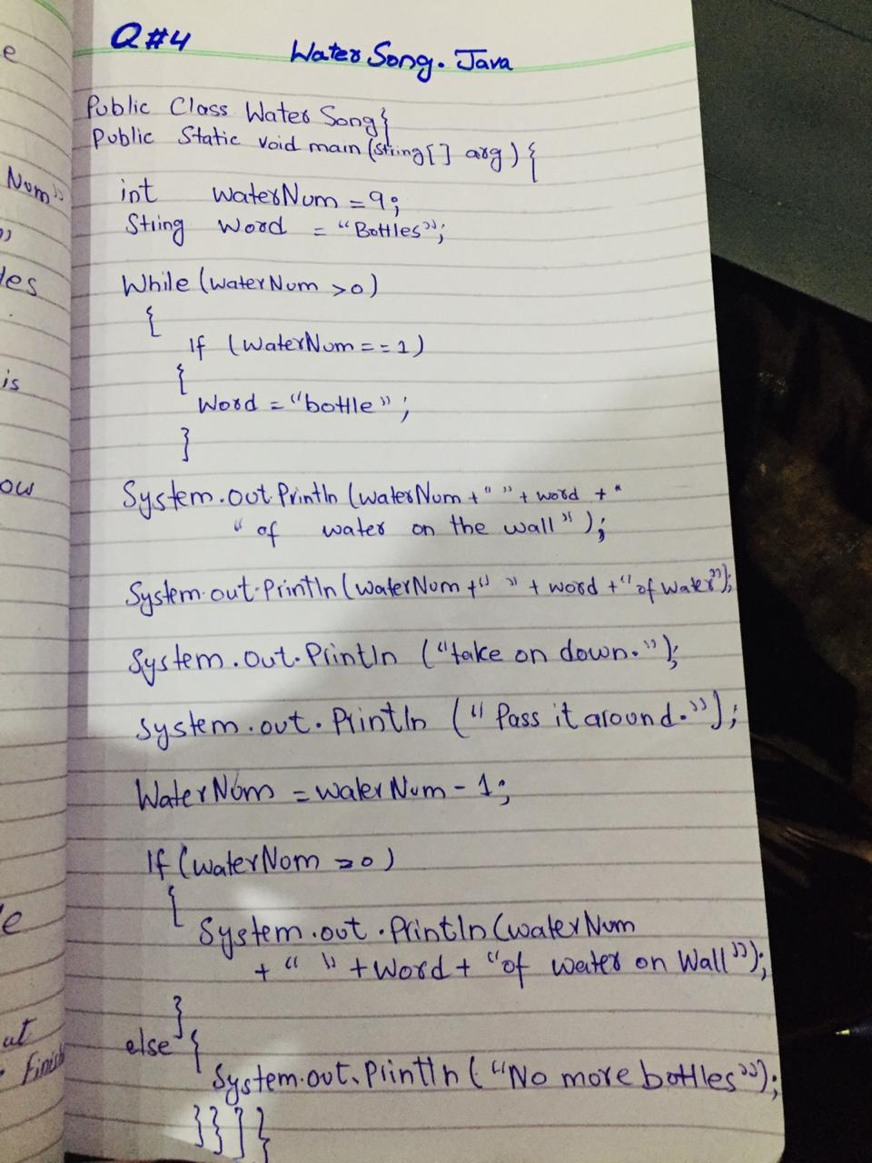

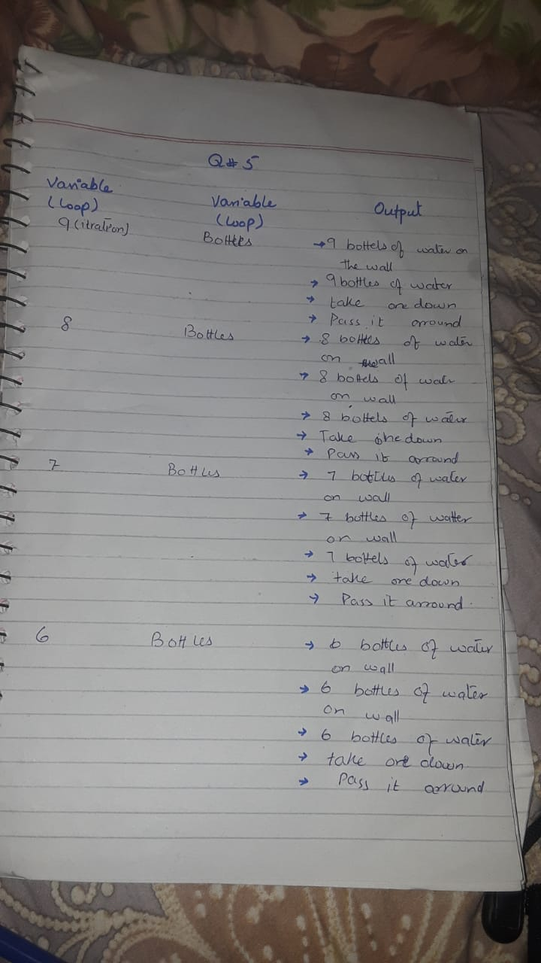

Question #5

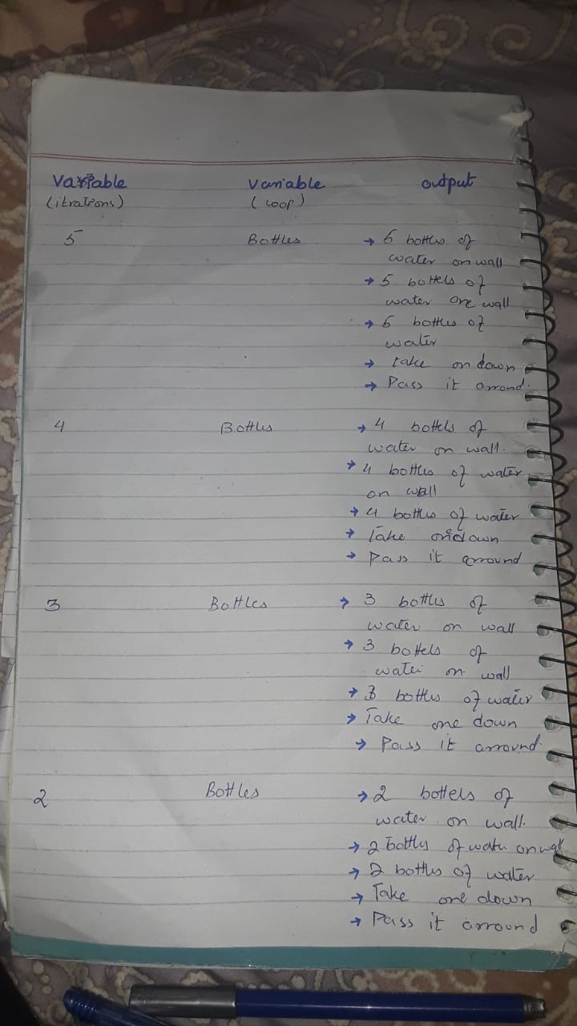

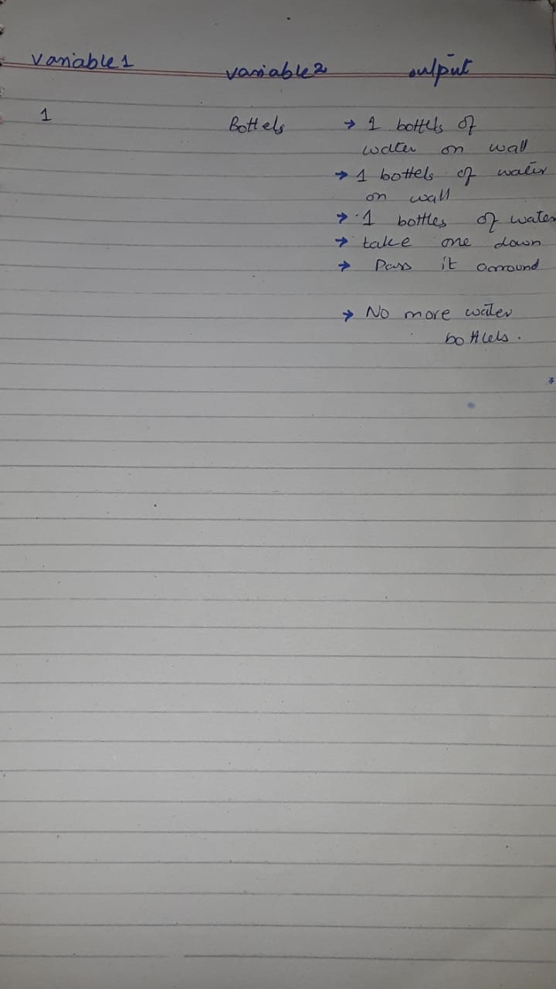

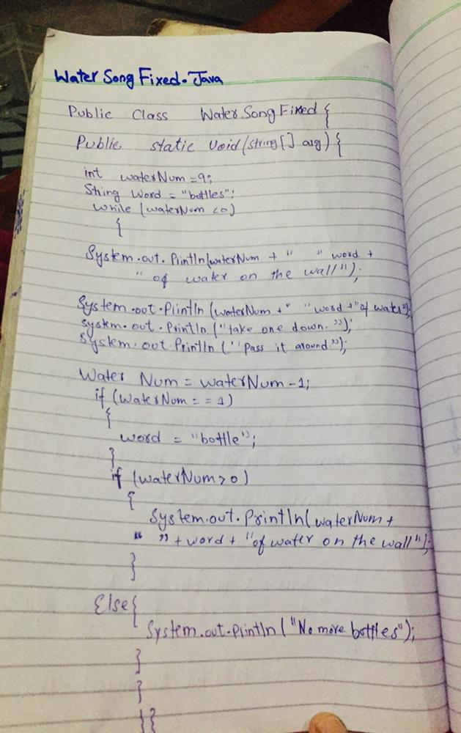

Question #6

**File Uploaded on Github**

Question #7

Question #8

**Water Song Fixed Upload On github**

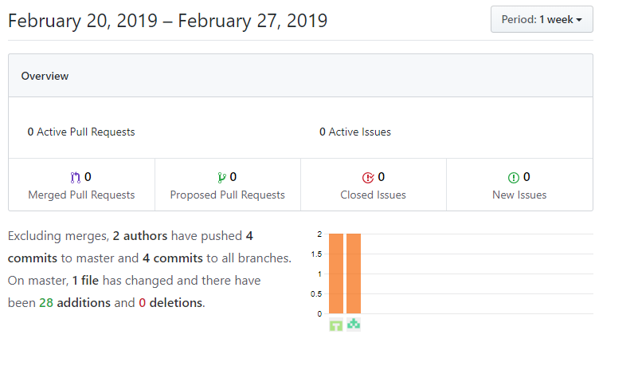

Question #9