CHAPTER THREE

SYSTEM ANALYSIS AND DESIGN

3.1 Introduction
This chapter turns the requirements identified in Chapters One and Two into a concrete technical plan. It sets out the methodology used to study and build the system, the techniques used to gather requirements, an analysis of the existing manual process compared with what is being proposed, a feasibility study, the functional and non-functional requirements the system must satisfy, a traceability matrix linking those requirements back to Chapter One's objectives, the tools and technologies selected, and the system design itself, expressed through a system architecture diagram, a use case diagram, an entity-relationship diagram, a normalised database structure, a class diagram, a sequence diagram, a system workflow narrative, and an activity diagram.

3.2 System Development Methodology
This project adopts an iterative, Agile-inspired development methodology rather than a strict Waterfall approach. Requirements for a system like this, spanning four user roles and a live payment integration, are unlikely to be fully known upfront; some details only surface once a working slice of the system exists to react to. Working in short, self-contained iterations, each producing a testable increment (authentication first, then menu management, then ordering, then payment, then delivery tracking, then analytics) keeps the project moving even under the tight timeframe of a final year project, and allows earlier modules to be corrected once later ones expose gaps in them.
The system itself is structured around Clean Architecture principles, which separate the codebase into layers, presentation, application, domain, and data access/infrastructure, such that inner layers (business logic) do not depend on outer layers (frameworks, databases, delivery mechanisms) (Martin, 2017). Practically, this means the core ordering and payment logic can be tested and reasoned about without needing a running database or a live payment gateway, and any of those outer components could later be swapped without rewriting the business rules that depend on them.

3.3 Fact-Finding Techniques
Three complementary techniques were used to establish the requirements set out later in this chapter: structured interviews with campus food vendors, a large-scale questionnaire administered to students and staff, and document review. Each was chosen for the kind of information it surfaces that the others cannot. The vendor interview instrument combined closed and open-ended questions to capture both quantifiable patterns and the reasoning behind a vendor's day-to-day practices. The student/staff questionnaire captured ordering habits and technology preferences across a population too large to interview individually. Document review grounds design choices in what has already been established rather than reinventing settled problems. Both instruments were administered as online forms (Google Forms) and their responses form the primary empirical basis for the requirements in Section 3.6.

3.3.1 Interviews (Vendors)
Interviews were chosen because a vendor's day-to-day reasoning, why an item goes out of stock unannounced, or why a particular record-keeping habit persists, is not something a closed-question survey alone reveals. A structured interview instrument, combining closed and open-ended questions, was distributed online to campus food vendors operating at Gombe State University. Four vendors returned usable responses: two managers (10 and 21 years in business respectively), one staff member (2 years), and one owner (3 years). This achieved sample is smaller than the vendor population the instrument targeted, and is treated as a limitation of the study in Section 3.10 rather than glossed over; the findings below should be read as indicative of common patterns among responding vendors rather than as representative of every vendor on campus.
Several consistent patterns emerged despite the small sample. All four vendors currently record customer orders entirely from memory or by phone, with none using any notebook, computer, or other written system, directly confirming the manual, unrecorded order-taking problem described in Chapter One. Payment is still overwhelmingly cash-based at the point of collection: all four vendors reported accepting cash, three of the four also reported POS, and three of the four reported bank transfer; none currently accepts a dedicated payment gateway. Peak-period volume varied by vendor, from one reporting more than 100 customers at peak to three reporting 20 to 50; one vendor separately estimated 8 to 15 students during the busiest window, concentrated specifically between 12:00 p.m. and 2:00 p.m., corroborating the lecture-break congestion pattern identified in Chapter One.
On operational challenges, payment issues were reported by three of the four vendors and long customer queues by two; one vendor (a staff respondent handling day-to-day operations) reported facing all five listed peak-period challenges simultaneously, long queues, delayed preparation, incorrect orders, payment issues, and staff shortage, at once. Two vendors said customers frequently complain about waiting time, citing delay in service and conflicts with students' lecture schedules. Order-taking mistakes were described as occasional or rare by all four, with reported error types including wrong or changed orders, mix-ups, missing items, and food prepared at the wrong time.
Support for the proposed system was unanimous and specific. All four vendors said an online ordering system would improve their business operations, citing reduced errors, shorter queues, the ability for students to order ahead, and clearer, more trackable order records. All four said they would be willing to display their daily menu online, and all four said automatic notification of new orders would help them respond and prepare faster. All four said a university delivery service would benefit their customers, and three of the four wanted automatic sales reporting, specifically daily sales totals, best-selling items, and a breakdown by payment method. On a five-point pilot-interest scale, three vendors rated their interest a 5 and one rated it 4, indicating uniformly high willingness to take part in a pilot.
One nuance is worth carrying directly into the design: three of the four vendors said payment should be completed before food preparation begins, but the fourth qualified this explicitly, stating that upfront payment should apply to remote or online orders but not to a customer already standing in front of them. This supports building payment-before-confirmation as a rule specific to the digital ordering flow (FR4, FR5) rather than assuming it must govern every transaction a vendor handles. On preferred future payment channels, bank transfer was preferred by all four vendors, while Paystack, Flutterwave, debit or credit card, USSD, and mobile money were each mentioned by at least one vendor, directly supporting the choice of Paystack and/or Flutterwave as the integrated gateway (FR4).
These responses fed directly into the menu and order management requirements (FR2, FR5), the payment integration requirement and gateway choice (FR4), and the case for an administrator-facing and vendor-facing reporting capability (FR9), since vendors themselves identified record-keeping and payment friction, not just order-taking, as the core operational gap.

3.3.2 Questionnaires (Students and Staff)
A questionnaire was used specifically because it was the only technique capable of reaching a large enough sample of students and staff to generalise about ordering habits and technology preferences with reasonable confidence. An online questionnaire was distributed to students and staff across the university, and 83 usable responses were collected. Respondents spanned five undergraduate levels and postgraduate/staff status: 400L accounted for 32.5% of respondents (27), 300L for 26.5% (22), 100L for 22.9% (19), 200L for 8.4% (7), postgraduate students and staff for 6.0% (5), and 500L for 2.4% (2), with one respondent not specifying a level. By residence, 55.4% (46) of respondents live off-campus and 42.2% (35) live in an on-campus hostel.
The results give strong, quantified support to the problem statement in Chapter One. On queueing, 41.0% of respondents said they occasionally experience long queues and delayed service at peak hours and a further 31.3% said they experience this frequently, meaning 72.3% experience the problem at least occasionally; only 18.1% said never. Directly downstream of this, 65.1% of respondents (54 of 83) said they have missed or arrived late to a lecture specifically because they were stuck in a food queue. The relationship between the two is strong: among respondents who frequently experience long queues, 80.8% (21 of 26) have also missed or been late to a lecture as a result, compared with only 20.0% (3 of 15) among respondents who said they never experience long queues, evidencing the causal link Chapter One draws between manual queueing and disrupted academic schedules.
On menu visibility, 51.8% of respondents said they sometimes have to physically visit a vendor to check the menu and price before deciding what to order, and a further 36.1% said they always have to; only 12.0% said they do not. On order tracking, 68.7% of respondents said the current lack of any order-tracking option actively prevents them from ordering food when they have back-to-back lectures or a tight schedule, a direct, quantified justification for FR7.
On payment, the picture is transitional rather than settled: 42.2% of respondents already described their campus food payment method as mostly digital, while 27.7% said mostly cash, 14.5% said always cash, and 14.5% said rarely cash, meaning a slim majority, 56.7%, still pay mostly or always in cash for food specifically, even though digital payment habits are otherwise well established. This is confirmed elsewhere in the same questionnaire: 72.3% of respondents said they already use digital payment methods such as bank transfer, USSD, or cards frequently for their general convenience and flexibility. Preference for change is clear: 77.1% of respondents agreed or strongly agreed that they find cash handling inconvenient and would prefer a secure electronic payment method for campus food specifically. Trust in the proposed gateway choice is high: 67.5% said they would trust a campus food platform integrating Paystack or Flutterwave completely, and a further 18.1% said they would somewhat trust it, 85.6% combined, with only 3.6% saying they would not trust it.
On the core value proposition of the platform, 75.9% of respondents rated a system that lets them compare vendors and menus in one place before ordering as "Very Useful." On real-time tracking, 47.0% said it would make them highly likely to use the platform and a further 36.1% said likely, 83.1% combined. On adoption drivers, 43.4% strongly agreed and 39.8% agreed that they would adopt the system primarily if it is easy to use and fits effortlessly into their existing routine, 83.2% combined, a result that lines up directly with the Technology Acceptance Model and UTAUT2 constructs discussed in Chapter Two (Nguyen et al., 2019; Lee et al., 2019). On personalisation, 67.5% said they would highly value a system that saves their preferences and allows quick reordering. On delivery format, 48.2% preferred delivery directly to their hostel or department, 26.5% preferred pickup at a designated central hub, and 9.6% preferred meeting a rider at a specific gate or landmark, with the remainder selecting some combination of these options, evidence that the delivery workflow needs to support more than one fulfilment mode rather than a single fixed option.
That combination, a stated preference for electronic payment, high trust in the proposed gateway, and a stated demand for tracking, is what elevates FR4 and FR7 from reasonable assumptions to confirmed, quantified requirements, and it echoes the ease-of-use and performance-expectancy factors identified in the technology-acceptance literature reviewed in Chapter Two (Nguyen et al., 2019; Lee et al., 2019).

3.3.3 Document Review
Document review served a different purpose from the two data-collection instruments above: rather than generating new data, it was used to avoid re-deriving decisions that have already been worked out elsewhere. This covered the empirical and theoretical literature discussed in Chapter Two, the official developer documentation for Paystack and Flutterwave, and the university's own final year project guidelines governing structure and format. Reading the payment gateway documentation directly, rather than assuming how integration would work, is what settled the decision to rely on webhook-based payment verification rather than a purely client-reported success callback, since client-side confirmation alone cannot be trusted for a transaction involving real money. The RBAC and JWT literature reviewed in Chapter Two (Sandhu et al., 1996; Krasniqi & Rexha, 2023) similarly shaped the authentication and access-control requirements (FR1, FR10) before a single line of the system was designed.
Technique | Target Participants | Sample Size | Purpose | Outcome
Interviews | Campus food vendors (owners/managers/staff) | 4 vendors (structured online interview) | Understand current order recording, stock, and payment-handling practices | Confirmed universal memory-based order recording and cash dependence; unanimous support for online ordering, gateway payment, and delivery (FR2, FR4, FR5, FR9)
Questionnaires | Students and staff (customers) | 83 respondents | Quantify ordering habits, payment preferences, and desired features across a wider population | Confirmed the queueing/missed-lecture link (65.1%), strong preference for cashless payment (77.1%) and order tracking (68.7%) (FR4, FR7)
Document Review | Ch. 2 literature; Paystack/Flutterwave docs; GSU FYP guidelines | N/A (documentary) | Ground design choices in prior work and official integration requirements | Informed webhook-based payment verification and RBAC/JWT security design (FR1, FR4, FR10)
Table 3.1: Summary of Fact-Finding Techniques

3.3.4 Summary of Findings from Fact-Finding
Table 3.1 and the discussion above cover a wide range of detail; the points below distil that detail into the specific findings that most directly shaped the requirements formalised in Section 3.6.
- Queueing directly disrupts academic schedules: 65.1% of the 83 surveyed students and staff have missed or been late to a lecture because of a food queue, and this rises to 80.8% among those who experience long queues frequently, versus 20.0% among those who never do — this informed FR3 (remote browsing and ordering) and the parallel-processing performance target in Section 3.6.2.
- Vendors record orders manually with no reconcilable sales record: confirmed unanimously across all 4 vendor interviews, none of whom use any written or digital order-recording system — this informed FR2, FR5, and FR9.
- Payment remains substantially cash-dependent specifically for campus food, despite broader digital habits: 56.7% of students pay mostly or always in cash for food even though 72.3% already use digital payment regularly elsewhere, and 77.1% say they would prefer electronic payment for campus food specifically — this informed FR4 and the choice of Paystack/Flutterwave.
- Trust in gateway-integrated payment is high: 85.6% of students said they would trust a Paystack- or Flutterwave-integrated platform at least somewhat — reinforcing the TAM perceived-usefulness driver discussed in Chapter Two (Nguyen et al., 2019).
- Vendors want simpler, less error-prone order management, particularly around payment handling: payment issues were the most commonly reported peak-period challenge across the vendor interviews, and one vendor reported facing all five listed challenge categories at once — this informed FR2 and FR5.
- Students strongly prefer real-time order tracking over an opaque wait: 83.1% said tracking would make them likely or highly likely to use the platform, and 68.7% said its current absence already stops them from ordering under time pressure — this informed FR7, consistent with the performance-expectancy construct in UTAUT2 (Lee et al., 2019).
- Administrators currently have no operational data at all: no vendor interviewed keeps any reconcilable sales record, and three of the four explicitly asked for automatic sales reporting — this informed FR9.
Taken together, these findings confirm that the problems described in Chapter One are not assumptions but interview-confirmed and survey-validated conditions on the GSU campus, quantified across an 83-respondent student/staff sample and 4 vendor interviews, and that the ten functional requirements in Section 3.6.1 are a direct response to them rather than a generic feature list. The achieved sample sizes, particularly the vendor interview count, are smaller than initially targeted and are carried forward explicitly as a limitation in Section 3.10.

3.4 Analysis of the Existing System
The current process at GSU, described in Chapter One and confirmed by the fact-finding above, is manual end to end: students queue physically, vendors record orders by hand or from memory, and payment is almost entirely cash-based. Walking through it step by step exposes exactly where the weaknesses sit. A student cannot know what is available at a given vendor without walking over, which wastes time and often ends in a wasted trip if the desired item has sold out. Orders are taken and prepared sequentially with no parallel processing, so a queue backs up quickly once volume rises. Payment happens at the point of collection, in cash, with no receipt trail, which makes it difficult for a vendor to reconcile a day's sales or for a student to dispute an error. There is no delivery option at all; anyone unable to queue in person is simply excluded from the service. And no one, neither vendor nor university administration, has any structured record of order volume, timing, or vendor performance to plan around.

3.5 Analysis of the Proposed System
The proposed system replaces each of those weak points directly. Menus become digital and centrally visible, so a student can compare vendors and check availability before deciding where to order. Orders are placed and queued digitally, which lets a vendor process several orders in parallel rather than strictly one at a time, and which gives every order a timestamped digital record. Payment happens electronically through a Nigerian payment gateway before an order is confirmed, removing cash handling and giving both student and vendor a verifiable transaction record. A delivery workflow, coordinated through registered riders, extends the service to anyone who cannot spare the time to queue. And every transaction that passes through the system becomes a data point an administrator can use, order volumes by hour, vendor performance, revenue trends, none of which exists under the current manual process.

3.5.1 Feasibility Study
Before committing to the design in Section 3.8, four dimensions of feasibility were assessed specifically against the environment the system will operate in: Gombe State University.
Technical Feasibility: The core technologies selected in Section 3.7, JavaScript (Node.js and Express.js on the backend, plain JavaScript on the frontend), MySQL, and Bootstrap, are widely taught, extensively documented, and require no separate build tooling or compiler step to get started, which keeps the technical risk within what a solo final-year student, without prior React or mobile-development experience, can reasonably absorb in one semester using only Node.js, a code editor, and a browser. Working in one language, JavaScript, on both the client and the server also removes the extra overhead of context-switching between two different syntaxes, which matters given the timeframe available. The questionnaire (Section 3.3.2) was distributed and completed entirely online, and 72.3% of respondents separately confirmed they already use digital payment methods regularly, evidence of routine access to internet-enabled devices among GSU's student and staff population, the minimum technical precondition for a web-based system to be usable at all. A responsive, browser-based interface reaches every one of those devices without requiring a separate native app to be installed. Paystack and Flutterwave both provide free sandbox environments and well-documented Node.js integration guides, so payment integration can be built and verified without upfront financial cost. On balance, the project is technically achievable, within the student's existing skill set, within the university's existing digital environment.
Operational Feasibility: Operational feasibility depends on whether the people who would actually run the system day to day, vendors in particular, can and will use it. The interview findings in Section 3.3.1 suggest they will: all four vendors interviewed said an online system would improve their operations, and none raised any objection to the concept itself, only practical nuances such as when upfront payment should apply. A mobile-first interface with role-specific views (FR10) keeps each actor's screen limited to what their role actually needs, lowering the training burden that Chapter Two's TAM and UTAUT2 findings identify as central to adoption (Nguyen et al., 2019; Lee et al., 2019). The main operational risk is uneven digital literacy among vendors, which the design partially addresses through a deliberately simple order-management flow rather than a feature-dense dashboard.
Economic Feasibility: The system carries no software licensing cost, since every component of the proposed stack is open-source, and hosting can begin on free or low-cost tiers adequate for a pilot deployment at GSU's scale. Paystack and Flutterwave charge a small percentage per transaction rather than a fixed subscription, so cost scales with actual usage instead of being incurred upfront. Beyond the student developer's own time, the main economic requirement is a modest hosting and domain cost once the system moves past prototype testing, well within reach of a departmental or student-run budget and not dependent on university capital funding to get started.
Schedule Feasibility: The iterative methodology adopted in Section 3.2 was chosen partly for schedule reasons: authentication, menu management, ordering, payment, delivery tracking, and analytics can be built and demonstrated as separate, working increments rather than as one large system that only becomes visible at the end. That structure fits the fixed, non-negotiable deadline of a final year project, since a delay in one later module does not block earlier modules from being complete, tested, and demonstrable. Chapter Four's testing schedule is planned around this same incremental structure.

3.6 Requirements Specification

3.6.1 Functional Requirements
The system shall provide the following capabilities, grouped by the user role they primarily serve:
- FR1. The system shall allow students, staff, vendors, and riders to register and authenticate securely using role-specific accounts.
- FR2. The system shall allow vendors to create, update, and remove menu items, including price and availability status.
- FR3. The system shall allow students and staff to browse menus across multiple vendors, add items to a cart, and place an order.
- FR4. The system shall integrate with a Nigerian payment gateway (Paystack and/or Flutterwave) to process and verify payment before an order is confirmed.
- FR5. The system shall notify a vendor when a new paid order is received, and allow the vendor to accept, prepare, and mark it ready for pickup.
- FR6. The system shall allow a delivery rider to accept an assigned delivery and update its status through to completion.
- FR7. The system shall allow a student or staff member to track the real-time status of an order from confirmation through to delivery.
- FR8. The system shall allow a customer to rate and review a completed order.
- FR9. The system shall provide an administrator dashboard for managing users and vendors, and viewing order and revenue analytics.
- FR10. The system shall enforce role-based access control so that each user can only perform actions permitted to their assigned role.

3.6.2 Non-Functional Requirements
Category | Requirement
Security | Passwords hashed (bcrypt/argon2); JWT-based authentication; RBAC on every protected endpoint; all traffic served over HTTPS.
Performance | Core API endpoints (menu browse, order placement) shall respond within 2 seconds under normal campus network conditions.
Scalability | The database schema and API shall support additional vendors and users without structural redesign.
Usability | Interfaces shall be mobile-first and usable by a first-time user without prior training or a manual.
Availability | The system shall degrade gracefully under intermittent connectivity rather than failing outright.
Maintainability | Code shall follow a layered, modular architecture to keep individual components independently testable and replaceable.
Auditability | Every order, payment, and status change shall be timestamped and stored for later reporting.

3.6.3 Requirements Traceability Matrix
Table 3.3 links each objective set out in Chapter One back to the functional requirements it produced and the system module responsible for delivering it, to demonstrate that no stated objective has been left unaddressed at the design stage.
Chapter One Objective | Functional Requirement(s) | System Module
1. Study the existing GSU food ordering process and identify the gaps a digital system must close. | Informs all of FR1–FR10 (baseline analysis, Sections 3.3–3.5) | Requirements Analysis (this chapter)
2. Design a normalised, scalable database for menus, orders, payments, delivery, and reporting. | Underlies FR2, FR3, FR4, FR5, FR6, FR7, FR9 | Database / Data Access Layer (Sections 3.8.3–3.8.4)
3. Build a secure RESTful API with authentication, RBAC, validation, and error handling. | FR1, FR10 | Authentication & Security Module
4. Build responsive, mobile-first interfaces for four user roles. | FR3, FR6, FR9 | Presentation Layer (Responsive Web Interface)
5. Integrate a Nigerian payment gateway for secure, verifiable payment. | FR4 | Payment Integration Module
6. Implement real-time order status tracking and notifications. | FR7, FR5, FR6 | Order & Delivery Tracking Module
7. Test the system for functionality, security, usability, and performance. | Validates FR1–FR10 | Testing (Chapter Four)
Table 3.3: Requirements Traceability Matrix
As the matrix shows, every objective from Chapter One maps onto at least one functional requirement and a corresponding system module, which is what allows Chapter Four to test against Section 3.6.1 directly and still be able to report, module by module, on how completely the original objectives were met.

3.7 Tools and Technologies
This project is implemented as a single, fully web-based system for all four user roles, students/staff, vendors, riders, and administrators, accessed through a standard mobile or desktop browser rather than through a separate native mobile app. This choice was made deliberately: it keeps the project within a single, more manageable technology stack given the timeframe of a final year project, and it relies only on core web technologies, HTML, CSS, and JavaScript, that are already part of a standard computer science curriculum, rather than a frontend framework such as React or a mobile toolkit such as React Native, neither of which is assumed here. Frontend: HTML5, CSS3, and Bootstrap for a responsive, mobile-first layout, with vanilla JavaScript handling form validation, cart interactivity, and all communication with the backend through the Fetch API, sending and receiving plain JSON rather than full page reloads. Backend: Node.js with Express.js, organised into a lightweight, Clean Architecture-inspired folder structure (routes, controllers, services, and data-access modules) rather than a heavier full-stack framework, which keeps the learning curve manageable while still enforcing the separation of concerns described in Section 3.2 and exposing a RESTful API that consistently returns JSON. Database: MySQL, accessed through a Node.js driver (such as mysql2) with parameterised queries, chosen for the same relational and transactional guarantees discussed in Section 3.8.3, and because it is widely taught alongside JavaScript in Nigerian computer science programmes. Authentication: JWT-based authentication (via the jsonwebtoken package) combined with RBAC middleware checked on every protected route (Sandhu et al., 1996; Krasniqi & Rexha, 2023). Payment: Paystack and/or Flutterwave Node.js SDKs for transaction initialization, redirect checkout, and webhook-based verification. Order and delivery tracking: implemented through periodic polling of a status endpoint, the frontend's JavaScript calling the Fetch API every few seconds to request the latest JSON status, which is simple to implement correctly and more than adequate for status updates that change on the order of minutes rather than milliseconds. Version control: Git, hosted on GitHub. Diagramming and design: Graphviz and Figma.

3.8 System Design
The subsections below present the system's design through eight complementary views: the overall layered architecture, the use case diagram showing how each actor interacts with the system, the entity-relationship diagram underlying the database, the normalisation applied to that database, the class diagram showing the core application objects, a sequence diagram walking through order placement and payment, a system workflow narrative, and an activity diagram showing the full order lifecycle. Each diagram is introduced with what it represents and why it matters before it is shown, so that the visual notation is read with the right question already in mind.

3.8.1 System Architecture
The architecture diagram matters because it is the one artefact in this chapter that shows the whole system at once, and it is what every other diagram in this section sits inside. The system follows a layered, Clean Architecture-inspired structure, implemented entirely as a web application rather than as separate web and native mobile codebases. Browser-based client interfaces for each of the four roles, including the rider, who uses the same responsive web interface on a mobile browser rather than a dedicated app, talk to a single Node.js/Express-based RESTful API layer that returns JSON, which delegates to role-specific controllers for authentication, orders, payments, and delivery. Those controllers call into a domain layer of use-case services that contain the actual business rules, independent of any specific framework. The domain layer talks to the outside world only through repository interfaces, which are backed by a MySQL database, with payment verification and notifications handled as clearly separated infrastructure concerns. This separation is what lets the payment gateway or notification provider be replaced later without touching order or menu logic, and it is also what would let a native mobile client be added in a future iteration without redesigning the business logic underneath it.
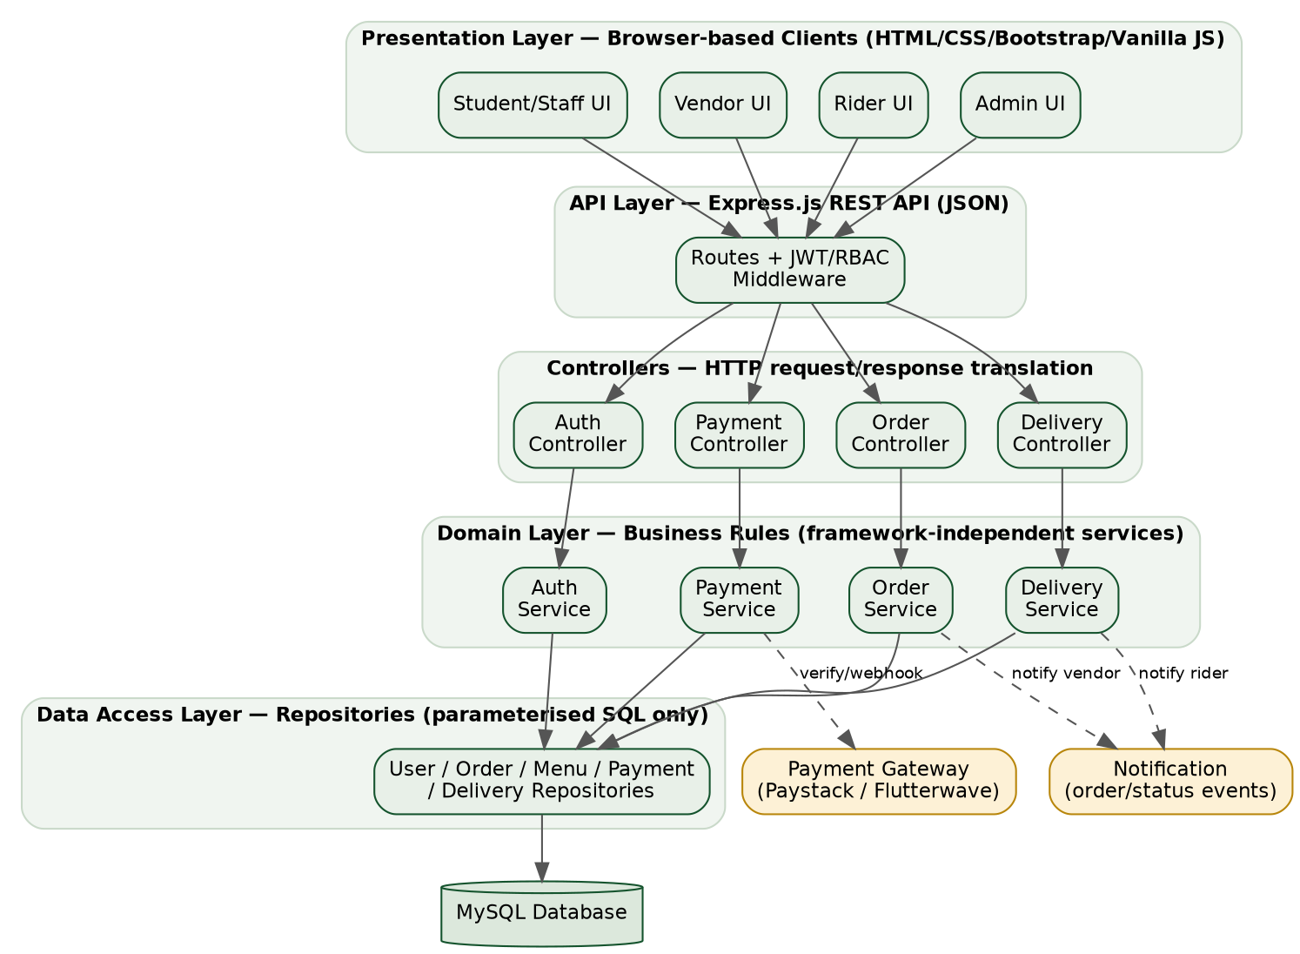
Figure 3.1: Layered System Architecture

3.8.2 Use Case Diagram
The use case diagram matters because it is the clearest way to check, at a glance, that every actor identified in this project has a defined set of interactions with the system and that no actor has been given a responsibility that belongs to someone else, a direct visual check on the role-based access control requirement (FR10). The diagram below captures the four human actors, Student/Staff, Vendor, Delivery Rider, and Administrator, together with the Payment Gateway as an external system actor. “Make Payment” includes “Process Payment” as a dependent use case, since a payment can never be completed without the gateway being invoked.
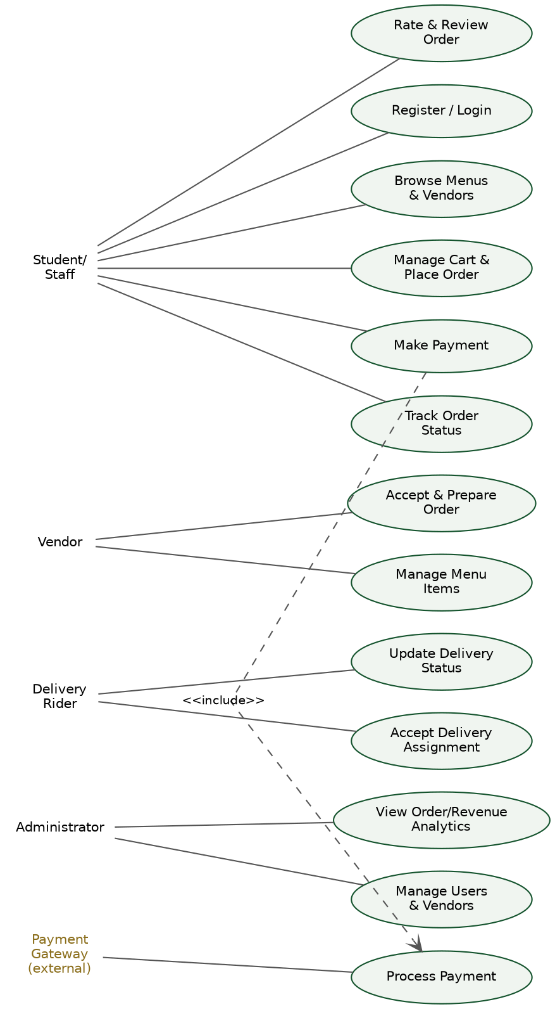
Figure 3.2: Use Case Diagram

3.8.3 Entity-Relationship Diagram
The entity-relationship diagram matters because it is the blueprint every other part of the system, the API, the business logic, the reports an administrator eventually sees, is ultimately built on top of; an error here would surface as a data-integrity problem everywhere else. The relational schema centres on the Order entity, which links a User (the customer), a Vendor, and, once assigned, a Rider through the Delivery entity. Each Order is composed of one or more OrderItem rows referencing a MenuItem, is settled by exactly one Payment record, and may carry one Review once completed. Vendor and Category both feed into MenuItem, giving each item a seller and a browsable grouping.
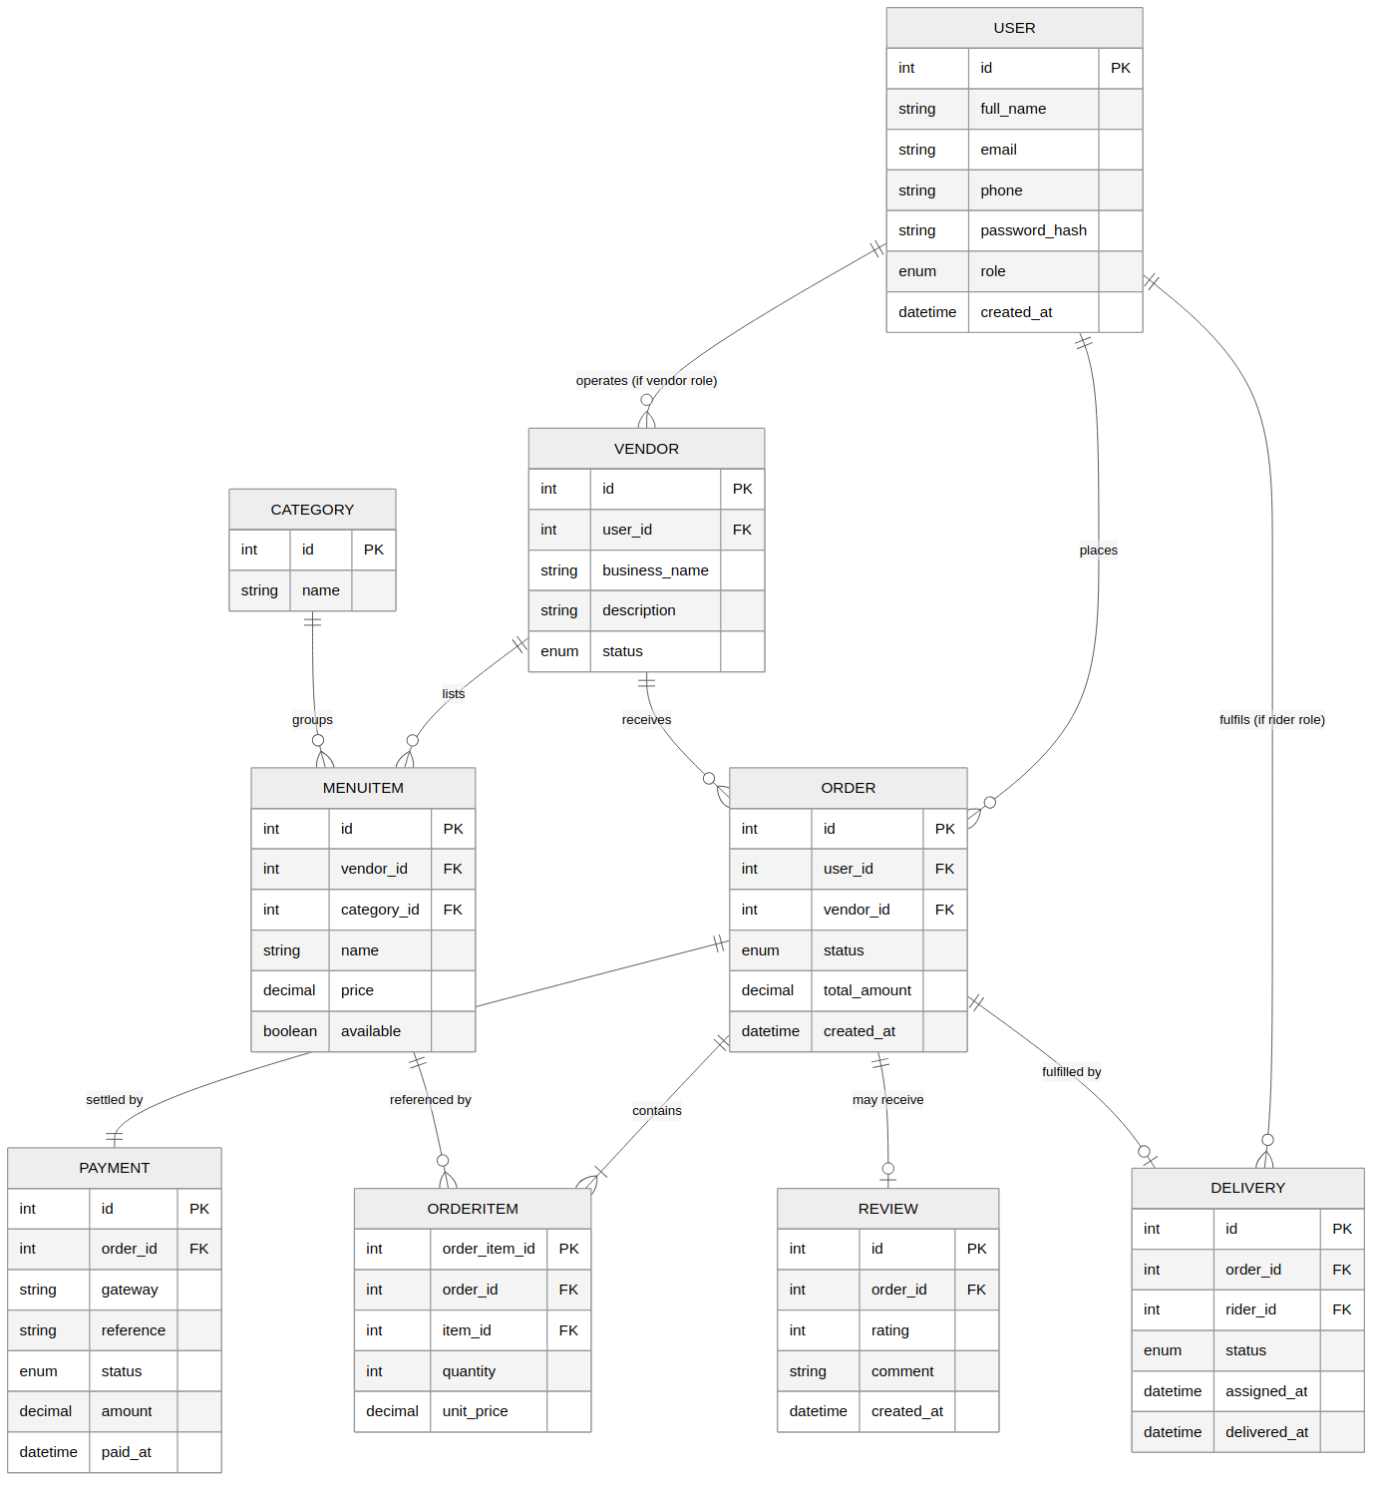
Figure 3.3: Entity-Relationship Diagram

3.8.4 Database Normalization
The schema in Figure 3.3 was normalised to Third Normal Form (3NF), a discipline that matters here specifically because this system handles money: an order total, a vendor's business details, or a payment status must never be allowed to disagree with itself across different parts of the database.
First Normal Form (1NF) requires that every column hold a single, atomic value and that each row be uniquely identifiable. Every table in the schema, User, Vendor, MenuItem, Order, OrderItem, Payment, Delivery, and Review, satisfies this: there are no repeating groups (an order's items are held as separate OrderItem rows rather than a single delimited list inside the Order row), and every table carries its own primary key.
Second Normal Form (2NF) additionally requires that every non-key attribute depend on the whole of the primary key, not part of it. This matters most for OrderItem, which relates an Order to a MenuItem. Rather than using the composite pair (order_id, item_id) as the primary key, which would create a partial-dependency risk for attributes such as quantity, the schema gives OrderItem its own surrogate order_item_id, so quantity and unit_price depend cleanly on that single key.
Third Normal Form (3NF) removes transitive dependencies, attributes that depend on another non-key attribute rather than on the key itself. This is why vendor details live in their own Vendor table rather than being repeated on every Order row, and why menu categories live in a separate Category table rather than being duplicated as free text on every MenuItem. Without that separation, updating a vendor's business name would require rewriting every historical order associated with it, exactly the kind of update anomaly 3NF is designed to prevent. The practical benefit for this project is that a vendor's profile, a menu category, or a payment status can each be changed in exactly one place, with every part of the system that references it seeing the update immediately and consistently.

3.8.5 Class Diagram
The class diagram matters because it moves from the storage-oriented view of the ER diagram to the behaviour-oriented view an actual codebase needs, showing not just what data each object holds but what it can do. At the application level, Vendor and Rider are modelled as specialisations of User, sharing common authentication behaviour while adding role-specific operations. A Cart accumulates MenuItem selections and, on checkout, produces an Order, which in turn owns its Payment and Delivery objects and may accept a single Review.
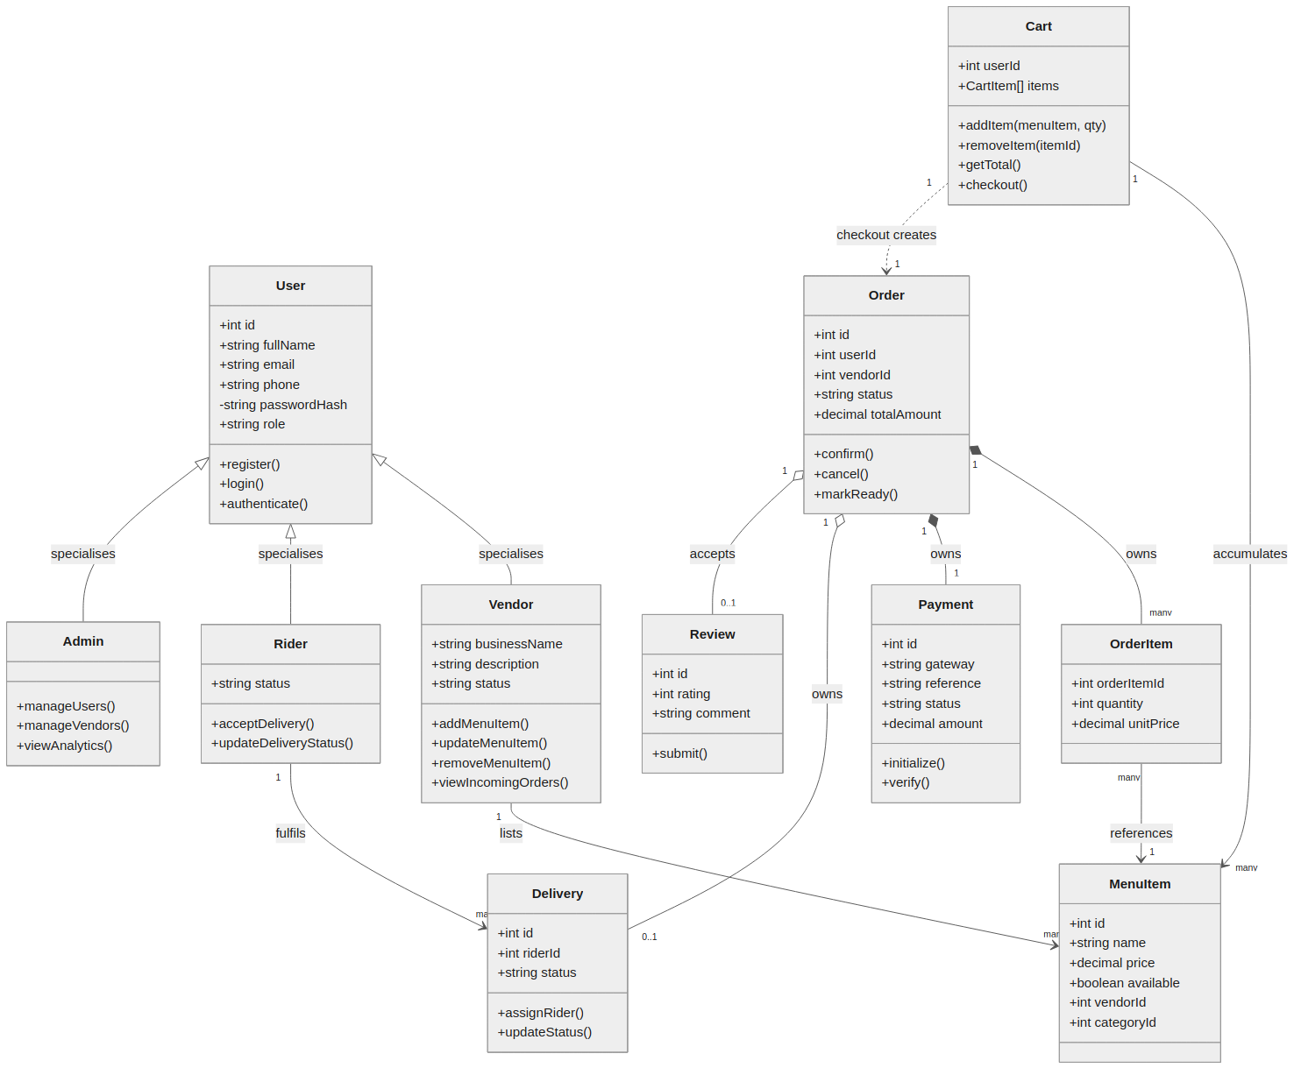
Figure 3.4: Class Diagram

3.8.6 Sequence Diagram: Order Placement and Payment
A sequence diagram matters where a static structure diagram cannot show what actually happens over time, and order placement is the single transaction in this system where timing and ordering of calls matter most, since money changes hands partway through it. This diagram traces the most critical transaction in the system, from a student adding items to a cart through to payment verification and delivery notification. The Web Browser and API Server are shown as activated for the duration of a request; dashed arrows represent return values, while solid arrows represent calls or notifications, consistent with standard UML sequence diagram notation.
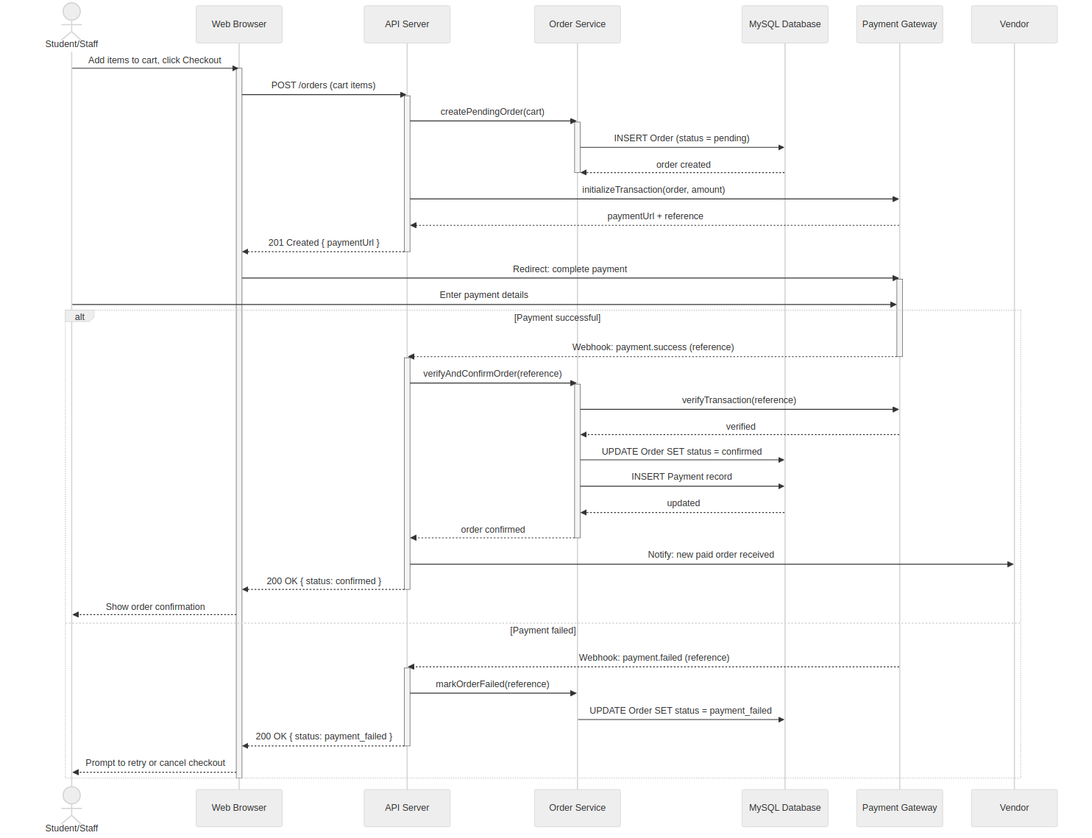
Figure 3.5: Sequence Diagram — Order Placement and Payment

3.8.7 System Workflow
Before presenting the activity diagram itself, it is worth walking through the workflow it formalises in prose, since the diagram compresses several role hand-offs that are easier to follow described in order first.
A session begins when a student, staff member, vendor, or rider authenticates through the JWT-based login described in Section 3.6.1; role-based access control (Section 2.2.3) immediately scopes what that session can see and do. A student or staff customer browses menus across registered vendors, adds items to a cart, and proceeds to checkout, at which point the system creates a pending order and hands off to the payment gateway for electronic payment. A successful payment moves the order to a confirmed state and notifies the owning vendor; a failed payment returns the customer to checkout to retry or cancel, rather than leaving an ambiguous half-placed order sitting in the database. Once confirmed, the vendor prepares the order and marks it ready, at which point the system assigns an available rider, who accepts the delivery, collects the order from the vendor, and delivers it to the customer, updating status at each step so the customer's tracking view (FR7) stays current throughout. On receipt, the customer confirms delivery and is prompted to rate and review the order; if receipt is not confirmed within an expected window, the order is flagged for administrator review rather than silently closed. This is the sequence Figure 3.6 formalises as an activity diagram.

3.8.8 Activity Diagram
The activity diagram matters because it is the one view that shows both the happy path and the exception paths, the failed payment retry, the unconfirmed delivery escalation, in a single picture, which is what makes it useful for planning the test cases in Chapter Four. It shows the complete order lifecycle as a flow of actions and decisions, from login through to a rated, completed order, including the retry path for a failed payment and the escalation path for a delivery that a customer does not confirm as received.
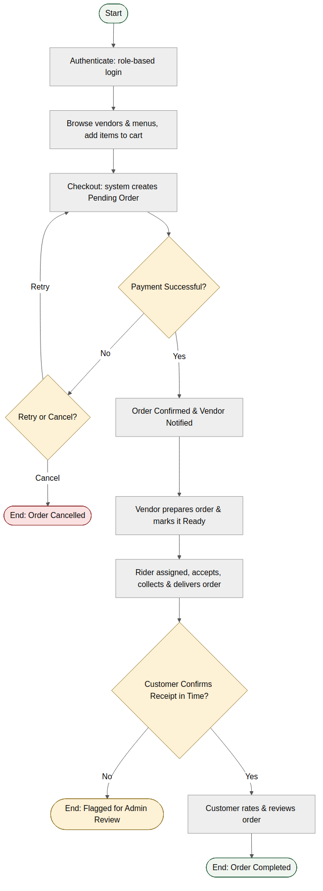
Figure 3.6: Activity Diagram — Order Lifecycle

3.9 System Assumptions
The design in this chapter rests on the following assumptions, each treated as a precondition for the system to function as intended:
- Users (students, staff, vendors, and riders) have access to a smartphone or computer with a functioning internet connection, whether through campus Wi-Fi or mobile data.
- Vendor accounts are created and verified by an administrator rather than through open self-registration, keeping the vendor list limited to legitimate, GSU-recognised sellers.
- The selected payment gateways (Paystack and/or Flutterwave) remain available, operational, and compliant with Central Bank of Nigeria regulation throughout the system's use.
- Delivery riders possess a smartphone with a modern web browser capable of running the rider web interface and receiving real-time delivery assignments.
- Students and staff hold valid, verifiable university accounts or identifiers that can be used to confirm their affiliation with GSU during registration.
Where any one of these does not hold for a particular user, for instance a rider without a smartphone, the system falls outside its intended operating conditions rather than failing silently; this is addressed further as a constraint below.

3.10 System Constraints
The following constraints bound what the system can guarantee, and were treated as fixed boundaries the design worked within rather than problems the system itself could solve:
- Internet connectivity on campus is not uniformly reliable, which can affect real-time features such as order tracking and payment confirmation regardless of how the system itself is engineered.
- The system depends on third-party payment gateways for transaction processing; any downtime, policy change, or fee adjustment on the part of Paystack or Flutterwave is outside the project's control but directly affects the payment module.
- Testing is constrained to a simulated, limited-scale environment rather than a full live rollout across the entire student population, given the scope of a final year project (Section 1.6).
- The achieved fact-finding sample is limited in size, particularly on the vendor side (4 of a larger target population interviewed) and, to a lesser extent, on the student/staff side (83 respondents). Findings are treated as strongly indicative rather than statistically representative of the full GSU population, and this is acknowledged as a limitation of the study rather than presented as exhaustive.
- Not every student, vendor, or rider can be assumed to own a smartphone capable of running the web interface smoothly, which limits how much the design can rely on browser features only recent devices support well.
- The project operates within a fixed academic-year timeline, which constrains how many iterations (Section 3.2) can realistically be completed before final submission and testing (Chapter Four).
These constraints echo, and in places sharpen, the limitations already noted in Section 1.6.

3.11 Summary
This chapter has translated the problem and literature review from Chapters One and Two into a concrete technical plan: fact-finding grounded in structured vendor interviews (4 respondents) and an 83-respondent student/staff questionnaire, together with document review; a feasibility study covering technical, operational, economic, and schedule dimensions; requirements traced back to Chapter One's objectives through Table 3.3; a layered system architecture; a normalised database; and a full set of design diagrams covering structure (use case, ER, class, architecture) and behaviour (sequence, workflow, activity). Chapter Four builds on this design directly, walking through the implementation of each module and the testing carried out to confirm the system meets the requirements set out here.

References
Krasniqi, B., & Rexha, B. (2023). Enhancing JWT authentication and authorization in web applications based on user behavior history. Computers, 12(4), 78. https://doi.org/10.3390/computers12040078
Lee, S. W., Sung, H. J., & Jeon, H. M. (2019). Determinants of continuous intention on food delivery apps: Extending UTAUT2 with information quality. Sustainability, 11(11), 3141. https://doi.org/10.3390/su11113141
Martin, R. C. (2017). Clean architecture: A craftsman's guide to software structure and design. Prentice Hall.
Nguyen, T. T. H., Nguyen, N., Nguyen, T. B. L., Phan, T. T. H., Bui, L. P., & Moon, H. C. (2019). Investigating consumer attitude and intention towards online food purchasing in an emerging economy: An extended TAM approach. Foods, 8(11), 576. https://doi.org/10.3390/foods8110576
Sandhu, R. S., Coyne, E. J., Feinstein, H. L., & Youman, C. E. (1996). Role-based access control models. Computer, 29(2), 38–47. https://doi.org/10.1109/2.485845

