**Topics in Software Engineering**

**Assignment#1**

**Group Members:**

Khadija Butt FA19-BSE-045-A

Ameena Hameed FA19-BSE-027-A

Arslan Asif FA19-BSE-116-A

**Submitted To:**

Ma’am Dr. Fatima Sabir

**Submission Date:**

3-10-22

**Part (a)**

1. **Identify deprecated technology or API.**

Answer:

They are found in:

* Frame1.java (line#103)

Because the getText() method is deprecated. This method is no longer used.

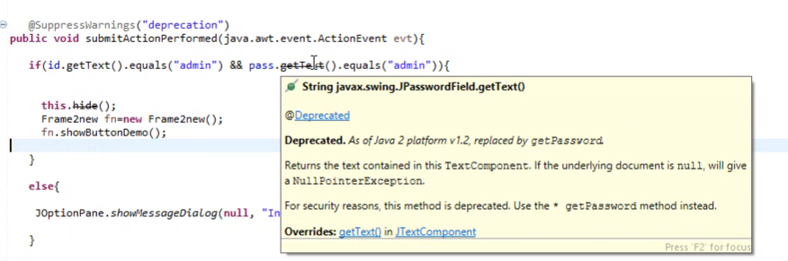

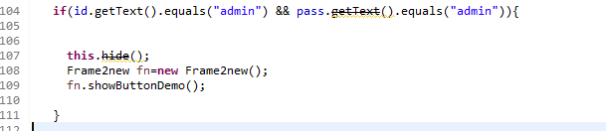

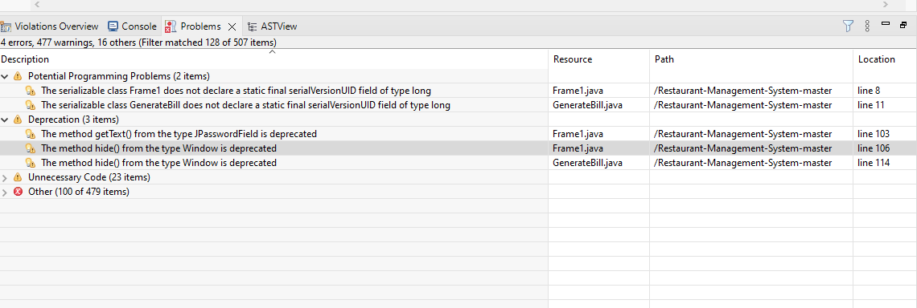

* Frame1.java (line#106)

Because hide() method is deprecated. This method is no longer used

.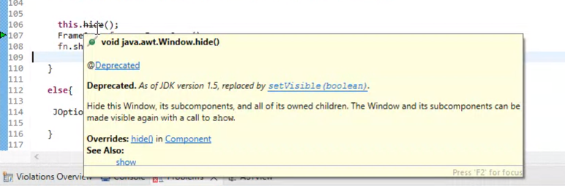



* GenrateBill.java (line#114)

Because hide() method is deprecated. This method is no longer used.

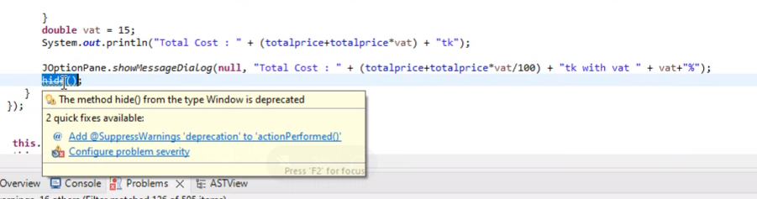

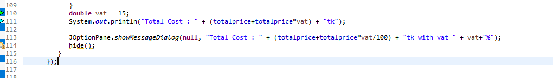

1. Potential issues missing in the documentation but available in the code

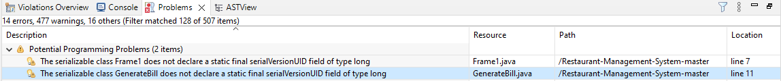

* Frame1.java (Line#7)

Because the serializable class Frame1 does not declare a static final serialVersionUID field of type long.

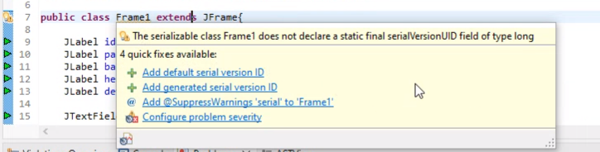

* GenerateBill.java (Line#11)

Because the serializable class GenerateBill does not declare a static final serialVersionUID field of type long.

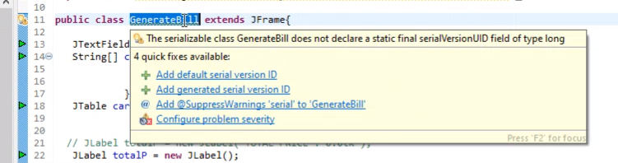

* **Unnecessary Code:**

Screenshots of unnecessary code is pasted on the next page. That particular piece of code is never used, that's why it is unnecessary.

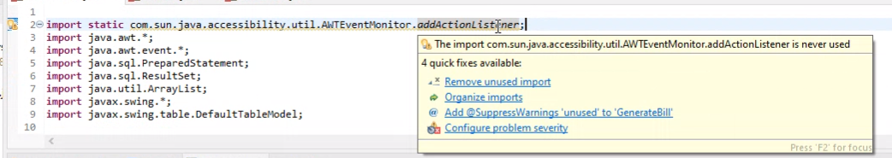

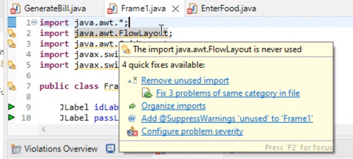

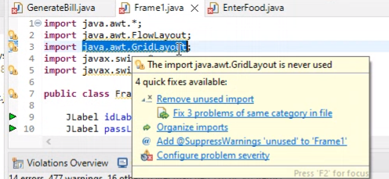

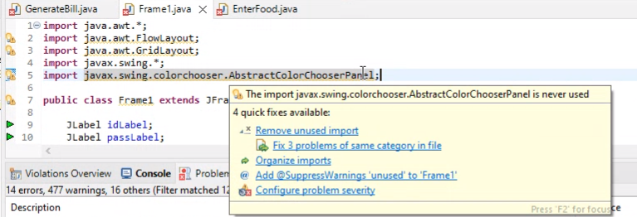

**Part (b)**

Use PMD to help identify potential coding errors and customize the rules you use to make sure only pertinent rules are applied to your source code.

1. Create and view code issues directly from your editor.

The table below is given to explain what the colors symbolize.

|  |  |
| --- | --- |
| **Color** | **Explanation** |
| Red | Change absolutely required |
| Cyan | Change highly recommended |
| Green | Change recommended |
| Purple | Change optional |
| Dark Blue | Change highly optional |

1. Generate Bill Violations

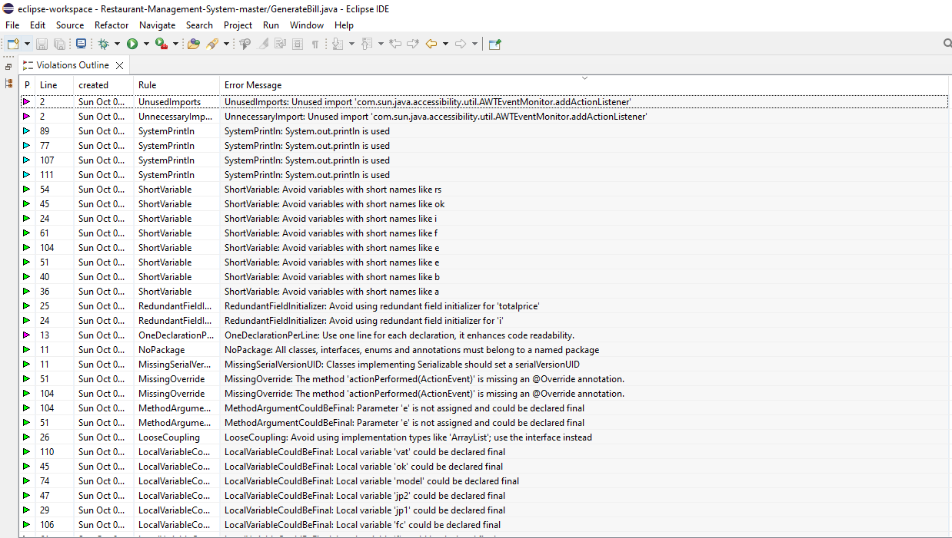

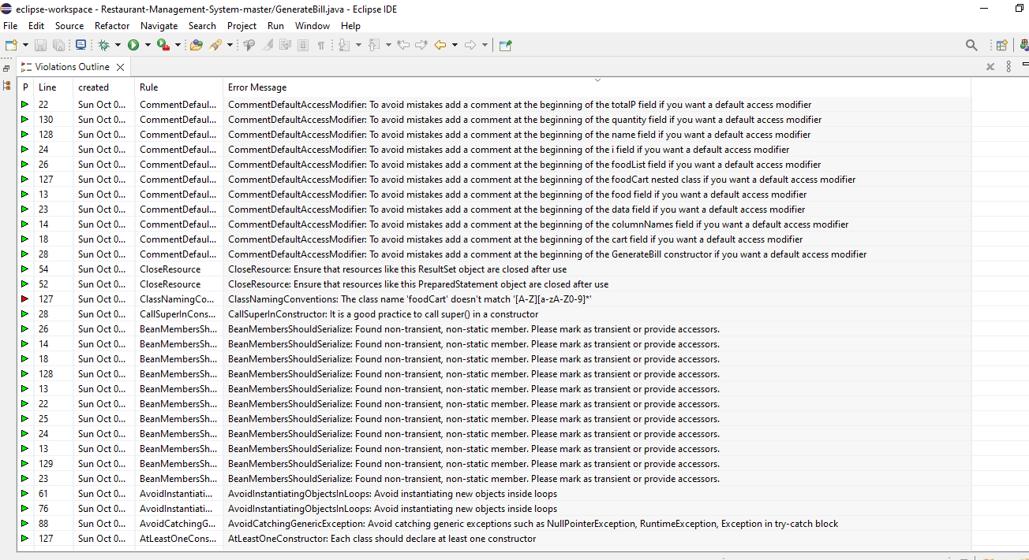

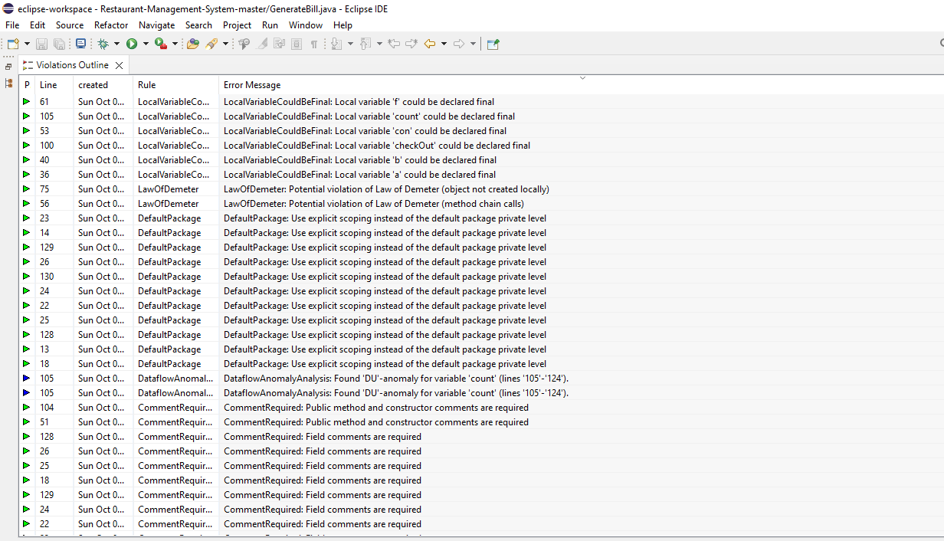

1. Frame1 Violations:

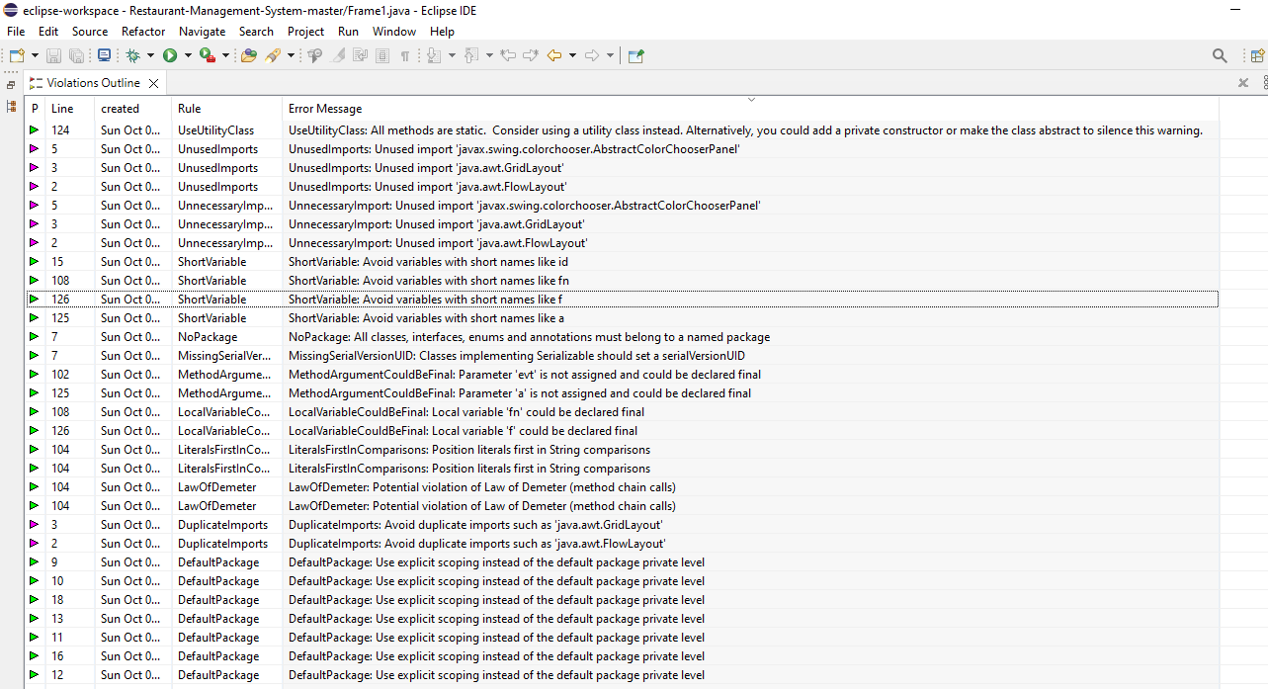

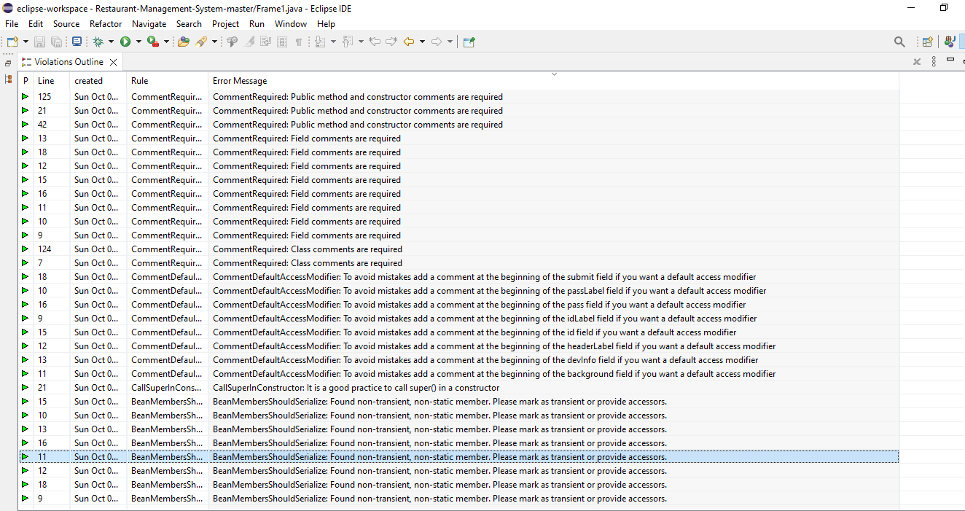

1. Track and prioritize code improvements like technical debt. The numbering bullets represent the priority.
2. Change is absolutely required here. That’s why we will prioritize this improvement.

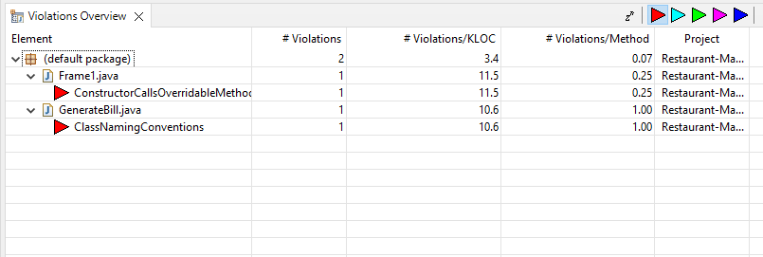

1. Change is highly recommended here. So, After improving the above part we will improve this change.



1. Change is recommended here. So, after improving the above part we will improve this change.

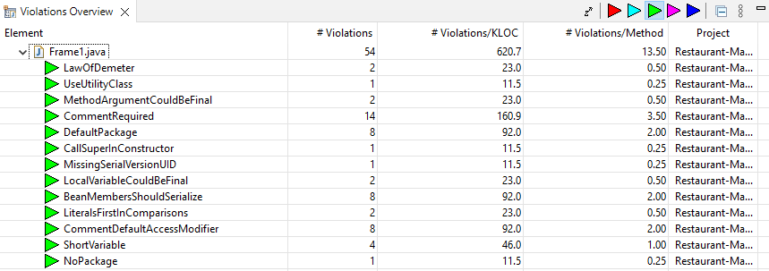

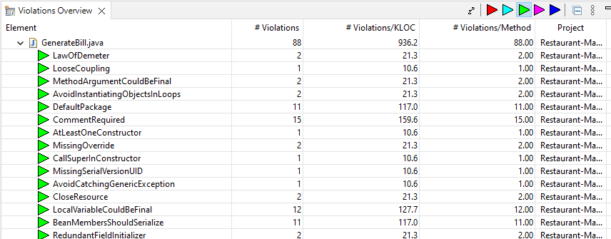

1. Change is optional here. So, After improving the above part we will improve this change





1. Change is highly optional here. So, after improving all the parts which are mentioned above. We will improve this. This will be least in priority.

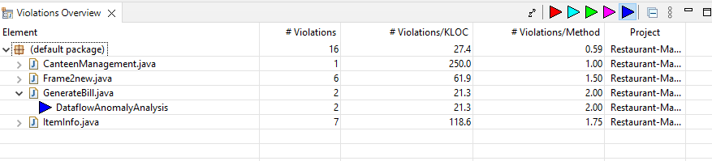

1. Check your code quality.

Quality of the code is checked using Codiga.

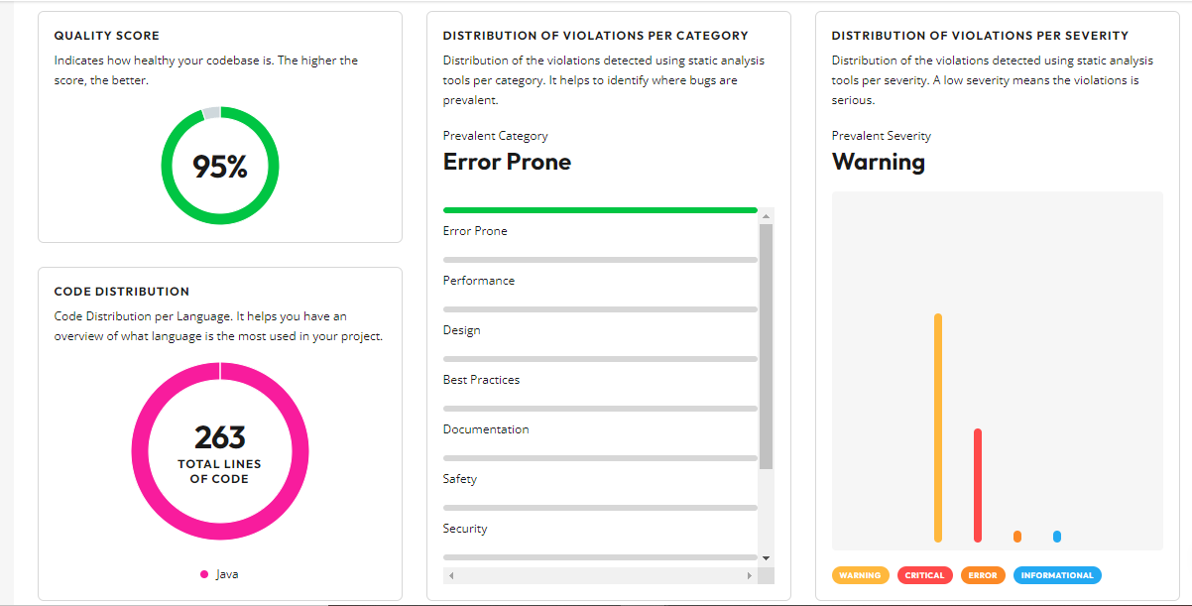

1. Apply at least 3 PMD rules with the help of tools.

After tracking and prioritizing the code improvements. The following improvements are done. The problem and its solution both screenshots are pasted.

* Problem:

The problem here was class naming convention.

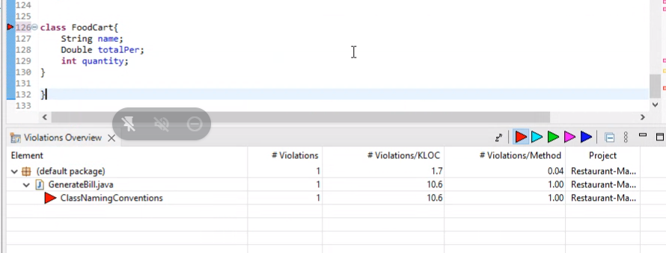

* Solution:

PMD Rule ClassNamingConvention was applied here. The name foodCourt is replaced by FoodCourt

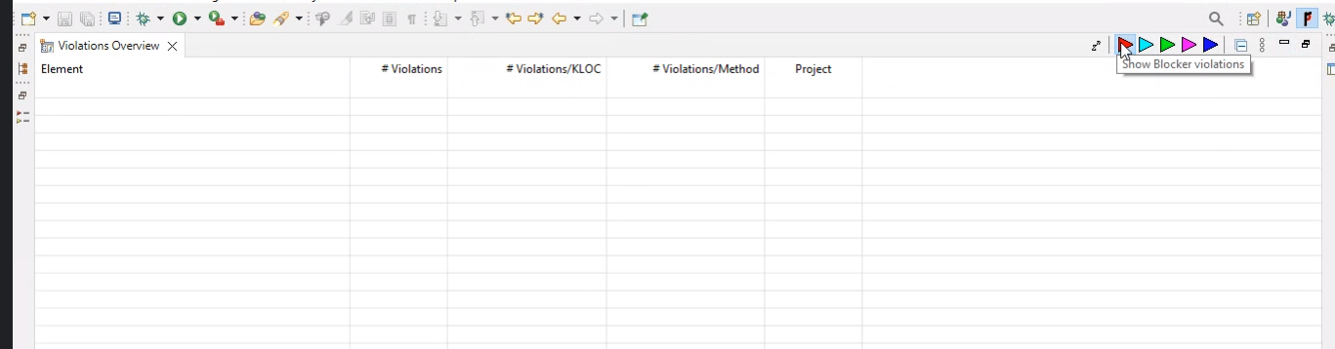

* Problem:

Instead of using System.out.println use SystemPrintln.

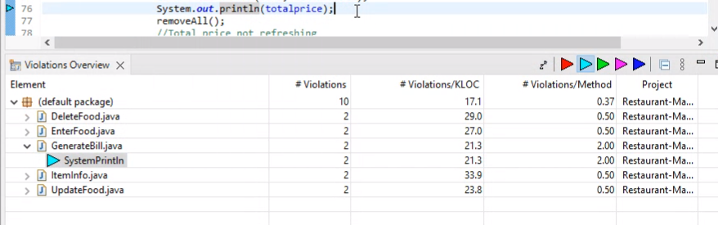

* Solution:

System.out.println should be written as SystemPrintln.

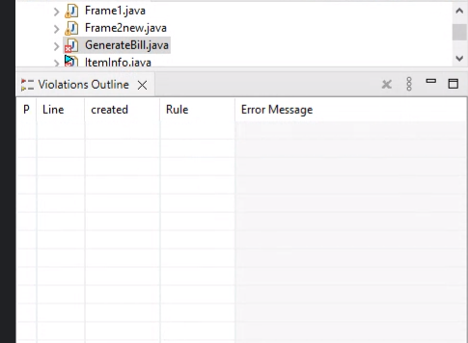

* Problem:

The problem here is UnusedImports, DuplicateImports and UnnecessaryImports.

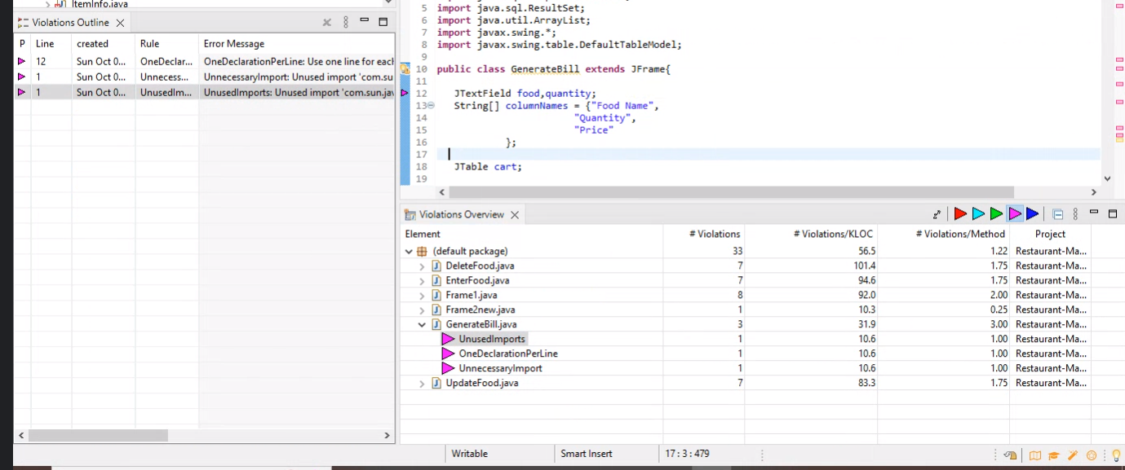

* Solution:

Here UnusedImports, DuplicateImports and UnnecessaryImports are removed.

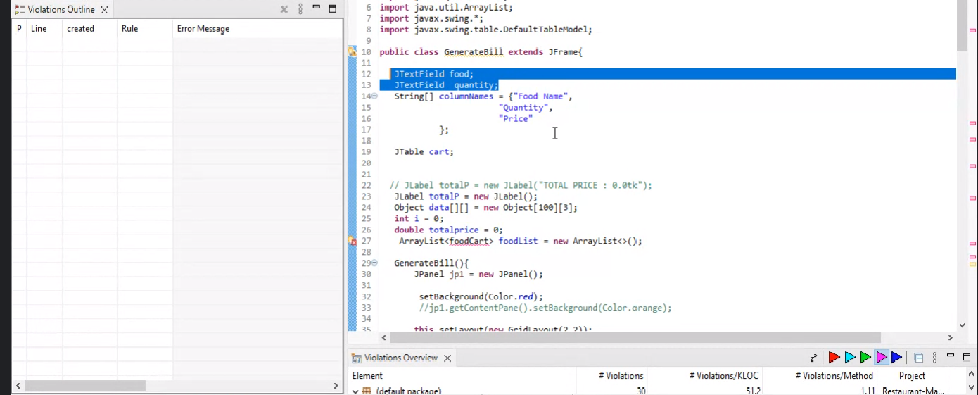

1. Generate the Abstract Syntax Tree of your source code using PMD.

The Abstract Syntax Tree of the source code is generated using PMD. Screenshots are pasted below.

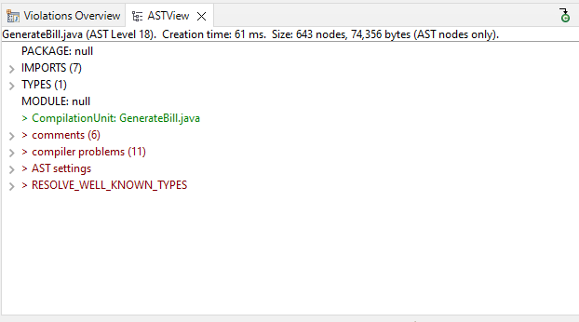

**Part c**

1. Use the check Style tool to review your code. At least apply 2 rules on your code using CheckStyle
2. WhiteSpaces are removed.

Before:

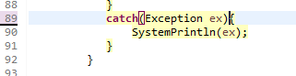

After:

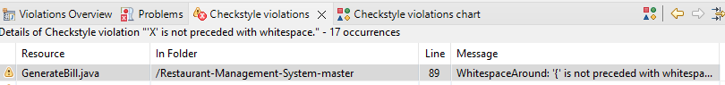

1. Indentation issues are removed.

Before:

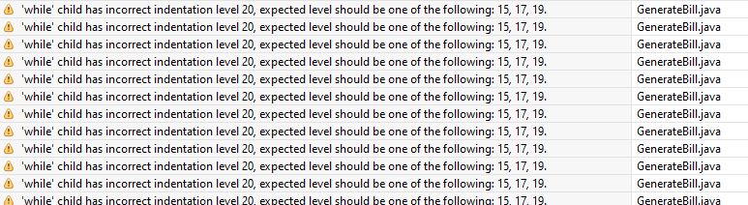

After:

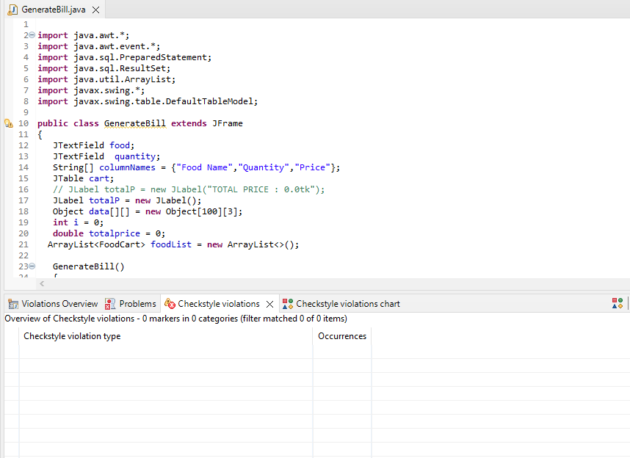

1. Tab characters Removed.

Before:



After:

