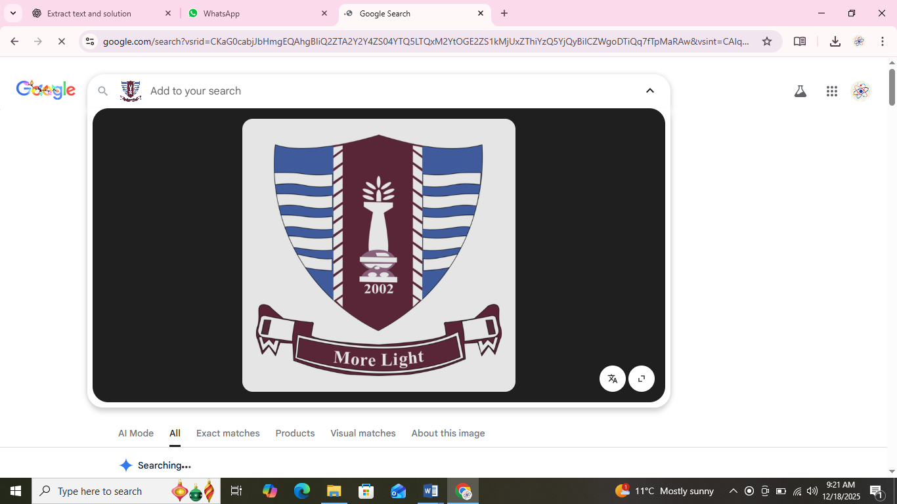
Prepared by: Khadija Nadeem
Semester: BS SE-1 Mor(B)
Roll No.: 250818
Tutor: Dr. Sheraz Malik
Submission Date: 18th December 2025

List of common computer hardware components

Component | Description
- Motherboard | The main circuit board that connects all other components.
- Processor (CPU) | The “brain” of the computer; executes instructions, calculations.
- Graphics Card (GPU) | Handles graphics rendering, displays, also acceleration of certain tasks.
- Memory (RAM) | Short-term volatile memory used by the CPU to store working data.
- Storage (HDD/SSD) | Long-term data storage: operating system, applications, files.
- Power Supply Unit (PSU) | Provides electrical power to all components from mains
- Computer Case / Chassis | The enclosure that houses the components with mounting and cooling.
- Cooling System (fans, heatsinks, liquid) | Maintains safe temperatures for components.
- Network / Sound / Expansion cards | Additional functionality: Wi-Fi, sound, extra ports, etc.

Component | Specifications | Manufacturer | Price
Processor / CPU | clock speed (GHz), core count (e.g., 4-8 cores), Threads, cache size, supported socket | , Intel, AMD. (AMD is a well-known manufacturer of CPUs) | depending on model, region and generation, maybe USD 100 to USD 500+ (in Pakistan maybe PKR 20,000–150,000 or more)
Random Access Memory (RAM | capacity (e.g., 8 GB, 16 GB, 32 GB), speed (e.g., DDR4-3200 MHz), latency (CL16 etc) | , Corsair, Kingston, etc. | maybe USD 30-100 for common modules (in Pakistan maybe PKR 5,000-25,000)
Motherboard | socket type, chipset, number of RAM slots, PCIe slots, form-factor (ATX, Micro-ATX), connectivity (USB, SATA, M.2) | ASUS (ASUSTeK Computer Inc.) | depends highly, maybe USD 100-300+ depending features
Storage (HDD / SSD | capacity (e.g., 500 GB, 1 TB, 2 TB), interface (SATA, NVMe/PCIe), speed (MB/s) | Samsung, Western Digital | SSD 1 TB maybe USD 70-150 (PKR 15,000-40,000)
Graphics Card / GPU | memory size (e.g., 8 GB), memory bus width, GPU clock, number of CUDA/Stream processors | NVIDIA Corporation, AMD | very wide range, USD 150 to USD 2000+ depending on tier
Power Supply Unit (PSU) | wattage (e.g., 500 W, 650 W, 850 W), efficiency rating (e.g., 80 Plus Bronze/Silver/Gold), modularity | Corsair again, others | USD 50-150+ depending on power and quality
Computer Case / Chassis | form-factor compatibility, airflow design, front panel I/O, size (mid-tower, full tower) | Corsair, Corsair, NZXT, Thermaltake | USD 50-200+
Cooling System | airflow (CFM), radiator size, fan speed noise level, compatibility with socket | Cooler Master, Corsair, Noctua, NH-D1  DeepCool | USD 30-150+
Specifications, Manufacturer, Price

Use & Features of Three Component

1. CPU (Processor)

Use:

The CPU executes instructions of software, does calculations, controls other components. Without a capable CPU the system will lag or be unable to run heavier applications.

Key Features:

- Clock speed (higher GHz = faster for many tasks)

- Core count / Threads (more cores help multitasking, parallel workloads)
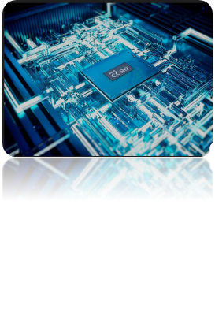
- Cache size (larger cache helps speed)

- Power consumption / efficiency (especially for laptops)

- Compatibility with motherboard socket and chipset

Why it matters: If you pick a weak CPU, everything else (RAM, GPU) may be bottlenecked. It sets the performance ceiling of the system.

Example:
A recent CPU from Intel or AMD might cost in a mid-range USD 200-300 range and support 6-8 cores, etc.
2. RAM (Memory)

Use:

RAM stores data temporarily while programs run. This allows the CPU to access data faster than from storage. More RAM enables better multitasking, smoother running of many programs concurrently.

Key Features:

- Capacity (e.g., 8 GB, 16 GB, 32 GB) — larger means more programs/data in memory
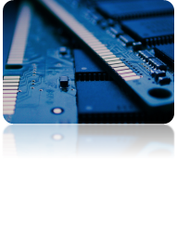
- Speed (e.g., DDR4-3200 MHz) — faster speed reduces latency

- Latency (e.g., CL16, CL18) — lower latency is better

- Dual/quad channel configuration (two modules better than one, for bandwidth)

Why it matters: Even with a strong CPU, having insufficient RAM means slowdowns, swapping to disk, poor performance with many tabs/apps.

Example:

A 16 GB DDR4-3200 kit might be seen as a sweet spot for general use.

3. Storage (SSD / HDD)

Use:

Provides long-term storage of operating system, applications, files, etc. SSDs (Solid State Drives) are much faster compared to traditional HDDs, improving boot time, load time of applications.

Key Features:

- Capacity (e.g., 500 GB, 1 TB)
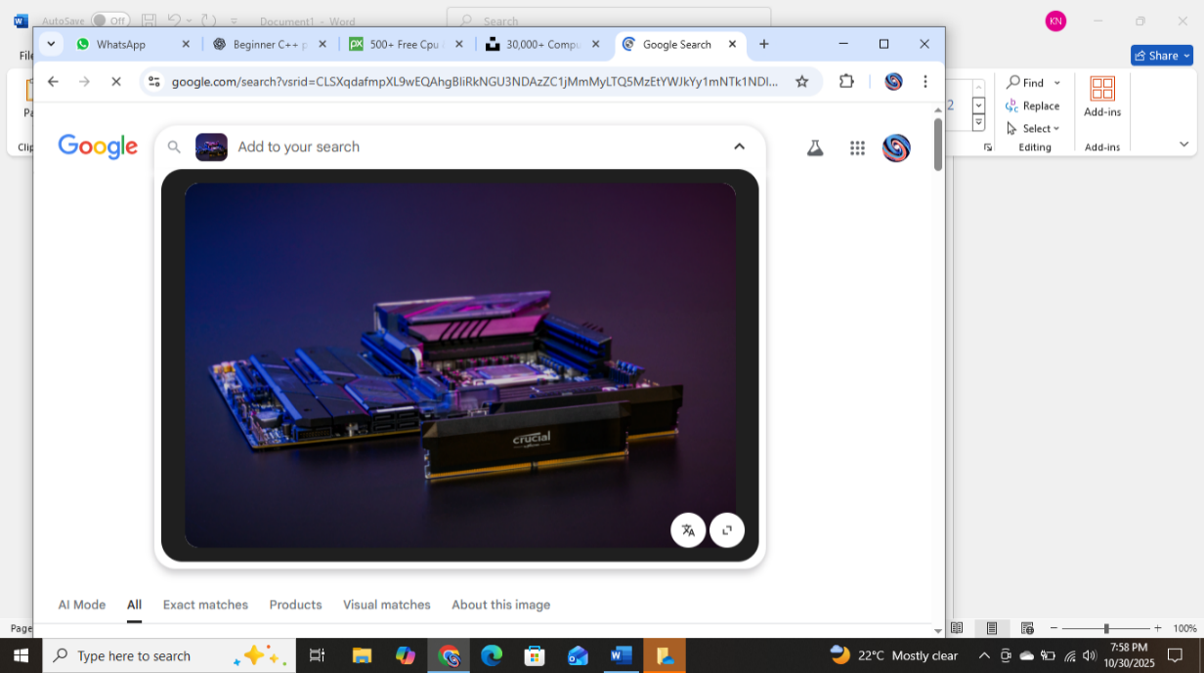
- Interface & speed (SATA vs NVMe/PCIe; NVMe much faster)

- Read/write speed (higher = faster loading)

- Reliability, endurance (especially for heavy write workloads)

Why it matters: A slow drive makes everything feel sluggish (booting, opening programs). Upgrading to a fast SSD often gives one of the biggest “feel” improvements in a PC.

Example:

A NVMe SSD 1 TB might cost USD 100-150 and give significantly better performance compared to a >500 GB HDD.

4. Motherboard:

Use:

The motherboard is the main circuit board that connects the CPU, RAM, storage, power supply and other components so they can work together.

Key Features:

- CPU socket (decides which processor fits)

- RAM slots (number of slots and RAM type: DDR3, DDR4, DDR5)

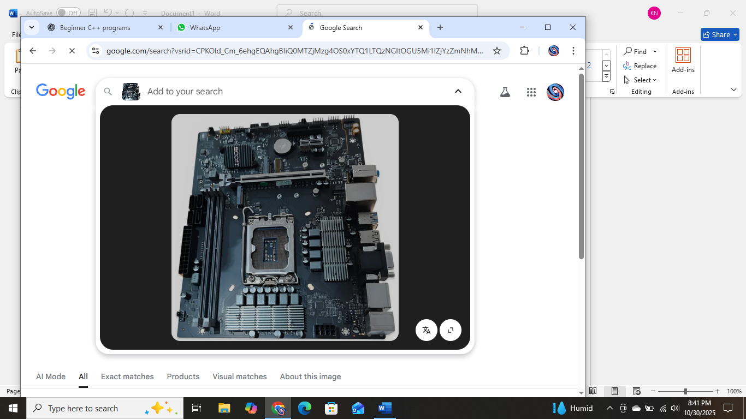
- PCIe slots (for graphics cards or expansion cards)

- SATA ports and M.2 slots (connect HDD/SSD)

- USB ports, audio, LAN/Wi-Fi support

- Form-factor (ATX, Micro-ATX, Mini-ITX)

Why it matters:
If the motherboard does not support a specific CPU or RAM type, the system will not work. A good motherboard allows future upgrades, supports fast storage, and keeps the system stable.

Example:
An ASUS B550M motherboard supports AMD processors, DDR4 RAM, M.2 SSD, PCIe graphics card, and costs around PKR 25,000 – 35,000.

