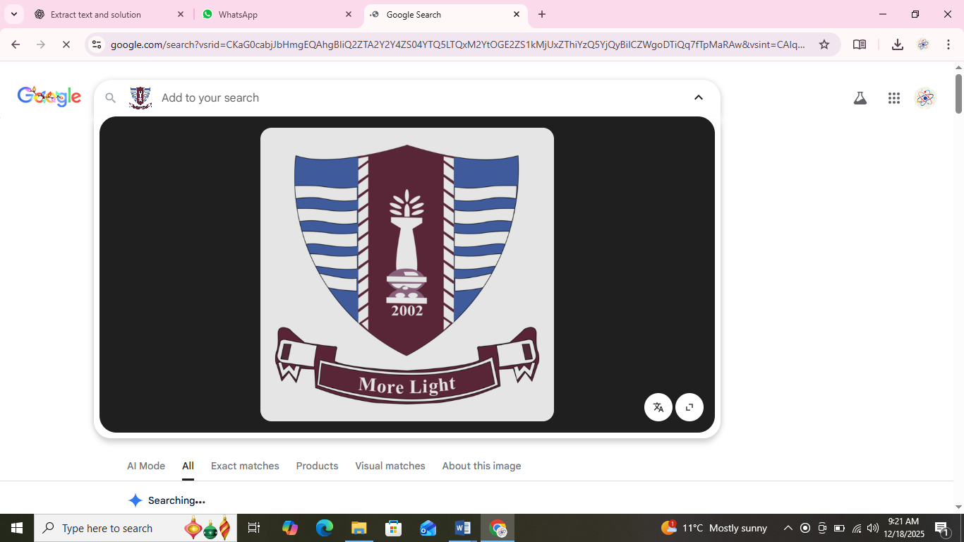

Prepared by: Khadija Nadeem
Degree : BS SE-1 Mor(B)
Roll No.: 250818
Tutor: Dr. Sheraz Malik
Submission Date: 18th December 2025

Q1. What is a Computer Virus? Types of Viruses & Prevention Methods

What is a Computer Virus?
A computer virus is a malicious software program designed to infect a computer, modify data, spread to other systems, and cause damage. It attaches itself to files or programs and executes when the file/program is opened.
A virus can steal data, corrupt files, slow down the system, or crash the entire operating system.

Types of Computer Viruses

1. Boot Sector Virus
- Infects the boot sector or system startup area.
- Activates when the computer starts.
- Example: Michelangelo virus.

2. File Infector Virus
- Attaches itself to executable files like .exe or .com.
- Spreads when infected files are opened.

3. Macro Virus
- Written in macro languages of applications like MS Word and Excel.
- Example: Melissa virus.

4. Polymorphic Virus
- Changes its code every time it infects a system.
- Hard to detect by antivirus software.

5. Stealth Virus
- Hides itself by disguising as normal files.
- Tries to avoid detection from antivirus software.

6. Resident Virus
- Installs itself in system memory and infects files while they are opened or closed.

7. Worm
- Self-replicating program that spreads through networks.
- Does not need a host file.

8. Trojan Horse
- Appears as useful software but contains hidden malicious code.

Virus Prevention Methods
✔ Install updated antivirus software (e.g., Windows Defender, Avast).
✔ Keep Windows and other software updated.
✔ Do not download programs from untrusted websites.
✔ Do not open unknown email attachments or suspicious links.
✔ Use strong firewalls and enable real-time protection.
✔ Backup important data regularly.
✔ Avoid using unknown USB or storage devices.
✔ Scan files before installing them.

Q2. Steps to Install Windows 8 and Linux

A. Steps to Install Windows 8

1. Create Bootable USB
- Download Windows 8 ISO.
- Use software like Rufus.
- Select USB → Choose partition scheme → Start.

2. Boot From USB
- Restart PC → Press boot key (F2, F12, ESC, DEL).
- Select “USB Storage Device”.

3. Windows Setup
- Choose Language → Time → Keyboard → Next.
- Click Install Now.

4. Product Key
- Enter valid Windows 8 key → Next.

5. Installation Type
- Choose Custom (advanced).

6. Partition Disk
- Create new partition → Format → Select partition → Next.

7. Installation
- Windows files copy → PC restarts → Setup continues.

8. Personalization
- Add computer name → Choose color → Sign in with Microsoft or local account.

B. Steps to Install Linux (Ubuntu Example)

1. Create Bootable USB
- Download Ubuntu ISO.
- Use Rufus / BalenaEtcher to write ISO.

2. Boot from USB
- Restart PC → Press boot key → Select USB.

3. Start Installation
- Choose Install Ubuntu.

4. Keyboard & Network
- Select keyboard layout → Connect to Wi-Fi (optional).

5. Installation Type
- Choose Erase disk and install Ubuntu
(or Install alongside Windows for dual-boot).

6. Partitioning
- Automatically partition or manually specify sizes.

7. User Information
- Enter name → computer name → username → password.

8. Installation Begins
- Files copy → System installs → Restart PC.

Drug Awareness & Preventive Measures
Drug abuse destroys families, careers, and health. Awareness, education, and timely intervention reduce addiction. Schools, communities, and health providers must work together. Early recognition of warning signs and providing counseling helps recovery. Prevention includes good parenting, community programs, and rehabilitation services.
Prevention:
- Strong family guidance and support
- Awareness programs in schools
- Healthy activities (sports, counseling)
- Avoiding bad company
- Early identification of risky behavior
Causes | Effects
- Peer pressure | - 1. Health problem
- Stress | - 2. Social problem
- Easily available | - 3. Addiction

 Prevention Strategies & Community Role
SHAPES

Q4. Role and Impact of Information Technology in Society

Information Technology (IT) plays a central role in shaping modern society. It affects communication, education, health, business, and almost all sectors.

Advantages of IT

1. Fast Communication
Email, messaging apps, and video conferencing make communication instant.

2. Better Education
Online learning, digital libraries, simulations, and educational software.

3. Improved Healthcare
Electronic medical records, telemedicine, robotic surgeries.

4. Business Automation
Online banking, e-commerce, ERP systems, digital payments.

5. Employment Opportunities
New fields like AI, cybersecurity, cloud computing, data science.

6. Global Connectivity
Social networks connect people worldwide.

7. Efficient Government Services
E-services, online forms, NADRA systems, tax filing, smart IDs.

Disadvantages of IT

1. Cybersecurity Threats
Hacking, phishing, identity theft.

2. Job Loss Due to Automation
Machines replace human labor.

3. Social Isolation
Overuse of devices reduces physical interaction.

4. Digital Addiction
Excessive use of social media and games.

5. Privacy Issues
Companies collect user data without consent.

6. Misinformation & Fake News
False news spreads rapidly on social platforms.

Q5. 10 Latest Computer Technology Developments
Below are 10 modern technologies currently in development or used today:

1. Artificial Intelligence (AI)
AI systems are being used in robotics, chatbots, automation, and medical diagnostics.

2. Machine Learning
Algorithms that learn from data and improve automatically.

3. Quantum Computing
Super-powerful computers that use quantum bits (qubits).

4. 5G & 6G Technology
High-speed internet connectivity for smart cities and IoT.

5. Internet of Things (IoT)
Smart devices connected to the internet — homes, cars, factories.

6. Blockchain Technology
Used for secure transactions, cryptocurrencies, smart contracts.

7. Robotics & Automation
Self-driving cars, delivery robots, industrial robots.

8. Cloud Computing
Services like AWS, Azure, Google Cloud delivering online computing power.

9. Cybersecurity Advancements
Zero Trust security, advanced encryption, biometric verification.

10. Augmented Reality (AR) & Virtual Reality (VR)
Used in gaming, training, education, and simulations.

