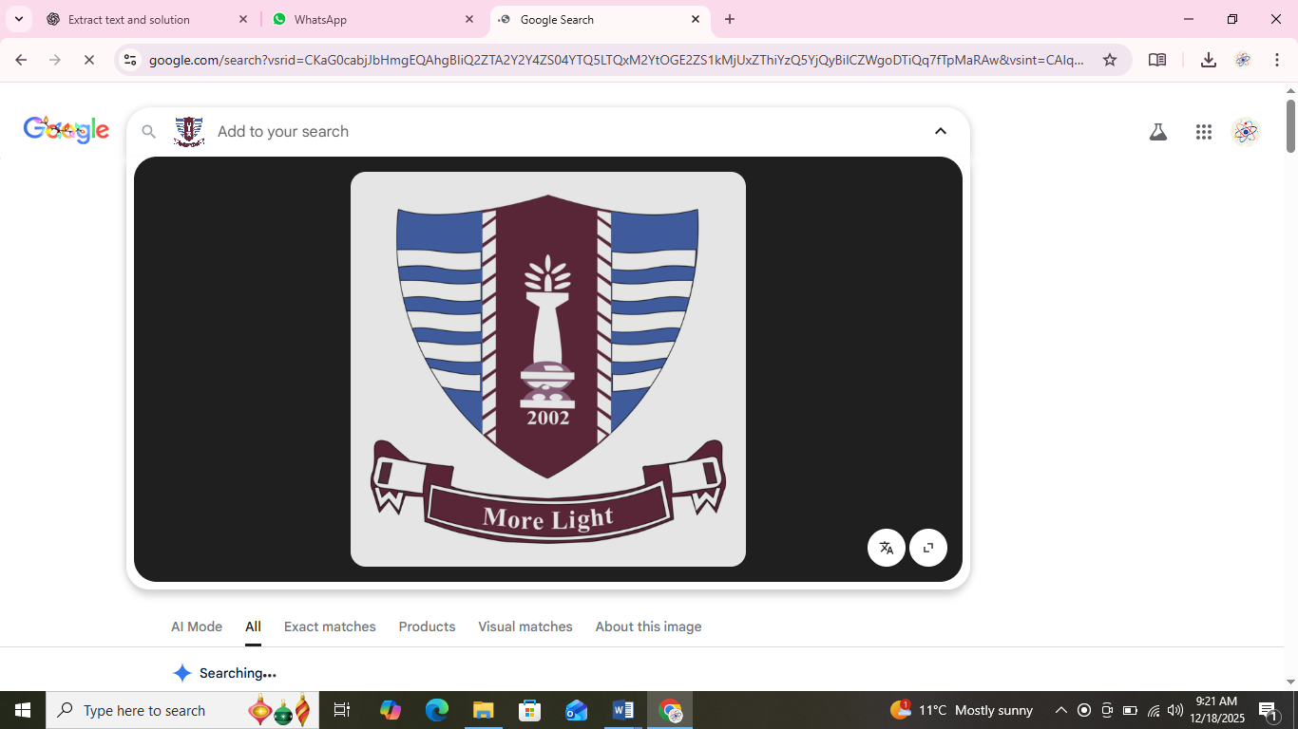
Prepared by: Khadija Nadeem
Degree: BS SE-1 Mor(B)
Roll No.: 250818
Tutor: Dr. Sheraz Malik
Submission Date: 18th December 2025

Q1. Display formatted output using the function <iomanip>
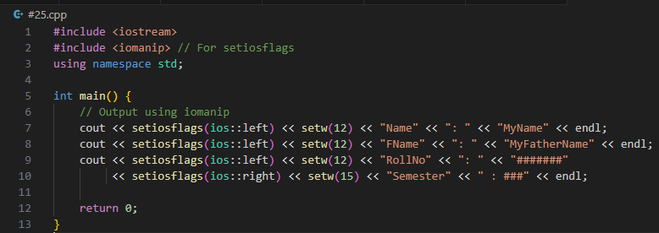
Explanation:
setw(n) → sets the width of the field.
setiosflags(ios::left/right) → aligns text left or right.
Combining left and right alignment gives neat formatting.
Q2. Input two values, add and multiply them and display
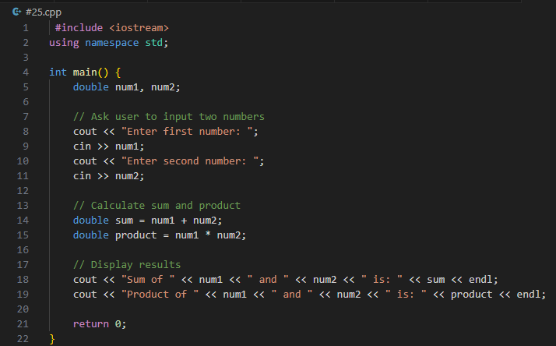
✅ Explanation:
cin for input
cout for output
Simple arithmetic operations
Q3. Implement given equations with user input Here’s a generic template where you can add your own equations. I’ll assume 2 sample equations:
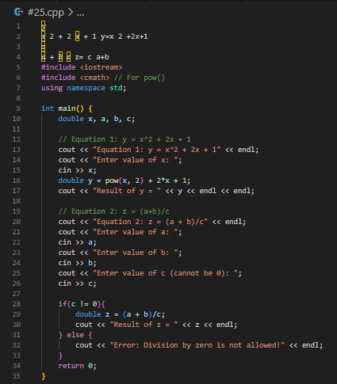

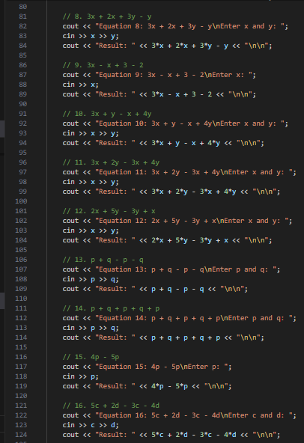
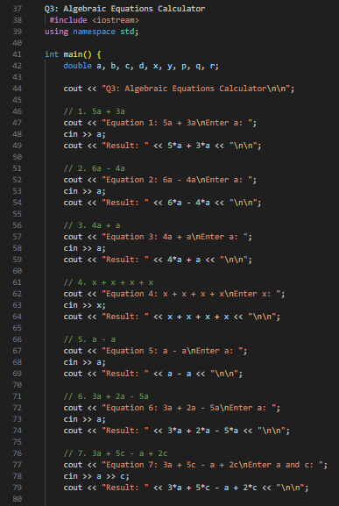
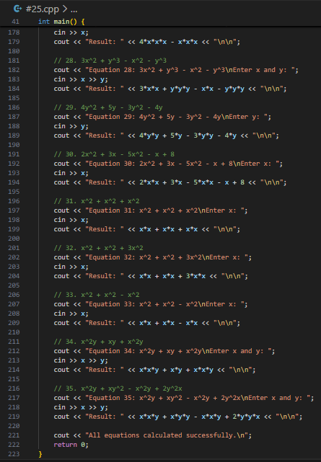
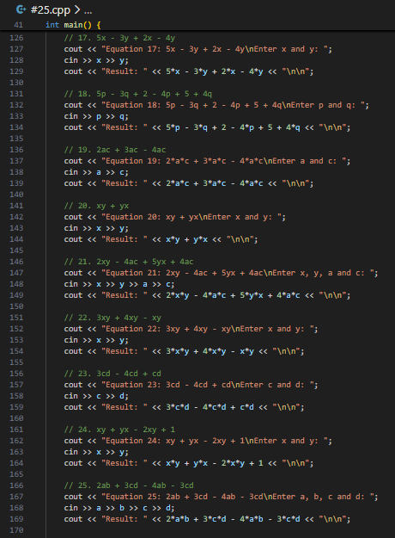

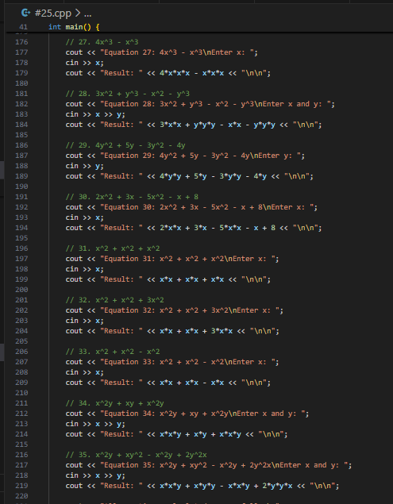

Explanation:
Used pow() for powers.
Added clear messages to guide the user.
Checked division by zero.

