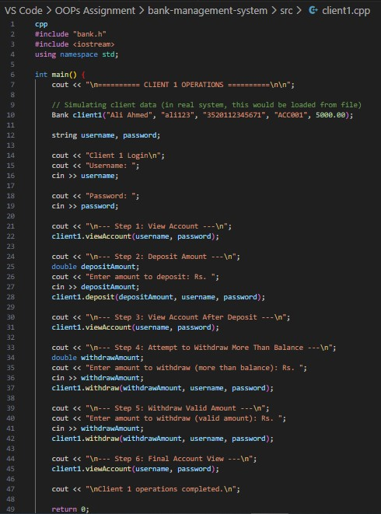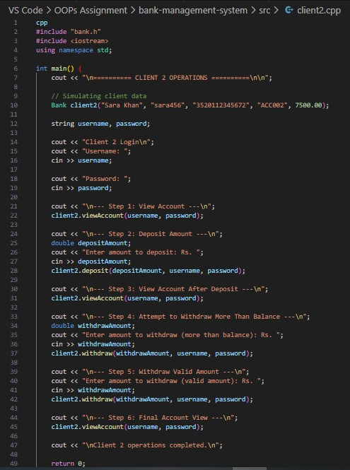
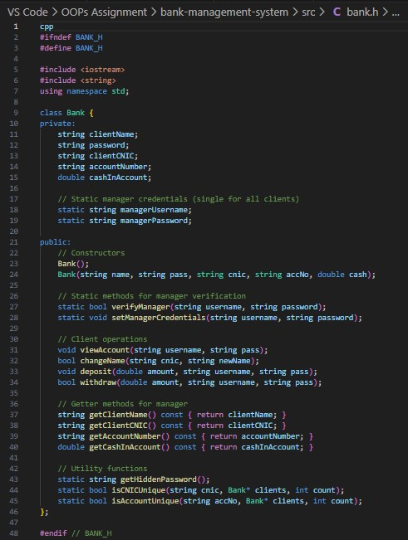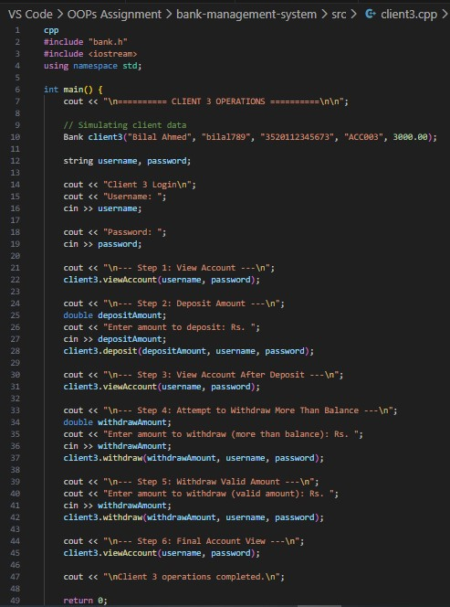

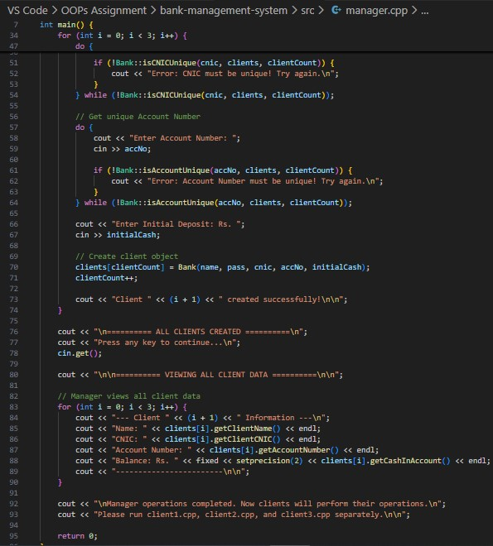
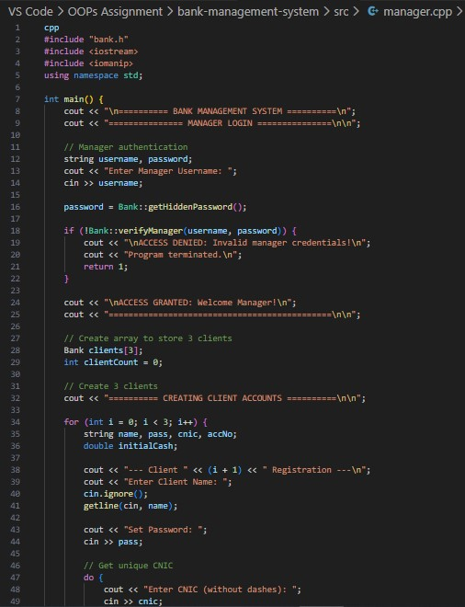
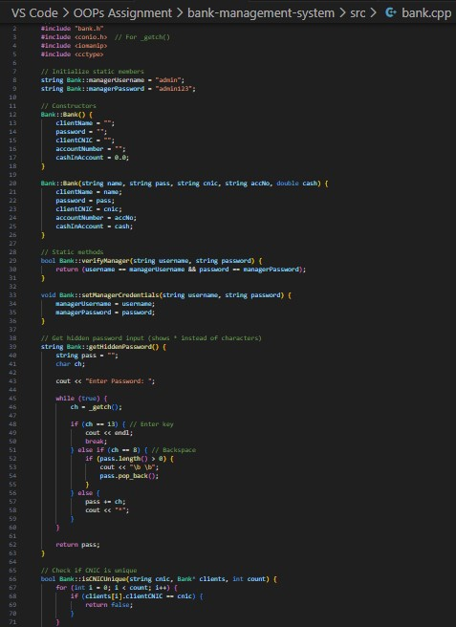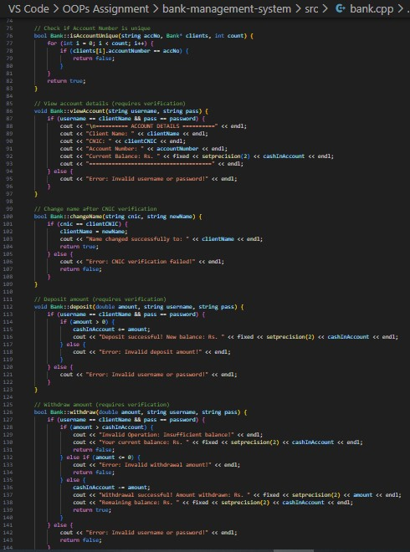

BANK MANAGEMENT SYSTEM - OOP ASSIGNMENT
SOLUTION

4. SAMPLE OUTPUT
MANAGER OUTPUT
(manager.cpp):

===== BANK MANAGEMENT SYSTEM ===== ========= MANAGER LOGIN ==========

Enter Manager Username: admin
Enter Password: *******

ACCESS GRANTED: Welcome Manager!
================================

===== CREATING CLIENT ACCOUNTS ======

--- Client 1 Registration --- Enter Client Name: Ali Ahmed
Set Password: ali123
Enter CNIC (without dashes): 3520112345671
Enter Account Number: ACC001
Enter Initial Deposit: Rs. 5000 Client 1 created successfully!

--- Client 2 Registration --- Enter Client Name: Sara Khan
Set Password: sara456
Enter CNIC (without dashes): 3520112345672
Enter Account Number: ACC002
Enter Initial Deposit: Rs. 7500 Client 2 created successfully!

--- Client 3 Registration --- Enter Client Name: Bilal Ahmed
Set Password: bilal789
Enter CNIC (without dashes): 3520112345673
Enter Account Number: ACC003
Enter Initial Deposit: Rs. 3000
Client 3 created successfully!

====== VIEWING ALL CLIENT DATA ======

--- Client 1 Information ---
Name: Ali Ahmed
CNIC: 3520112345671
Account Number: ACC001
Balance: Rs. 5000.00
------------------------

--- Client 2 Information ---
Name: Sara Khan
CNIC: 3520112345672
Account Number: ACC002
Balance: Rs. 7500.00
------------------------

--- Client 3 Information ---
Name: Bilal Ahmed
CNIC: 3520112345673
Account Number: ACC003
Balance: Rs. 3000.00

CLIENT 1 OUTPUT (client1.cpp):

====== CLIENT 1 OPERATIONS =========

Client 1 Login
Username: Khadija
Password: khadija@123

--- Step 1: View Account ---

========= ACCOUNT DETAILS =========
Client Name: Khadija
CNIC: 33401-0741908-0
Account Number: ACC001
Current Balance: Rs. 5000.00

===============================

--- Step 2: Deposit Amount --- Enter amount to deposit: Rs. 2000
Deposit successful! New balance: Rs. 7000.00

--- Step 3: View Account After Deposit ---

========= ACCOUNT DETAILS =========
Client Name: Khadija
CNIC: 33401-0741908-0
Account Number: ACC001
Current Balance: Rs. 7000.00
===============================

--- Step 4: Attempt to Withdraw More Than Bal ance ---
Enter amount to withdraw (more than balance): Rs.
8000
Invalid Operation: Insufficient balance!
Your current balance: Rs. 7000.00

--- Step 5: Withdraw Valid Amount --- Enter amount to withdraw (valid amount): Rs. 3000
Withdrawal successful! Amount withdrawn: Rs. 300
0.00
Remaining balance: Rs. 4000.00

--- Step 6: Final Account View ---

========= ACCOUNT DETAILS =========
Client Name: Khadija
CNIC: 33401-0741908-0
Account Number: ACC001
Current Balance: Rs. 4000.00

===============================

Client 1 operations completed.

