[How Does the Internet Work?](https://web.stanford.edu/class/msande91si/www-spr04/readings/week1/InternetWhitepaper.htm" \l ":~:text=The%20web%20browser%20connects%20to,an%20HTTP%20404%20error%20message.)

The web browser **connects to the web server and sends an HTTP request** (via the protocol stack) for the desired web page. The web server receives the request and checks for the desired page. If the page exists, the web server sends it. If the server cannot find the requested page, it will send an HTTP 404 error message.

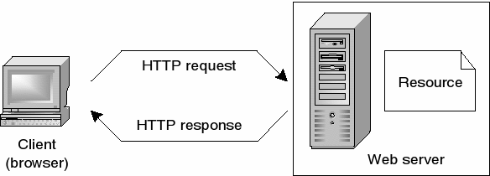

What do you need to be a web developer ?

## What qualifications do you need to become a web developer?

While there are no formal or specific qualifications required to become a web developer, a numerate degree in a subject such as maths or science will be useful.

You should also ideally have an aptitude for - or experience of - elements such as:

* User experience (UX)
* User interface (UI)
* Visual design
* Coding languages including HTML and CSS
* Frontend web programing languages and skills such as JavaScript, Ajax and web animation techniques
* Backend web programing languages such as C# or Java, PHP and Ruby
* Design software like Photoshop and Illustrator and Sketch
* An understanding of SEO
* Web servers and how they function

A career as a web developer is very specialised. While programs such as Adobe Dreamweaver and platforms such as WordPress are often perceived to take the place of core coding skills - and they do indeed allow novice users to create sites with basic knowledge - developing sites for corporate clients requires high levels of customisation which cannot be met with the use of programs such as Adobe Dreamweaver, as web developers are required to code in the raw language of the web.

A portfolio of your work is an ideal way to demonstrate your skills as a developer. Aim to include:

1. Examples of websites you've worked on - this allows you to share the work you have completed and helps to show prospective clients what you can do
2. Testimonials from clients you have previously worked with - this will reassure prospective clients that you have completed work for other clients and they were happy with what you delivered. Always ask any clients you work for to provide a testimonial once you complete a project
3. Your USPs - this is the ideal way to really sell yourself to prospective clients, showing what makes you stand out and why they should choose you over other developers
4. Your contact details - your name, email address, telephone number and social media handles, plus a link to your portfolio

Resources you may find helpful in building your portfolio include:

* [Sitepoint](https://www.sitepoint.com/how-to-create-a-portfolio-site-that-will-get-you-hired/)- tips on how to create a portfolio site to get you hired
* [Codementor](https://www.codementor.io/learn-programming/12-important-things-to-include-in-web-dev-portfolios) - advice on elements you should always include in your portfolio

If you are considering which subjects may stand you in good stead for a career in web development, consider numeracy-based subjects such as maths or science, plus subjects such as computer science.

## What skills do you need to become a web developer?

Key skills to be successful in web development include:

* Computer literacy
* Strong numeracy skills
* Strong creative ability
* Attention to detail
* Strong communication skills
* Excellent problem-solving skills
* A logical approach to work
* The ability to explain technical matters clearly
* A keen interest in technology

Ongoing self-learning is key to developing in a web development role, in order to stay up to date with ever more frequent technological advancements and updates.

What is the rule of a web developer ?

A Web Developer is **responsible for the coding, design and layout of a website according to a company's specifications**. As the role takes into consideration user experience and function, a certain level of both graphic design and computer programming is necessary.