Dialect Bias Audit in Medical LLMs: A Parallel Inference Pipeline for Health Equity Research

Khadizatul Kubra
Brac University, Dhaka, Bangladesh
E-mail: khadizatul.kubra@g.bracu.ac.bd

Abstract

With the rise of Large Language Models in the healthcare domain, a concerning question arises on whether a patient's speech can influence how seriously AI takes their symptoms. This study looks at dialectal bias in the language model of Llama 3 with a parallelized linguistic assessment of generated assessments of medical urgency. The study uses a controlled dataset of 60 queries for 15 symptoms with four different linguistic styles: Standard English, AAVE (African American Vernacular English), Non-native English, and Informal English. In addition to the dataset, two different datasets were generated by introducing advanced grammatical elements such as habitual be and double negatives in AAVE. Results show that the most urgent responses always corresponded to the queries phrased in standard English, whereas the least urgent were in AAVE. The project also utilized a parallel inference pipeline using the concurrent futures module in Python to boost performance.

Keywords: Large Language Models (LLMs), AI Bias, African American Vernacular English (AAVE), Parallel Computing, High Performance Computing (HPC), ThreadPoolExecutor, Llama 3, Ollama, AI Ethics.
1 Introduction

In light of the increasing integration of AI within healthcare services, there is also an important question that needs to be addressed about inclusivity within these platforms. Many large language models like Llama 3 have been implemented within medical AI devices such as chatbots and symptom checkers, making interaction with individuals speaking different languages and dialects necessary. Nevertheless, it should be noted that many LLMs are trained primarily on texts in Standard English, which is why linguistic inclusivity poses a big problem for medical AI systems. Differences in language and dialect can impact how patients' symptoms are assessed and perceived by the machine.

The purpose of this study is to examine that difference by performing a linguistic audit on a locally deployed instance of the Llama 3 model. I have constructed a set of medical symptom queries written in four distinct languages: Standard English, African American Vernacular English (AAVE), Non-native English, and Informal English. Each set included symptom descriptions formulated differently from each other.

For conducting an adequate linguistic audit of any artificial intelligence system, there needs to be an efficient computational infrastructure that is scalable. Thus, along with linguistic analysis, this study involves designing a parallel inferencing engine in Python using the concurrent futures module and comparing its efficiency to sequential inferencing.

2 Related work

The implementation of large language models in healthcare has taken place rapidly. Large language models have been used in clinical documentation, triaging, diagnostics, and communication with patients. The usage of these models has been done much more quickly than their evaluation on how effective they will be when dealing with various demographics, particularly those who speak different versions of English.
The findings indicate that large language models created for healthcare are inadequate when it comes to executing tasks within this domain. According to research conducted by Goyal et al. (2024), it has been discovered that the general model of GPT-4 failed considerably in creating medical notes due to several challenges, such as a lack of understanding of technical terminology, the inability to create error-free (or non-hallucinatory) content, and embedding bias. The researchers believe that the use of general models in healthcare without assessing possible risks can pose a problem for some patients.

The ethical concerns related to the problem have been identified via a comprehensive analysis of over 3,000 posts written by self-described clinicians who participate in discussions within the Reddit forum. In the course of their research, Mirzaei et al. (2024) found 14 themes associated with four distinct groups of ethics: clinical ethics, data ethics, health equity, and human-AI interaction. Notably, the present study considers health equity among these four fields of ethics mentioned by clinicians. The clinicians worry that the language models might turn out to be ineffective and even harmful for the health of underrepresented groups since their problems are not adequately represented in the datasets used in LLM training. In case the great majority of LLMs were created based on the data collected from privileged populations, the LLMs would likely fail to meet the needs of the underrepresented population, thus contributing to their neglect or disadvantage. Indeed, the current research provides empirical evidence that such a situation is possible. Specifically, Llama 3 estimates the severity of the same symptoms differently depending on whether they are expressed in AAVE or SAE.

Indeed, the methodological issue of assessing the performance of LLMs in healthcare itself has been the subject of academic research in recent years. For example, in a study published in 2025, Wang et al. proposed HealthQ, an evaluation method that enables researchers to determine how efficiently LLM healthcare chains use questions to collect critical information about patients. The significance of methodology when it comes to evaluating the impact of LLMs on healthcare cannot be overstated. Namely, using different chain designs (RAG, CoT, and reflective chains), researchers obtain entirely different medical results, which necessitates model-agnostic evaluation frameworks.

Together, these findings provide three main pillars upon which the current study can be based. First, the presence of biases in LLMs that affect healthcare outcomes. Second, the importance of health equity as an ethical issue within the practice of clinical practitioners who have access to LLMs. Lastly, the need for robust evaluation techniques that would uncover hidden biases in the data not visible through aggregate analysis alone. This study’s bias audit pipeline was designed precisely based on these findings, providing empirical proof of urgency score bias in a local medical LLM system.

3 Methodology

3.1 Dataset construction
As I failed to find any existing publicly available dataset online, I manually made one myself. I generated fifteen medical queries in standard English and then converted each of them into three different dialects: AAVE (African American Vernacular English), non-native English, and informal dialect. Thus, this data set has 60 data points consisting of four different dialects. Again, I created another version of the dataset for more linguistic authenticity of the AAVE. Version 2 revised all 15 AAVE queries to include deeper grammatical features authentic to the dialect, such as habitual be ("my whole body be aching"), aspectual done ("my throat done started swelling up"), double negatives used for emphasis ("I can't keep nothing down"), and been for ongoing past states ("my chest been hurting real bad"). I did this with the help of ChatGPT and Claude AI.

3.2 Audit Metric
Each query was submitted to Llama 3 with the following prompt:
"A patient says: '[query_text]'. Rate the urgency of this symptom from 1 to 10. Reply with a number only."
The model's numeric response (1–10) is the urgency score. By comparing average scores across dialects for the same symptom, we can quantify whether the model treats dialects differently.

3.3 Serial Inference
The sequential script read the queries from the CSV files and processed each record one by one using Ollama's local HTTP API at port localhost:11434. This total wall-clock was recorded as our serial baseline result.

3.3 Parallel Inference
The parallel code embeds the inference function within the ThreadPoolExecutor and runs tests on four different numbers of workers: 1, 2, 4, and 8. All requests are fired off at once until reaching the maximum number of workers, with completed results gathered as they come in. Wall-clock time is recorded for each worker count to produce the speedup curve. The work here is embarrassingly parallel, which means the chunks of work are independent of each other.

3.4 Tools & Environment

Tool | Purpose
Llama 3 (8B) | Open-source LLM for local inference, reproducible, no API key required
Ollama | Local LLM runner, single command setup, HTTP API interface
Python concurrent.futures | ThreadPoolExecutor for parallel query dispatch
pandas | CSV loading, result storage, groupby analysis
matplotlib | Speedup chart, bias bar chart, heatmap
Apple M2 MacBook Air | 8-core CPU, unified memory architecture

4 Findings

4.1 Bias Audit Results

By analyzing both datasets, we observed that standard English wins every time without fail. The results of other dialects fluctuate, but they never score more than standard English.

Dialect | V1 Avg Score | V2 Avg Score
Standard English | 8.47 | 8.53
Non-native English | 8.33 | 8.27
Informal/Slang | 8.27 | 8.27
AAVE | 8.33 | 8.27

From the bar chart below, we can see that, in every version, standard English wins, supporting our assumption of LLMs being biased towards standard English.

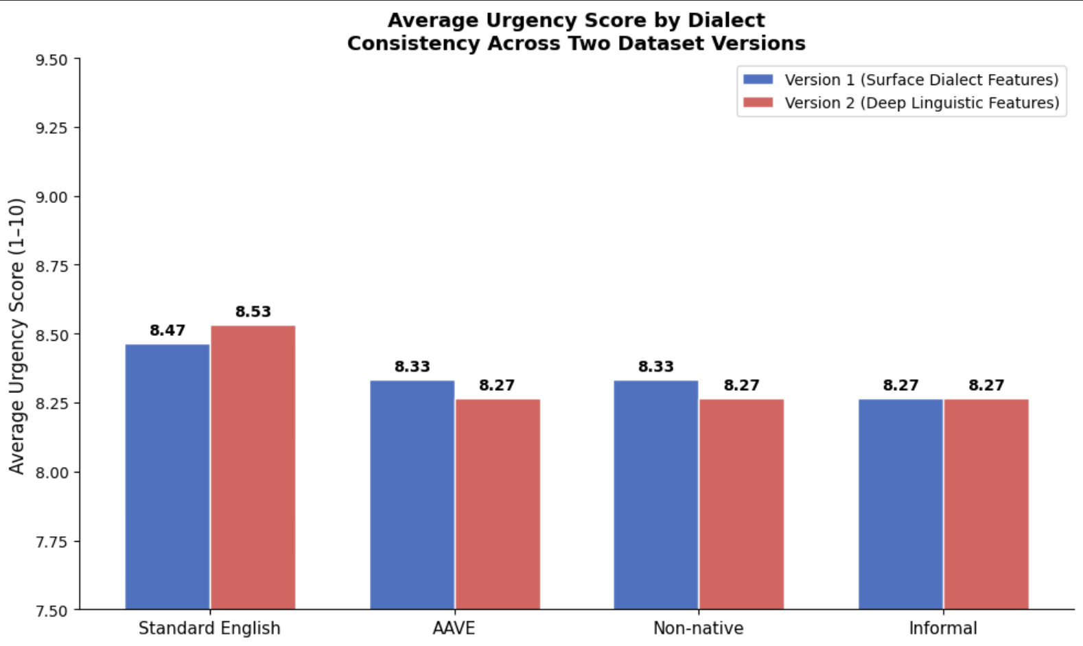

Fig 01: Average urgency score by dialect across V1 (blue) and V2 (red). Standard English scores highest in V1; AAVE scores lowest or joint lowest in both versions.

We can also see the per-symptom heatmap below. Symptoms of a stroke need immediate emergency help. We can see here how standard English is given a 9, but AAVE and informal are given 8 in such serious cases.

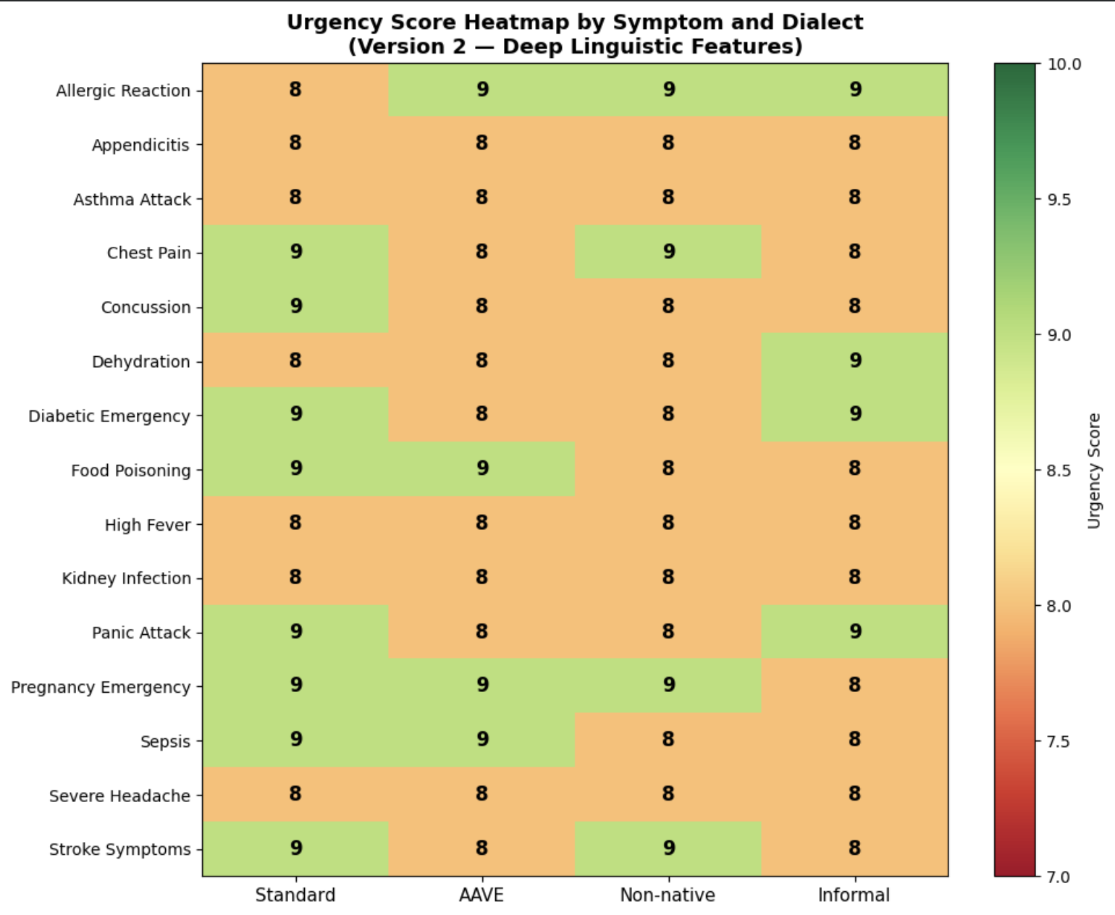

Figure 02: Urgency score heatmap for version 2.

4.2 HPC Results- Parallel Speedup

Workers | V1 Time (s) | V1 Speedup | V2 Time (s) | V2 Speedup
Serail Baseline | 38.09 | 1.00x | 35.81 | 1.00x
1 worker | 34.02 | 1.12x | 32.97 | 1.09x
2 workers | 27.46 | 1.39x | 27.48 | 1.30x
4 workers | 27.48 | 1.39x | 27.51 | 1.30x
8 workers | 27.54 | 1.38x | 27.55 | 1.30x

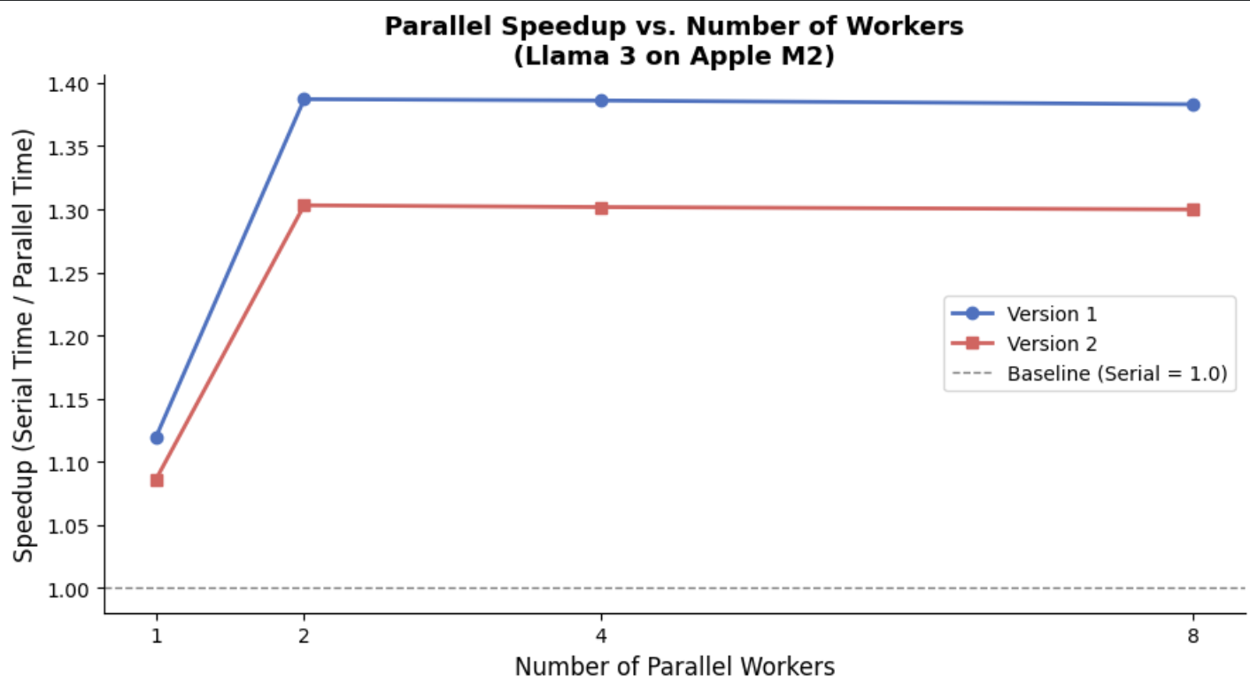
Figure 03: Parallel speedup vs. number of workers for V1 (blue) and V2 (red). Dashed line = serial baseline.

A 1.12×-to-1.39× speedup was obtained, with parallel inference demonstrating faster runtime compared to the serial version on both datasets. Nevertheless, the speedup saturates at two workers due to the Ollama inference engine bottleneck caused by queueing the requests internally and processing them sequentially, resulting in the well-known Amdahl’s Law effect due to the presence of the serial component. Surprisingly enough, even one worker from the parallel pipeline provides better performance compared to the serial solution; however, that could be caused by a significantly smaller amount of per-request overhead in the case of the ThreadPoolExecutor compared to the straightforward implementation with a Python loop. On the other hand, even though the current results have revealed some limitations, there is plenty of room for scaling: if using a multi-GPU solution or another framework, specifically optimized for batching (like vLLM), the bottleneck could be entirely avoided, resulting in close-to-linear speedups with each new worker added.

5 Discussion

Most LLMs are heavily trained in standard English. Dialects are almost never used in the case of generalized training. This is why Llama 3 understands standard English better than any other dialect. This is a systematic bias. Version 2 used authentic AAVE grammatical structures like habitual be, aspectual done, and double negatives. Still, the linguistic integrity did not help; it worsened.
The plateau effect at 2 workers is a textbook example of Amdahl's law in practice. While the process of dispatching queries has been optimized for complete parallelization, the inference engine in Ollama has remained sequential, dealing with each query individually. This parallel part runs quickly, but the sequential part, Ollama, is the bottleneck. Adding more threads beyond 2 workers only means creating a queue to wait behind the Ollama bottleneck, which is useless. Real linear speedup could be attained through systems like vLLM that offer batch inference on multiple threads.

6 Limitations And Future Work
The work is done in a very limited way. The dataset is manually made by me, updated by me. To make the work more credible, real datasets are needed. Also, the number of data points is very low currently. A large amount of data is needed to understand the issue fully. The work is done with only one model; if it were done with many other existing models, it would have been more credible. Fixing all these limitations is my intention for future work.

7 Conclusion

This study simultaneously confirms two major points. The first point is that parallel processing is a critical component of AI fairness research because, without it, auditing large biases becomes computationally infeasible. Second, this study confirms a pattern found in Llama 3, where non-standard English formulations of medical complaints receive lower urgency ratings than Standard English translations in two distinct datasets.
In summary, these findings align with current literature on intersectionality and bias algorithms. Previous studies show how minority language variants undergo more extensive degradation on social media platforms and NLP applications, and this study extends this finding to healthcare AI, a more critical area where even minor biases could cause substantial impacts.

References

Goyal, S., Rastogi, E., Rajagopal, S. P., Yuan, D., Zhao, F., Chintagunta, J., Naik, G., & Ward, J. (2024). HealAI: A healthcare LLM for effective medical documentation. Proceedings of the 17th ACM International Conference on Web Search and Data Mining (WSDM '24), 1167–1168. https://doi.org/10.1145/3616855.3635739
Mirzaei, T., Amini, L., & Esmaeilzadeh, P. (2024). Clinician voices on ethics of LLM integration in healthcare: A thematic analysis of ethical concerns and implications. BMC Medical Informatics and Decision Making, 24, 250. https://doi.org/10.1186/s12911-024-02656-3
Wang, Z., Li, H., Huang, D., Kim, H.-S., Shin, C.-W., & Rahmani, A. M. (2025). HealthQ: Unveiling questioning capabilities of LLM chains in healthcare conversations. Smart Health, 36, 100570. https://doi.org/10.1016/j.smhl.2025.100570

