

Lab-2 Assignment

Submitted by:

Angkit Khadka

Student ID: 23058064

Submitted to:

Professor: Nawaz Chowdhury
Subject: Database-2

Course code: CSD216

Honesty Statement: “I declare that this submission is my own work in compliance with Sault College Academic Policies.”

Due Date: 26th Sep 2024

1 | P a g e

Table of Content

Section A: Design and GUI (120 Marks) 3

Section B: Database Connection (180 Marks) 3

Section C: Data Retrieval (240 Marks) 5

Section D: GitHub and Documentation (360 Marks) 5

2 | P a g e

Section A: Design and GUI (120 Marks)

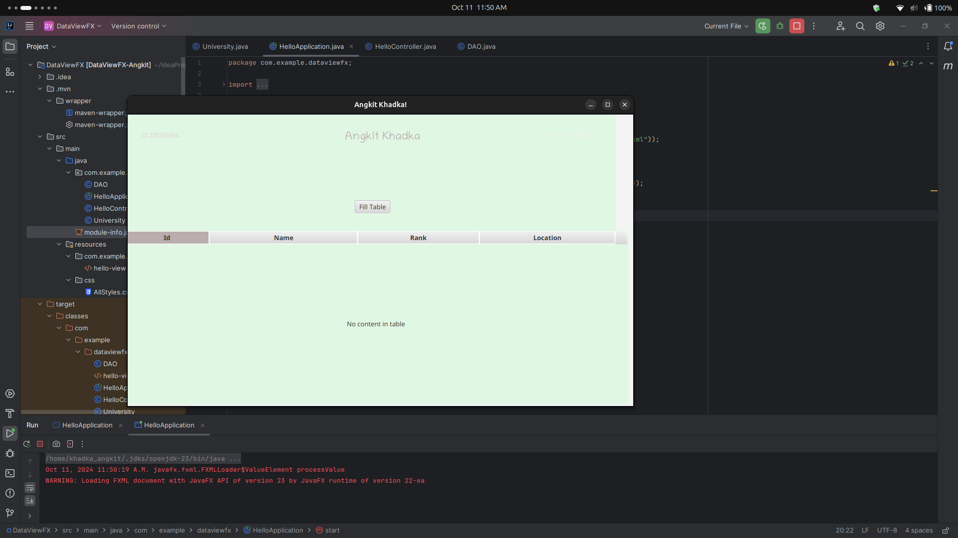

Section B: Database Connection (180 Marks)

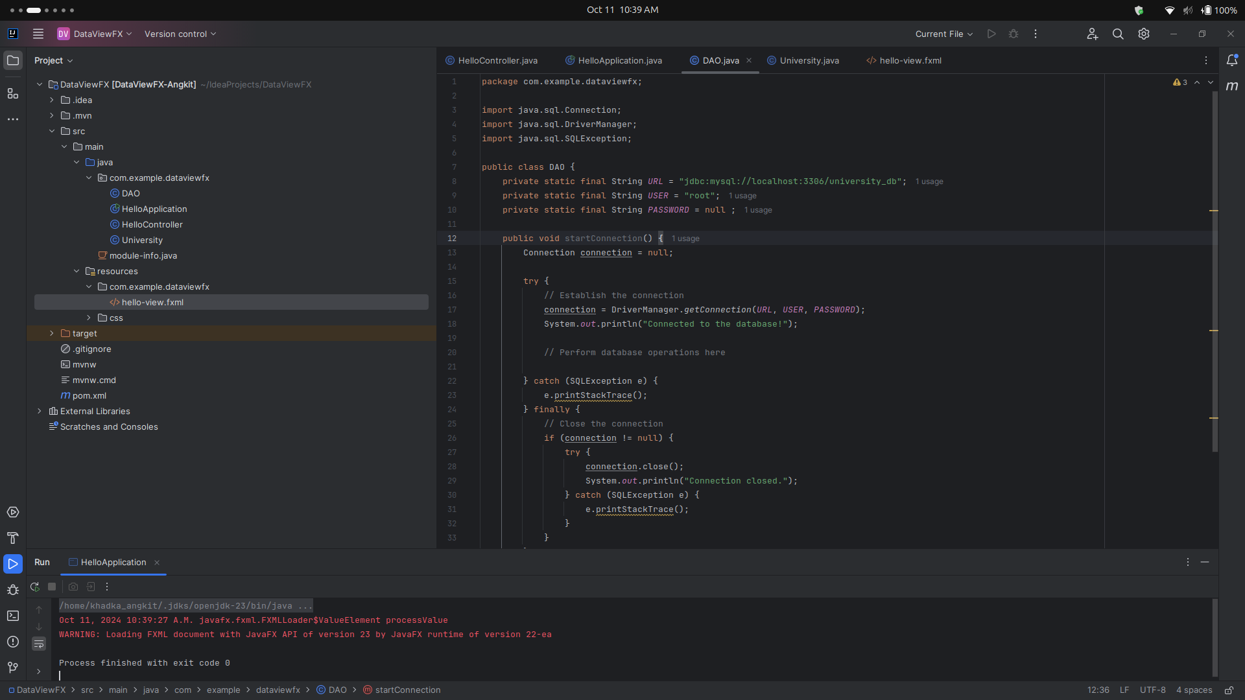

3 | P

4 | P a g e
Section C: Data Retrieval (240 Marks)

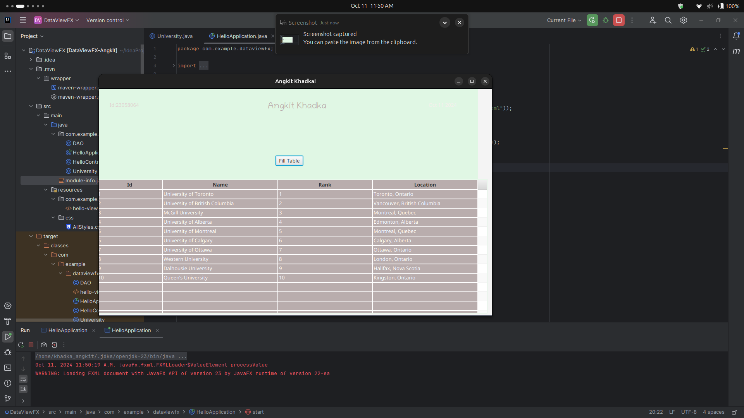

Section D: GitHub and Documentation (360 Marks)

This is the main UI of The application

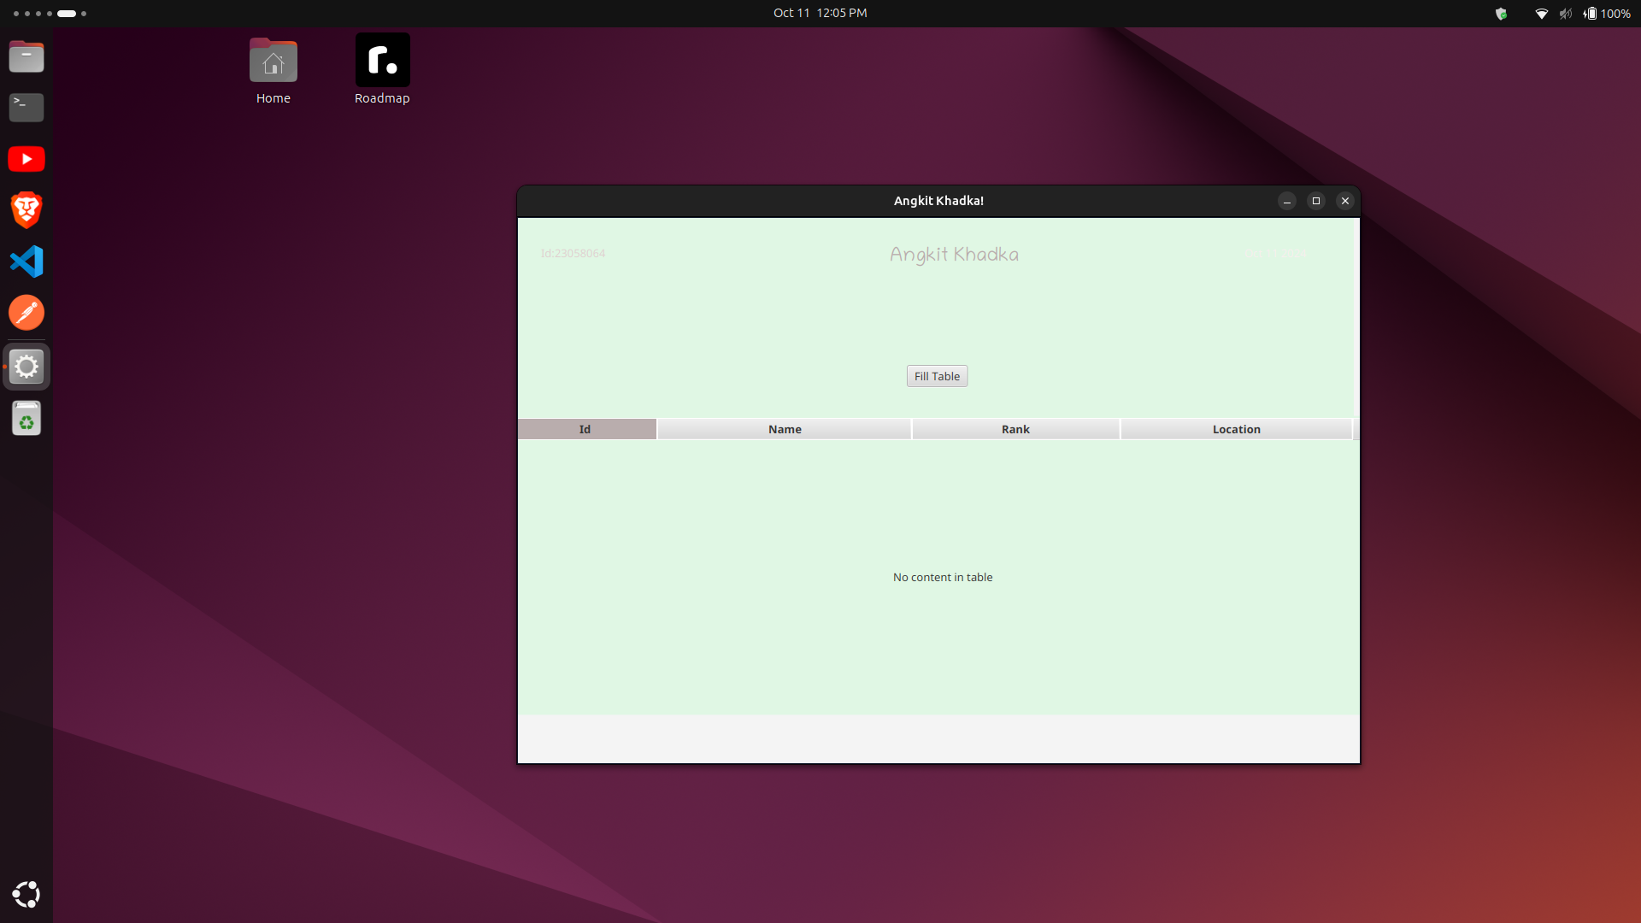
.

This is the database:

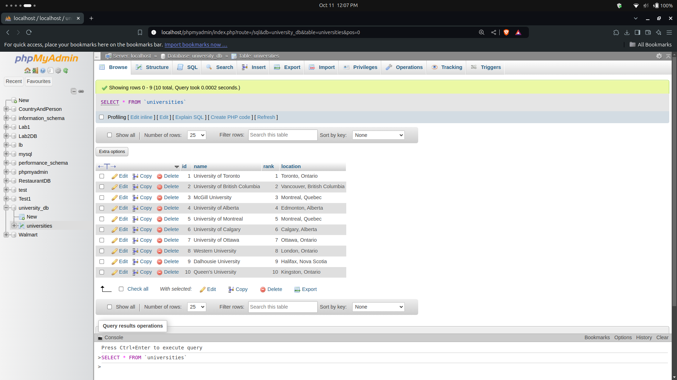
This is the modal of data:)
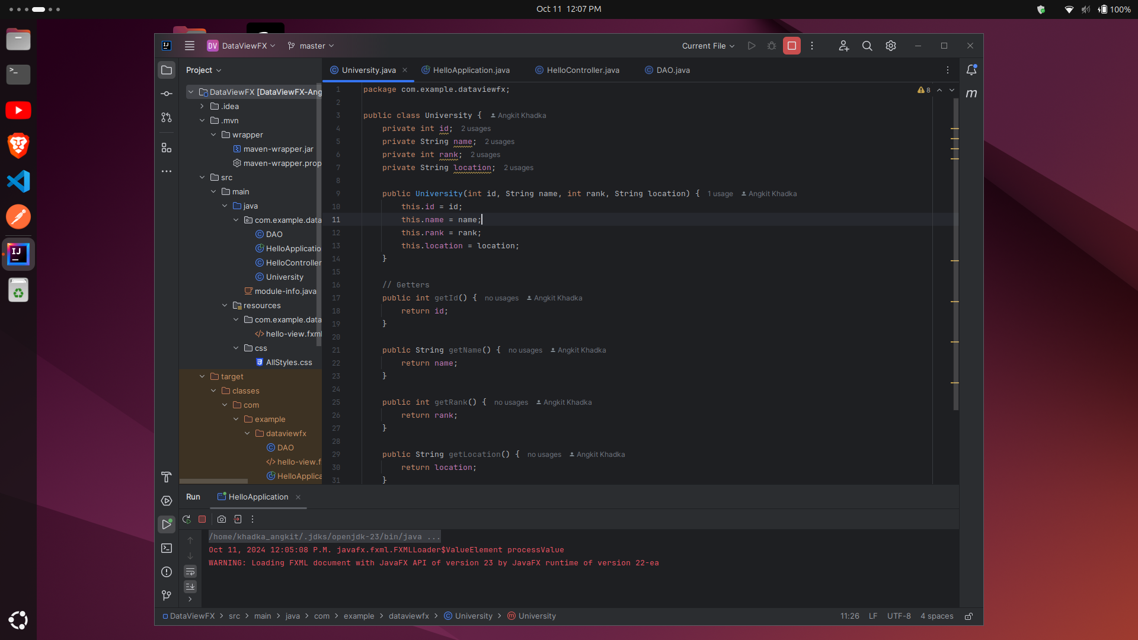

We use JDBC to connect to our SQL Database:
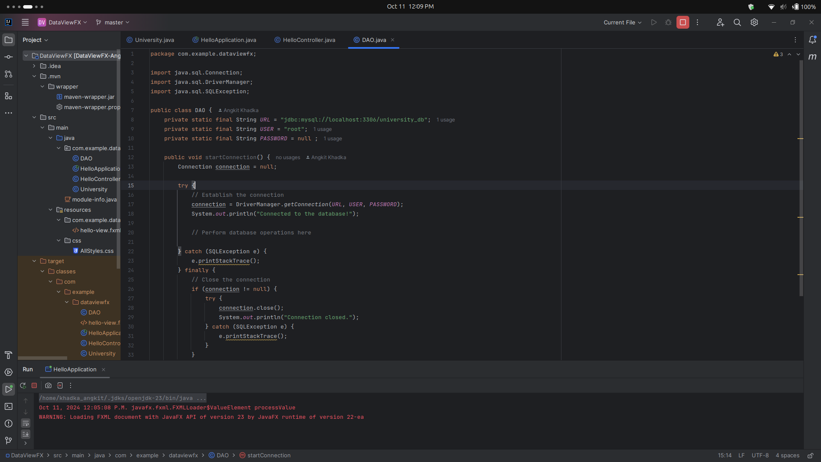
.
This is how data is being retrieved from the databse:
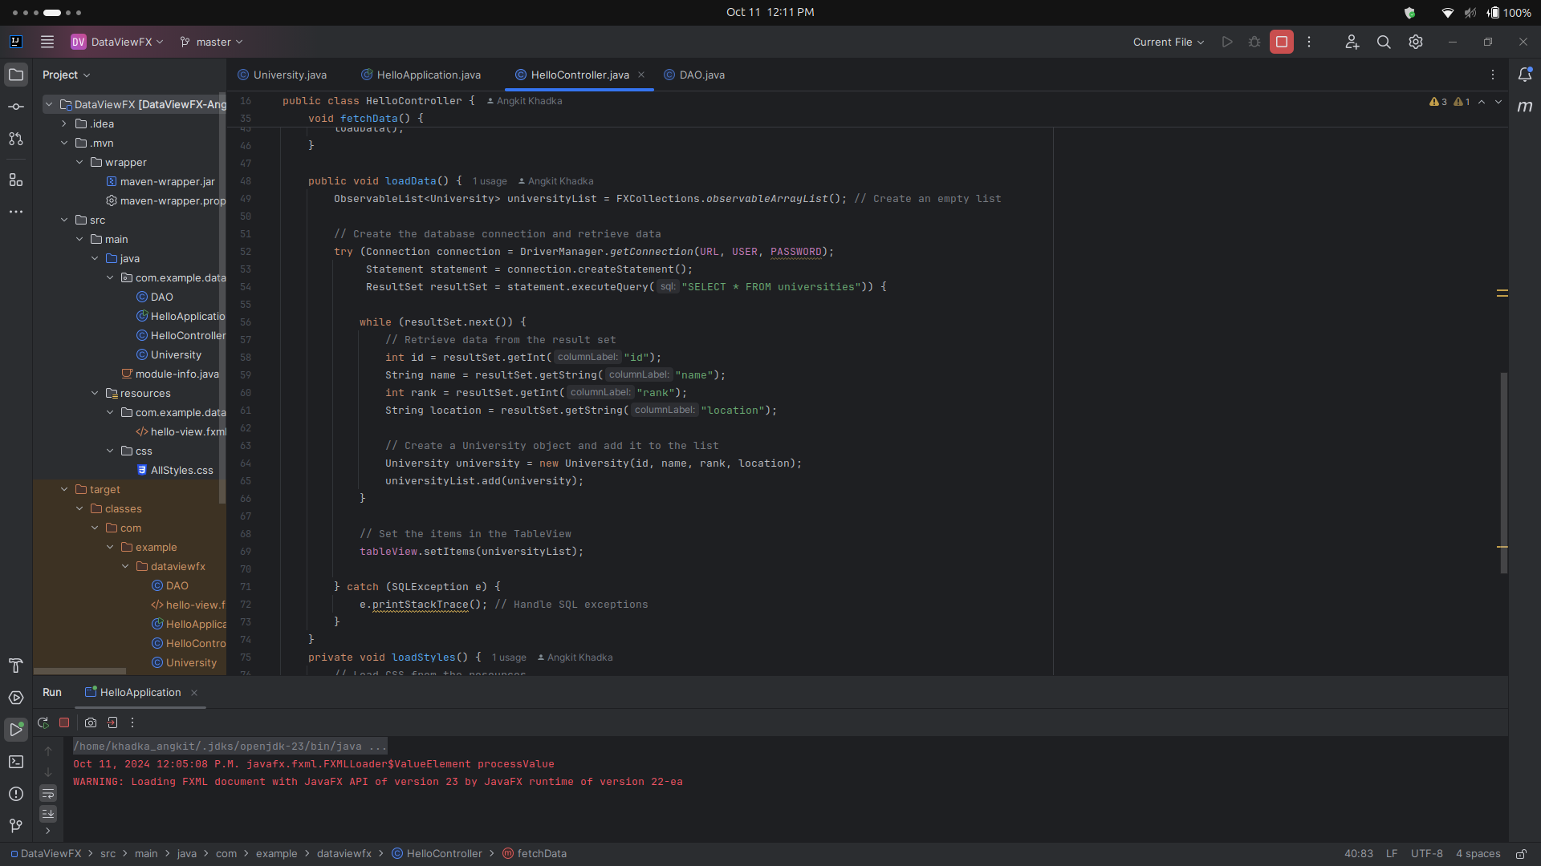

Link to GitHub: https://github.com/khadkaankit85/DataviewFX

5 | P a g e

