Lab 3: Keypad Scanning in C

Goals
- Understand and implement algorithms for scanning keypad inputs.
- Apply software debouncing techniques to enhance input reliability.

Pre-lab Assignment
- Reading: Study Chapter 15.9 on Keypad Scanning from the course textbook to grasp the fundamental concepts and algorithms.
- Preparation: Complete the register tables provided in the pre-lab section to familiarize yourself with the required hardware registers.

In-lab Assignment
- Keypad Polling and Display:
  - Use polling to scan a keypad and display the inputs via a serial terminal.
  - When a key is pressed, its value should be displayed on the serial terminal.
  - Implement software debouncing to prevent accidental double-presses.

- Something cool. Enhance your keypad scanning program with an extra feature. You can choose from the suggestions below or create your own:
  - When a key is pressed for an extended period, you have two options: generate a single input regardless of the duration or generate a periodic input with an interval of 2 seconds (known as auto-repeat).
  - Use the “*” key to delete the previous input.
  - Use the “#” key to repeat the previous inputs.
  - Detect if multiple keys are pressed simultaneously.
  - Incorporate the motor lab and display the current rotation angle on the LCD (for those who have completed the motor lab).
  - Receive input from the keypad to rotate the motor by a specified number of degrees (for those who have completed the motor lab).

Part A: LCD Integration and Demonstration
In this lab, you will use the OLED-SSD1306 LCD module, which communicates with the STM32L4 via the I2C communication interface.
The LCD has a diagonal size of 0.96 inches and a resolution of 128x64 pixels. The schematic for this module can be found at the following link:
http://wiki.sunfounder.cc/index.php?title=OLED-SSD1306_Module
OLED-SSD1306 | - 0.96” OLED display module  - Driver chip: SSD1306  - Resolution: 128×64 pixels  - Working voltage: 3.3V – 5.5V  - Power consumption: 0.04W during normal operation  - I2C Interface, default I2C address: 0x78  - SCL and SDA are already pulled up to Vcc on the board.
First, connect the LCD module to the STM32L4 board. The OLED-SSD1306 module has four pins: Vcc, GND, SCL, and SDA. These should be connected to the Nucleo board as shown below:
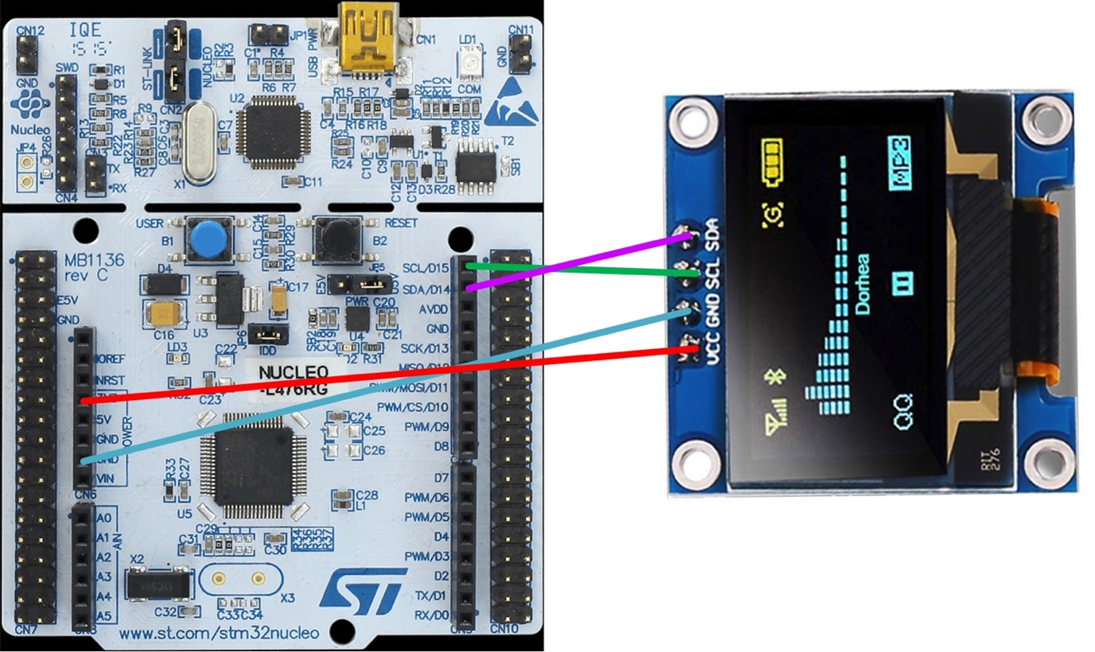
Specifically, as shown in the figure above, connect the microcontroller's GPIO pins PB 8 and PB 9 to the SCL and SDA connectors.
You will be provided with the LCD software driver, which has already configured PB 8 and PB 9 accordingly (see the table below).
Pin | Connection | Mode | AF 4 | Output Type | Pull-up/Pull-down | Clock
PB 8 | I2C1_SCL | AF | I2C1 | Open-drain | Pull-up | 40 MHz
PB 9 | I2C1_SDA | AF | I2C1 | Open-drain | Pull-up | 40 MHz
Additionally, the LCD software driver defines a font library and utilizes the I2C interface to communicate with the OLED-SSD1306 module.
Compile and download the LCD demo code to the Nucleo board. This code displays a string and is adapted from an open-source project developed by Aleksander Alekseev.
...
char message[64] = "ABCDEFGHIJK";
...
ssd1306_Fill(Black);
ssd1306_SetCursor(2,0);
ssd1306_WriteString(message, Font_16x26, White);
ssd1306_UpdateScreen();

The complete list of functions for the LCD is provided in the header file ssd1306.h, as shown below:

void ssd1306_Init(void);
void ssd1306_Fill(SSD1306_COLOR color);
void ssd1306_UpdateScreen(void);
void ssd1306_DrawPixel(uint8_t x, uint8_t y, SSD1306_COLOR color);
char ssd1306_WriteChar(char ch, FontDef Font, SSD1306_COLOR color);
char ssd1306_WriteString(char* str, FontDef Font, SSD1306_COLOR color);
void ssd1306_SetCursor(uint8_t x, uint8_t y);
void ssd1306_Line(uint8_t x1, uint8_t y1, uint8_t x2, uint8_t y2, SSD1306_COLOR color);
void ssd1306_DrawArc(uint8_t x, uint8_t y, uint8_t radius, uint16_t start_angle, uint16_t sweep, SSD1306_COLOR color);
void ssd1306_DrawArcWithRadiusLine(uint8_t x, uint8_t y, uint8_t radius, uint16_t start_angle, uint16_t sweep, SSD1306_COLOR color);
void ssd1306_DrawCircle(uint8_t par_x, uint8_t par_y, uint8_t par_r, SSD1306_COLOR color);
void ssd1306_FillCircle(uint8_t par_x,uint8_t par_y,uint8_t par_r,SSD1306_COLOR par_color);
void ssd1306_Polyline(const SSD1306_VERTEX *par_vertex, uint16_t par_size, SSD1306_COLOR color);
void ssd1306_DrawRectangle(uint8_t x1, uint8_t y1, uint8_t x2, uint8_t y2, SSD1306_COLOR color);
void ssd1306_FillRectangle(uint8_t x1, uint8_t y1, uint8_t x2, uint8_t y2, SSD1306_COLOR color);
void ssd1306_DrawBitmap(uint8_t x, uint8_t y, const unsigned char* bitmap, uint8_t w, uint8_t h, SSD1306_COLOR color);
void ssd1306_SetContrast(const uint8_t value);
void ssd1306_SetDisplayOn(const uint8_t on);
uint8_t ssd1306_GetDisplayOn();
void ssd1306_Reset(void);
void ssd1306_WriteCommand(uint8_t byte);
void ssd1306_WriteData(uint8_t* buffer, size_t buff_size);
SSD1306_Error_t ssd1306_FillBuffer(uint8_t* buf, uint32_t len);

Part B: Connecting the Keypad
The 4x4 keypad requires a total of 8 pins, four for rows and four for columns. In this lab, refer to the table below for the connections between the keypad and the Nucleo kit.
Connections | Pin 1 | Pin 2 | Pin 3 | Pin 4
Row Connections | R1 → PC 0 | R2 → PC 1 | R3 → PC 2 | R4 → PC 3
Column Connections | C1 → PC 4 | C2 → PC 10 | C3 → PC 11 | C4 → PC 12

All input port pins (C1, C2, C3, and C4) are connected to a 2.2 kΩ resistor that pulls them up to 3V. While the microcontroller has an internal pull-up resistor (typically 40 kΩ) that can be used to pull up a GPIO pin, it is insufficient for this specific application. Therefore, an external pull-up resistor is necessary.

It is important to note that a GPIO pin can either source or sink a maximum current of 20 mA. When determining the value of external pull-up resistors, ensure that the current does not exceed this limit.
$$\frac{3V}{2.2KΩ}=1.4 mA$$
Figure 1. Pinout of a 4x4 keypad. If your keypad is only 4x3, the connections remain the same, except C4 is missing. | Figure 2. Pin connection between the Nucleo kit and keypad

Part C: Setting Up and Working with the Keypad

Development Setup:

- File Structure:
  - Create two new files named keypad.c and keypad.h.
  - Implement all keypad-related functions in these files to maintain organized code.

- Keypad Initialization Function:
  - Add a function called Keypad_Pin_Init().
  - Start by enabling the clock for GPIO Port C (GPIOC).
  - Set GPIOC pins 0, 1, 2, and 3 as digital outputs, and GPIOC pins 4, 10, 11, and 12 as digital inputs (these values were calculated in the pre-lab).
keypad.h | keypad.c | main.c
#ifndef KEYPAD_H  #define KEYPAD_H  void Keypad_Pin_Init();  char keypad_scan();  #endif | #include "keypad.h"  void Keypad_Pin_Init() {  ...  }  char keypad_scan() {  ...  } | #include "keypad.h"  int main(){  char key;  Keypad_Pin_Init();  while(1) {  key = keypad_scan();  ...  }  }

- The #include directive is crucial for organizing code into multiple files, promoting reuse, and simplifying maintenance. By separating declarations into header files and definitions into source files, programs become more modular and easier to navigate.
- In keypad.h, the #ifndef, #define, and #endif preprocessor directives together form an "include guard." These are essential for preventing the double inclusion of header files, which can lead to errors and complications in your C programs.
  - #ifndef (if not defined): This directive checks if a unique identifier (commonly the name of the header file converted to uppercase with underscores) has not been defined yet. If the identifier has not been defined, the compiler processes the code following the #ifndef directive up to the corresponding #endif.
  - #define: If the #ifndef check passes, this directive defines the unique identifier, ensuring that the code between #ifndef and #endif is included only once, regardless of how many times the header file is included.
  - #endif: This marks the end of the conditional code that is processed only if the unique identifier has not been defined.
- Notice how keypad.c includes keypad.h to ensure it has the declarations of the functions it implements.
- The main program file (main.c) uses the keypad module by including keypad.h, enabling it to call the functions defined in keypad.c.

Scanning Implementation:

- Main Scanning Process:
  - In keypad.c, create a function keypad_scan() that encapsulates the scanning logic.
  - In the main() function, use an infinite loop to continuously call keypad_scan().
  - Output the result of the keypress to the LCD within this loop.
  - Use the template from Chapter 15.9 of the textbook as a starting point.
Task Breakdown:

- Part 1: Basic Input Reading:
  - Have keypad_scan() write 0b0000 to the rows, then read the column inputs. Print the raw 4 bits of the result you read from the inputs on the LCD.
  - Remember, you can convert the numeric values 0 or 1 to their ASCII representation for display by adding ’0’. By printing the value you read on the display, you should be able to see the changes as you press the buttons.
  - HINT: Keep in mind that the GPIO pins are not consecutive. The GPIO pins connected to C1, C2, C3, and C4 are PC4, PC10, PC11, and PC12. You need to access bits 4, 10, 11, and 12 individually, and you may need to shift and mask them separately to interpret the results.
  - If no key is pressed, return 0xFF from the function.

- Part 2: Column Scanning:
  - Once you have verified that your wiring is correct and that the buttons are functioning, perform a column scan to determine which column the keypress is occurring in.
  - You can achieve this by taking the value from the previous step and checking which bit is 0. If PC4 is 0, it corresponds to the first column. If PC10 is 0, it corresponds to the second column, and so on.
  - Print this on the display to verify that you are obtaining the expected column.

- Part 3: Row Determination:
  - Next, iterate through the rows to determine which row contains the pressed key. Set just a single bit to zero in each iteration, using the following row output values: 0b0111, 0b1011, 0b1101, 0b1110. Note that these bits are not consecutive in the output register.
  - Additionally, you may need to introduce a small delay after setting the row before reading the column value to avoid obtaining old values.
  - Cycle through these four row values (remember to clear all bits before ORing in the desired pattern). Read the column results, and if the column result is not all 1s, it indicates that you have found the row with a pressed key. Print the row on the LCD to assist with debugging.

- Part 4: Key Value Resolution:
  - Combine the identified column and row to determine the pressed key.
  - Implement a lookup table as illustrated in the textbook to map row and column combinations to their corresponding key values.
  - For example, if row=0 and col=0, return '0' (ASCII 48). If row=0 and col=1, return '1'. If row=1 and col=1, return '5', and so on.
  - Display the resulting character on the LCD to confirm the keypad's functionality.

Debugging Tips:
- Tackle each part sequentially, verifying its correctness before proceeding.
- While pressing and holding down the key, utilize the System Viewer feature in Keil to observe and analyze the Output Data Register (ODR) and Input Data Register (IDR) values.
- Set up breakpoints to check the execution flow of your program.
- Consider creating additional utility functions if any step becomes complex.
By breaking down the task and validating each step, you will systematically develop a robust keypad scanning system. Ensure to document your process and any decisions you make along the way.

Part D: Displaying Button Presses on the LCD

Now that we can detect a keypress, our next step is to track the keypresses and display them on the LCD. We need to create a keypress buffer that can store the last N keypresses.
Keypress Buffer Implementation:
- Buffer Initialization: Set up a circular buffer to store the last 'N' keypresses. This buffer should be initialized with space characters (' ') to indicate an empty state at the start of the program.
- LCD Update Mechanism: Program a routine to update the LCD with the current contents of the keypress buffer in real-time.
- Single Keypress Registration:
  - To ensure each keypress is registered distinctly, implement logic that records a keypress in the buffer only after the key has been released. This will prevent a quick keypress from registering multiple times.
  - Maintain a variable to track the last key pressed. Update the buffer with a new keypress only if it differs from the last one, or if the keypress is '0xFF' (indicating no key is currently pressed). When keypad_scan() returns 0xFF, reset the last-key tracking variable (so the same key can re-register after release) rather than storing 0xFF in the buffer.
  - Incorporate a software debouncing technique to filter out spurious multiple inputs from a single press due to switch bounce.
Buffer Management for Continuous Input:
- Buffer Content Shifting (Optional Enhancement): When the buffer is full and a new keypress is detected, shift the contents of the buffer left by one position to make space for the new input. Use a loop to move each entry to its new position. Then, insert the new keypress at the end of the buffer, preserving the chronological order of inputs.

Part E: Something Cool

Extend the functionality of your keypad interface with additional creative features. Here are some ideas to inspire you, or feel free to design your own unique functionality:
- Auto-Repeat Functionality: Develop an auto-repeat feature where holding a key down continuously outputs the character at regular intervals on the LCD.
- Backspace Feature: Utilize the '*' key as a backspace to remove the last character entered into the buffer.
- Input Replay: Assign the '#' key to replay and display the entire sequence of previous keypresses.
- Multi-Key Detection: Develop a system capable of detecting and responding to multiple keys pressed simultaneously, and display this functionality on the LCD.

Part F: Tips for Successful Lab Completion
- Test all functionalities before the demonstration, including edge cases such as simultaneous key presses.
- Review the theories behind keypad scanning, debouncing, and pull-up resistor usage to enhance your understanding and ability to explain these concepts.
- Engage with your TA during the demonstration; clear communication is essential for conveying your understanding of the lab material.

Lab 3: Keypad Scanning in C
Pre-Lab Assignment

Student Name: _______________________________
TA: ___________________________________
Time & Date: ________________________

- Textbook Reading
- Read Textbook Chapter 15.9 to review keypad scanning.

- Configure Port C
We need to set the mode of pins 0, 1, 2, and 3 as digital outputs, and pins 4, 10, 11, and 12 as digital inputs
Register | 31 | 30 | 29 | 28 | 27 | 26 | 25 | 24 | 23 | 22 | 21 | 20 | 19 | 18 | 17 | 16 | 15 | 14 | 13 | 12 | 11 | 10 | 9 | 8 | 7 | 6 | 5 | 4 | 3 | 2 | 1 | 0
Mode Register  (MODER) | MODER15[1:0] |  | MODER14[1:0] |  | MODER13[1:0] |  | MODER12[1:0] |  | MODER11[1:0] |  | MODER10[1:0] |  | MODER9[1:0] |  | MODER8[1:0] |  | MODER7[1:0] |  | MODER6[1:0] |  | MODER5[1:0] |  | MODER4[1:0] |  | MODER3[1:0] |  | MODER2[1:0] |  | MODER1[1:0] |  | MODER0[1:0]
Mask
Value
Note: Digital Input (00), Digital Output (01), Alternative Function (10), Analog (11)

Mask in hex: ______________________ Value in hex: ______________________

Lab 3: Keypad Scanning in C
Lab Demonstration Guidelines

Code Submission and README:
- Submit your fully commented source code for evaluation. Ensure that each function and logic block within the code is accompanied by comments explaining its purpose and operation.
- Prepare a README.md document detailing your answers to the post-lab questions and reflecting on the design decisions made during the lab.

Live Demonstration to Lab TA:
- Exhibit your keypad scanning implementation by showcasing the interaction between the keypad and the display.
- Be prepared to discuss and answer the following:
  - Confirm that each keypress is accurately represented on the display.
  - Describe the software debouncing method you have implemented to handle keypresses.
  - Explain the logic behind your keypad scanning algorithm and how it processes inputs.
  - Justify the use of external pull-up resistors in your circuit instead of relying on the microcontroller's built-in options.

Lab 3: Keypad Scanning in C
Post-Lab Assignment

Submission of Answers:
- Document your responses to the post-lab questions in the README.md file, ensuring that your explanations are thorough and well-reasoned.
- Upload your code and README.md file to the designated GitLab server for review.

Post-Lab Questions:

1. Evaluating Key Press Detection and Ghosting: Evaluate the effectiveness of your scan algorithm in detecting simultaneous keypresses. Consider the phenomenon of 'ghosting' or 'ghost key' effects in your assessment. Can your algorithm identify all individual keys during multi-key presses? Discuss your findings and detail any methods employed to mitigate ghosting, if applicable.

2. Reflection: Reflect on the development process for this lab. Consider challenges, insights, and areas for improvement.
- What was the most challenging part of implementing the keypad scanning algorithm?
- How did you overcome these challenges?
- If you had more time, what improvement would you make to your implementation or testing methods?

