# **This file explains prerequisites for this project:**

Please installs the following Python libariries before running this project:

Versions:

Python==3.10.0

keras==3.5.0

numpy==1.26.4

streamlit==1.22.0

opencv_python==4.6.0.66

tensorflow==2.19.0

# **Follow the below steps to run this project:**

1. Open Anaconda Prompt.

Start by opening the Anaconda Prompt terminal on computer.

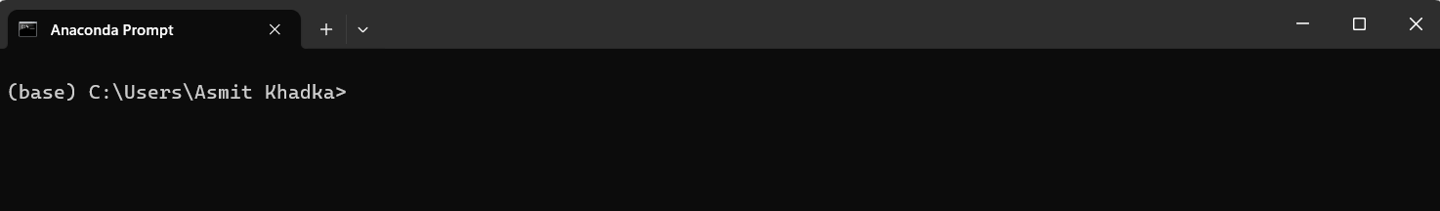

2. Navigate to the Streamlit App Folder.

In the terminal, change the directory to the folder where the Streamlit app files are saved.

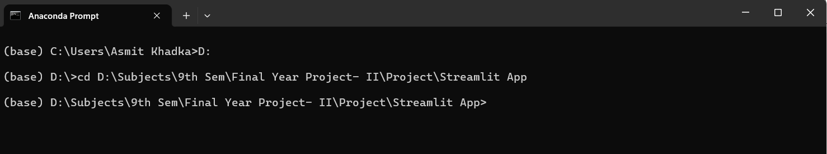

3. Run the Streamlit Application.  
In the same terminal, type the following command to launch the web application:

- streamlit run main_app.py

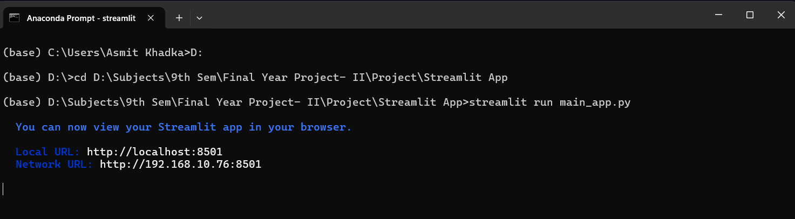

4. Access the Web Interface.

After a few moments, the Streamlit web interface will automatically open in default web browser.

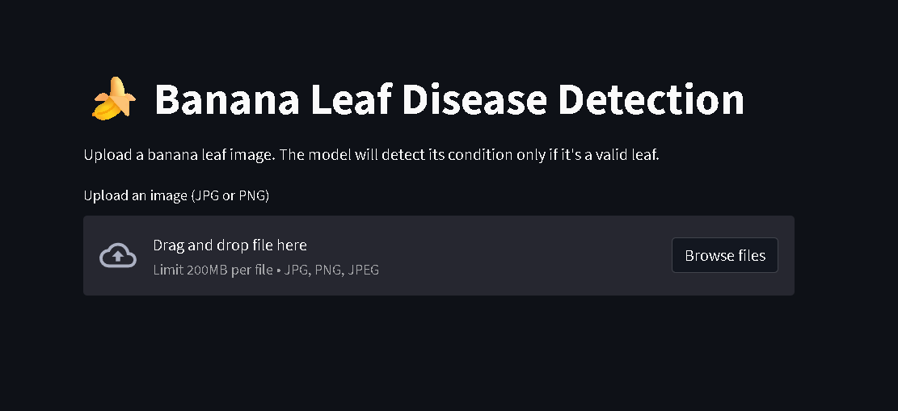

5. Upload the Banana Leaf Image.

On the web page, click the "Browse Files" button.

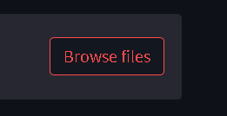

Select a banana leaf image from the "Test Image" folder.

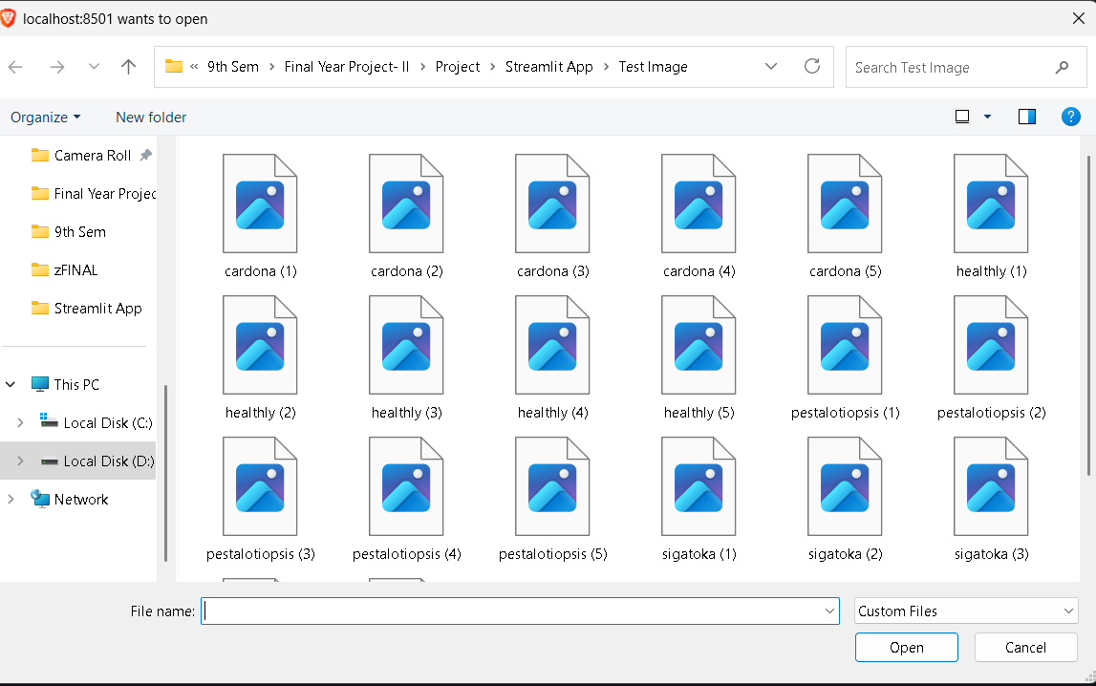

The selected image will appear on the interface.

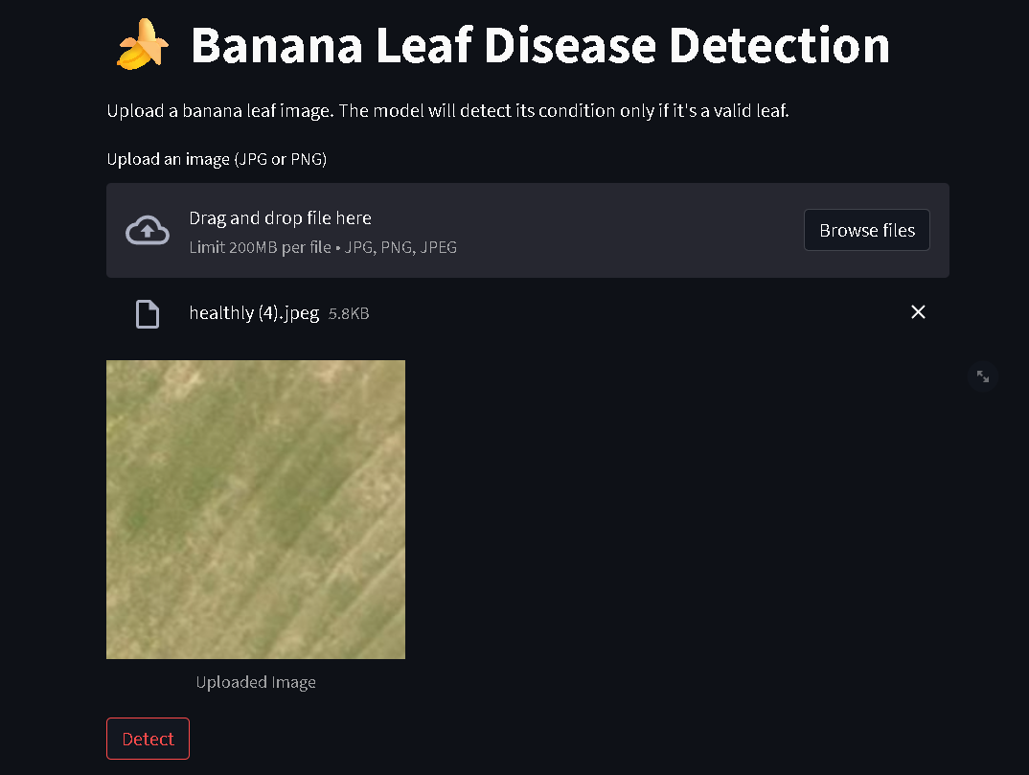

6. Detect the Disease.

After the image is displayed, click the "Detect" button.

The system will process the image and show the result:

* It will either detect the disease affecting the banana leaf

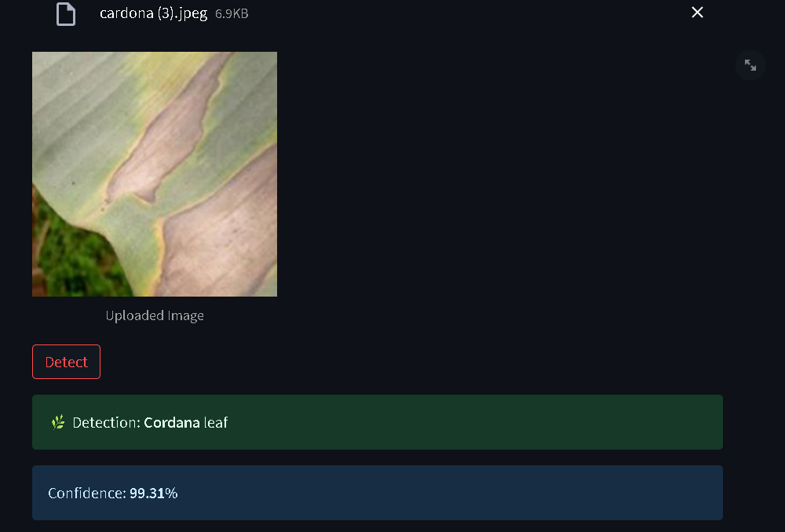

* Or indicate that the leaf is healthy.

