UK Natural Gas Consumption and Dependency Analyse

Dan Kha Pham - 100367994

# INTRODUCTION

Europe has recently faced the problem of the Energy crisis, with the fact that the UK has already left the European Union (EU). I want to learn about the UK’s energy situation in recent years. Furthermore, the most recent conflict in Europe between Russia and Ukraine tremendously exacerbates the problem. Many nations in the EU have a sizeable Natural Gas dependency on Russia, namely Germany, Italy and France. Therefore, this study is to find out the situation and dependence of the UK on natural gas energy, demonstrating using Information Visualisation theories.

# ABSTRACT

In 2021, UK gas demand rose by 5.4 per cent compared to 2020, reaching 854 TWh. This increase reflected an easing of lockdown restrictions from spring until the end of the year, reduced renewables generation, and increased nuclear demand for electricity generation. The easing of restrictions predominantly increased demand across the industrial, commercial and public sectors.

Gas production reached a record low in 2021 at 363 TWh, 47 TWh below the previous record low in 2013. This was a 17 per cent fall compared to 2020 and was primarily the result of scheduled maintenance, including a shutdown of the Forties Pipeline System (FPS) which serves a significant proportion of UK oil and gas production. To meet demand, imports of natural gas increased by 17 per cent, and exports fell by 29 per cent to the lowest level since 1998. This resulted in a 30 per cent increase in net imports. The rise in imports was driven by increased pipeline imports, up 44 per cent; imports of Liquified Natural Gas (LNG) fell by 22 per cent.

Quarter 4 2021 saw a 6.3 per cent fall in demand for natural gas compared with Quarter 4 2020. This was due to reduced demand for electricity generation and warmer quarterly temperatures reducing domestic demand. Production continued to increase from the summer lows but was down 1.7 per cent on the same period in the previous year. Net imports fell 17 per cent in Quarter 4 2021, primarily due to significant exports in October. Imports of LNG remained substantial but were down 5.5 per cent compared with Quarter 4 2020.

# UK GAS CONSUMPTION COMPARED TO THE EUROPE

## Data Analyse

As in the Dataset, Russia’s natural gas consumption figure equals all the EU combined. Therefore, to not diluted the visualisation, I eliminated Russia to compare the UK with the EU’s nations only.

The UK has become the highest gas consumption country in Europe since 1997. Germany then overtook this position in 2011 until now, making the UK placed 2nd in Europe in gas consumption.

**Figure 1. Gas consumption of Europe countries**

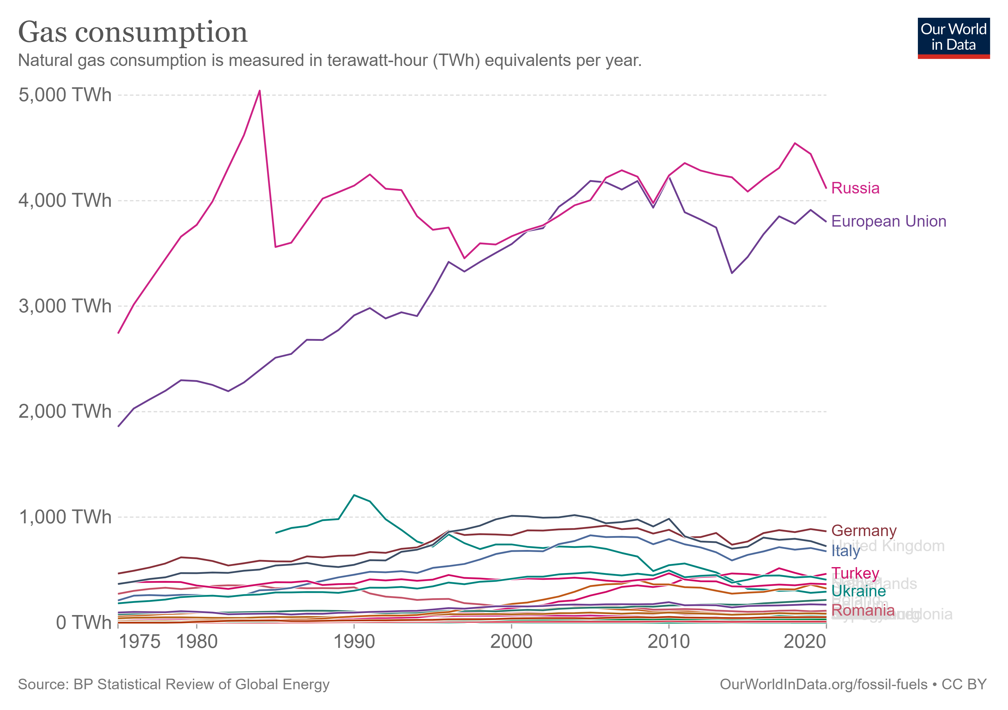

## Visualise Solution

I could use a basic line graph like in the data source; however, I want to add more intuitive to the data, where the audience could see the actual location of the countries. Therefore, for this dataset, I choose to illustrate by maps graph with the help of a time running slider to see the changes throughout the years.

# UK DEMAND FOR NATURAL GAS

## Data Analyse

Domestic demand increased in 2021, up by 6.2 per cent compared to the previous year. This was due to colder average temperatures in the first half of the year, coinciding with lockdown restrictions which led households to spend more time at home. Demand for gas used for electricity generation was up by 9 per cent in 2021, resulting in reduced renewable and nuclear output.

In Quarter 4 2021, demand for natural gas fell by 6.3 per cent compared to Quarter 4 2020. This was driven by warm temperatures, leading to an 8.7 per cent fall in domestic demand. Gas demand for electricity generation also fell, down 3.9 per cent compared with Quarter 4 2020, due to increased output from renewable sources.

Table 1. Percentage changes in demand

|  |  |  |  |  |  |
| --- | --- | --- | --- | --- | --- |
|  | Total Demand | Domestic | Energy generation | Industry | Other |
| Year | **5.4%** | **6.2%** | **9.0%** | **-2.6%** | **6.0%** |
| Q4 | **-6.3%** | **-8.7%** | **-3.5%** | **-3.4%** | **-8.8%** |

## Visualise Solution and Limitations

These figures contain information about the proportion of consumption by quarterly series. I want to convey the idea of how the proportion variate seasonally. Therefore, the stacked area chart seems to appropriate. I would use a tick mark on every four figures in the graph to make it easy for yearly comparison. Colouring options are just contrasting so the audience can easily see separate sectors.

Using a stacked area chart helps the audience see the total amount of consumption all together with the proportion of each sector. But it could not deliver the amount of each sector separately to compare them to each other. To make it better, I added the plot option to show the sector amount, with the total of other sectors altogether by hovering through the column.

# UK PRODUCTION AND TRADE OF NATURAL GAS

## Data Analyse

**In 2021, gas production hit a record low of 363 TWh,** 47 TWh below the previous record low in 2013. This was a 17 per cent fall compared to 2020 and equivalent to 30 per cent of the peak in 2000. Low production resulted from an extensive summer maintenance schedule that saw shutdowns at several major terminals and the Forties Pipeline System (FPS), which serves around a significant proportion of UK oil and gas production.

To meet demand amid low production, there was a 17 per cent increase in natural gas imports and a substantial slowing in exports. Exports in 2021 reached their lowest level since 1998, down 29 per cent in 2020. Overall, this resulted in net imports increased by 30 per cent in 2021 compared to 2020.

**In Quarter 4 2021, gross gas production fell 1.7 per cent on Quarter 4 2020**. Production has recovered following substantial maintenance in the summer but remains lower than pre-pandemic levels. This results from delays to care in 2020, following restrictions to curb the Covid-19 pandemic, on the back of several years of low investment in North Sea infrastructure. Net imports fell 17 per cent compared to Quarter 4 2020, due to exports more than doubling compared to Quarter 4 2020. This rise in exports was driven by a substantial increase in exports to Belgium and the Netherlands while UK demand was low.

## Visualise Solution and Limitations

To visualise the trend of production and trade, I use a basic line chart with an inherited format from the first graph. The purpose is to illustrate the proportion and difference between production and trade.

By using a line chart, the audience cannot see the correlation between the three lines.

# IMPORTS BY ORIGIN

## Data Analyse

In 2021, Norway remained the largest import source of natural gas. Imports from Norway accounted for 39 per cent of supply (production + imports) and 64 per cent of total imports. Historically, the UK imports a large amount of gas from Norway; however, in 2021, Norwegian imports increased 35 per cent compared to 2020, when LNG took centre stage. Increases were also seen in imports from the Netherlands and Belgium, which more than doubled in comparison with 2020. This reflects the rise in imports to meet demand amid low indigenous production.

LNG imports decreased by 22 per cent in 2021, though volumes imported remained substantial. LNG accounted for 17 per cent of supply (production + imports) and 28 per cent of total gas imports. Qatar remained the largest source of LNG, contributing 40 per cent of LNG imports in 2021. However, this represents a fall in its share in comparison with 2020, as well as being the lowest share of LNG from Qatar since 2008. The USA remained the second largest source of LNG despite decreasing just over a quarter compared to 2020. Imports of LNG from Russia were up 37 per cent in 2021 compared to 2020, accounting for 3.7 per cent of supply (production + imports) and 6.1 per cent of imports.

In Quarter 4 2021, LNG imports fell 5.5 per cent compared to Quarter 4 2020. Qatar was the largest supplier of LNG to the UK, comprising 34 per cent of total LNG imports. This was more than double that recorded in Quarter 4 2020. Following zero imports to the UK for 2 years, Peru was the second largest supplier of LNG in Quarter 4 2021, comprising 21 per cent of total LNG imports. This reflects gas market conditions towards the end of 2021, which saw European countries secure LNG cargoes from further afield. Imports from the USA increased by close to a third in the same period. Conversely, imports from Russia decreased by close to a third, accounting for 3.6 per cent of supply (production + imports) and 5.8 per cent of imports.

## Visualise Solution and Limitations

The imports origin dataset is divided into pipeline and shipping origins, some contains the same import nation, making it more complicated to illustrate the origins of importers with proportion. I want to show the proportion of importers, also want to show the dependent of that importer.

The limitations is solved by 2 charts for 2 visualisation purposes. One stacked columns chart is to illustrate the total amount of each importer by year. One proportion graph to illustrate the dependent to that importer nation.

# CONCLUSION

Through this visualisation project, we can see that the UK is consuming a lot of gas energy and has recently switched to renewable energy sources. This illustrates an unsustainable for the long term future,

We can also see that, among many gas importers, Russia is just a minor source accounting for around 6% up to 2020. The UK is independent of Russia’s sources. This explains why the UK is among countries that spoke out strongly against Russia’s behaviour, unlike the case of Germany and part of France.

# REFERENCES

BP, 2021. *Statistical Review of World Energy.* [Online]   
Available at: https://www.bp.com/en/global/corporate/energy-economics/statistical-review-of-world-energy.html

Department for Business, E. &. I. S., 2022. *National statistics GOV.UK.* [Online]   
Available at: https://www.gov.uk/government/statistics/gas-section-4-energy-trends