Chapter 1 Linux Commands
For each command, I will provide the following Three sections in English:
1.Command : The Linux command
2.Definition :What the command does
3.Option : The option used with the command and its function.

Commands
- Whoami
Command: whoami
Definition: Displays the username of the currently logged-in user.
Option: No option is shown in Chapter 1.
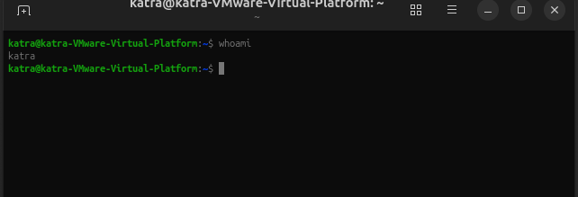
pwd
Command: pwd
Definition: Displays the full path of the current working directory.
Option: No option is shown in Chapter 1.

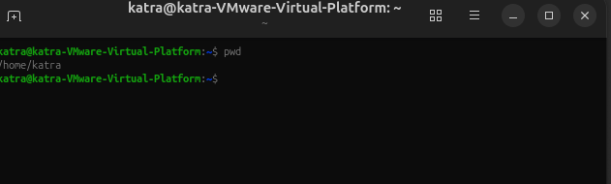

- Uname –r

Command: uname -r
Definition: Displays the Linux kernel release version.
Option: -r displays the kernel release. 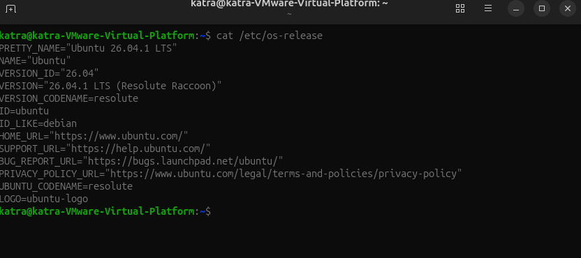

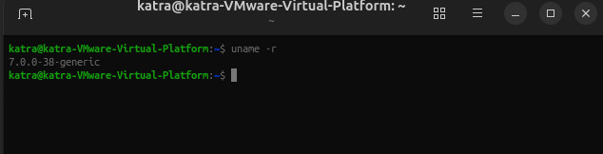
- Uname -s

Command: uname -s
Definition: Displays the operating system name.
Option: -s displays the operating system name.

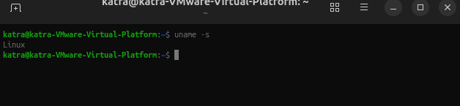

- Ls
Command: ls
Definition: Lists files and directories in the current directory.

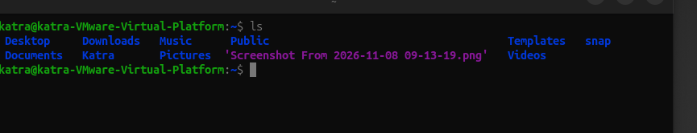

- Cat

cat
Command: cat /etc/os-release
Definition: Displays the operating system release information.
Option: No option is shown in Chapter 1. /etc/os-release is the file path used as an argument

- cp

Command: cp
Definition: Copies files or directories from one location to another.
Option: No option is provided in Chapter 1.

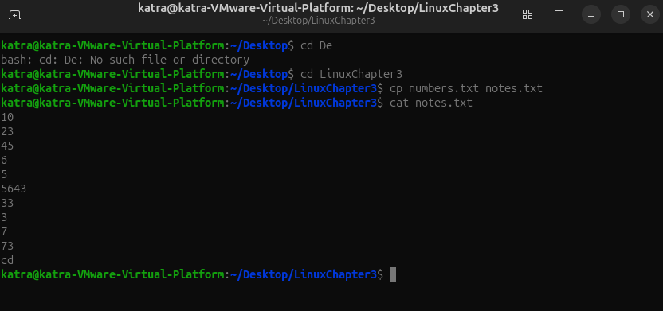

- mv

Command: mv
Definition: Moves or renames files and directories.
Option: No option is provided in Chapter 1.

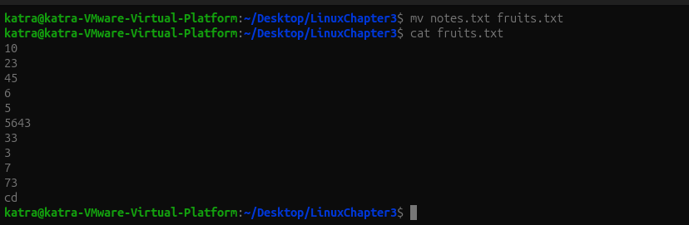

Chpater 2 Commands
Commands
- pwd
Command: pwd
Definition: Displays the absolute path of the current working directory.
Option: No option is shown in Chapter 2.

- cd
Command: cd
Definition: Changes the current working directory.
Option: No option is shown in Chapter 2.

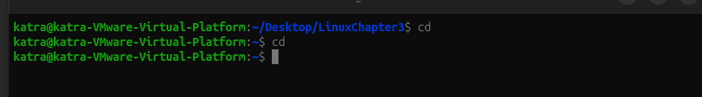

- cd ~

Command: cd ~
Definition: Moves the user to the home directory.
Option: No option is shown in Chapter 2.

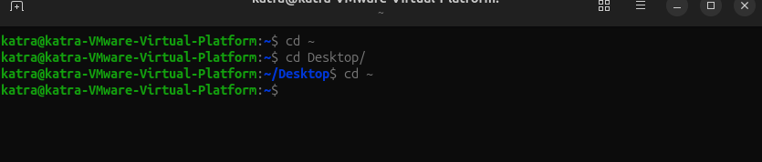

- cd ..
Command: cd ..
Definition: Moves one directory level up to the parent directory.
Option: No option is shown in Chapter 2.
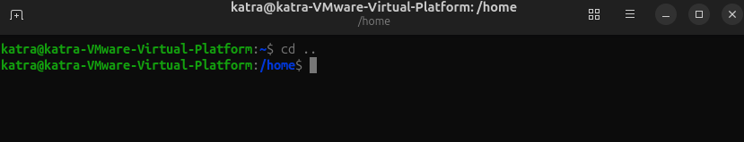

- cd –

cd -
Definition: Returns to the previous working directory.
Option: No option is shown in Chapter 2.

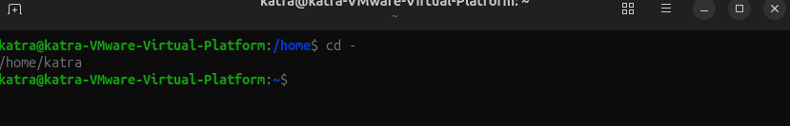

- ls

Command: ls
Definition: Lists files and directories in the current directory.
Option: -a displays all files, including hidden files.

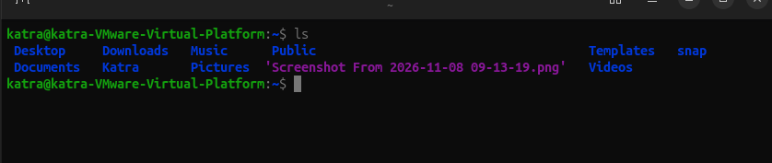

- ls –a

Command: ls -a
Definition: Lists all files, including hidden files.
Option: -a means all.

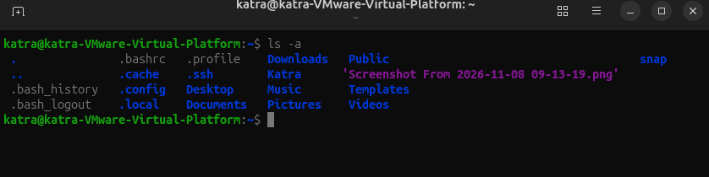

- ls –l

Command: ls -l
Definition: Displays files and directories in a detailed long-listing format.
Option: -l displays one line per entry with detailed information.

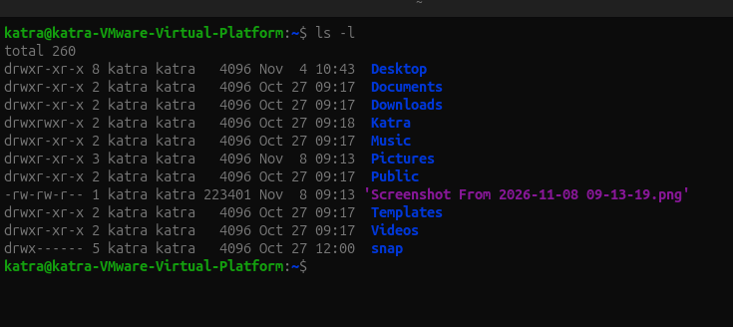

- ls –h

Command: ls -h
Definition: Displays file sizes in a human-readable format.
Option: -h displays sizes using K, M, and G.

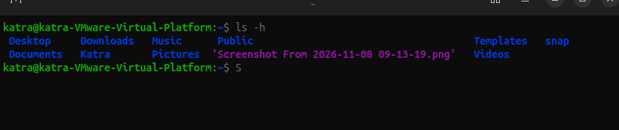

- ls –lah

Command: ls -lah
Definition: Displays all files, including hidden files, with detailed information and readable file sizes.
Option: -l means long listing, -a means all, and -h means human-readable.

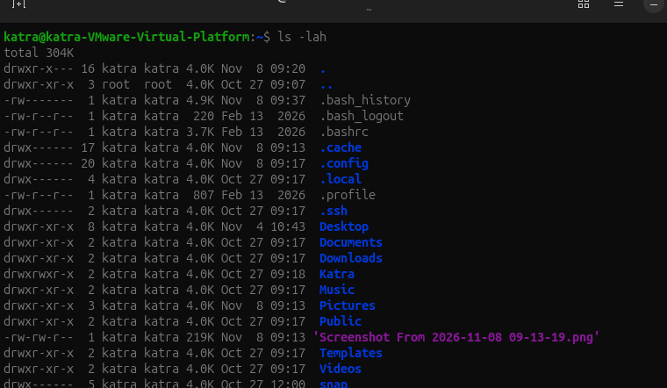

- history

Command: history
Definition: Displays the list of previously executed commands.
Option: No option is shown in Chapter 2.

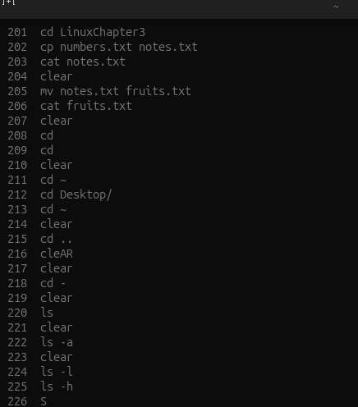

- echo

Command: echo
Definition: Displays text or variable values in the terminal.
Option: No option is shown in Chapter 2.

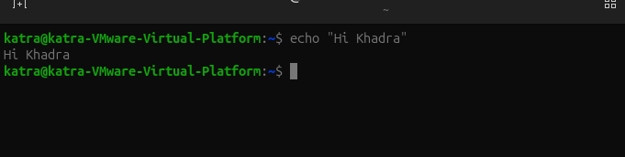

- man man

Command: man man
Definition: Displays the manual page of a command.
Option: No option is shown in Chapter 2.

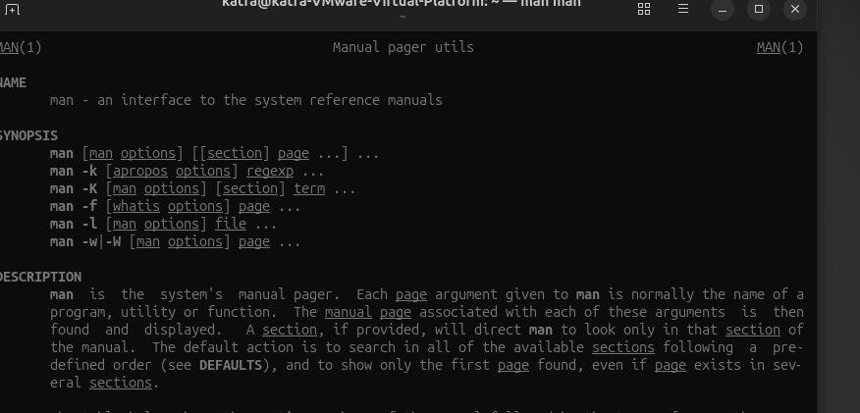

- Info

Command: info
Definition: Displays detailed documentation about a command or program.
Option: No option is shown in Chapter 2.

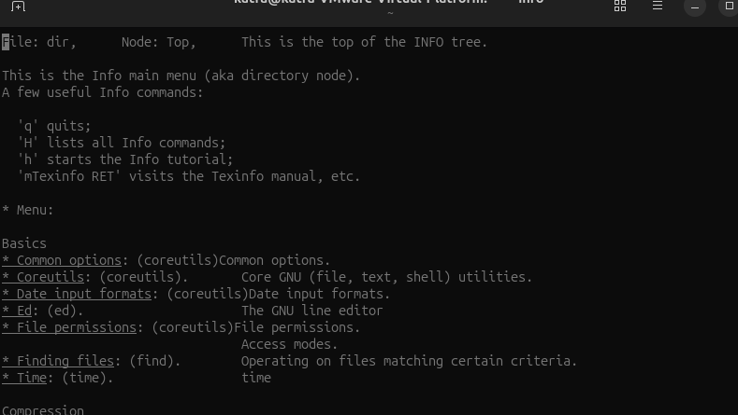

- Help
Command: help
Definition: Displays help information about Bash built-in commands.
Option: No option is shown in Chapter 2.
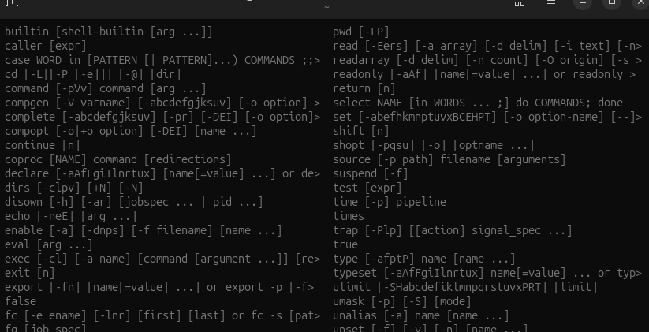

- Help --

Command: help --
Definition: Displays brief help information about a command.
Option: --help shows command usage and available options.

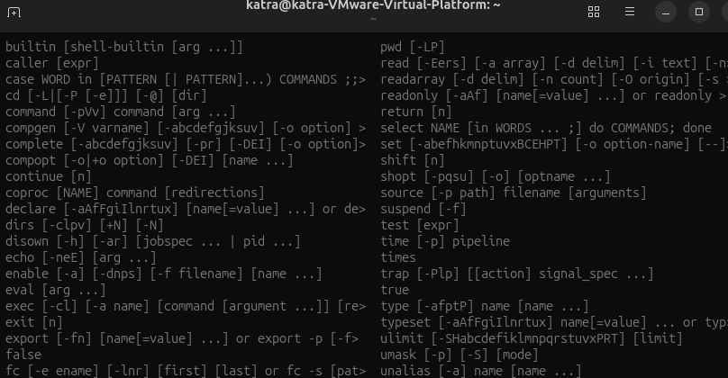

- Export

Command: export
Definition: Makes a shell variable available to child processes.
Option: No option is shown in Chapter 2.

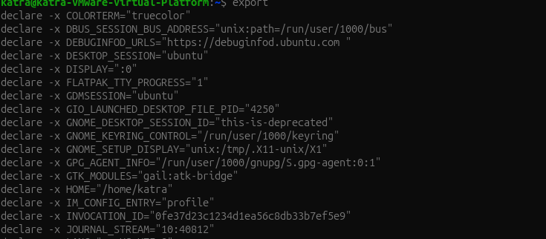

- Name=Value

Command: NAME=value
Definition: Creates or assigns a value to a shell variable.
Option: No option is shown in Chapter 2.
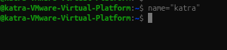

- Source
Command: source
Definition: Executes a file in the current shell environment.
Option: No option is shown in Chapter 2.

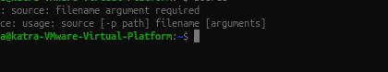

- Touch
Command: touch
Definition: Creates an empty file or updates the timestamp of an existing file.
Option: No option is shown in Chapter 2.

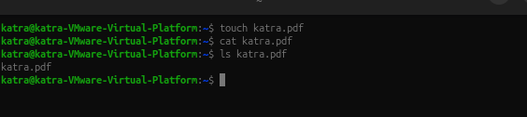

- Mkdir

Command: mkdir
Definition: Creates a new directory.
Option: -p creates missing parent directories.

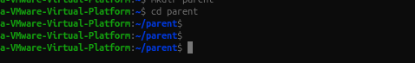

- Mkdir –p

Command: mkdir -p
Definition: Creates a directory and any missing parent directories in one command.
Option: -p means create parent directories when necessary.

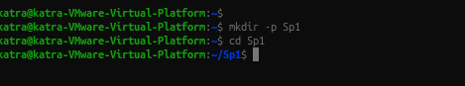

- rmdir
command: rmdir
Definition: Removes empty directories.
Option: No option is shown in the basic command example.

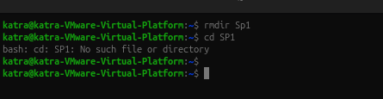

- cp
Command: cp
Definition: Copies files from one location to another.
Option: No option is required for basic file copying.



- cp –r
Command: cp -r
Definition: Copies a directory and all its contents recursively.
Option: -r means recursive.

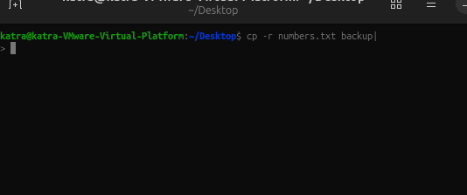

- cp –i
Command: cp -i
Definition: Copies files and asks before overwriting an existing file.
Option: -i means interactive confirmation.

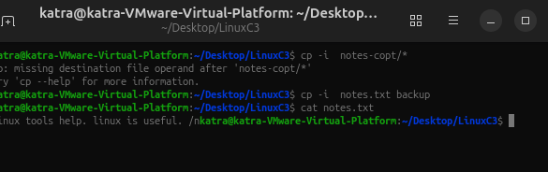

- mv
Command: mv
Definition: Moves files or directories from one location to another and can rename them.
Option: No option is required for basic moving or renaming.

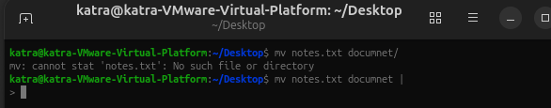

- mv –i
Command: mv -i
Definition: Moves or renames files and asks before overwriting an existing file.
Option: -i means interactive confirmation.

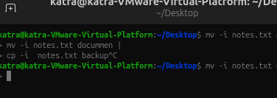

- rm
Command: rm
Definition: Removes files from the system.
Option: No option is required for basic file removal.

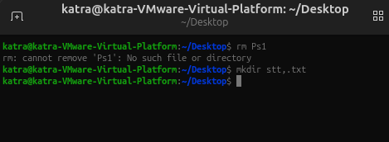

Chapter 3 Linux Commands
Commands
Command: cat
Definition: Displays the contents of text files and combines multiple files into one output.
Options:
-n – Numbers all output lines.
-b – Numbers only non-empty lines.
-a – Displays non-printing characters and line endings.

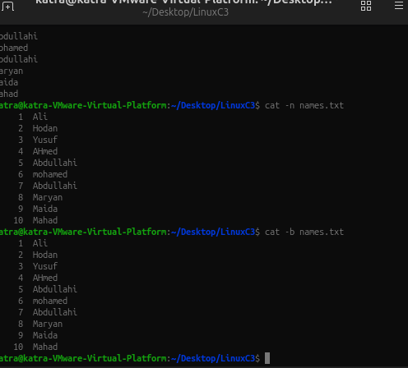

Command: less
Definition: Displays long text files one screen at a time without modifying the file.

Keyboard shortcuts:
Space – Moves forward one screen.
b – Moves backward one screen.
/word – Searches for a word.
n – Finds the next match.
q – Exits the viewer.
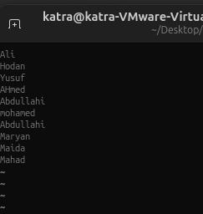

Command: more
Definition: Displays a text file one screen at a time.
Options: No option is shown in the Chapter 3 examples.

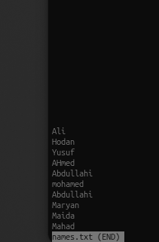

Command: head
Definition: Displays the beginning lines of a file. By default, it displays the first 10 lines.
Options:
- -n – Specifies the number of lines to display.

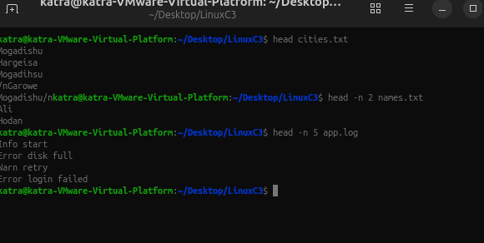

Command: tail
Definition: Displays the last lines of a file. By default, it displays the last 10 lines.
Options:
-n – Specifies the number of lines to display.
-f – Continuously monitors a file and displays new lines as they are added.

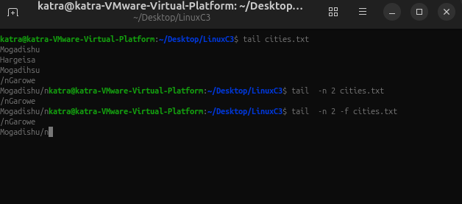

Command: file
Definition: Identifies the actual type of a file by examining its contents.
Options: No option is shown in the Chapter 3 examples.

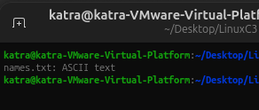

Command: stat
Definition: Displays detailed information about a file or directory, including size, permissions, owner, and timestamps.
Options: No option is shown in the Chapter 3 examples.

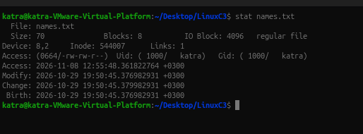

Command: which
Definition: Searches directories in the PATH environment variable to locate executable programs.
Options: No option is shown in the Chapter 3 examples.

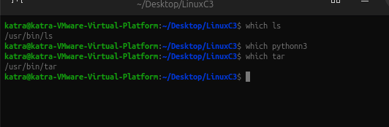

Command: type
Definition: Identifies whether a command is a shell built-in, executable program, alias, or function.
Options: No option is shown in the Chapter 3 examples.
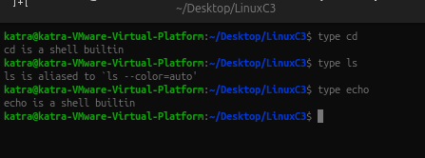

Command: command -v
Definition: Identifies how the shell resolves a command and displays its location or command type.
Options:
- -v – Displays the command's resolved name or path.

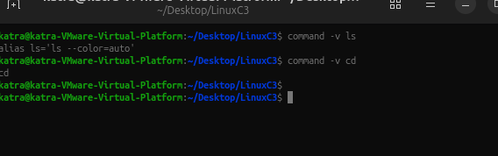

Command: whereis
Definition: Locates the executable binary, source code, and manual pages associated with a command.
Options: No option is shown in the Chapter 3 examples.

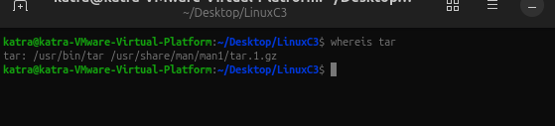

Command: find
Definition: Searches for files and directories based on their names, types, sizes, modification times, and other conditions.
Options:
-name – Searches for a filename using case-sensitive matching.
-iname – Searches for a filename without considering letter case.
-type f – Searches for regular files.
-type d – Searches for directories.
-size – Searches for files based on their size.
-mmin – Searches based on modification time in minutes.

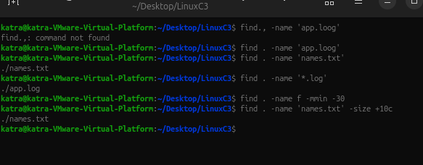

Command: locate
Definition: Quickly searches for files and directories using a previously created database of file paths.
Options: No option is shown in the Chapter 3 examples

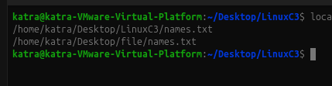.

Command: updatedb
Definition: Updates the database used by the locate command so that newly created files can be found.
Options: No option is shown in the Chapter 3 examples.
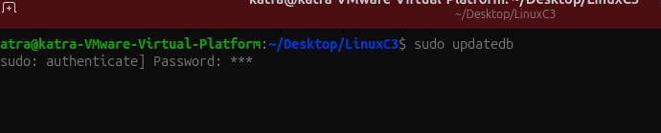

Command: grep
Definition: Searches for specific text or patterns inside files and displays only the matching lines.
Options:
-n – Displays line numbers for matching lines.
-i – Ignores uppercase and lowercase differences.
-v – Displays lines that do not match the specified pattern.
-r – Searches recursively inside directories and their files.
-R – Searches recursively and follows symbolic links.
-in – Combines case-insensitive searching and line numbers.

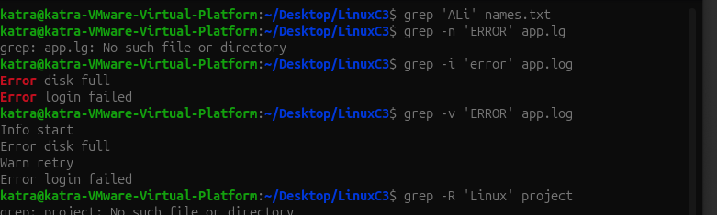

Command: printf
Definition: Displays formatted text and allows users to create text files with specific content.
Options: No option is shown in the Chapter 3 examples.

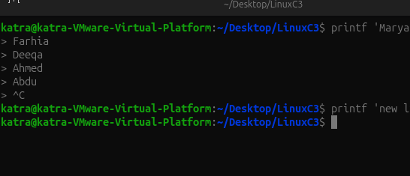

Command: sort
Definition: Arranges lines of text alphabetically or numerically.
Options:
-n – Sorts numbers according to their numerical values.
-r – Reverses the sorting order.
-rn – Combines numeric sorting and reverse order.

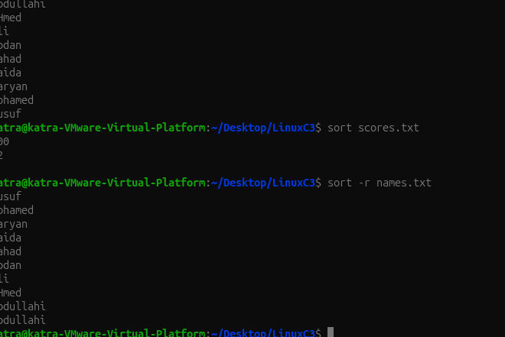

Command: uniq
Definition: Removes repeated adjacent lines from input text.
Options:
-c – Counts repeated occurrences.
-d – Displays only duplicated lines.

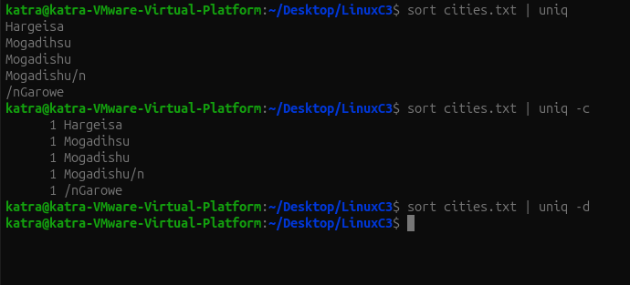

Command: cut
Definition: Extracts selected characters, bytes, or fields from each line of text.
Options:
-d – Specifies the delimiter used to separate fields.
-f – Selects specific fields.
-c – Selects specific characters.

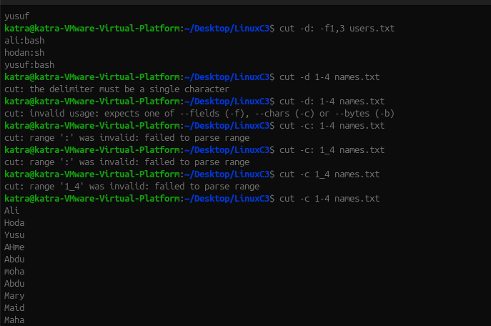

Command: paste
Definition: Combines corresponding lines from two or more files into a single line.
Options:
-d – Specifies the delimiter between combined fields.
-s – Combines lines from one file serially into one line.

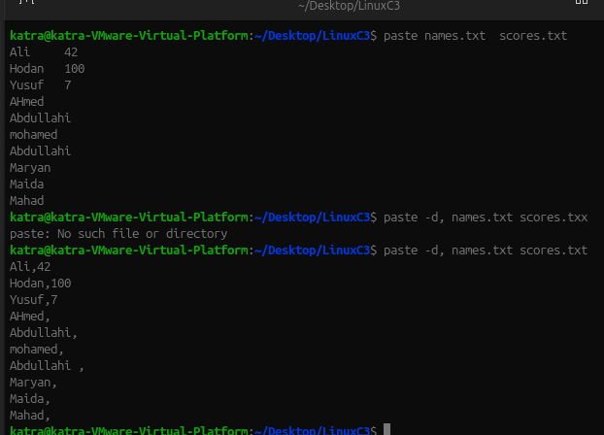

Command: wc
Definition: Counts the number of lines, words, characters, and bytes in a file or command output.
Options:
-l – Counts lines.
-w – Counts words.
-c – Counts bytes.
-m – Counts characters.

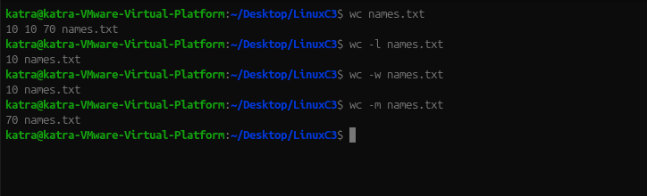

Command: tr
Definition: Translates, deletes, or replaces selected characters in text. It reads from standard input and writes to standard output.
Options:
-d – Deletes selected characters.
-s – Replaces repeated characters with a single occurrence.
-c – Uses the complement of the selected character set.

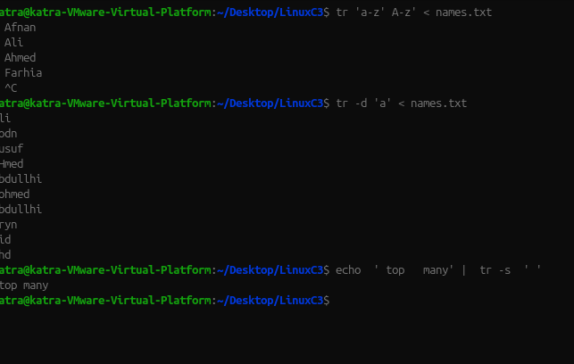

Command: tar
Definition: Combines multiple files and directories into a single archive and can also extract or list archive contents.
Options:
-c – Creates a new archive.
-x – Extracts files from an archive.
-v – Displays the names of files being processed.
-f – Specifies the archive filename.
-t – Lists the contents of an archive.
-z – Uses gzip compression.
-j – Uses bzip2 compression.
-J – Uses xz compression.
-C – Changes to a specified directory before performing the operation.

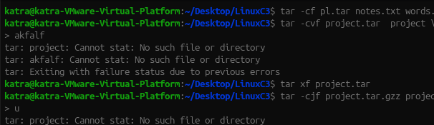

Command: gzip
Definition: Compresses files to reduce their storage size.
Options:
-k – Keeps the original file after compression.
-9 – Uses the highest compression level, which may take longer.

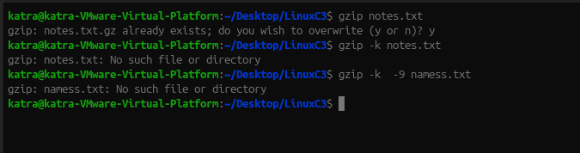

Command: gunzip
Definition: Decompresses files compressed using gzip and restores their original contents.
Options:
- -c – Writes decompressed content to standard output without removing the compressed file.

Command: zip
Definition: Combines multiple files and directories into one ZIP archive and compresses them.
Options:
- -r – Includes directories and their contents recursively.

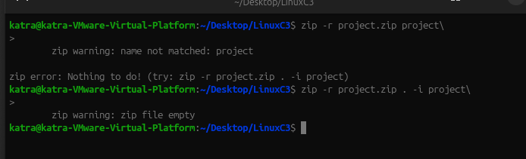

Command: nano
Definition: Opens a simple terminal-based text editor used to create and edit text files.
Options: No command option is shown in the Chapter 3 examples.

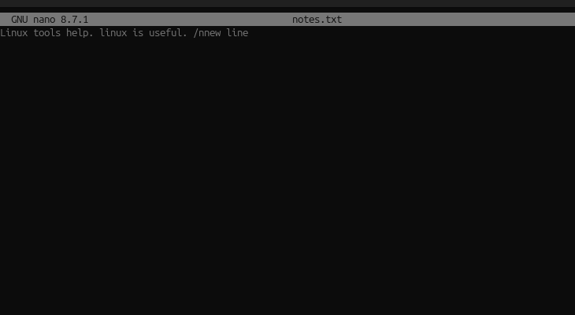

Command: vim
Definition: Opens a terminal-based text editor that uses different modes to edit and manage text files.
Options: No command option is shown in the Chapter 3 examples.

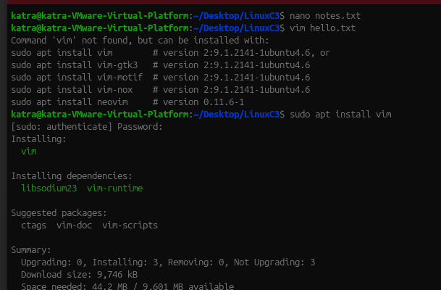

Command: ln
Definition: Creates a link that provides another name for an existing file. By default, it creates a hard link.

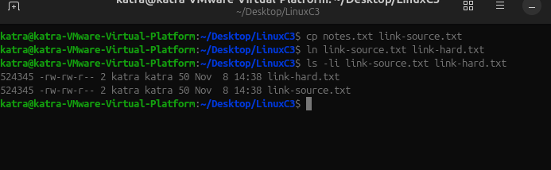

Command: ln -s
Definition: Creates a symbolic (soft) link that points to another file or directory using its pathname.
Options:
- -s – Creates a symbolic link instead of a hard link.

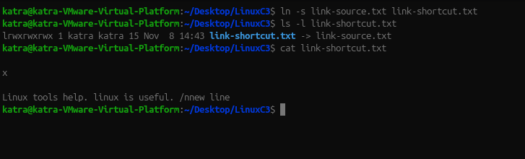

Command: ls -li
Definition: Displays file information, including inode numbers and link counts.
Options:
-l – Displays detailed file information.
-i – Displays the inode number of each file.

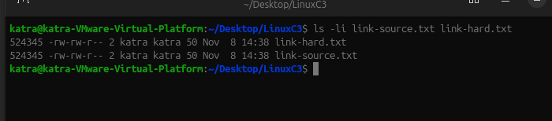

Chapter 4 Commands
commands

ps
Definition: Displays a snapshot of currently running processes.
Options:
-f – Displays full-format information, including owner, PPID, and start time.
-p PID – Displays only the process with the specified PID.
-o COLS – Displays only the columns you specify.
aux – Displays processes belonging to all users, including CPU and memory usage. This is BSD-style syntax, without a dash.
-e – Displays every process.
-ef – Displays every process in full format.
--sort=-%mem – Sorts processes by memory usage, highest first.

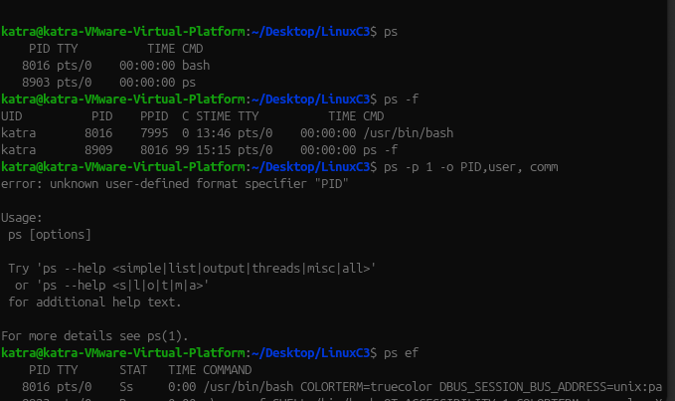

top
Definition: Displays a live, continuously updating view of running processes and system resource usage.
Options:
-u USER – Displays only processes belonging to the specified user.
-p PID – Displays only the specified process
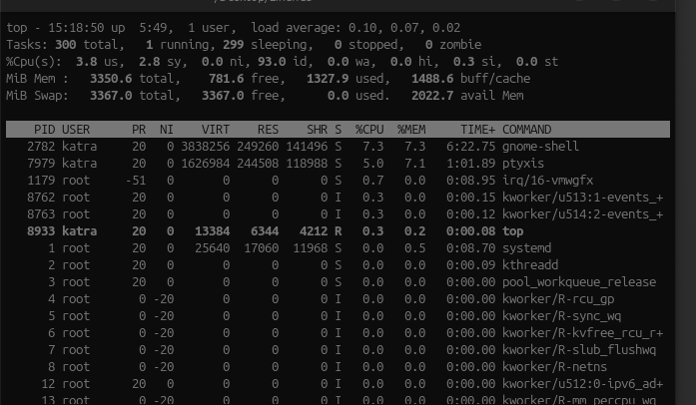

htop
Definition: Displays processes in an interactive interface with colour bars, mouse support, and function-key menus. It may need to be installed first.

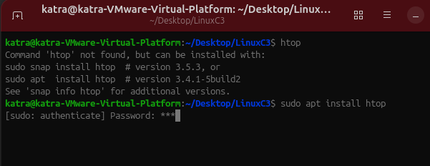

Options and keys:
-u USER – Displays only the specified user's processes.
-t – Displays processes in tree view.
F6 – Selects the sorting column.
F9 – Sends a signal to the selected process.
F10 or q – Quits htop.

pstree
Definition: Displays running processes in a tree structure, showing parent and child relationships.
Options:
-p – Displays process IDs (PIDs) in the tree.
PID – Starts displaying the tree from the specified process.

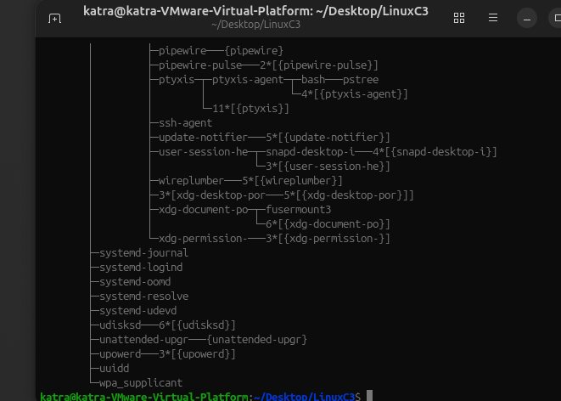

jobs
Definition: Lists background and stopped jobs belonging to the current terminal shell.
Options:
-l – Displays each job's PID.
%N – Refers to a job number, such as %1.
Without %N – bg or fg uses the current job, marked with +.

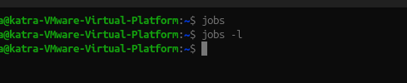

bg
Definition: Resumes a stopped job and runs it in the background.
Options:
%N – Specifies the job number to resume.
Without %N – Resumes the current job.

sleep
Definition: Delays execution for a specified amount of time. It is used in the chapter to practise foreground and background jobs.
Options: No option is shown in the chapter.

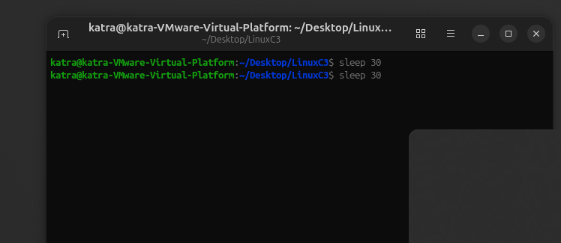

echo $$
Definition: Displays the PID of the current shell. The special variable $$ contains the shell's process ID.
Options: No option is shown in the chapter.

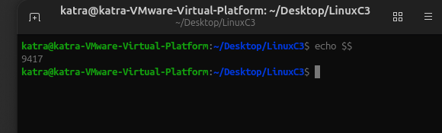

kill
Definition: Sends a signal to a process using its PID or a job number.
Options:
No signal specified – Sends SIGTERM (15) by default.
-TERM – Sends SIGTERM, asking the process to finish cleanly.
-HUP – Sends SIGHUP; many services interpret it as a request to reload.
-9 – Sends SIGKILL, forcing the process to end immediately.
%N – Targets a job number in the current shell.
-l – Lists available signals.
-l 15 – Displays the name of signal number 15.
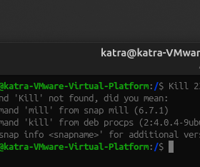

Pgrep

Definition: Searches for running processes by name and displays their PIDs.
Options:
- -a – Displays the PID and the full command line.
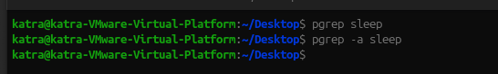

pkill
Definition: Sends a signal to processes matching a specified name or pattern.
Options:
-u USER – Targets processes owned by the specified user.
NAME – Specifies the process name or matching pattern.

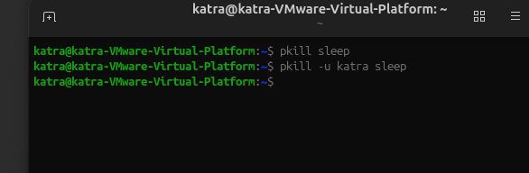

killall
Definition: Sends a signal to processes matching the exact process name.
Options: No option is shown in the chapter.

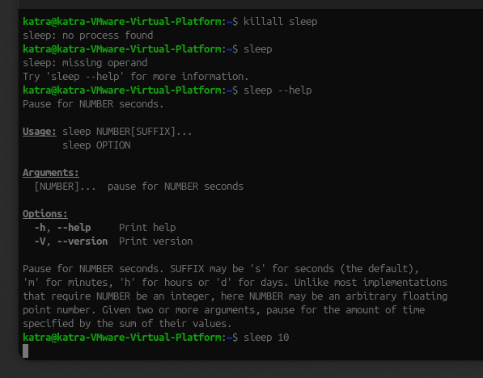

nice
Definition: Starts a process with a specified niceness value, which affects its CPU scheduling priority.
Options:
-n N – Sets the niceness value when starting the process.
No option – Displays the current niceness value.

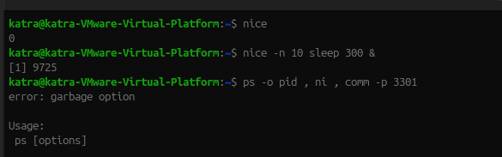

Niceness values:
-20 – Highest priority.
0 – Default priority.
19 – Lowest priority.

renice
Definition: Changes the niceness value of a process that is already running.
Options:
-n N – Specifies the new niceness value.
-p PID – Specifies the process to modify

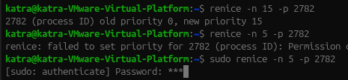

Uname

Definition: Displays information about the running kernel and machine architecture.
Options:
-r – Displays the kernel release.
-m – Displays the machine hardware type or CPU architecture.
-n – Displays the hostname.
-a – Displays all available system information on one line.

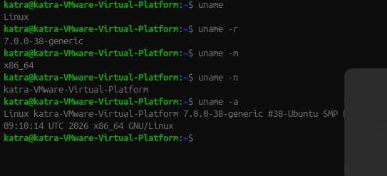

hostnamectl
Definition: Displays information about the system hostname, operating system, kernel, and virtualization.
Options and arguments:
No argument – Displays the full system summary.
hostname – Displays only the hostname.
Changing the hostname requires administrator permission; the chapter only practises reading it.

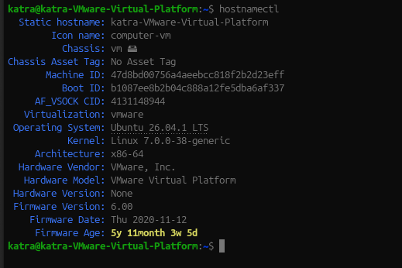

uptime
Definition: Displays how long the system has been running, the current time, logged-in users, and system load averages.
Options:
-p – Displays the time since boot in a readable format.
-s – Displays the date and time when the system booted.

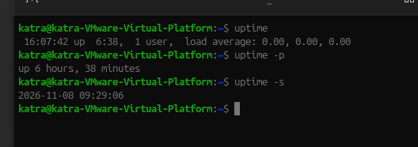\

free
Definition: Displays information about RAM and swap memory usage.
Options:
-h – Displays memory sizes in human-readable units such as Mi and Gi.
-m – Displays memory sizes in mebibytes.
-s N – Repeats the memory report every N seconds.

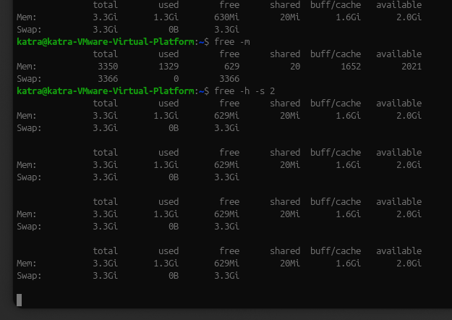

lscpu
Definition: Displays detailed information about the CPU, including architecture, CPU count, model, and hypervisor information.
Options: No option is shown in the chapter.

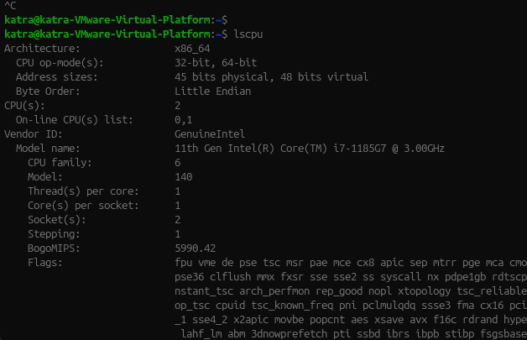

nproc
Definition: Displays the number of processing units available to the current process.
Options: No option is shown in the chapter.

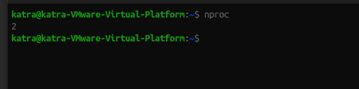

lsblk
Definition: Lists block devices visible to the Linux kernel, including disks and partitions.
Options:
-e 7 – Excludes devices with major device number 7, commonly loop devices.
-d – Displays whole disks only, not their partitions.
-o COLS – Selects the columns to display, such as NAME, SIZE, and MODEL.
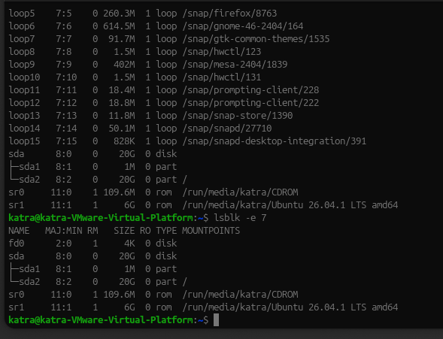

systemctl
Definition: Controls and manages services using systemd, the service manager that runs as PID 1.

Actions, options, and arguments:
status UNIT – Displays the service status and recent log entries.
is-active UNIT – Checks whether the service is currently running.
is-enabled UNIT – Checks whether the service is configured to start at boot.
start UNIT – Starts a service now.
stop UNIT – Stops a service now.
restart UNIT – Stops and starts a service again.
reload UNIT – Asks a service to reload its configuration without stopping; only supported by some services.
reload-or-restart UNIT – Reloads if supported; otherwise restarts.
enable UNIT – Configures the service to start at boot.
disable UNIT – Prevents the service from starting automatic

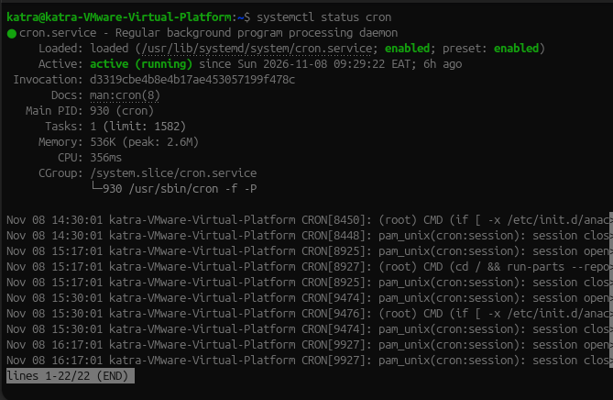

Journalctl

Definition: Reads systemd journal logs, including messages from the kernel and system services.
Options and arguments:
-n N – Displays the last N log entries.
-b – Displays logs from the current boot.
-p err – Displays error-level messages and more severe messages.
-u UNIT – Displays logs for a particular service.
-e – Jumps to the end of the journal.
-x – Adds explanatory information to log messages.
-f – Follows new log entries as they appear; use Ctrl+C to stop.

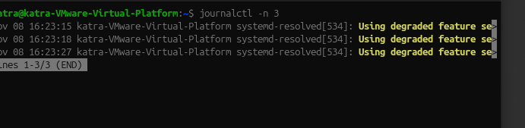

logger
Definition: Writes a test message to the system log or journal.
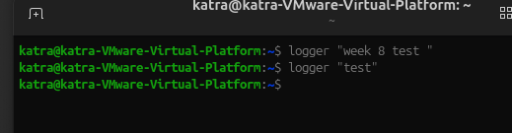

last
Definition: Displays information about recent user logins and system reboots.
Options:
- -n N – Displays only the last N entries.

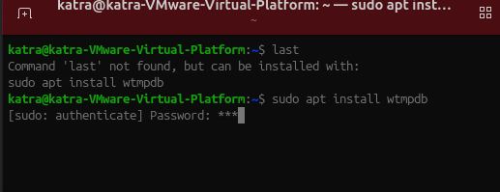

dmesg
Definition: Displays kernel messages, including hardware detection, driver loading, and device information.
Options:
- -T – Displays readable clock times instead of timestamps in seconds.
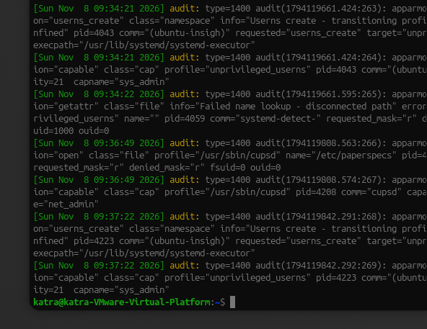

Shutdown

Definition: Shuts down or restarts the Linux system cleanly.
Options and arguments:
now – Performs the shutdown immediately.
+N – Schedules shutdown after N minutes.
-r – Restarts the system instead of powering it off.
-c – Cancels a scheduled shutdown.
TIME – Specifies when the shutdown should happen.

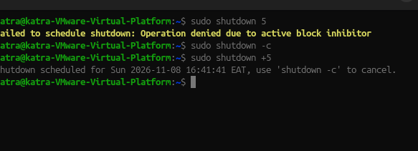

reboot
Definition: Restarts the Linux system immediately.
Options: No option is shown in the chapter.

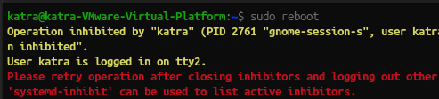

poweroff
Definition: Shuts down the Linux system and switches off the machine.
Options: No option is shown in the chapter.

sshd
Definition: The SSH server daemon. In this chapter, its -t option is used to check the SSH server configuration for errors.
Options:
- -t – Tests the configuration file and reports errors. No output means the configuration check passed.



