**Server Info Gather commands to retrieve CPU, Memory, and Storage ( On-Prem / Azure VM )**



**SERVER HARDWARE INFO (CPU, DISK CAPACITY, MEMORY)**

**LINUX**

* CPU -- **cat /proc/cpuinfo**
* Disk -- **df -h**
* Memory -- **cat /proc/meminfo**

**\*\*\*\*\*\*\*\*\*\*\*\*\*\*\*\*\*\*\*\*\*\*\*\*\*\*\*\*\*\*\*\*\*\*\*\*\*\*\*\*\*\*\*\*\*\*\*\*\*\*\*\*\*\*\*\*\*\*\*\*\*\*\*\*\*\*\*\*\*\*\*\*\*\*\***

**WINDOWS**

If wmic is installed:

* CPU

**wmic cpu get caption, name, numberofcores, maxclockspeed, status, numberoflogicalprocessors  
echo %NUMBER_OF_PROCESSORS% (logical processors returned)**

* Memory

**wmic memorychip get capacity, speed, memorytype  
wmic computersystem get totalphysicalmemory**

* Storage

**wmic logicaldisk get Caption,FileSystem,FreeSpace,Size,Status**

**\*\*\*\*\*\*\*\*\*\*\*\*\*\*\*\*\*\*\*\*\*\*\*\*\*\*\*\*\*\*\*\*\*\*\*\*\*\*\*\*\*\*\*\*\*\*\*\*\*\*\*\*\*\*\*\*\*\*\*\*\*\*\*\*\*\*\*\*\*\*\*\*\*\*\***

**Azure VM ( Share JSON File )**

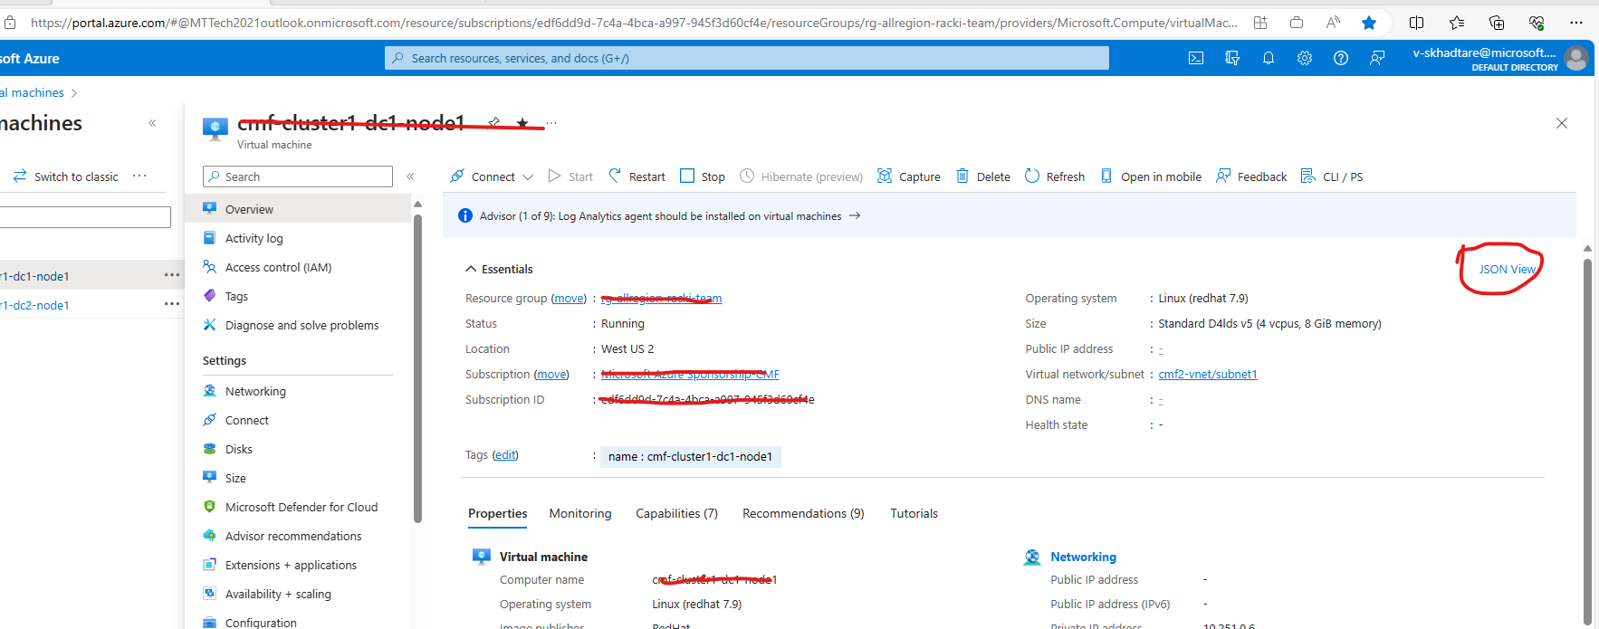

|  |  |  |  |  |  |  |
| --- | --- | --- | --- | --- | --- | --- |
| **Host-Name** | **Cores** | **Memory** | **Storage Size** | **Storage Type** | **OS type** | **OS version** |
|  |  |  |  |  |  |  |
|  |  |  |  |  |  |  |
|  |  |  |  |  |  |  |
|  |  |  |  |  |  |  |
|  |  |  |  |  |  |  |
|  |  |  |  |  |  |  |