create database supplier;

use supplier;

create table supplier(

sid int,

sname varchar(30),

city varchar(30),

primary key(sid)

);

create table parts(

pid int,

pname varchar(30),

color varchar(30),

primary key(pid)

);

create table catalog(

sid int,

pid int,

cost int,

primary key(sid,pid),

foreign key(sid)references supplier(sid),

foreign key(pid) references parts(pid)

);

insert into supplier

values

(10001,"acme widget","bangalore"),

(10002,"johns","kolkota"),

(10003,"vimal","mumbai"),

(10004,"reliance","delhi");

select *from supplier;

insert into parts

values

(20001,"book","red"),

(20002,"pen","red"),

(20003,"pencil","green"),

(20004,"mobile","green"),

(20005,"charger","balck");

select *from parts;

insert into catalog

values

(10001,20001,10),

(10001,20002,10),

(10001,20003,30),

(10001,20004,10),

(10001,20005,10),

(10002,20001,10),

(10002,20002,20),

(10003,20003,30),

(10004,20003,40);

select *from catalog;

select distinct p.pname

from parts p

join catalog c on p.pid=c.pid;

select s.sname from supplier s

where not exists(select p.pid from parts p

where not exists(select c.sid

from catalog c

where c.sid=s.sid and c.pid=p.pid)

);

select s.sname from supplier s

where not exists(select p.pid from parts p

where p.color='red'

and not exists(

select c.sid from catalog c

where c.sid=s.sid and c.pid=p.pid

)

);

select p.pname from parts p

join catalog c on p.pid=c.pid

join supplier s on c.sid=s.sid

where s.sname='acme widget'

and p.pid not in(

select c1.pid

from catalog c1

join supplier s1 on c1.sid=s1.sid

where s1.sname!='acme widget'

);

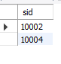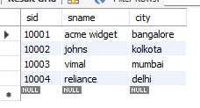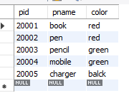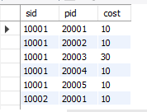

select distinct c.sid from catalog c

join(

select pid,avg(cost) as avg_cost

from catalog

group by pid

)

avgcosts on c.pid=avgcosts.pid

where c.cost>avgcosts.avg_cost;

select p.pname,s.sname from parts p

join catalog c on p.pid=c.pid

join supplier s on c.sid=s.sid

where c.cost=(

select max(c1.cost)

from catalog c1

where c1.pid=p.pid

);