

TRIBHUVAN UNIVERSITY INSTITUTE OF ENGINEERING PULCHOWK CAMPUS

**PROJECT PROPOSAL ON DSA**

**PRESENTED TO DEPARTMENT OF ELECTRONICS AND COMPUTER ENGINEERING**

AVAHAN TAMRAKAR ( 077BCT015 )

DIVYA SANGKAT KARKI ( 077BCT028 )

KHAGENDRA KARKI ( 077BCT036 )

KRIPESH NIHURE ( 077BCT037 )

**BY**

**ACKNOWLEDGEMENT**

First of all, we would like to express our sincere gratitude to our Data Structure and Algorithm teacher, Asst. professor Bibha Sthapit for encouraging us to work on a project. This initiative is the result of that encouragement.

We are thankful and fortunate enough to get constant encouragement, support and guidance from our senior brothers and sisters. There constant support is always encouraging and inspiring. Also, we would like to extend our sincere esteems to the Department of Electronics and Computer Engineering for granting us such a platform of doing project work. So, we would like to express our sincere gratitude to our teachers to provide us with such a challenging task which would enhance our skills and our knowledge related to the Data Structure and Algorithm.

Also, we would like to extend our gratitude to our teacher and lab assistant for guiding me through this course. With their guidance, I believe I/We can do any simple/complex project. I would like to also thank them for giving us this wonderful opportunity. With this project, we will be able to apply our knowledge/skill of programming into a real-world problem. Also, from this project, we will get to know some unique idea about project from our friends’ side too.

Last but not least we would like to thank the people out there on the internet whose resource we may have to use. It is because of those free and open source resource that many of our work becomes extremely easier.

**TABLE OF CONTENTS**

1 INTRODUCTION……………………………. 3

2 OBJECTIVES . . . . . . . . . . . . . . . . . . . . . . . . . . . . . . . . 3

3 EXISTING SYSTEMS . . . . . . . . . . . . . . . . . . . . . . . 3

4 PROPOSED SYSTEM

4.1 Description . . . . . . . . . . . . . . . . . . . . . . . . . . . . . . . 4

4.2 Block diagram. . . . . . . . . . . . . . . . . . . . . . . . . . . . 8

5 METHODOLODY. . . . . . . . . . . . . . . . . . . . . . . . . . . . . 9

6 PROJECT SCOPE. . . . . . . . . . . . . . . . . . . . . . . . . . . . . 9

7 CONCLUSION . . . . . . . . . . . . . . . . . . . . . . . . . . . . . . . . 10

**Introduction**

Communication is one of the fundamental aspects of human existence. The advancement in science and technology has digitalized the communication sector. It is not as conventional as it used to be a 100 years ago. It has grown to be much more than just expression of one’s thought. Apps like Facebook, Snapchat, Twitter are defining the driving the standards to a whole new level. This is why it holds an even deeper importance in today’s world.

Bringing the concepts of Data Structure and Algorithm and the need for a suitable medium of communication we have decided to make a social networking site. We have named this site ‘**Mitrata**’ which translates to friendship in English.

Mitrata will be a web-based app which provides the user with a platform to get to know other people and communicate with them.

In the further proceeding of this proposal we have outlined the objectives, methodology and description of our project.

**Objective**

The main objective of our project is

* To learn the concept of Data Structure and Algorithm
* To learn to implement Web Socket and HTTP server
* To learn to use front end framework like react
* To learn to implement database for an application
* To learn to work in team

**Existing System**

The idea of communication over internet isn’t new. There are a wide range of app already available in the market with each app specializing in some aspect of it. Here are some of those apps that are already out there and are widely recognized: -

**Facebook**: Facebook is a social networking platform that allows users to connect with friends and family online.

**Instagram**: Instagram is a visually-based social media platform that enables users to share photos and videos, interact with others by liking, commenting, or messaging, and enhance their content with filters and editing tools.

**WhatsApp**: WhatsApp is a cross-platform messaging and voice over IP (VoIP) service owned by Facebook. It allows users to send text messages, voice messages, make voice and video calls and share images, documents, user locations, and other media.

**Proposed System**

**Description**

The application is divided into three parts, the client, the server and the database. Each handling a specific part of the application. They have been further explained in detailed below.

**Frontend**

This is the part where user will interact and communicate. It will be written in HTML, CSS and JavaScript. The frontend is further divided into multiple pages as follow.

8request for the site is made. This page takes the credential from the user send it for verification to the server and based on the verification status code from the server it redirects the user to his/her user feed. User can also opt to sign up for the app which is linked via this page.

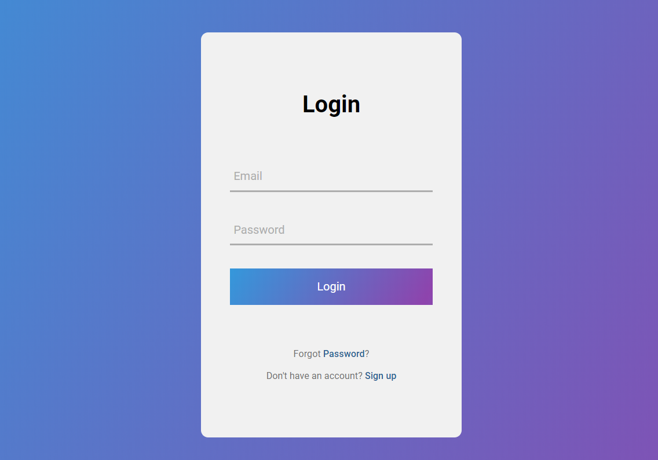

**Proposed UI for login Page**

**Sign Up Page:**  This is for new users who would like to sign up for the app. This page prompts the user to input the required credential and then sends it to the server for writing the data to the database. If everything is okay then the user is redirected to his/her first user feed.

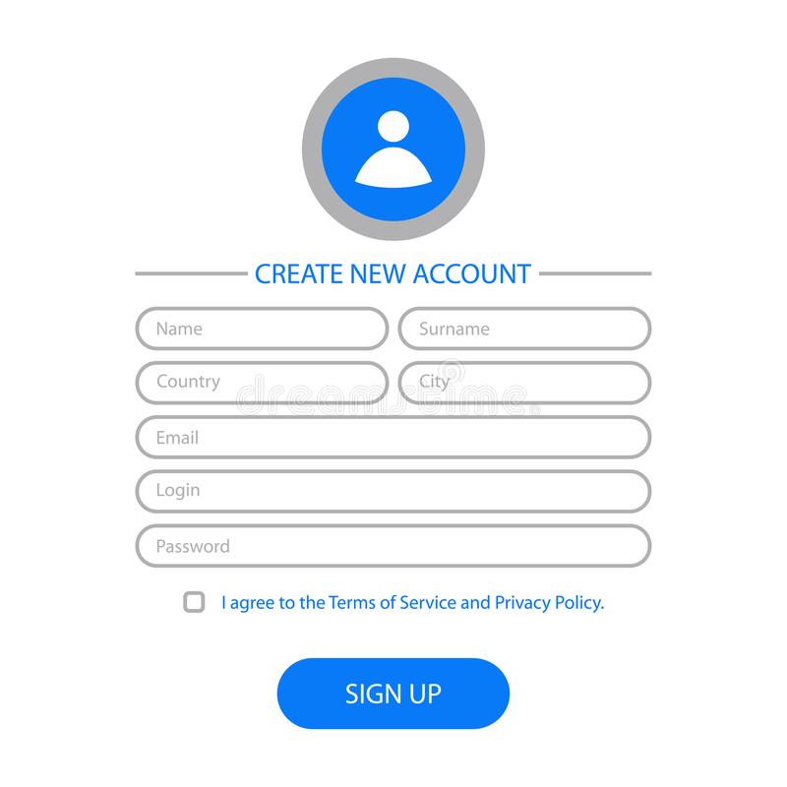

**Proposed UI for Sign Up page**

**User Feed:** This is the main page of the site. This page is generated once the user is logged into his\her account. The feed is generated by backend which in turn reads the database for the necessary data. The user can view other people profiles and can initiate chat if they want to be friends. The feed is linked to the chat space for chatting. UI is to be designed.

**Chat Room:** This is the page for chatting. The user can chat with other people via this page. The chat room establishes a web socket connection with the backend server for uninterrupted chat messages.

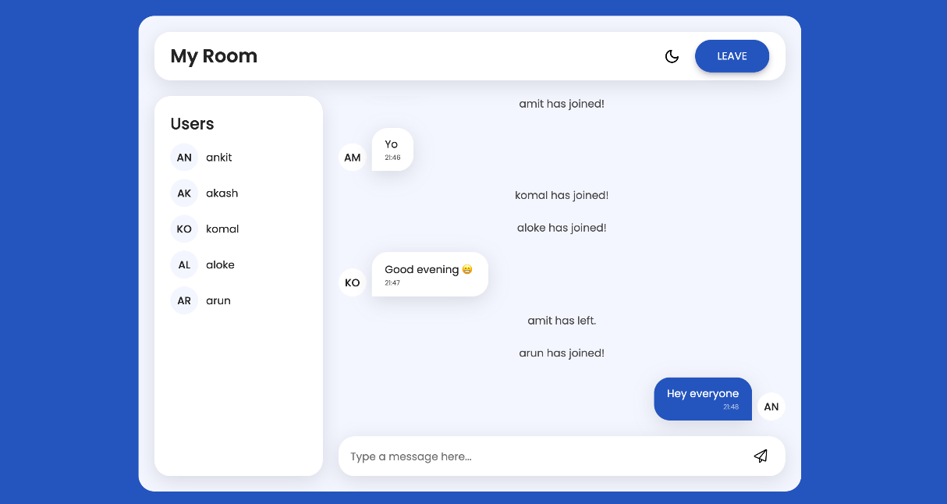

**Proposed UI for Chat Room page**

**Backend**

It is the part of the app responsible for handling the logic and data storage for the application, as well as providing an API for the frontend (client-side) of the application to communicate with. It is further divided into smaller logical units which are described below.

**User verification:** This section verifies the user by validating the received credential with the credential available in the database and response a verification status code.

**Handle new user:** This method handles the new user. It writes the credential to the database and after successful sign up session redirects the user to their user feed.

**User feed generator:** This part deals with generating the user feed. It reads from the data from the database and based on the user preferred interest the user feed is generated.

**Chat manager:** This block handles all the chats in the app. It does so by communicating with the frontend over a WebSocket. Here we decided to implement WebSocket instead of an HTTP server for managing chats because the chat need to be updated frequently in real time so the required connection has to stay alive for the whole time. HTTP server are slow in this case.

**Database:** Database stores all the data of all the users so that they can be referenced later. Database is only accessible to the backend server. All the data in the database will be in binary formatso that it occupies minimum space possible. All the low-level handling and the manipulation of the data will be done by the database. A high-level interface will be provided by it to the backend server

**Block Diagram**

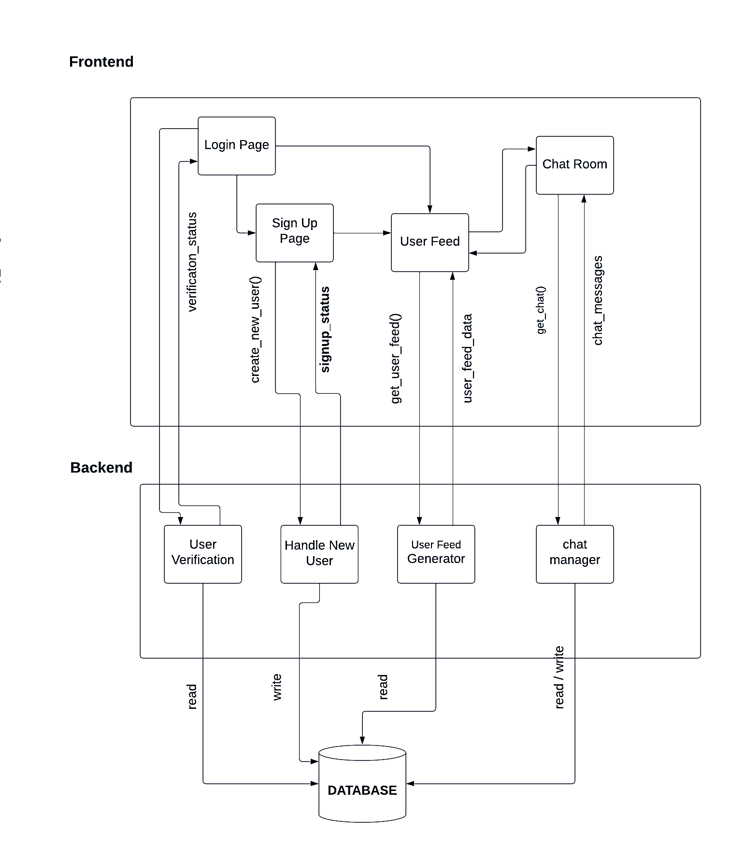

**Methodology**

Our application will be written in **JavaScript** Programming Language which runs on Node. Node is a runtime environment for JavaScript. We choose JavaScript because of its rich libraries that makes us easier to build the project.

For client side we will be using JavaScript language because of its simplicity and also because of the fact that there are already multiple frontend frameworks available. Among many such alternative framework we will be using one of the most popular frontend frameworks out there which is **REACT**.

React is a JavaScript library for building user interfaces. It allows us to build **reusable UI components** and manage the state of an application **virtual DOM** in an efficient way. React uses a, which improves the performance by reducing the amount of DOM manipulation required.

For styling the frontend elements i.e. HTML we have opted to use **Bootstrap**. Bootstrap is a **class-based CSS** library where the classes are predefined with some styling. These classes need to be added to the HTML element to beautify them.

For backend we will be using ‘ **Socket.IO** ’ . Socket.IO is a library that enables **low-latency**, **bidirectional** and **event-based** communication between a client and a server.

**Project Scope**

Mitrata being a small project, won’t be able to incorporate many features so as to expand to its scope. But we do will try to include some of the basic scope of a social networking app. These have been explained below.

**Profile Creation**: User can create their profile on the site by uploading their bio-data and their pictures.

**Messaging**: Users will be able to communicate with each other via chat message.

**Friend Connections**: The user can consistently view their friends profile and chat with them.

**Match making**: Based on the preferred interest two users can form a match. The match will be displayed in terms of percentage of the interest matched between two users.

**Conclusion**

In conclusion, the proposed project titled ‘Mitrata’ is a comprehensive and well-planned initiative undertaken to address the need of a simple and easy to use social networking site. We have carefully considered all aspects of the project, including a thorough research on the existing apps out there and their negative aspect so that we may eliminate those issues in our own design.

In this proposal, we have outlined the objective of the project and the methodology that we will be using to achieve this. We are confident that with the support of our teacher, friend and seniors, this project will be able to achieve the goals we have set out.

We are eager to move forward with this project and believe that it will be able to deliver on its aim and purpose. We look forward to the opportunity to collaborate with our team members and taking the necessary help from the teacher and seniors to make this project a reality. We are confident that by working together we can overcome any obstacle that may obstruct us.