A Major Project Report on

**DRASON: The web Based Application**

Submitted in Partial Fulfillment of the Requirement for

The Degree of Bachelor **of Engineering in Information Technology**

Submitted by:

**Anish Shrestha, 15408**

**Niraj Khatiwada, 15424**

**Abash Upreti, 15403**

**Hari Nyaupane, 15418**

Under the supervision of:

Date:

08-03-2019



**Department of Information Technology**

**NEPAL COLLEGE OF**

**INFORMATION TECHNOLOGY_**

Balkumari, Lalitpur, Nepal

**Acknowledgement**

This project would not have been possible without the joint efforts of many individuals. It has been a pleasure for us to acknowledge the assistance and contributions that were very important and supportive throughout the project. We would like to extend our sincere thanks to all of them. We owe special thanks to a number of people who has devoted much of their time and expertise without which it would have been very difficult for us to complete our project entitled “DRASON”.

We are highly indebted to our Project Supervisor Er**. Birendra Bista,** Engineering for his valuable guidance throughout the project development period and for providing technical support with suggestions which helped our project to grow and foster to a certain level we didn’t think of reaching in such a short period.

Last, but not the least, we would like to thank our teachers and colleagues who have been knowingly or unknowingly the part of this project and lent support and views during the entire development time.

# Abstract

*DRASON is web based software which is designed to provide easy and quality service to the different online customers. This is a computerized system design to deal with the customer to get platform directly using web browser for different operations like donate, recycle, advertisement, sell old and new product. It is mainly focus on the audience who have interest on the online shopping. It provide a platform to those company who recycle the old product. Admin has the full authority to control this website. Every customer has separate login id and password to buy product. There is lots of online gateway for shopping but no one can provide the platform like recycle and donate old product. DRASON overcome such situation by providing a boosting up various item to reach to the maximum customers.*

*Technology is playing an increasingly important role in various facets of development. DRASON is a web-based application which is designed & developed using PHP as a programming language and MySQL as a database. The main important while developing any system is to make the system usable.*

*Keywords: new, product, DRASON, recycle, donate*

Contents

Abstract i

1. Introduction 1

1.1 Problem Statement 1

1.1.1 Problem in the delivery of products 1

1.1.2 Security 1

1.1.3 Return Policy 2

1.1.4 Quality and Right Product 2

1.1.5 Recycle and old product 2

1.2 Project Overview 2

1.3 Objective 3

1.4 Significance of Study 3

1.5 Scope and Limitation 4

2. Literature Review 6

2.1 Review 6

2.2 Comparison with existing system 6

2.2.1 DARAZ 7

2.2.2 SastoDeal 7

2.2.3 Amazon 7

2.2.4 Hamro Bazar 7

2.3 Solution offered to the existing differences 8

3. Team and Division of work 9

4. Proposed Methodology 11

4.1 Software Development Life Cycle: SDLC 11

4.2 Increment 1: Develop the user interface 11

4.2 Increment2 12

4.2.1 Analysis 12

4.2.1 Design phase 12

4.2.3 Coding phase 13

4.2.4 Testing Phase 13

4.3 Tools and Technology used 13

4.4 Technology to be Used 14

5. Requirement Analysis 15

5.1 System Requirement Specifications 15

5.1.1 Functional requirements 15

5.1.2 Non Functional requirements 16

Output requirements 18

Security Requirement 19

6. System Design Through UML Models 20

6.1 ER Diagram of System 20

6.2USE Case diagram 21

6.3 Data flow diagram 22

6.4 Class Diagram 23

7. Budget Estimation 24

Functional point 24

8. Testing 25

9. Expected Outcomes 25

10. Task and Time Schedule 27

5.1 Project time and task schedule 27

6. References 28

List of Figures

1. Incremental model-------------------------------------------------------------------------------9
2. Gantt chart---------------------------------------------------------------------------------------13

# 1. Introduction

DRASON is the system where the aspects to the online shopping. The aspect involving managing different aspect like selling new product, recycle different old product, donate the different product. The project is based on the selling different goods through the online platform using internet. Managing different records addresses the specific issues involved in client records. It creates the way for which seller or customer allows directly buy goods and services using the internet and web browsers. This system also give platform to those companies who wants to recycle the old things. DRASON is such a platform where buying selling new and old product as well as recycle and donate the product. It create a platform for those companies who wants to recycle the product. The collection of old and recycle product from users paying certain amount. It is beneficial for both the customers as well as a company. It includes various advertisement boxes for advertisement. Advertisement help the developers for earning money.

## 1.1 Problem Statement

This is age of technology a lots of advancement in the field of technology, with this advancement different web application has been one of the most effective platform for online shopping. Beside this lots of problem in the online shopping some of them are as follows:

### 1.1.1 Problem in the delivery of products

There are lots of time required for the delivery of the purchased products. Lack of manpower is the main reason. People who ordered good wants immediately service but due to lack of manpower the product shouldn’t delivered in time.

### 1.1.2 Security

There is some online store which has lack of security that they show one product and sold another product to the customer. Since there website is also not secure so that huge concern in the security. Security is main things. If the delivery product has opened in way by the delivery boy then there is security issue. Such issue should be minimize by our site.

### 1.1.3 Return Policy

This is another factor which is important when shopping online. Sometime the customer does not look and feel of the product so there are chance of return while not satisfied with the products. Hence company doesn’t accept the return policy of the product. Long procedure should follow for return of the product which is time consuming.

### 1.1.4 Quality and Right Product

Quality is the main concern of any customer. Customer wants high and quality products and goods as they ordered. But many online shows one product and delivered another product to the customer.

### 1.1.5 Recycle and old product

Recycle reduce and reuse is main subject of concern today. Recycle old and waste product makes our environment clean but no one care about this, so we can try to address such issue and solve the problem.

## 1.2 Project Overview

The life style of people are different nowadays. People feel uncomfortable when going to busy and crowded market. Bargaining is another problem while buying the goods. So the shopper visit web store for online shopping from the house using computer and smartphone shopping become easy and time saving. Donate and recycle old product helps to clean the home environment and new useful things should be developed varities of product. The searching of goods helps easy to find as per the requirement. So many people of today world use online shopping.

## 1.3 Objective

After the research of the different data collection process, the objective of our project DRASON has been drawn out. The core objective of our project are as follows:

* Promoting service and product online.
* Selling the new as well as old product.
* Collect the old product for recycle.
* To make shopping easy.
* Develop an interactive web application with user friendly.
* Provide authentication login system to different users.
* To enable user to view different product.
* To enable user to donate the new as well as old product.

## 1.4 Significance of Study

The DRASON is very beneficial for online shopping. It will store complete record of items. The most important thing is it will make it easier for the customer information. It’s very important have an organized as well as appealing website that offers fantastic solutions as they play an essential role in the income of their business. The portal with an authentication designs are entirely customer centric. They help in marketing as well as branding of the portal. There looks like 3 advantages that is trust, convenience and security. In any kind of online shopping there are essential to sustain all the factors which are being reputed website. The main important things is trust once the customer trust and feel it is safe then sample and protected to shop. They also visit next time to time in regular basis.

The strength of the online and the development of the technology more and more websites are rising up. From one competes with every way we can achievable. Customer’s review is important for everybody to promote and get into a brand new website for shopping on-line. Staying at home and browsing through a web sites is a lot easier compared to going shopping offline. Different preferred brands with different discount which you are preferred in online shopping portal. Various discount offers are also deal which help to attract customer. There is no threat to buy, sell and donate anything which is helpful for valuable customer as well as seller and receiver. User friendly and pleasant environment for shopping offer an extra additional value which help the portals to get more and more shoppers. If once customer has been lead to proper place which he/she exposed precisely what they needs, they won’t even think of coming in the portal. It is always be successful deals to customers so that they visit next time also. Marketing online is properly manage and advantageous business. Hence, create and design the website portal with a lots of planning and interest which in turn would be offer rewarding returns.

## 1.5 Scope and Limitation

The purchasing of various list of product by using internet was impossible about 3-4 decade ago. But today the technology makes easy and it’s the age of online shopping. Scope among the online shopping helps to obtain the product from home in a simple click. Another factor is the satisfaction. Once a customer gets satisfied with his desired item, his trust on Online Shopping strengthens and this is the main cause of the success behind online shopping trend.

* Be updated about the products
* View and purchase through the various web browser
* Conduct the various vital information flow update to the people
* Share the old product and recycle

Although our projects seems to answer most of the recent activities and problem regarding the online shopping, it has certain limitation that might be crucial at time. Some limitation of our project are:

* Payment after delivery.
* Comparison.
* No discount voucher.

# Literature Review

A literature review discusses published information in particular areas, and sometimes information in a particular subject area within a certain time period. The system of shopping requires a lot of paper works and consumes a lot of time which may not be 100% accurate and may be misplacing of the details. This system consist the literature study on the web based shopping.

## 2.1 Review

There are lots of system in the market for online shopping. With the increasing and improving in various technology and internet online shopping becoming easy day by day which is going to add new features and services. Even there are insufficient service for the customer point of view. So there will always lots of area of improving. Hence our project is looking forward to define all the possible services so than online shopping makes great impact in the society.

## 2.2 Comparison with existing system

The new proposed web application provides an easy way for online with the minimum amount of processes and cost. Unlike paper work, it does not require too much time, money or unnecessary effort to do so. The buying and selling aspects are made convenient as well. Shopping online has never been easy job[3]. There are lots of system. Some of them are below:

### 2.2.1 DARAZ

Daraz is Chinese owned online marketplace and logistic company operated in south Asian markets. It is one of the renouned online shopping in Nepal. It is based on the consumer to consumer basis of online marketplace. Features like mysterious box, vouchers, crazy deals with discount across different catagories[4].

### 2.2.2 SastoDeal

It is one of the biggest online shopping website. With the internet user increase excessively in Nepal online shopping save valuable time and money. Sastodeal offer various gift voucher and discount which attract customer towards this portal. It has separate login system which makes website more secure. Shopping becomes also easy.[5]

### 2.2.3 Amazon

Amazon originally selling books through its website later on it has built a customer service shipping, inventory that allows the site to offer everything. It is American based company which spread all over the world. All the facilities are provided so that great faith of people towards amazon. Delivery of product in time, which is main features of this portal. About 60 million customer are connected in the circuit in 2018.[6]

### Hamro Bazar

Hamro bazar is a platform for those who can sold and buy new as well as old things. Hamrobazar.com is free online classified which enables individuals as well as companies to list wide variety of new or used product online. We at hamrobazar.com believe that Internet is a great promotional vehicle as well as communication channel for connecting buyers and sellers. Hamrobazar.com is perfect solution that helps to list your products for free.[7]

## 2.3 Solution offered to the existing differences

DRASON is looking forward to target the online customer who have interest in online shopping. It help user to find good and quality products. Working like active shopkeeper, it looks forward for the flow of information with the help of internet and browser. DRASON will make shopping easy. It will have features like donate, recycle which are not available in other portal. It will provide the features for those company who wants to collect the old product and recycle those product. In business point of view it will be beneficial for both the company and customer. DRASON provide such a platform to all the people who wants to sold their product.

# Team and Division of work

|  |  |  |
| --- | --- | --- |
| **Name** | **Roles** | **Responsibility** |
| Niraj Khatiwada | Project Manager/  End user Documentation | Review and approve all project deliverables (Initiation Plan, Detailed Plan, Testing etc.)  Day to Day responsibility to keep project on track for the successful delivery of DRASON  Manage project level risks and issues on an ongoing basis and take responsibility for a project change management |
| Anish Shrestha | System/ UI Designer  And Developer | Develop User-friendly Interface and work through design revisions  Test System Interfaces  Define and execute development requirement |
| Abash Upreti | Security and Authorizations | Create and maintain system security( Authentication, User profiles, Assignment of user to profiles) |
| Hari Nyaupane | Database Administrator | Develop, maintain and implement policies and procedures necessary to ensure the security and integrity of the corporate database |

# Proposed Methodology

## 4.1 Software Development Life Cycle: SDLC

System design is one of the section of programming. In this section of the project many preview are going to be seen and we are gradually getting use of the system. The framework we will be using for developing the project is Incremental model. This model combine linear and sequential model with iterative prototype model. New functionalities will be added as each increment is developed. This phase of linear sequential model are analysis, design, coding, testing. This process are described below:



Fig1: Incremental model

4.2 Increment 1: Develop the user interface.

In this increment we mainly focus on the user interface and helps to meet our objective of our project. We developed an initial project plan to help the future increment. The system architecture which was essential part was developed initial. The artifacts to be produced in this phase are:

* Actor
* Use case
* Project boundary
* Risk management
* ER Diagram
* Use case Diagram
* Dataflow Diagram
* Activity Diagram
* Class Diagram

### 4.2 Increment2

In this phase, we finalize the product. Backend was developed and testing of the project. A lot of bug are removed and checkup the various factor.

### 4.2.1 Analysis

In this phase analysis will be performed an order to find out the requirement of the system. The outcomes of this phase would be system requirement specification.

### 4.2.1 Design phase

In this phase the SRS would be translated into this system’s design. Context Diagram DFD, ER-Diagram. Use case diagram and class diagram will be developed.

### **4.2.3 Coding phase**

In this phase, coding will be done according to the design and a working system will be developed by the end of this process.

### 4.2.4 Testing Phase

In this phase, the system will be tested. With each testing a list of changes to the system developed, is suggested and the changes will be applied to the software and the software would be delivered as a successive increment until a satisfying system is achieved.

### 4.3 Tools and Technology used

PHP

Sublime Text

Xampp

HTML

CSS

BOOSTRAP

### 4.4 Technology to be Used

* MySQL for database for storing all the application data.
* PHP, for server-side validation, retrieval and also for Event Scraping/ Crawling.
* HTML and CSS to develop interactive user interfaces.
* JavaScript, for event handlers and behaviors to add user interaction
* Bootstrap, a CSS framework for further styling the application.

# Requirement Analysis

Requirements analysis, also called requirements engineering, is the process of determining user expectations for a new or modified product. These features, called requirements, must be quantifiable, relevant and detailed. In [software](https://searchmicroservices.techtarget.com/definition/software) engineering, such requirements are often called [functional specification](https://searchsoftwarequality.techtarget.com/definition/functional-specification)s. Requirements analysis is an important aspect of [project management](https://searchcio.techtarget.com/definition/project-management).Requirement analysis**,** in software engineering encompasses those tasks that go into determining the need and conditions to meet for a new or altered product, taking account of possibly conflicting requirements of the various stakeholders, such as beneficiaries and users. It is the early stage activity of requirement engineering which encompasses all activities concerned with eliciting, analyzing, documenting, validating and managing system requirements.

## 5.1 System Requirement Specifications

### 5.1.1 Functional requirements

|  |  |  |
| --- | --- | --- |
| **ID** | **REQUIREMENTS** | **PRIORITY** |
| 1 | Provide an interface for the user to search and view events | essential |
| 2 | Shopping details are displayed in web browser. | high |
| 3 | User is able to sign in to view details. | optional |
| 4 | User must be logged in to shopping and donate. | Essential |
| 5 | Provide user with the platform to share and donate the things that they have come across. | Optional |
| 6 | User must be connected to Internet | Essential |
| 7 | User is able to sign out from the web application. | Essential |

### 5.1.2 Non Functional requirements

In addition to the obvious features and functions that you will provide in your system, there are other requirements that don't actually DO anything, but are important characteristics nevertheless. These are called "non-functional requirements".The correct specification and adherence of non-functional requirements similarly plays at least an equal, if not a greater role in the success of mobile applications. This is due to the following reasons:

|  |  |  |
| --- | --- | --- |
| **ID** | **REQUIREMENT** | **PRIORITY** |
| 1 | The application should be user friendly. | Essential |
| 2 | Applications need to operate successfully (or degrade gracefully) within a wide spectrum of operating conditions, such as a range of supported screen resolutions and form factors, network bandwidth situations and network types (2G/3G/4G/Wi-Fi), etc. | Essential |
| 3 | Application should emphasize on High Performance, High Responsiveness, Good Scalability, Good Usability, High Reliability, Good Security, Modifiability and Maintainability | Desirable |

Input Requirements

Data Required

The data should be in input are:

* Information about user

This contains user’s need valid username, email, password.

Source of data

The information will be given by user themselves. And the shopping have to be selected by user in order to be notified about that.

Input list and validation

The user inputs, for each, are categorized on the basis of entry by the user. They are tabulated below along with data description, validation and data length which would be helpful in Design Phase.

|  |  |  |  |  |
| --- | --- | --- | --- | --- |
| S.N. | Input | Datatype | Length | Description |
| 1. | Username | Character | 15 | It is the user name address by the web application. |
| 2. | Email | Character | 20 | It is user unique mailing address. |
| 3. | Password | Character | 15 | It is unique password for the system of user. |
|  |  |  |  |  |

### Output requirements

**Output objectives**

The user requires following output from the system:

1. Broader details of all the online shopping and donate in the newsfeed.

2. Full details on the shopping they have joined to.

3. Things Recommendations based on user’s past and consumption pattern.

4. Acknowledgement of donate the things on through third party website

### Security Requirement

Users are to sign up and then only get access to the information regarding the shopping, advertisement, recycle, donate so that each user can have their separate record to the shopping they are interested in or joined to and only authorized user will be able to update the various product and old product. Therefore each user have been given their own account with username and password to login. Password are saved in database. This will kept the information safe from intruders as well as those who are authorized to manage database only.

# System Design Through UML Models

UML is intentionally **process independent** and could be applied in the context of different processes. Still, it is most suitable for use case driven, iterative and incremental development processes. An example of such process is **Rational Unified Process** (RUP). UML is not complete and it is not completely visual. Given some UML diagram, we can't be sure to understand depicted part or behavior of the system from the diagram alone. Some information could be intentionally omitted from the diagram, some information represented on the diagram could have different interpretations, and some concepts of UML have no graphical notation at all, so there is no way to depict those on diagrams.

## 6.1 ER Diagram of System

The Entity Relationship Diagram is a pictorial representation of the overall logical structure of the system’s database. The ER Diagram of our system is given below. It shows the relationship among the various entities of our system. The entities are represented in the rectangle, their attributes are represented in the oval and the attributes that are underlined are the primary keys.

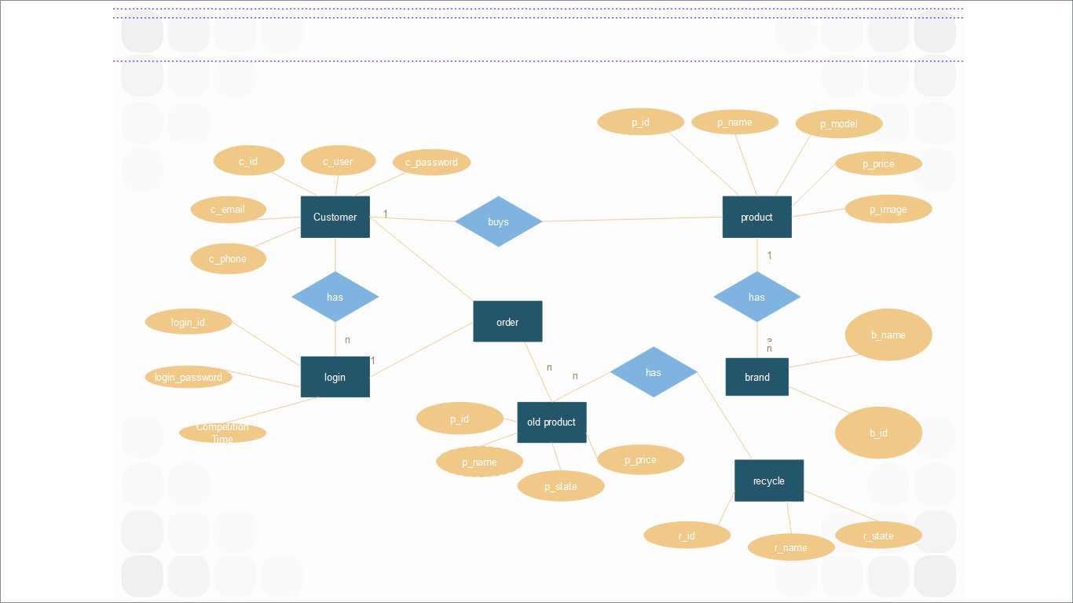

## 6.2USE Case diagram

A use case diagram at its simplest is a representation of a user's interaction with the system that shows the relationship between the user and the different use cases in which the user is involved. The actors for our system are: User, System and APIs. The simplified and graphical representation of what our system must actually do is represented below:

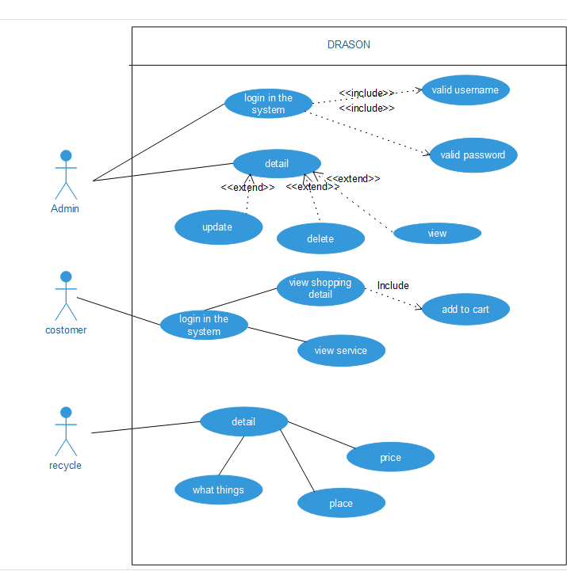

## 6.3 Data flow diagram

A data flow diagram (or DFD) is a [graphical](https://www.computerhope.com/jargon/g/graphic.htm) representation of the flow of [data](https://www.computerhope.com/jargon/d/data.htm) through an information system. It shows how information is [input](https://www.computerhope.com/jargon/i/input.htm) to and [output](https://www.computerhope.com/jargon/o/output.htm) from the system, information sources and destinations, and where it's [stored](https://www.computerhope.com/jargon/s/stordevi.htm).

## 6.4 Class Diagram

It is a structural UML diagram that shows the static structure at the level of class. We designed the following types of UML classes in our system.

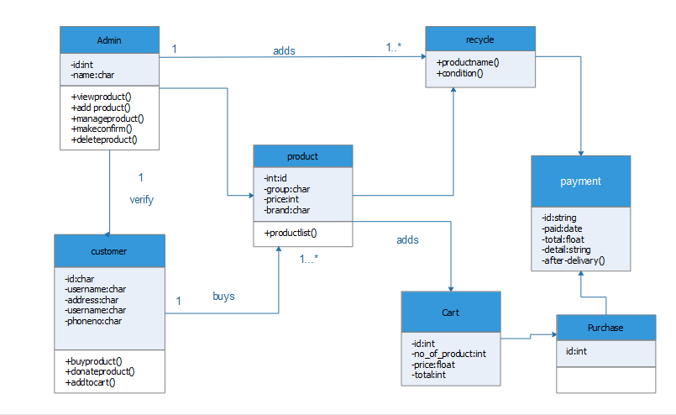

# Budget Estimation

## Functional point

FPA provides standardized method to functionally size the software work product. This work product is the output of software new development and improvement projects for subsequent releases. It is the software which is relocated to the production application at project implementation.

|  |  |  |  |
| --- | --- | --- | --- |
| Information domain Value | count | Weighted Value | Total count [weight*count] |
| No of user Inputs |  |  |  |
| No of User Output: |  |  |  |
| No of user inquiries |  |  |  |
|  |  |  |  |
|  |  |  |  |

# Testing

We wanted to make sure that all the elements of the developed worked functioned properly. For this, we created a test cases for our work, in which elements such as validation, reliability and user acceptance will be tested. The system will be tested for normal condition, primarily.

Testing Table

Each unit of the system was tested for its correct and proper functionality. The unit testing of each components is illustrated in the table below.

|  |  |  |  |  |  |  |
| --- | --- | --- | --- | --- | --- | --- |
| Test No. | Unit | Test | Expected result | Test Outcomes | Evidence | On Failure |
| 1. | Sign Up | Check whether the account can be created on filling details. | Successfully created | Successful | Test 1.1 |  |
| 2. | Login | Check for valid username and password. | Successfully login user. | Successful | Test 2.1 |  |
|  |  |  |  |  |  |  |
|  |  |  |  |  |  |  |

# Expected Outcomes

DRASON at its final phase will able to provide users with the various services that are essential yet not include in the online shopping services. After the completion of this project it will have following features:

* It will get update about the product list.
* Separate user login system for buying and selling the goods.
* Old and new product list.
* Advertisement of the products.
* It will provide a social platform to all people.
* It will provide a business platform.

# Task and Time Schedule

## 10.1 Project time and task schedule

The completion of project can be completed in 75 days approximately. Following are the key task involving in the project and the approximate time to complete.

|  |  |
| --- | --- |
| Task | Approx. duration (days) |
| Requirement analysis and specification | 11 |
| Undertake analysis of the system | 8 |
| Design system | 25 |
| Produce requirement specification | 12 |
| Testing and debugging | 9 |
| Test System module | 7 |
| Overall system test | 6 |
| Develop documentation | 75 |

Table-1: Task and Time Schedule

# 11 . References

[1]KennethE.Lantz.https://books.google.com.np/books/about/The_Prototyping_

Methodology.html? id=-SgnAAAAMAAJ&amp;redir_esc=y. Accessed on:2019/08/1.

[2]”Introduction about online shopping”http://www.w3schools.in/java/ Accessed:2019/08/01.

[3]”Student project Guideline”http://www.studentprojectCode.com Accessed:2019/08/02.

[4]”Article on Daraz”https://kathmandupost.com/money/2018/11/08/the ecommerce market in nepal. Accessed:2019/08/02

[5]” Roger S. Pressman”**Methodology of study,** New York, Mc Graw Hill Book,2008 Accessed:2019/3/08.

[6]”about amazon ”https://www.wekiapedai.com. Accessed: 2019/08/03

[7]”what is hamrobazar.com”https:// <https://hamrobazaar.com/faq.php>. Accessed: 2019/08/4

[7]’’software development life cycle”https://www.tutorialspoint.com” .Accessed:2019/08/03