A Project Mid-term Report on

**EASY MEDICATION: AN ONLINE PHARMACY SYSTEM**

Submitted in Partial Fulfillment of the Requirements for the Degree of **Bachelor of Engineering in Information Technology** under Pokhara University

Submitted by:

**Binita Thapa, 15414**

**Nisha Kumari Mandal, 15498**

**Pooja Kumari Chaudhary, 15427**

**Sharmila Timalsina, 15438**

Date:

22 11 2019

**Department of IT Engineering**



**NEPAL COLLEGE OF INFORMATION TECHNOLOGY**

Balkumari, Lalitpur, Nepal

**ABSTRACT**

The purpose of the project EASY MEDICATION is to build an application which can supply the medicine to doorsteps all over the country by just a single click which ultimately reduces time consumption.

It is basically a web based application where a user can post requirement for medicine also can purchase online. This project will thus overcome the flaws existed in the current and automate the manual task of searching medicine from shop to shop. Also person outside the valley can look up for medicine that aren’t available in their area and also can order them online. The system also keeps the record of orders information of customers also about data related to medicine’s expiry date.

Thus this application provides safe, secure, and verified platform for all parties involved to provide legitimate drugs. This also provides information of daily consumption of the medicines.

**Keywords: *EASY MEDICATION, medicine,online***

I

**LIST OF FIGURES**

Figure 1: Incremental Model

Figure 2: Use case diagram

Figure 3: ER Diagram

Figure 4: Domain model

Figure 5: Activity diagram for register, login and booking appointments

Figure 6: Activity diagram for login and managing appointments

Figure 7: Gantt chart for Increment 1

Figure 8: Gantt chart for Increment 2

Figure 9: Gantt chart for Increment 3

II

**TABLE OF CONTENTS**

1. INTRODUCTION 1

1.1 OBJECTIVES 2

1.2 PROBLEM STATEMENT 3

1.3 SIGNIFICANCE AND LIMITATIONS 4

2. LITERATURE REVIEW 5

3. METHODOLOGY 7

3.1 SOFTWARE DEVELOPMENT LIFE CYCLE 7

3.2 REASONS FOR USING INCREMENTAL MODEL 8

3.3 TOOLS AND TECHNOLOGIES TO BE USED 8

4. SYSTEM DESIGN AND UML MODELS 9

4.1 USE CASE DIAGRAM 9

4.2 ER DIAGRAM 11

4.3 DOMAIN MODEL 12

4.4 ACTIVITY DIAGRAM 13

4.5 SEQUENCE DIAGRAM 10

5. TIME SCHEDULE ESTIMATION 15

4.1 INCREMENT 1 15

4.2 INCREMENT 2 16

4.3 INCREMENT 3 16

6. PROJECT TASKS 17

4.1 TASKS DONE SO FAR 17

4.2 TASKS REMAINING 17

7. BIBLIOGRAPHY 18

III

**1. INTRODUCTION**

During our lifetime, sickness and illness are inevitable and medical assistance is compulsory in ailing them. Compared to the situation a few decades ago, people now understand the importance of seeking medicines. And with populated country like ours, the number of patients and medicine seekers is always on the rise making process of buying medicines unnecessarily time consuming and hectic.

OnlineMedication is an online pharmacy system. This website is proposed to provide a platform for booking and buying medicines as per the patient’s requirements from the comfort of their home. It provides detailed information of all the medicines and brands available. Customers have the option of searching for medicines based on brand, and cost, preorder medicines which are unavailable in the market. Customers can upload their prescription and order medicine as per prescribed from their home.

The proposed website makes use of the digital age where online services mean convenience, to provide a comfortable experience for customers.

1

1.1 OBJECTIVES

1. To create a smart online pharmacy system.
2. To keep record of customer and medicine database.
3. To reduce drug abuse by only selling medicines with needed prescription.
4. To reduce time consumption and provide effective internet medical shopping experience.
5. To provide medicines at customer doorsteps.
6. To sell medicine at appropriate price rate.

2

1.2 PROBLEM STATEMENT

* The existing system is of typical manual work.
* People in need of medicine take doctor’s prescription of the drugs and go to their preferred medical shop or pharmacy, hand them over the prescription and the pharmacist provide them with the required drugs if available with them or the person needs to visit another store which can be hectic.
* A good pharmacy store obviously has a large number of customers waiting for their turn to get their medicine which can take hours and consumes most of our valuable time. This can create a lot of problem as drug doses needs to be taken accurately in right time and right amount or the sickness can be worst.
* Mostly in many parts of our country unavailability of drugs has led to severe health condition and death.
* Drug abuse is another main scenario of problem existing in our country. In many parts of our country people tend to sell drugs without any prescription for money and people tend to misuse it.
* The third issue is overpricing of the medicines. Pricing of medicine varies in different parts of our country. Various pharmacists sell drugs at a very high price that many people of our country cannot afford them.

Thus the problems related to medicine and pharmacy prevailing in our country cannot be unseen. Health is wealth and in order to maintain a good health medicine plays great role.

3

1.3 SIGNIFICANCE AND LIMITATIONS

The significance of EasyMedication is listed as follows:

* The website can be accessed easily by the public and is easy for customer use.
* EasyMedication eliminates the need of reaching out from store to store to buy medicine. There are no time constraints so customer can place an order any time they are free.
* It includes both prescriptive and non prescriptive drugs and medicinal goods which is good for the customer.
* EasyMedication provides medicines at lower price point.
* It helps in reducing extended waiting time for medicine seekers and hectic work of visiting stores to store.

However, the system also has some limitations which are as listed below:

* Patients do not have the option to pay for the appointment in the website.
* There may be people who can give wrong address or phone number for the delivery which can cause chaos.

4

**2. LITERATURE REVIEW**

In the section the similar project that is developed by others that is used to automate the pharmacy management system is reviewed. There are many project done to automate this and some them are discussed below:

**1. ePharmacy**

The first one we reviewed is ePharmacy.

* According to this system a person or a customer must create an account before proceeding towards any steps. The step is mandatory in this system.
* Secondly the customer needs to text them on their social media accounts like messanger or viber to order the medicine. Hence there is no search engine.
* Customer cannot search for the availability of specific brand and options regarding it, which we feel is the main drawback of this system.
* As the customer cannot know the availability of the product and their order can later be cancelled during conformation.

So this system in our view must be evolved and a new system with better features should be introduced.

5

**2. ATMPharmacy**

ATMPharmacy is a website for pharmacy system in Kathmandu valley. It’s a website that allows customer to buy medicines at good price point with various options of brands. The website covers the entire valley for the supply of medicine. We’ll only compare the relevant features of the website.

This system has the following features:

* Customers can upload their prescription for approval of their order.
* The website let the customer order for both prescriptive or non prescriptive drugs.
* Customers can also buy healthcare equipments.
* Consists of both type of payment system (online and cash in hand).
* There are different catagories like for pregnancy, thyroid, kidney etc which makes it even easier to use.

This system is similar to ePharmacy in the aspect of ordering via another messaging application like viber, whatsapp for the conformation of the order. Some of the pages on the website do not seem to function as directed. Viewing medicines online on the website, uploading prescription on the website and later ordering via contacting them on another social media seems hectic.

Both of these websites are similar to EasyMedication in its essence. EasyMedication, however do not demand to use another application for the approval of the order, has a better search engine and every work is done on the same website from uploading the prescription, ordering the medicine to approval.

6

**3. METHODOLOGY**

3.1 SOFTWARE DEVELOPMENT LIFE CYCLE

For the development of this project, we are using Incremental model. In this model the requirements are broken down into different standalone modules which work as individual increments. Each increment goes through the requirement analysis, design, coding and testing phases.

* **Requirement analysis:** In this phase, requirements are identified by a thorough analysisof the project. A SRS (System Requirements specification) document is generated as output of this phase.
* **Design:** Initially, the requirements identified and documented in the previous stageg arestudied and system design is carried out according to it.
* **Coding:** In this phase, coding is done based on the system design developed. A workingproduct is developed by the completion of this phase.
* **Testing:** The completed system is tested and any required change is implemented tocreate the finished product that is ready for deployment.

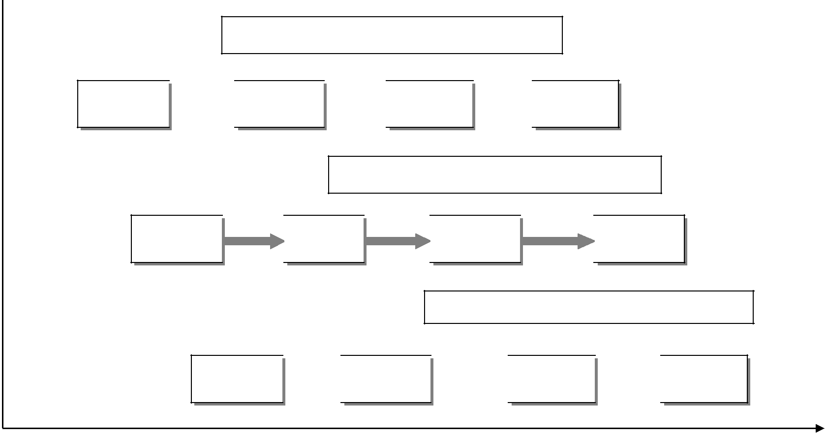

Increment1: Interface Development

Analysis  Design  Coding  Testing

Increment2: Interface Development

Analysis 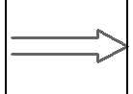 Design 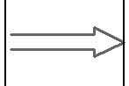 Coding 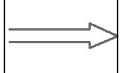 Testing

Increment3: Interface Development

Analysis  Design  Coding  Testing

Figure 1: Incremental model

7

3.2 REASONS FOR USING INCREMENTAL MODEL

* Development of software is easy and fast.
* Requirements can be defined clearly.
* Changes can be done though out the development phases.
* It is flexible so changing requirements and scope is easier.[2]

3.3 TOOLS AND TECHNOLOGIES TO BE USED

* Adobe Photoshop CC 2014 – template design
* E-draw – system design and models
* Netbeans IDE 8.2 – text editor
* MySQL – database management
* Apache – server
* Microsoft Word – Documentation
* PHP – Server side validation
* HTML, CSS, Bootstrap – UI and further styling

8

**4. SYSTEM DESIGN AND UML MODELS**

4.1 USE CASE DIAGRAM

The use case diagram is a UML model that represents the interaction of a user with the system.

In this project, the patient registers a new account for the website or logs into the site if they already have an account. The patient is allowed to book appointments by choosing doctors at their will. The patient also has the freedom to edit and manage their profile. The doctor is registered beforehand by the admin so he can log into his profile. The doctor receives appointment requests that they can approve or reject. They can also manage their profile. Both the admin and operator need to log in to access the system. The operator does the job of entering prescriptions of the appointments completed.

9

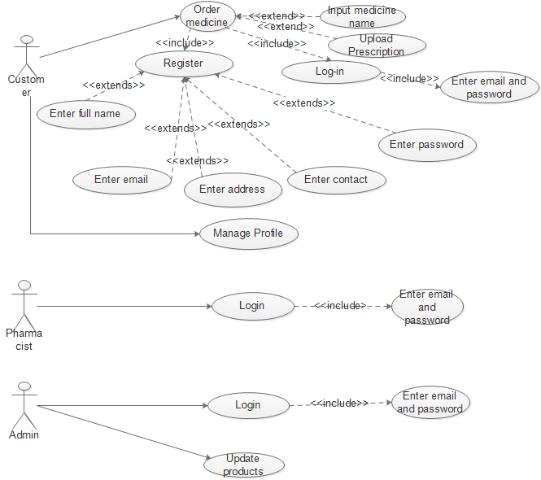

Figure 2: Use case diagram

10

4.2 ER DIAGRAM

The E-R diagram shows the relationship between entities stored in a database. For our project, it is illustrated as follows:

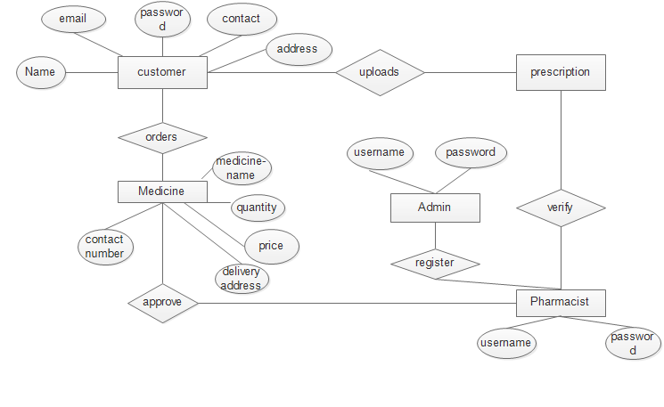

Figure 3: ER diagram

11

4.3 DOMAIN MODEL

Domain model describes concepts in problem domain and is important to represent meaningful concepts that are understandable by everyone.

The domain model for this project is illustrated as below:

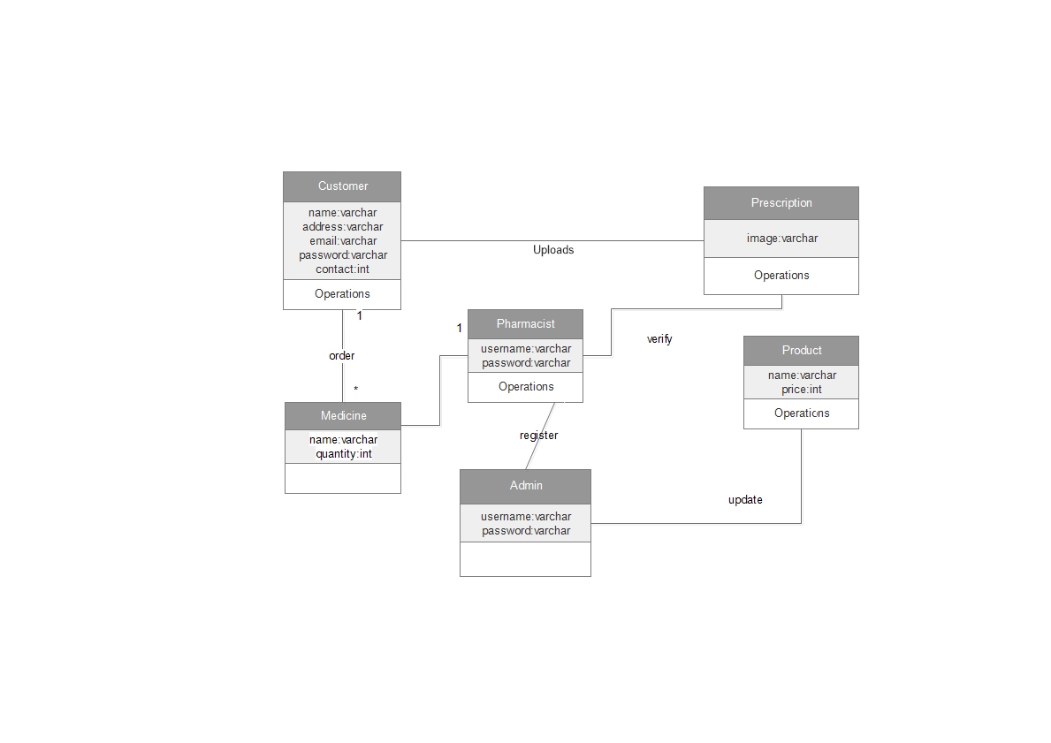

Figure 4: Domain model

12

4.4 ACTIVITY DIAGRAM

Activity diagram represents the sequential flow of actions visually.

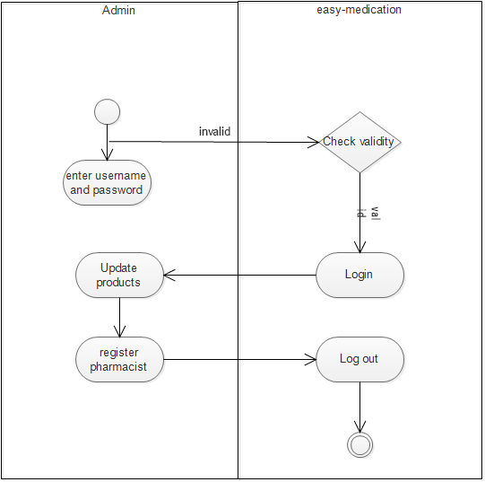

Figure 5: Activity diagram for admin and website.

13

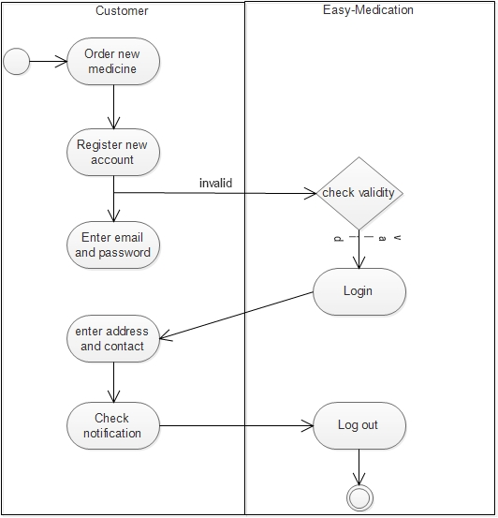

Figure 6: Activity diagram for customer and website.

14

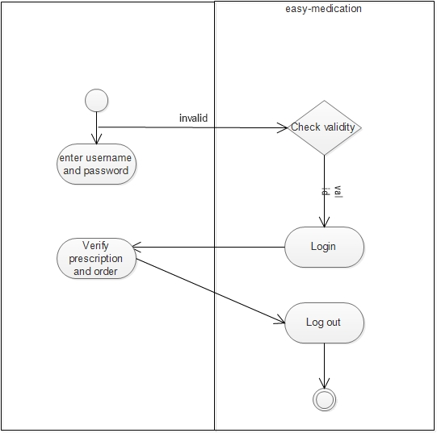

Figure 7: Activity diagram for pharmacist and website.

15

**5. TIME SCHEDULE ESTIMATION**

The time schedule for the project has been estimated according to the stages involved in the development of the system. Our project is estimated to be completed in around 3 months.

5.1 INCREMENT 1

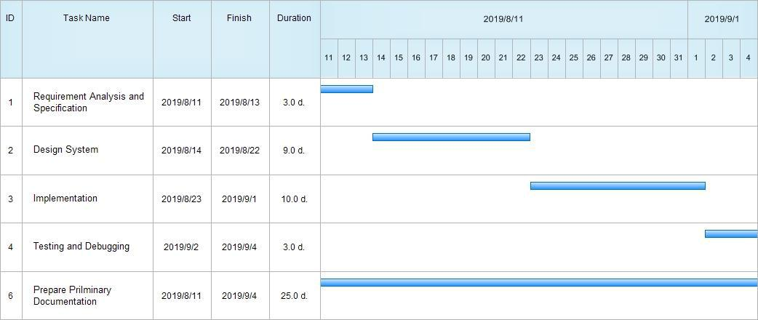

Figure 7: Gantt chart for Increment 1

16

5.2 INCREMENT 2

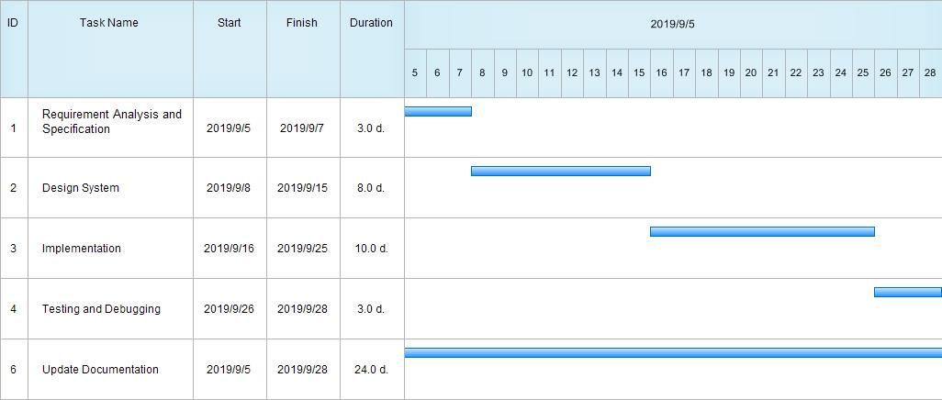

Figure 8: Gantt chart for Increment 2

5.3 INCREMENT 3

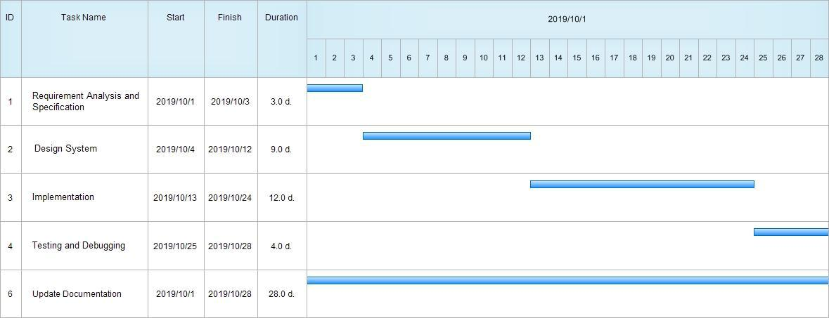

Figure 9: Gantt chart for Increment 3

17

**6. PROJECT TASKS**

6.1 TASKS DONE SO FAR

* Developed user interface
* Created Registration and Login system
  + Patient’s registration page and login page
  + Doctor’s login page
  + Admin and operator’s login page
* Created database
  + Tables for patient, doctor, appointment, prescriptions, etc.
* Created patient’s profile and doctor’s profile

6.2 TASKS REMAINING

* Notification feature
* Billing system
* Appointment system
* Prescription feature

18

1. **BIBLIOGRAPHY**
   * [1] ePharmacy. Retrieved from [http://www.epharmacy.com.np](http://www.epharmacy.com.np/). Accessed 11th August, 2019.
   * [2] Incremental model in SDLC. Retrieved from <https://www.guru99.com/what-is-incremental-model-in-sdlc-advantages-disadvantages.html> . Accessed 11th August, 2019.
   * [3] 24/7 online pharmacy. Retrieved from  [https://www.24seven.com.np/category/medicinet](https://norvichospital.com/schedule-an-appointment) . Accessed 11th August, 2019.
   * [4] Annapurna pharmacy. Retrieved from <http://annapurnapharmacy.com/>. Accessed 11th August, 2019.
   * [5] ATMPharmecy. Retrieved from <https://www.atmpharmacy.com/>. Accessed 11th August, 2019.

19

**APPENDIX**

* System Snapshots

* Home

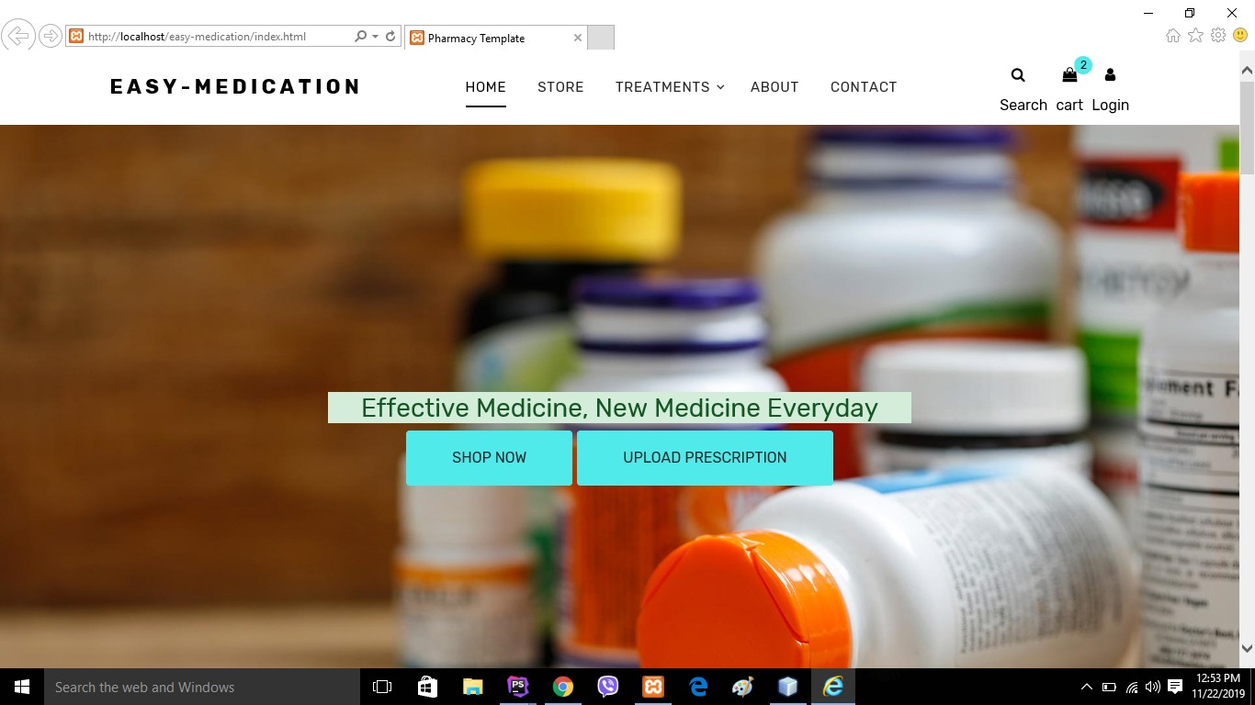

* Admin Panel

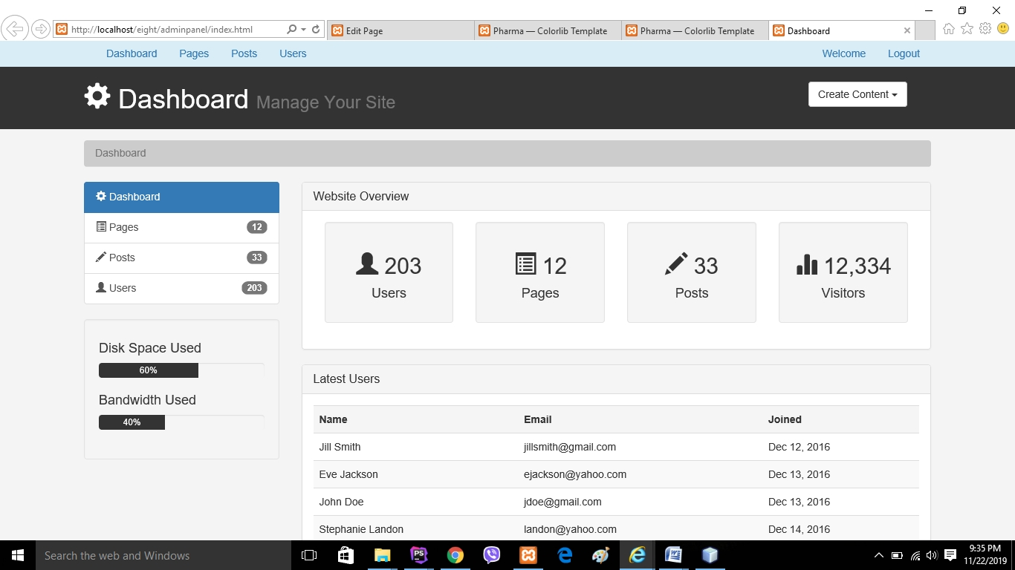

* Shipping form

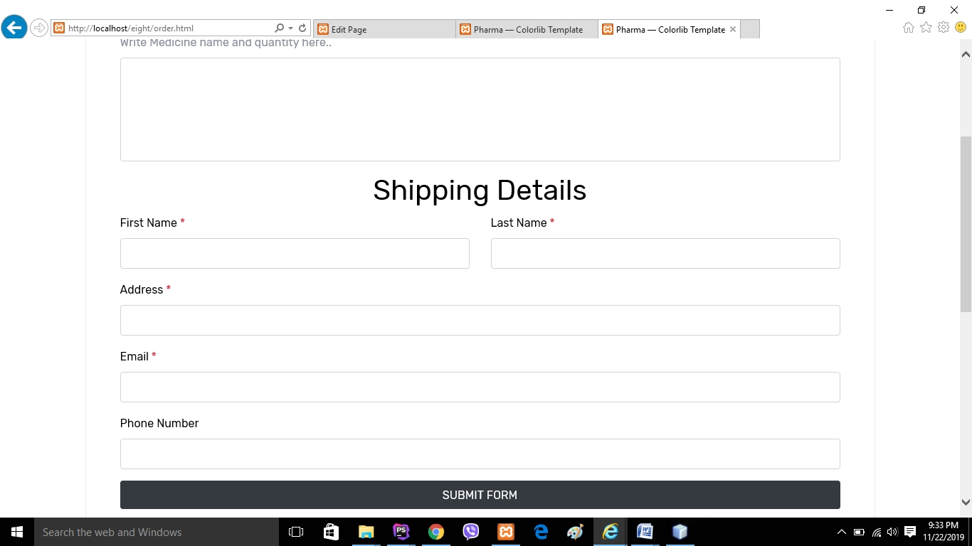

* Store medicine

